0795-压缩机减震垫3D打印生产记录
Compressor vibration isolator pad
🖨️ SLS尼龙烧结
🖥️ 打印机: EOS
📦 材料: 摆放着未成型的液态光敏
生活是一场不断试错的实验，就像我们这次为压缩机减震垫研发的工作，挑战与成长总在每一次打印中交织。
Life is an ongoing experiment of trial and error, much like our work on developing the shock-absorbing pads for the compressor, where challenges and growth intertwine with each print.
________________________________________________________________________________
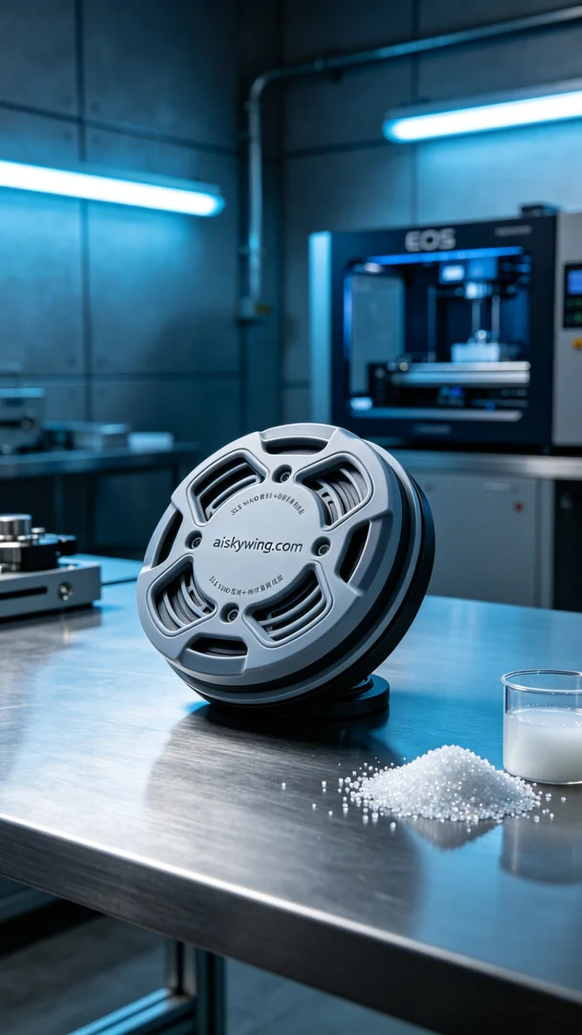
Life is an ongoing experiment filled with trials and errors, just like our recent work on developing a compressor vibration pad, where challenges and growth intertwine with every print.
On LinkedIn, someone reached out to us for assistance in solving their technical issues related to compressor vibration. They required a high-performance vibration pad and hoped to achieve it through 3D printing. We quickly decided to take on the project for the compressor vibration pad, with a clear goal and tight timeframe.
For this pad, we chose the SLS nylon sintering process, utilizing liquid photopolymer resin that is not yet formed. This material offers excellent elasticity and durability. In terms of equipment preparation, we used an EOS brand 3D printer and set the printing parameters: a layer thickness of 0.1 millimeters, a temperature of 160 degrees Celsius, a power setting of 90 watts, a print speed of 30 millimeters per second, with an estimated print time of 6 hours.
During the printing process, the EOS printer operated steadily, and the precise temperature and power settings ensured uniform material distribution and good adhesion. Every detail was monitored, and the quality control system provided timely feedback on the print status, ensuring that every aspect met our high standards.
After printing, we entered the post-processing stage. First, we cleaned the prints to remove any uncured resin from the surface; next, we sanded the surface of the vibration pad to ensure a smooth and comfortable feel. Finally, we conducted a curing process using UV light to ensure the material achieved optimal hardness and performed a quality inspection on the finished product to confirm its exceptional performance and appearance.
Through this production run, we successfully delivered a high-quality compressor vibration pad, showcasing the endless possibilities of 3D printing technology and our professional capabilities.
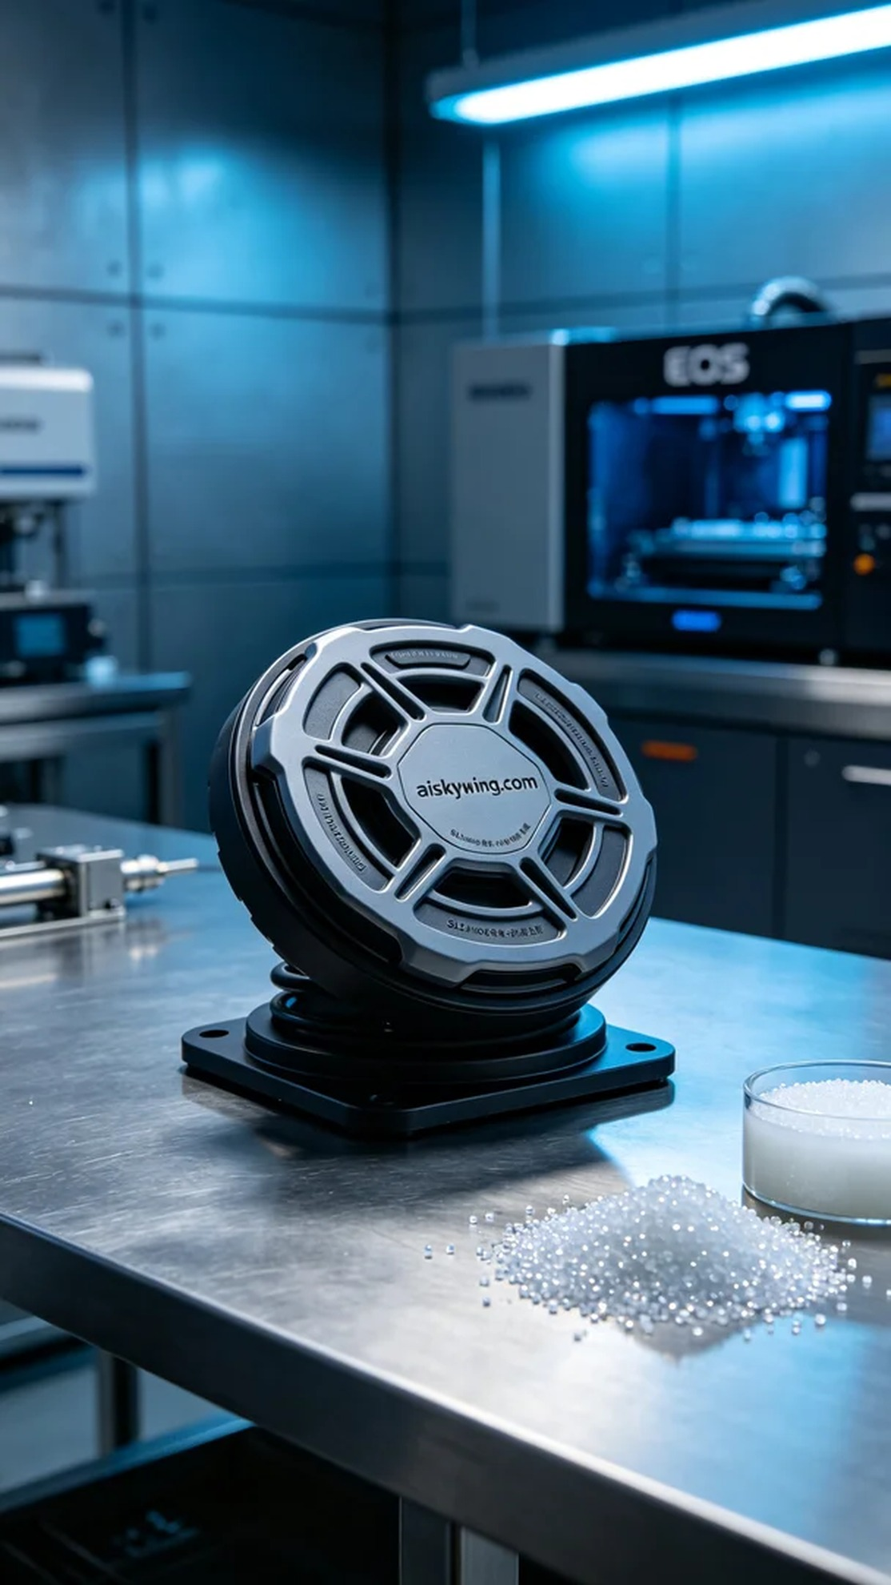
在LinkedIn上，有人向我们寻求帮助，希望解决他们在压缩机减震方面的技术难题。他们需要一款高性能的压缩机减震垫，期待通过3D打印实现。我们迅速决定接下这个压缩机减震垫的项目，目标明确，时间紧迫。
针对这款减震垫，我们选择了SLS尼龙烧结工艺，使用未成型的液态光敏树脂，这种材料具有优良的弹性和耐用性。设备准备方面，我们使用的是EOS品牌的3D打印机，设置了打印参数：层厚为0.1毫米，温度保持在160摄氏度，功率设定为90瓦特，打印速度为30毫米每秒，预计打印时间为6小时。
在打印过程中，EOS打印机稳定运行，精确的温度和功率设置确保了材料的均匀分布和良好的附着力。每个细节点都在监控之中，质量监控系统及时反馈打印状态，确保每个细节都无懈可击。
打印完成后，我们进入后处理环节。首先，将打印件进行清洗，去除表面的未固化树脂；接着，对减震垫表面进行打磨，以确保光滑和舒适的触感。最后，进行固化处理，使用UV灯照射确保材料达到最佳硬度，并对成品进行质量检验，确保其具备出色的性能和外观。
通过这次的生产，我们成功交付了一款高质量的压缩机减震垫，展现了3D打印技术的无限可能和我们的专业能力。
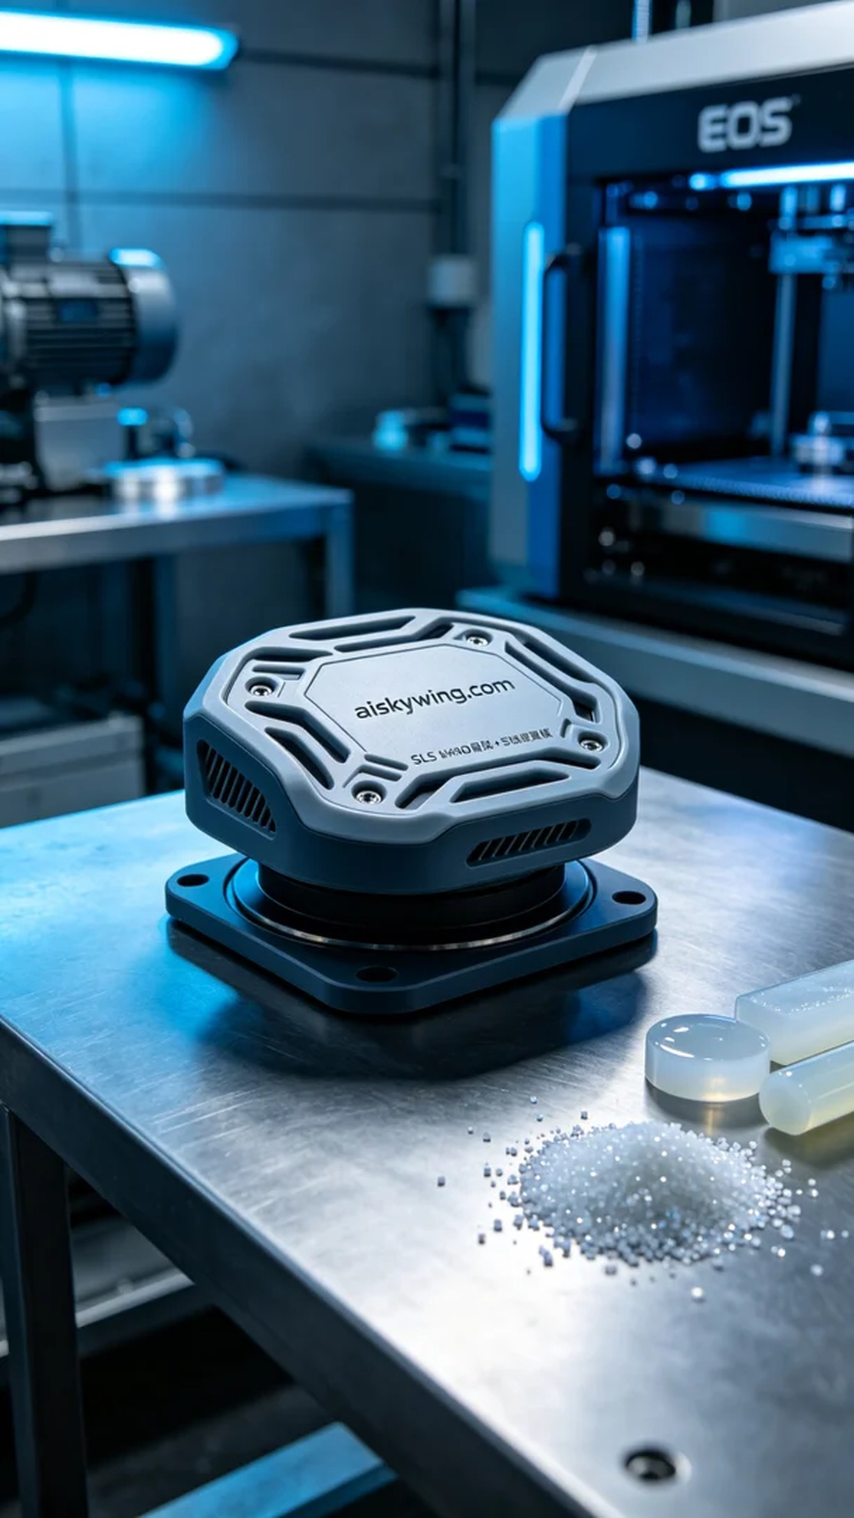
Aiskywing Industrial 3D Printing
Compressor vibration isolator pad


