0796-夹具防护套3D打印生产记录
Fixture Protective Sleeve
🖨️ SLS尼龙烧结
🖥️ 打印机: Rize
📦 材料: 摆放着未成型的液态光敏
在生活的每一个环节中，我们都在不断追求完美。就像这个夹具防护套在LinkedIn上获得的关注，承载了许多期待与责任。
In every aspect of life, we are constantly striving for perfection. Just like the attention this fixture protective cover has received on LinkedIn, it carries many expectations and responsibilities.
________________________________________________________________________________
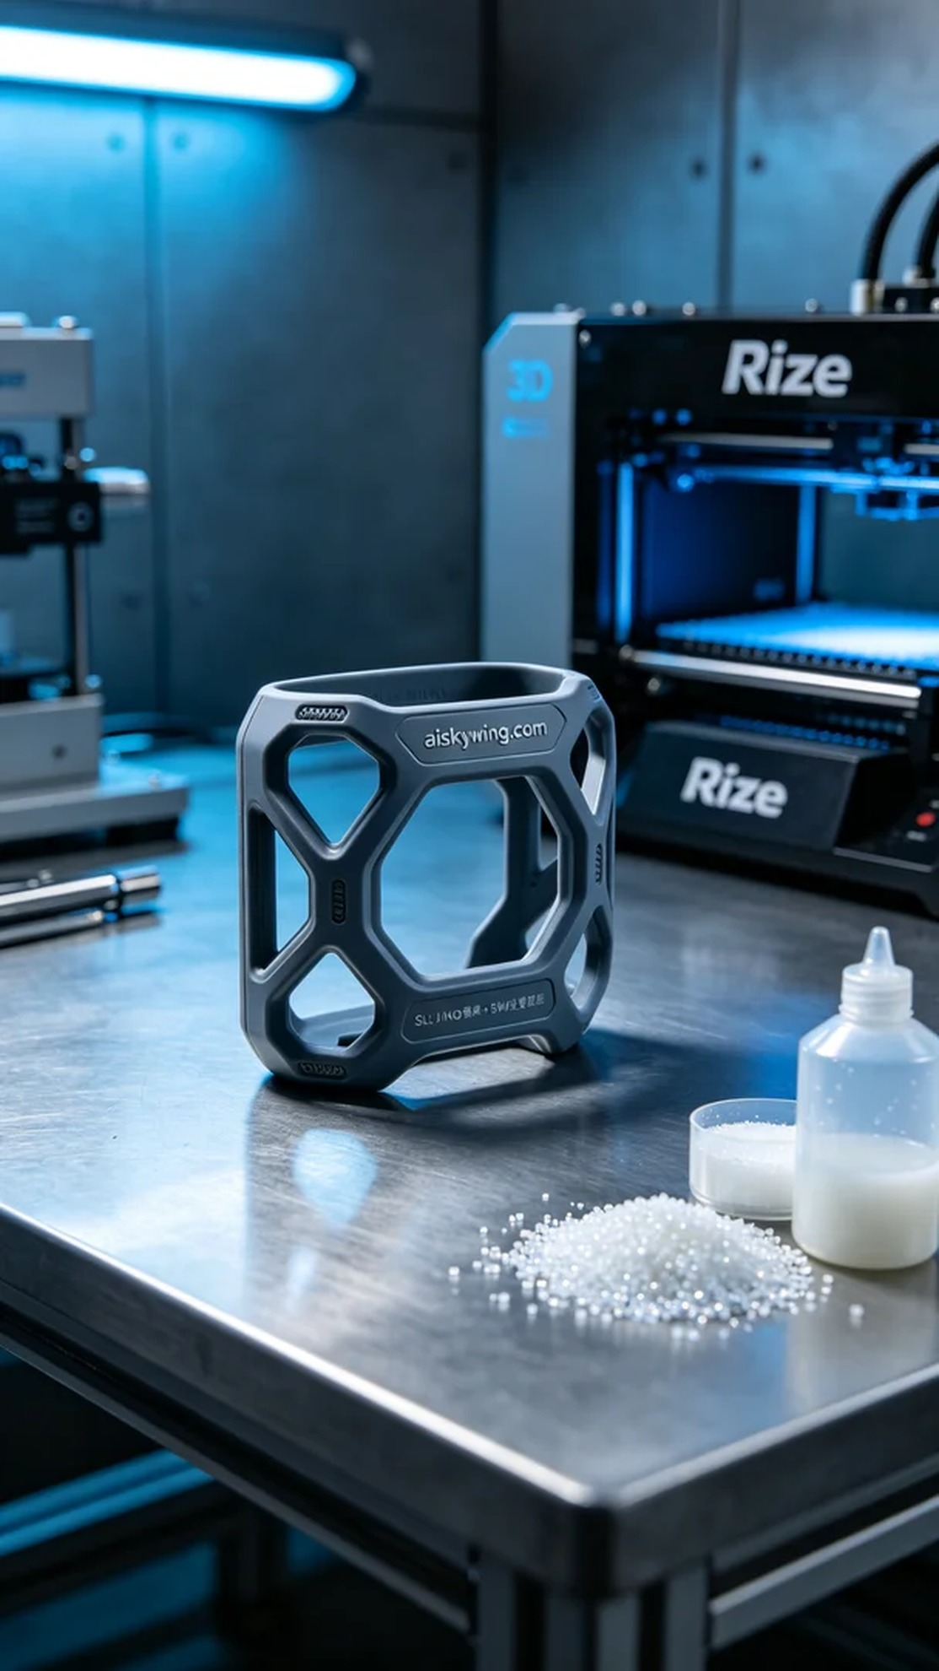
Recently, someone approached us to create a fixture protective cover to address their need for equipment protection. This product needs to possess good support and flexibility to adapt to different working scenarios, and clearly, our 3D printing technology is well-suited to meet this demand.
We chose to use liquid photopolymer resin, as it has excellent detail reproduction and surface smoothness, making it ideal for the physical properties of the fixture protective cover. To ensure the print quality, we set the Rize printer parameters to a layer thickness of 0.1 mm, maintained the temperature at 50°C, with a power of 120W, and set the print speed to 30 mm per second, estimating a total print time of about 3 hours.
During the printing process, the machine operated smoothly, and the liquid photopolymer resin gradually formed in layers. We closely monitored the device's operation to ensure there were no bubbles or material blockages. As time passed, the fixture protective cover took shape, with details clearly visible, meeting our expectations.
In the post-processing stage, we first placed the formed cover in a cleaning tank to remove excess resin from the surface. Next, we polished the edges to ensure a smooth finish. Finally, we processed it through a curing device to enhance the durability and stability of the final product, followed by a thorough inspection to ensure all details met the required standards.
The entire process went smoothly, and we successfully delivered the fixture protective cover, showcasing the charm of 3D printing and the power of technology.
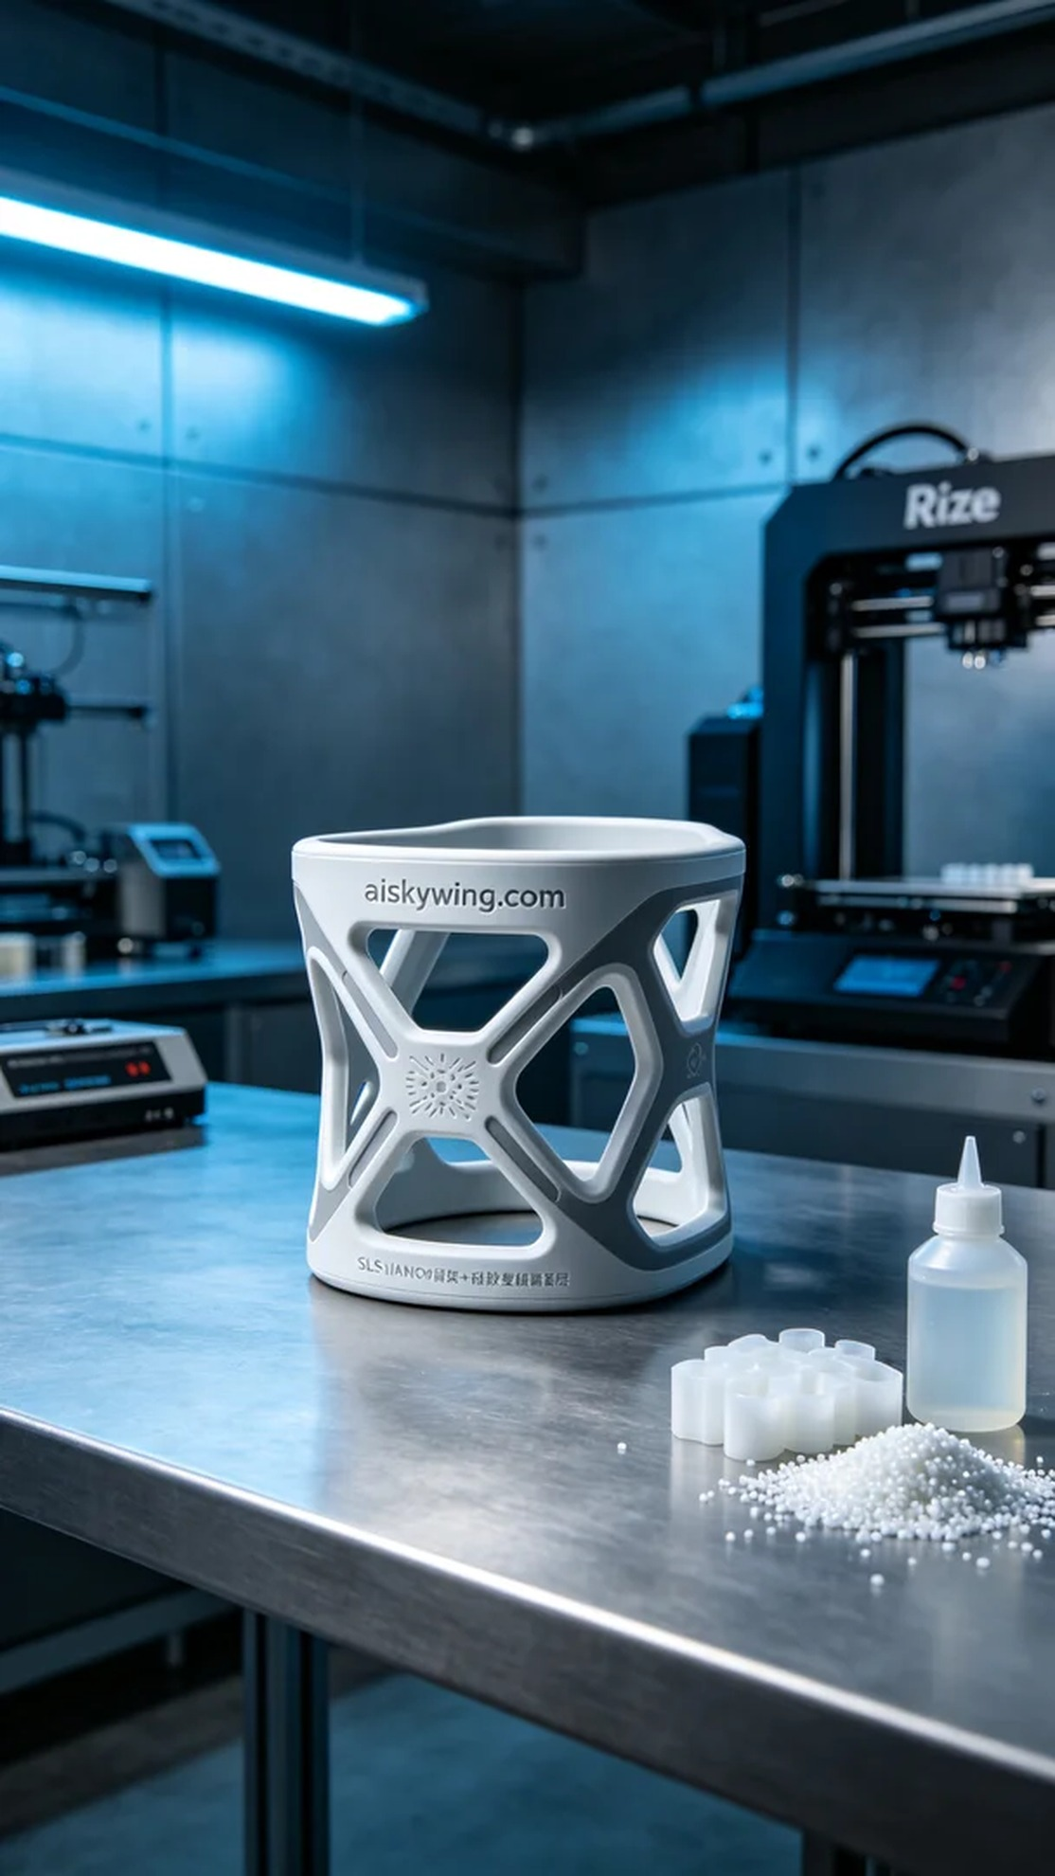
近期，有人找我们制作一个夹具防护套，以解决他们在设备使用过程中的防护问题。这款产品需要具备良好的支撑性和柔韧性，以适应不同的工作场景，显然，对于这样的需求，我们的3D打印技术能够很好地满足。
我们选用了摆放着未成型的液态光敏材料，因其优良的细节还原能力和表面平滑度，能够为夹具防护套提供理想的物理特性。为了确保打印效果，我们将Rize打印机的参数设置为层厚0.1毫米，温度控制在50℃，功率为120W，打印速度设置为30毫米每秒，整个打印预计需要3个小时。
打印过程中，机器运转平稳，液态光敏树脂在层层叠加中逐渐成型。我们严格监控设备的运行状态，确保没有气泡或材料堵塞的情况发生。随着时间推移，夹具防护套最终形成，表面细节清晰可见，效果符合我们的预期。
在后处理工序中，首先将成型的防护套放入清洗槽进行清洗，去除表面多余的树脂。接着，我们对其进行打磨，确保边缘光滑。最后，通过固化设备进行加固，以提高成品的耐用性和稳定性，最后进行检验，确保每个细节都达到标准。
整个过程顺利进行，最终我们成功交付了这个夹具防护套，充分展示了3D打印的魅力和技术的力量。
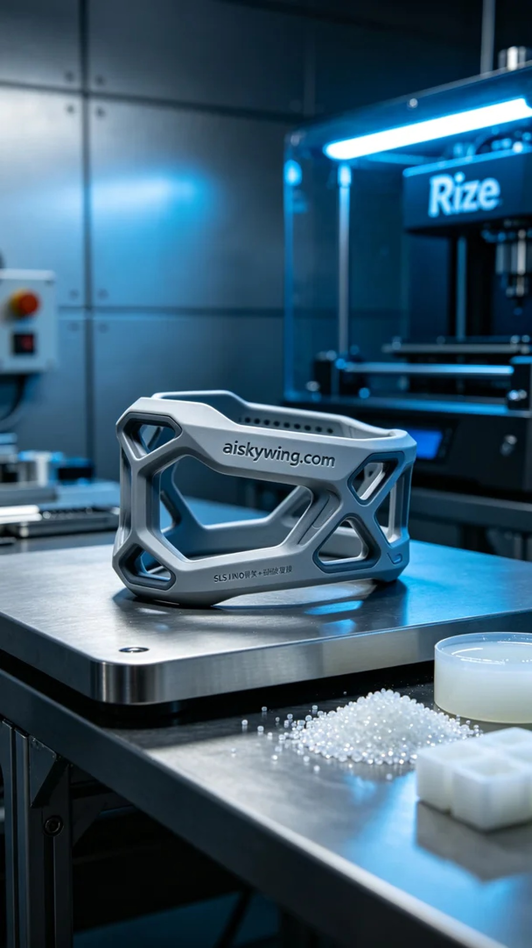
Aiskywing Industrial 3D Printing
Fixture Protective Sleeve


