0797-存储卡收纳盒3D打印生产记录
Storage Card Organizer Box
🖨️ SLM金属打印
🖥️ 打印机: Stratasys
📦 材料: 摆放着未成型的液态光敏
生活再难，也别停下脚步。就像接下这个存储卡收纳盒的单子，有人因为缺乏好的存储方案而找上了我们。
No matter how difficult life gets, don't stop moving forward. Just like when we took on the order for this storage card organizer, someone reached out to us because they lacked a good storage solution.
________________________________________________________________________________
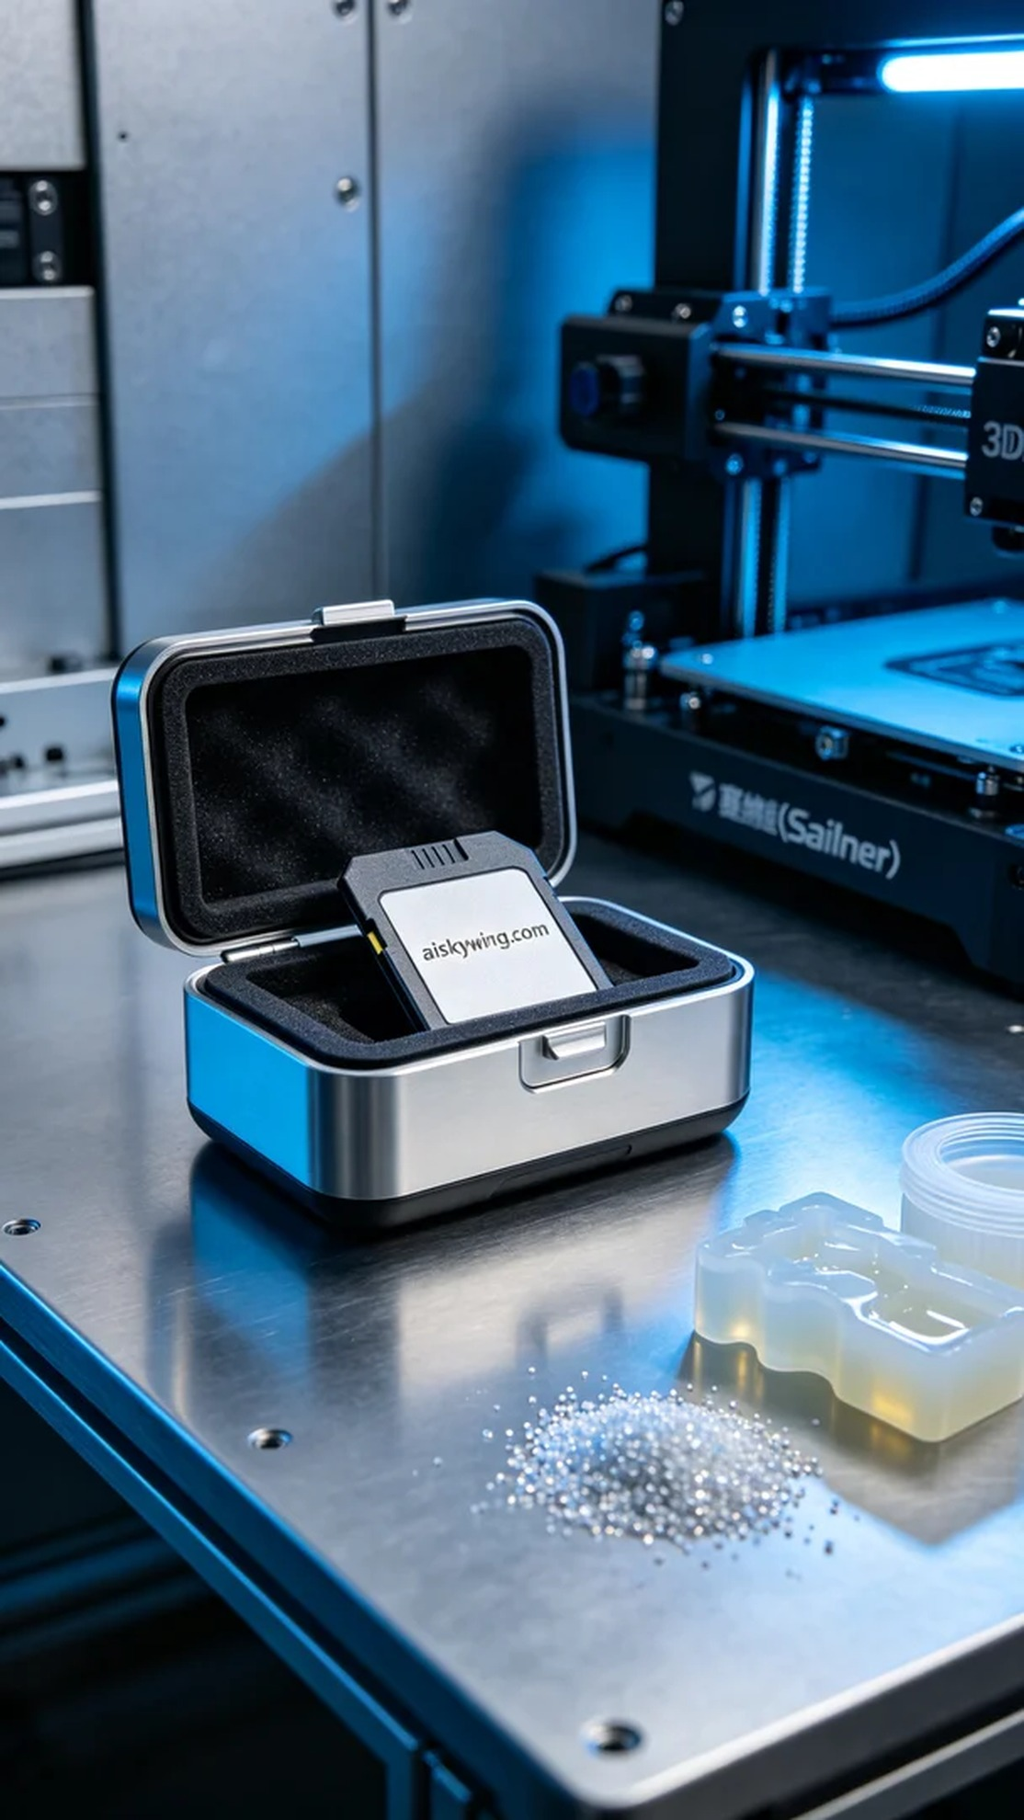
As the demand for storage cards continues to rise with the proliferation of electronic devices, someone approached us with a request to create a storage card organizer. This storage card organizer needed to not only function effectively but also possess high aesthetic and tactile qualities.
We opted to use unformed liquid photopolymer resin as our raw material to ensure the final product's precision and durability. Utilizing the Stratasys printer for SLM metal printing, we set the layer thickness to 0.1mm, maintained a printing temperature of 25°C, set the power at 200W, and the speed at 60mm/s, estimating a printing time of approximately 8 hours. This configuration was crucial for achieving perfection in every layer's detailing.
Once the printing process began, the machine operated smoothly, with liquid photopolymer resin solidifying according to the prescribed trajectory. We closely monitored print quality in real-time to ensure that every layer remained free from bubbles and defects. After several hours of operation, the finished product started to reveal clear engraved lettering and a robust structure, with its surface displaying a sleek industrial feel.
After printing, we proceeded with post-processing steps. First, we placed the finished product in a cleaning solution to thoroughly remove excess resin. Then, we sanded it with fine-grit paper to enhance its surface smoothness. Finally, we cured it in a curing machine to ensure that its strength and durability met our standards. Following a strict quality inspection, we confirmed that every detail was perfect, completing the production of this storage card organizer.
With each process successfully executed, the storage card organizer was finally ready, showcasing its unique design and craftsmanship. We believe this product will provide users with a more convenient storage experience.
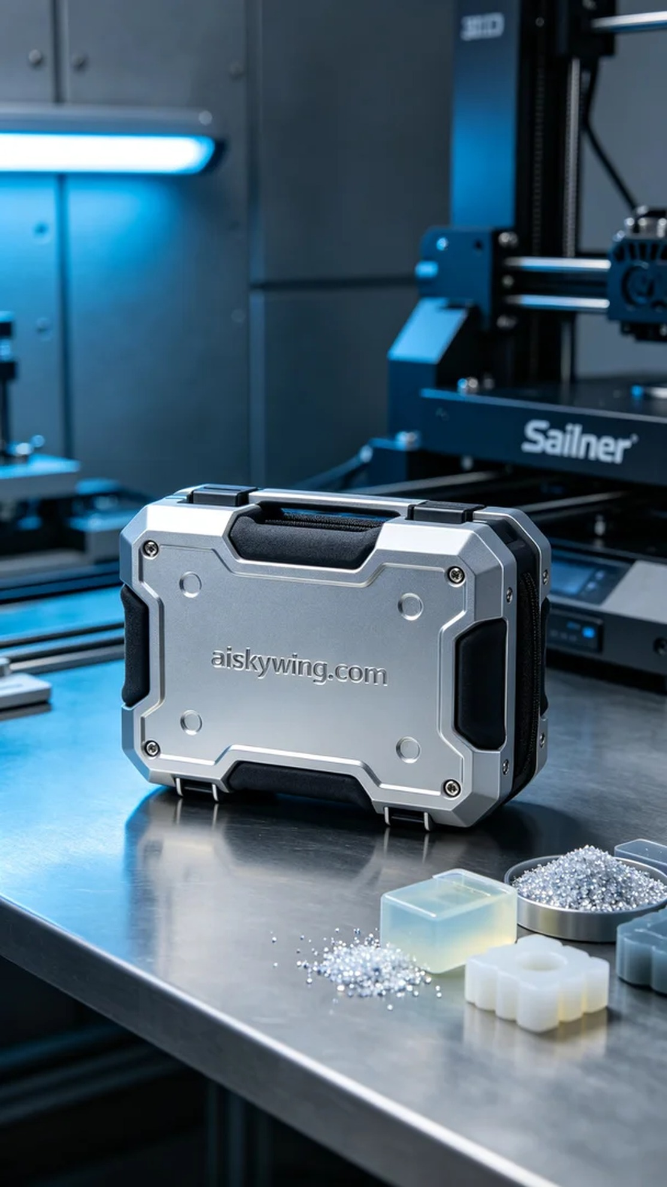
随着越来越多的电子设备，存储卡的需求也在不断增加。有人因为无法找到合适的存储解决方案，向我们提出了制作一个存储卡收纳盒的请求。这个存储卡收纳盒不仅需要满足储存功能，还要具备较高的视觉和触感品质。
我们选择使用摆放着未成型的液态光敏树脂作为原材料，确保最终产品的精细度和坚固性。使用Stratasys打印机进行SLM金属打印，设置层厚为0.1mm，打印温度控制在25°C，功率设定为200W，速度为60mm/s，预计打印时间约为8小时。这样的参数设置可以确保每一层的细节都得到完美呈现。
打印过程开始后，设备运行稳定，液态光敏树脂按照预设轨迹不断固化成型。我们保持对打印质量的实时监控，确保每一层都不出现气泡或其他缺陷。经过几小时的运行，成品逐渐显现出其清晰的雕刻字样和整体结构，表面光滑且富有工业感。
打印完成后，我们进行了后处理工序。首先将成品置于清洗液中，彻底去除多余的树脂。接着，使用细砂纸进行打磨，以提升其表面光洁度。最后，将其放入固化机中进行固化，确保强度和耐用性达到标准。经过严格的检验，确保每一个细节都完美，最终完成了这款存储卡收纳盒的制作。
随着各个工序的顺利完成，这个存储卡收纳盒终于呈现在眼前，展现出其独特的设计与工艺。我们相信，这样的产品会为用户带来更加便利的使用体验。
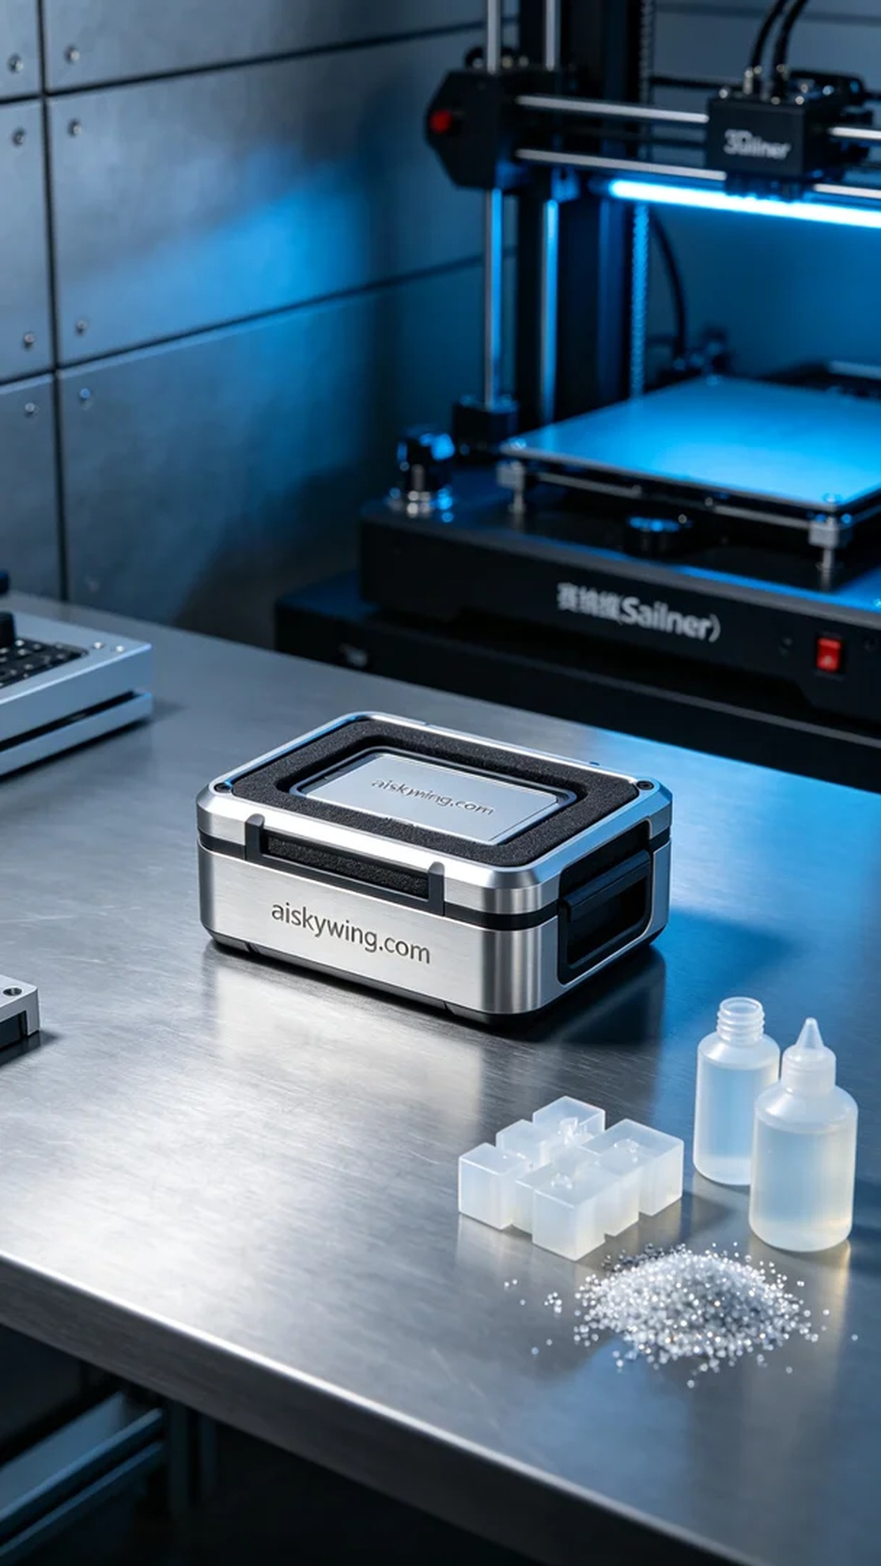
Aiskywing Industrial 3D Printing
Storage Card Organizer Box


