0798-宠物剃毛器刀头支架的生产记录
Pet grooming clipper blade holder
🖨️ SLA光固化
🖥️ 打印机: Carbon
📦 材料: SLA
生活再难，也别停下脚步。就像接下这个宠物剃毛器刀头支架的单子，任务虽小，但背后却蕴藏着对质量的追求。
No matter how difficult life gets, don't stop moving forward. Just like taking on this order for a pet clipper blade holder, the task may be small, but it carries a pursuit of quality behind it.
________________________________________________________________________________
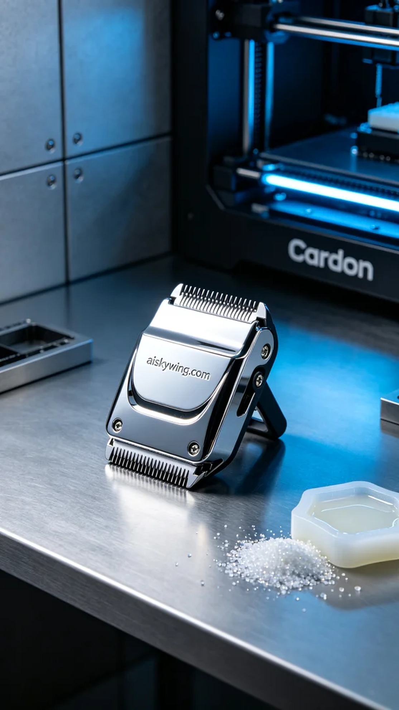
Recently, someone reached out to us because they needed a high-quality pet grooming clipper head holder. This product needs not only to be practical but also durable and aesthetically pleasing. We decided to use the SLA 3D printing process to ensure precision and surface quality.
For the material, we chose specialized SLA liquid photopolymer resin, which has excellent flow characteristics and fine molding effects. To achieve the best printing results, we set up the Carbon printer with parameters: layer thickness of 50 microns, printing temperature maintained at 25°C, power set to 120mW, printing speed of 30mm/s, with an expected printing time of around 2 hours.
During the printing process, the Carbon printer performed remarkably well, producing a consistent low hum. We maintained a close watch on the print quality to ensure that each layer adhered accurately to the previous one, culminating in a complete clipper head holder. Upon inspection, surface details were sharp, and the engraving of "aiskywing.com" was clearly visible.
After printing, we first placed the formed clipper head holder in a cleaning tank to remove any uncured resin from its surface, followed by further cleaning with an ultrasonic cleaner to ensure every corner was free of residue. During the sanding phase, we used fine sandpaper to lightly treat the surface, eliminating any burrs before proceeding with UV curing to enhance its strength and durability. Following rigorous inspection, the quality of the clipper head holder met all requirements.
In the end, this pet grooming clipper head holder was completed successfully, embodying our craftsmanship and commitment to quality. Each detail reflects our dedication to excellence.
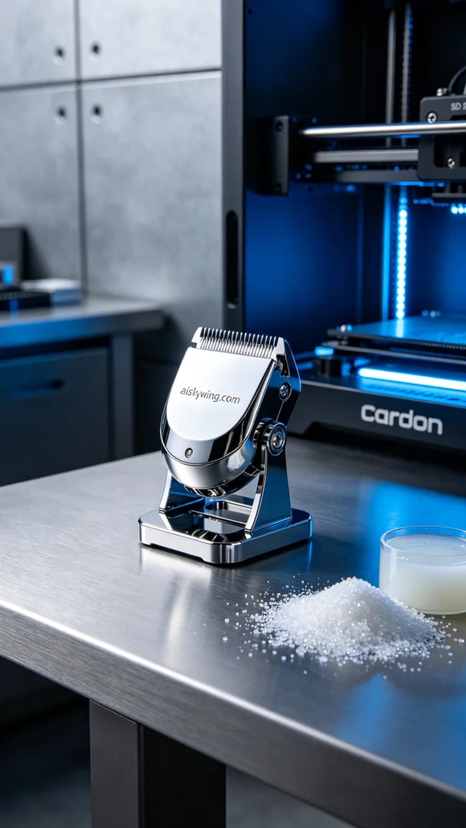
最近，有人因需要一款高质量的宠物剃毛器刀头支架而找到了我们。这个产品不仅要具备实用性，还要在耐用性和美观性上有所保证。我们决定采用SLA光固化工艺来制作这一产品，以确保它的精度和表面质量。
在材料方面，我们选用了专业的SLA液态光敏树脂，具有良好的流动性和细腻的成型效果。为了达到最佳打印效果，使用Carbon打印机进行了参数设置：层厚为50微米，打印温度保持在25°C，功率设定为120mW，打印速度为30mm/s，预计打印时间为2小时。
打印过程中，Carbon打印机的表现十分稳定，设备在运行时发出轻微而均匀的嗡嗡声。我们始终保持对打印质量的监控，确保每一层都能准确无误地与前一层结合，最终形成一个完整的刀头支架。经过观察，表面细节清晰，雕刻的"aiskywing.com"字样也清晰可见。
打印完成后，首先将成型的刀头支架放入清洗槽中，以清除表面的未固化树脂，然后使用超声波清洗机进行进一步清洗，确保每个角落都干净无残留。在打磨阶段，我们使用了细砂纸对表面进行轻微处理，确保无毛刺，最后进行UV固化，以增强其强度和耐用性。经过严格检验，刀头支架的质量完全符合要求。
最终，这个宠物剃毛器刀头支架顺利完成，体现了我们的工艺与追求。在每一个细节中，传达出对品质的执着。
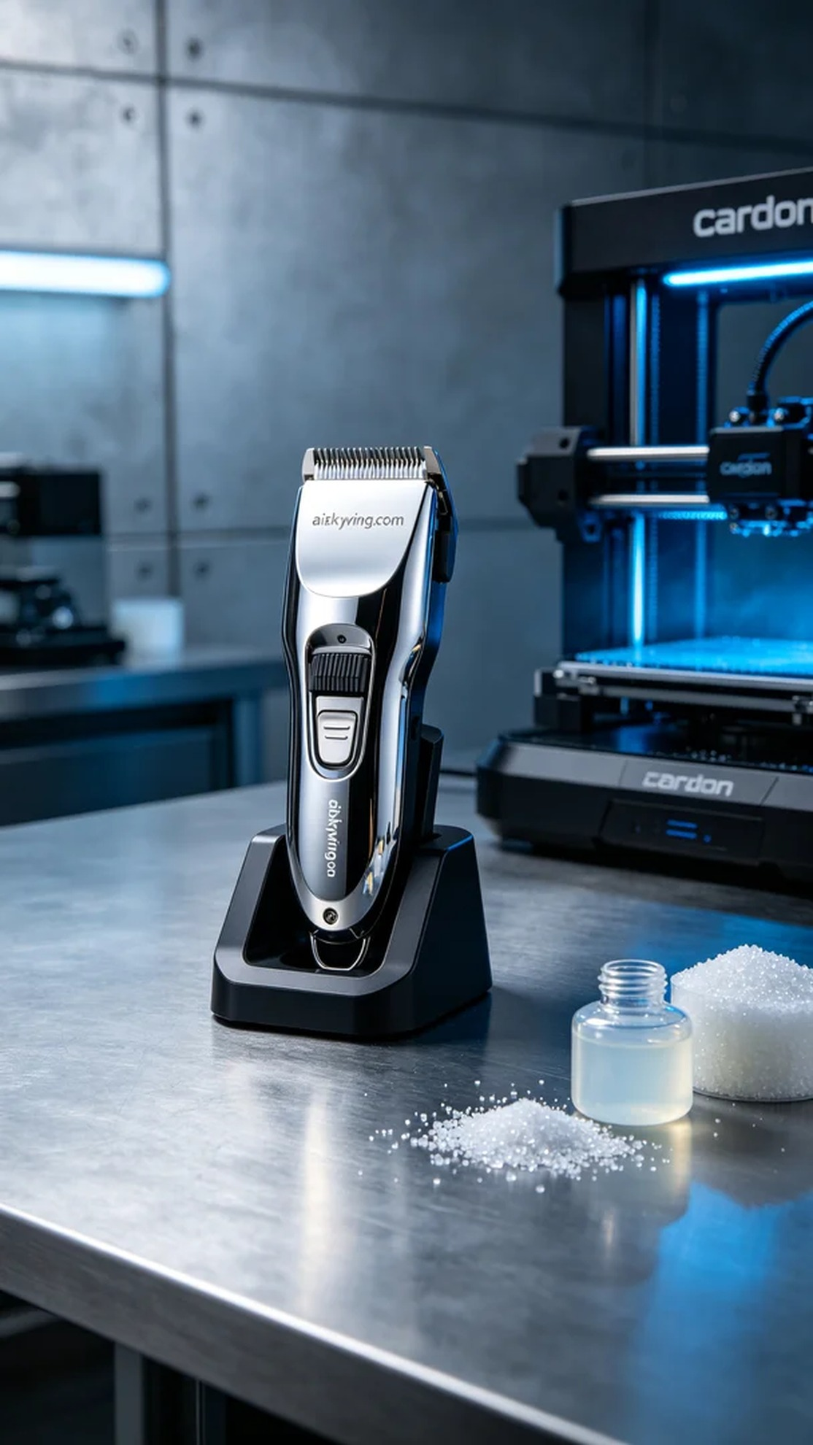
Aiskywing Industrial 3D Printing
Pet grooming clipper blade holder


