0799-宠物吹水机风嘴的3D打印记录
Pet blow dryer nozzle
🖨️ SLS尼龙烧结
🖥️ 打印机: HP
📦 材料: 摆放着未成型的液态光敏
生活再难，也别停下脚步。就像接下这个宠物吹水机风嘴的单子，听说很多人都在为宠物洗澡后的干燥烦恼。
No matter how tough life gets, don't stop moving forward. Just like taking on this order for a pet dryer nozzle, I've heard that many people are troubled by their pets' dryness after bathing.
________________________________________________________________________________
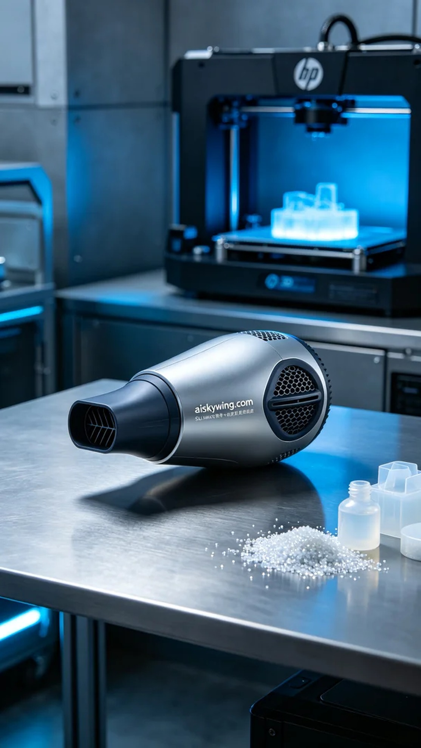
Life can be tough, but we should never stop moving forward. Just like taking on this project for a pet blower nozzle, where many people are struggling to dry their pets effectively after a bath.
For this task, we selected high-quality liquid photopolymer resin as our material, which offers excellent photo-curing properties and a fine surface finish. This ensures that the final nozzle is both robust and aesthetically pleasing. We prepared an HP 3D printer for the job, setting the printing parameters to a layer thickness of 0.1mm, a temperature of 25°C, a speed of 30mm/s, and a power setting of 80%. The estimated print time was around 4 hours to ensure precision and detail.
The printing process ran smoothly, with the HP printer consistently curing the liquid photopolymer resin layer by layer. Throughout the process, we monitored the operation closely to ensure every detail met our design expectations. There were no abnormalities, which guaranteed the stability of the print quality. Once completed, the nozzle showcased clear details, and the engraved text was highly precise.
Post-processing is crucial after printing. First, we carefully removed the nozzle from the printing platform and then cleaned it using a specialized cleaning solution to remove any uncured resin from the surface. Next, I sanded the nozzle down to ensure a smooth and flawless finish, before placing it in a UV curing machine for full curing. Afterward, I meticulously checked every detail to ensure there were no defects.
The final pet blower nozzle not only resolved many pet owners' issues but also showcased the endless possibilities of 3D printing technology. Each printing project is a new exploration, and I look forward to the challenges of the next assignment.
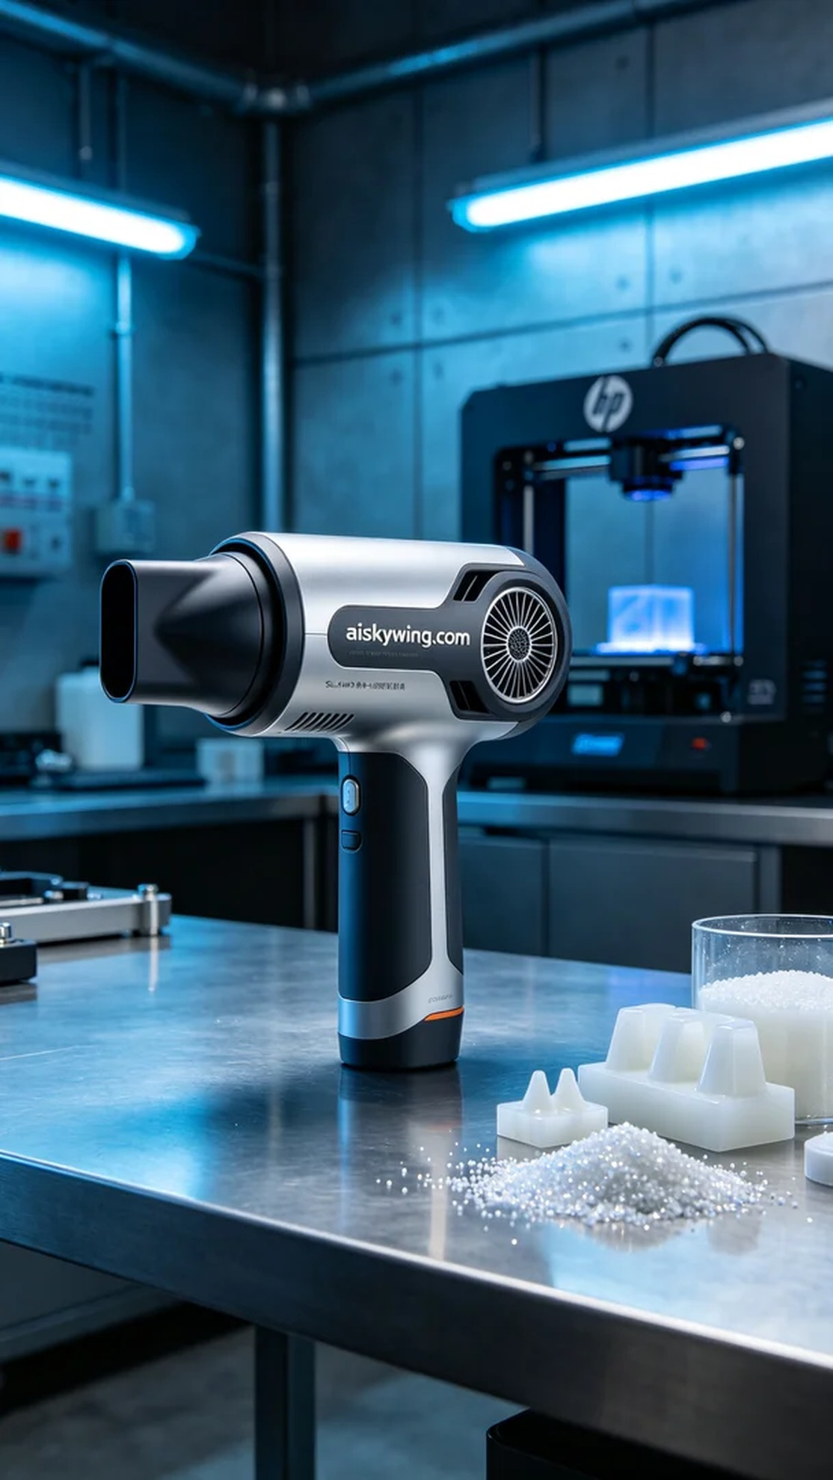
这次的任务是为一款宠物吹水机制作风嘴，有人在Facebook上提到，许多宠物主人面临着洗澡后无法有效干燥宠物毛发的问题。于是，他们寻求我们帮助，希望通过创新的设计来解决这一痛点。
我们选择了高质量的液态光敏树脂作为原材料，具有优异的光固化性能和细腻的表面效果，确保打印出的风嘴既坚固又美观。设备方面，我们准备了一台HP 3D打印机，设置的打印参数为：层厚0.1mm，温度25°C，速度为30mm/s，功率设置在80%。预计打印时间大约在4小时左右，确保精度和细节都能达到要求。
打印过程中的运行情况非常顺利，HP打印机稳定地将液态光敏树脂逐层固化。整个过程我们进行了实时监控，确保每个细节都符合设计要求。过程中，设备没有出现任何异常，确保了打印质量的稳定。打印完成后，风嘴的每个细节都清晰可见，表面雕刻的字样也精准度极高。
打印完成后的后处理尤为重要。首先，需要将风嘴从打印平台上取下，随后进行清洗，使用专用的清洗液去除表面未固化的树脂。接下来，我会进行打磨，确保表面光滑无瑕，最后将风嘴放入紫外线固化机中进行固化，待完全固化后，仔细检查每个细节，确保没有任何的缺陷。
最终制作出的宠物吹水机风嘴，不仅解决了许多宠物主人的困扰，也展现了3D打印技术的无限可能。每一次打印都是一次新的探索，而我也期待着下一个项目的挑战。
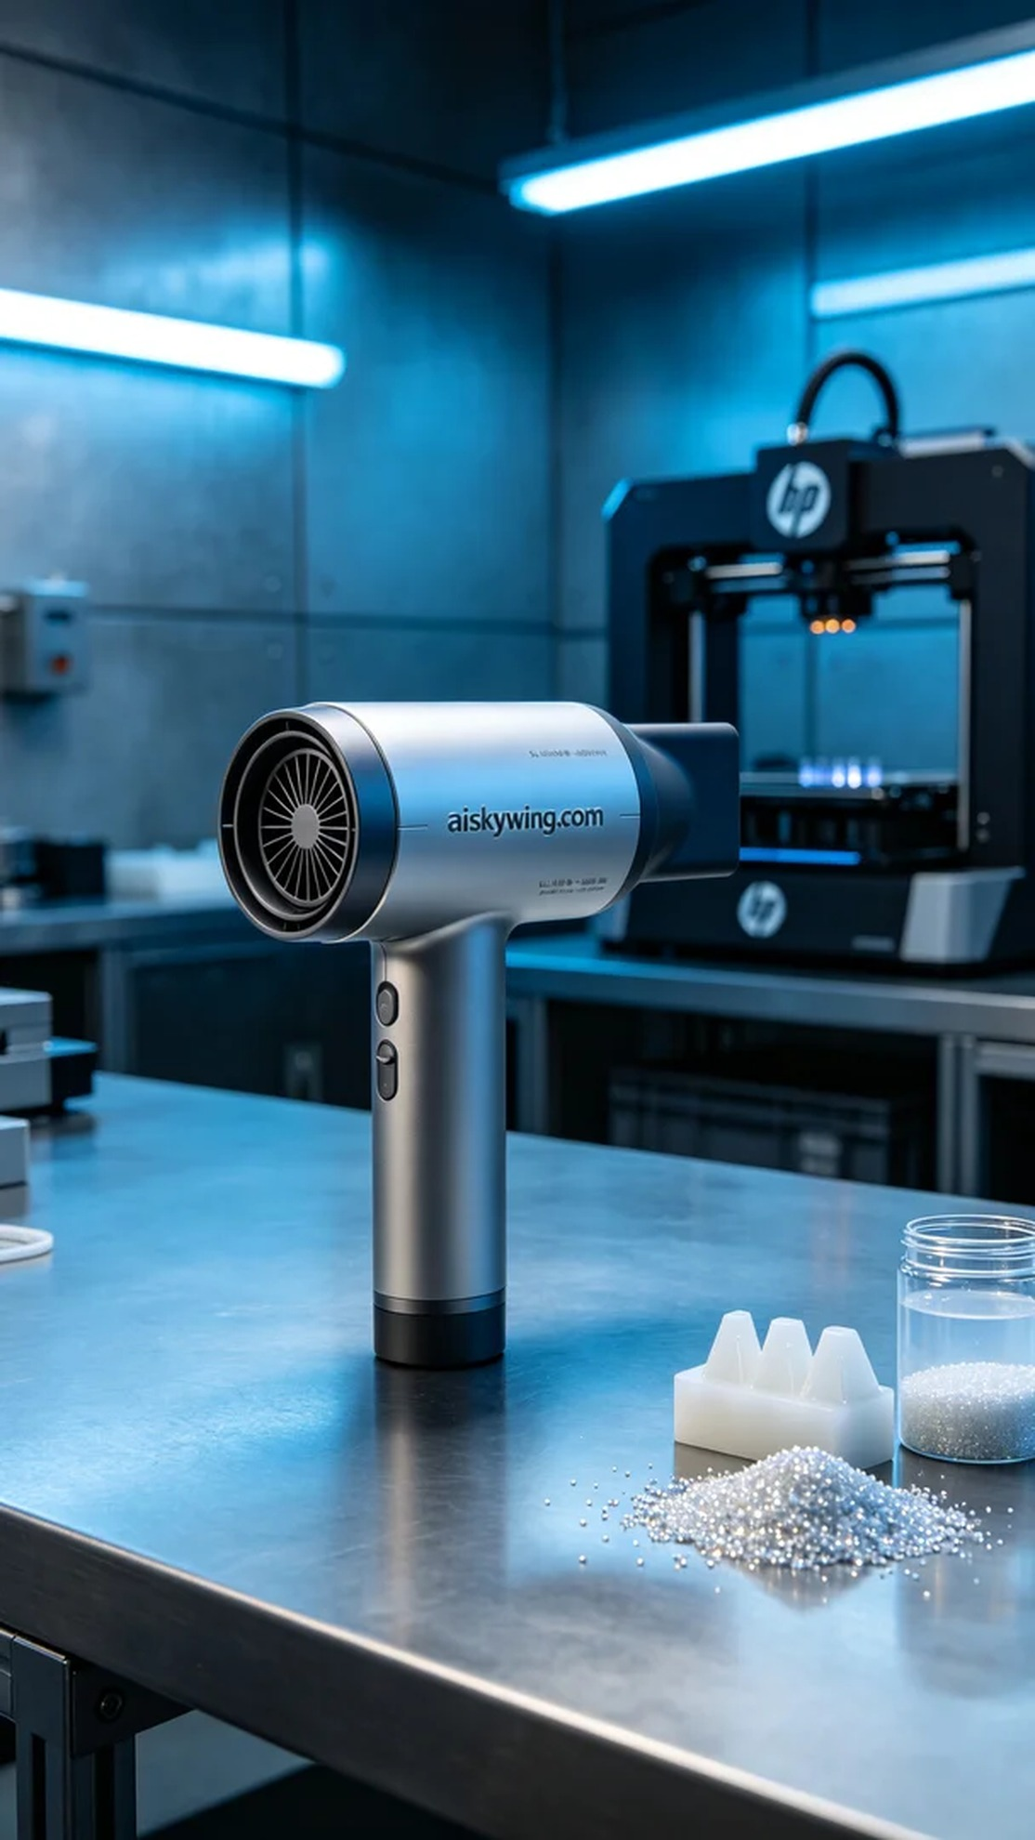
Aiskywing Industrial 3D Printing
Pet blow dryer nozzle


