0800-3D打印宠物喂药器外壳记录
Pet medication dispenser shell
🖨️ SLA光固化
🖥️ 打印机: Stratasys
📦 材料: SLA
生活有时像是3D打印的过程，虽有坑洼波折，但最终能成型的都是珍贵的体验。有人通过WhatsApp联系我，询问宠物喂药器外壳的生产问题。
Life is sometimes like a 3D printing process; despite its bumps and setbacks, what ultimately takes shape are precious experiences. Someone contacted me via WhatsApp to inquire about the production issues of a pet medication dispenser shell.
________________________________________________________________________________
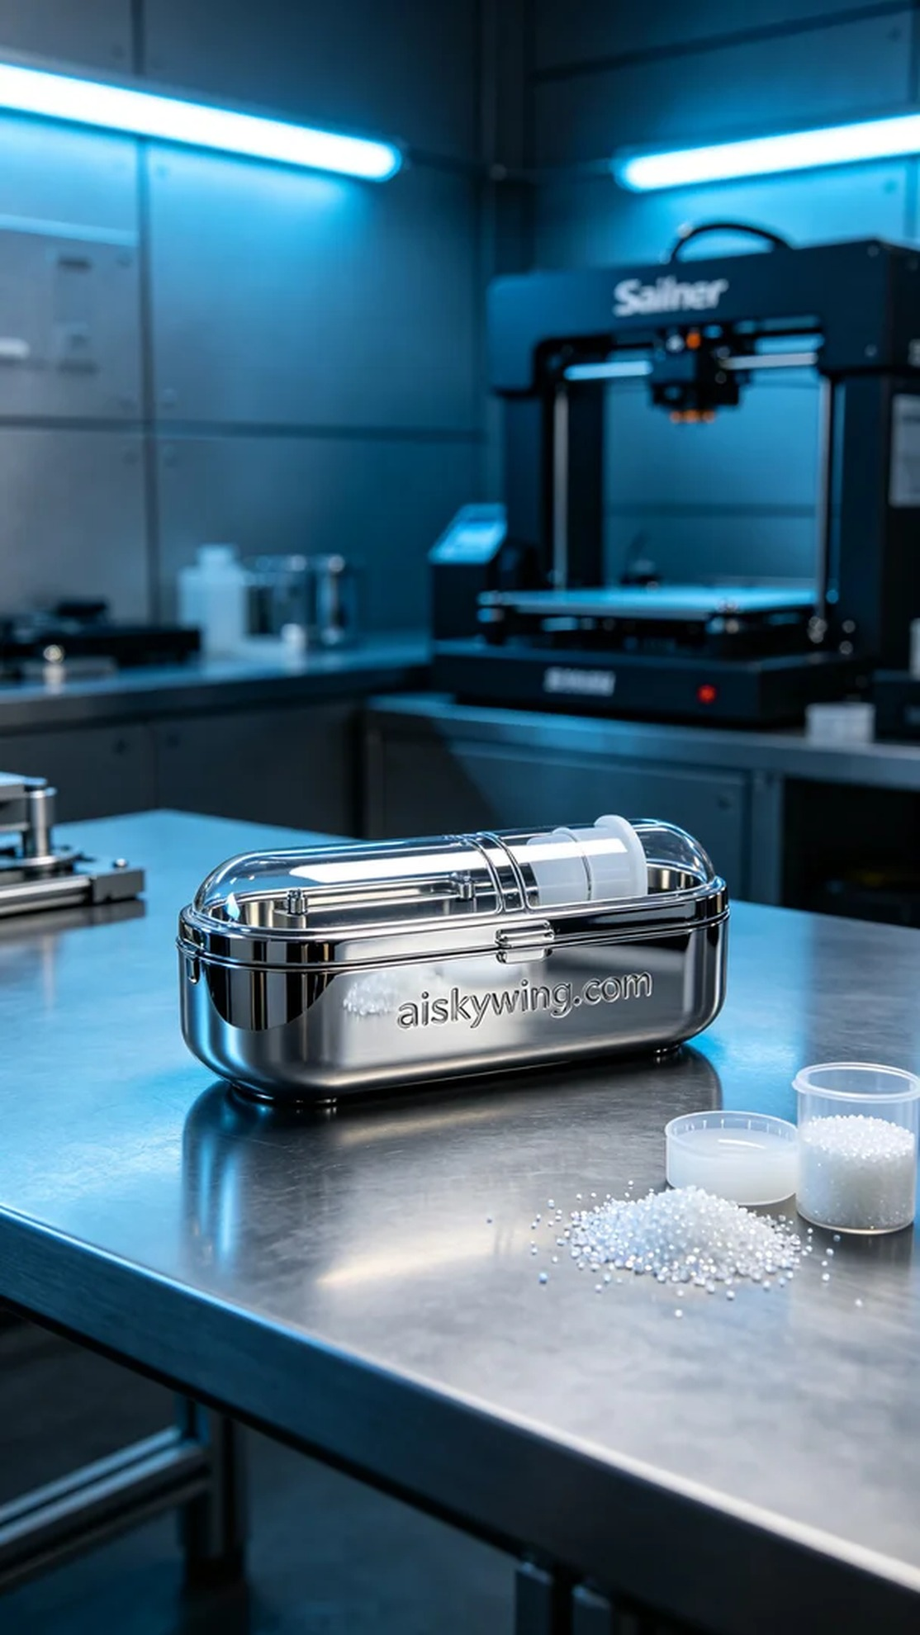
Sometimes, life resembles the process of 3D printing—filled with bumps and turns, yet what eventually takes shape are valuable experiences. Someone reached out to me via WhatsApp, inquiring about the production of a pet medication dispenser housing.
To meet these requirements, I decided on SLA (Stereolithography) technology for production. The raw material used is high-performance SLA resin, known for its excellent flow properties and detail representation. For the printing settings, I opted for a layer thickness of 0.05 millimeters, with a temperature set at 25 degrees Celsius, a laser power of 50 milliwatts, and a printing speed of approximately 30 millimeters per second. These parameters ensure meticulous detail and stability in each layer.
During the printing process, I utilized a Stratasys 3D printer, allowing the device to run smoothly without any unusual noises. Throughout the printing, I continuously monitored the status to ensure a uniform supply of material and printing quality. The entire printing process took around 5 hours, and the final product displayed a high-gloss mirror finish, with the engraving of “aiskywing” clearly visible on the surface.
Once the printing was complete, a series of post-processing steps were necessary. First, I placed the printed part in a cleaning tank, thoroughly washing it with isopropyl alcohol to remove any uncured resin. Next, I carried out sanding to eliminate surface imperfections, particularly addressing the details at the seams, followed by curing in a UV curing machine to ensure strength and durability. After final inspection, the product was ready for packaging.
The production of this pet medication dispenser housing was a success, showcasing the precision and reliability of our 3D printing technology. I look forward to seeing it provide convenience for many pet owners in the future.
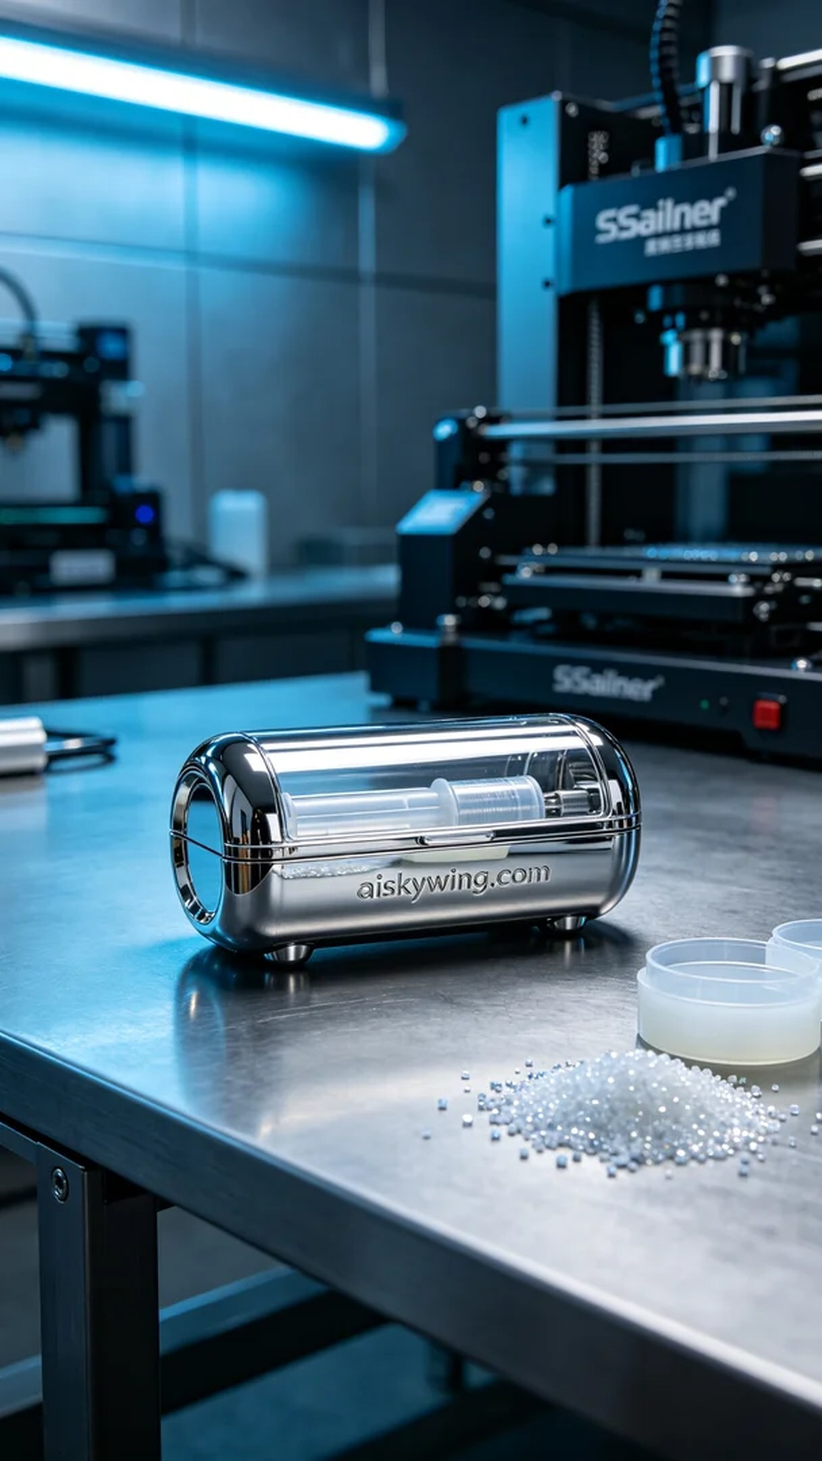
在接到来自WhatsApp的询问时，有人告诉我，他们需要一款高质量的宠物喂药器外壳。这款外壳的设计要求严谨，不仅要完美贴合内部组件，还要具备良好的外观和耐用性。
为了满足这些需求，我选择了SLA光固化技术进行生产。原材料使用的是高性能SLA树脂，具有优良的流动性和细节表现。打印设置方面，采用了0.05毫米的层厚，温度设定在25摄氏度，激光功率为50毫瓦，打印速度约为30毫米每秒。这样的参数能确保每一层的细致度与稳定性。
打印过程中，我使用的是Stratasys品牌的3D打印机，设备运行平稳，无异常噪音。在整个打印过程中，我不断监控打印状态，确保材料的均匀供应和打印质量。打印历时大约5小时，最终成品的外观呈现出高光镜面质感，表面雕刻的"aiskywing"字样清晰可见。
完成打印后，需要进行一系列后处理工序。首先，将打印件放入清洗槽中，使用异丙醇彻底清除未固化的树脂。接着，进行打磨处理，以去除表面瑕疵，特别是接缝处的细节处理，最后将其放入紫外线固化机中固化，确保其强度和耐用性，完成检验后再进行包装。
此次生产的宠物喂药器外壳顺利完成，展现出我们3D打印技术的精湛与可靠。期待它在未来能为更多的宠物主人带来便利。
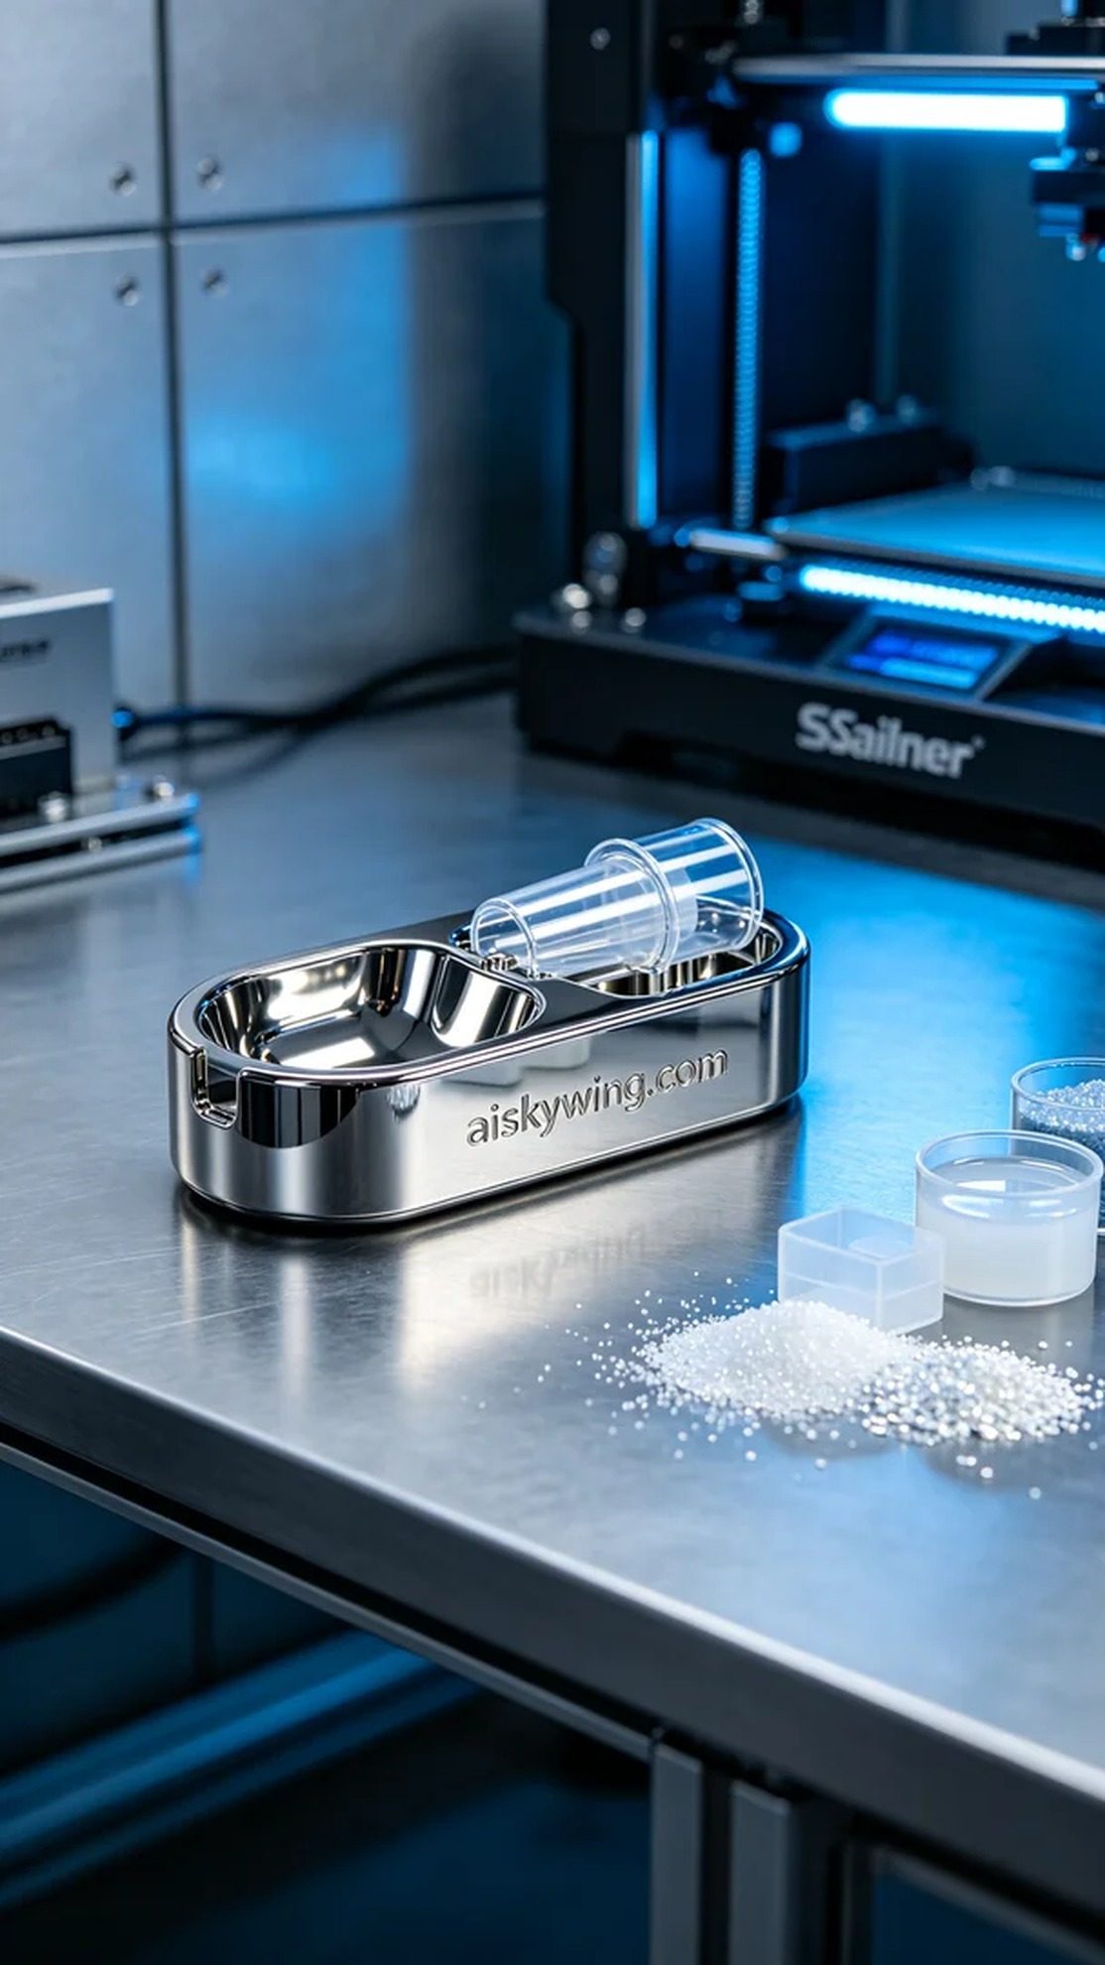
Aiskywing Industrial 3D Printing
Pet medication dispenser shell


