0802-宠物慢食器隔板生产记录
Pet slow feeder divider
🖨️ SLA光固化
🖥️ 打印机: Rize
📦 材料: SLA
有时候咬牙坚持，不是为了证明什么。就像有人通过WhatsApp找我们要做这个宠物慢食器隔板，希望改善他们爱宠的进食习惯。
Sometimes persevering through gritted teeth is not about proving anything. It's like when someone contacts us via WhatsApp asking for a slow feeder divider for their pet, hoping to improve their beloved pet's eating habits.
________________________________________________________________________________
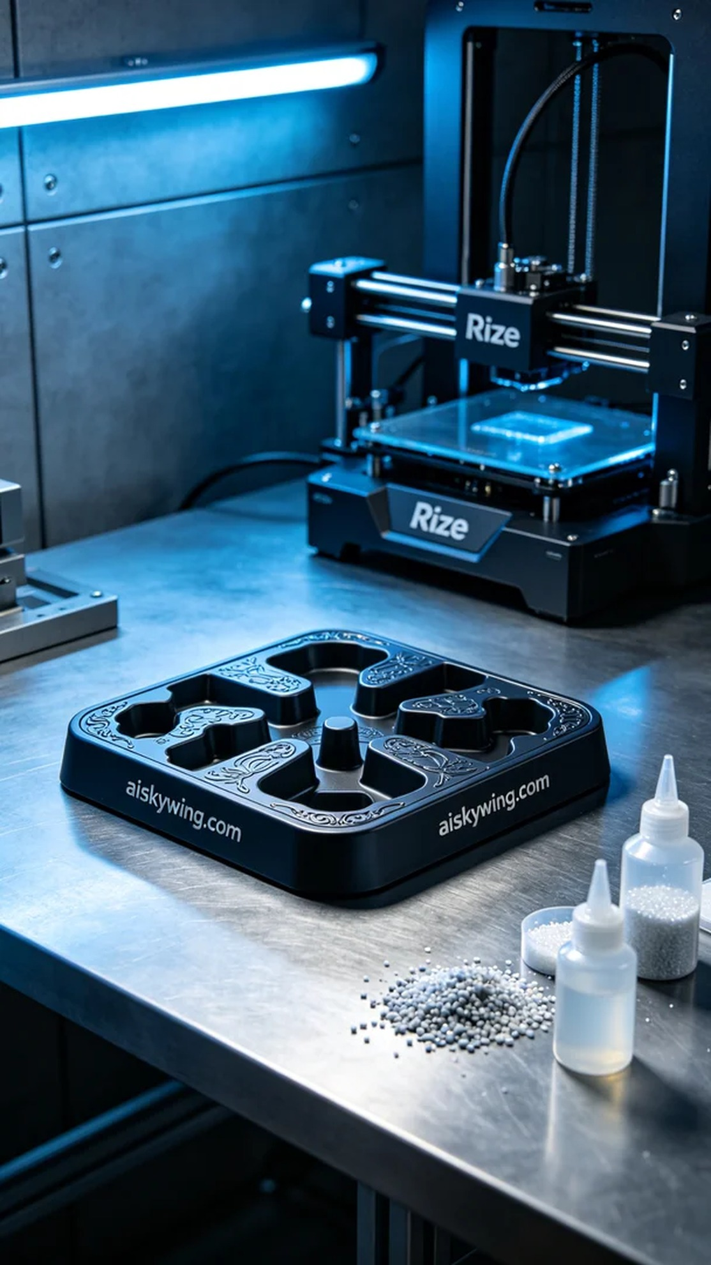
Sometimes perseverance isn't about proving something. Like when someone reached out to us via WhatsApp looking for a pet slow feeder partition to help their furry friend eat more slowly and comfortably.
In this production, we utilized high-quality SLA resin as our material. This material showcases excellent detail and smoothness after printing. To ensure the best results, we set the Rize printer to a layer thickness of 0.05mm, maintained a temperature of 25°C, set the power to 60W, and controlled the speed at 40mm/s, with an estimated print time of about 4 hours.
During the printing process, the Rize printer operated smoothly and efficiently, constructing the pet slow feeder partition layer by layer. We monitored the equipment status in real-time to ensure that every detail met our expected standards. The cool-toned ambient lighting created a sense of industrial technology, enhancing the professionalism of the entire process.
After printing, we conducted a meticulous post-processing workflow. First, the finished product was soaked in a cleaning solution to remove excess resin from the surface; then, we proceeded with sanding to ensure smooth edges. Following that, we performed curing to enhance the material’s hardness and durability. Finally, after inspection, we confirmed that every engraved detail was as clear as anticipated.
This production process of the pet slow feeder partition highlights that meticulous craftsmanship and a rigorous attitude are the keys to success. Ultimately, we successfully delivered this customized product, allowing pets to enjoy their meals healthily while enhancing their owners' satisfaction.
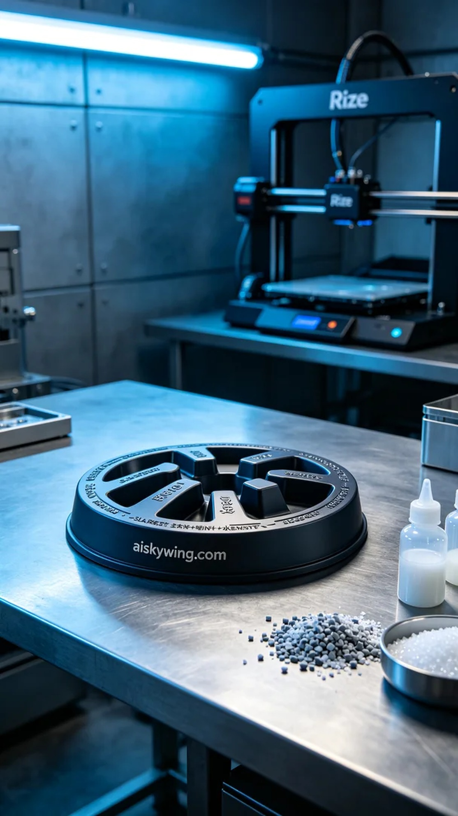
在这次生产中，有人向我们咨询了宠物慢食器隔板的设计，指出他们的宠物在进食时总是太快，导致不适。于是我们决定为他们定制一个独特的产品，帮助他们的爱宠慢慢享用美食。
我们使用的原材料是高品质的SLA光敏树脂，这种材料在打印后展现出极佳的细节和光滑度。为了确保最佳的打印效果，我们将Rize打印机设置为0.05mm的层厚，打印温度保持在25℃，功率设定为60W，速度则控制在40mm/s，预计打印时间约为4个小时。
在打印过程中，Rize打印机的运行平稳而高效，逐层构建出宠物慢食器隔板的形状。我们实时监控设备状态，确保每一个细节都能达到预期效果。打印过程中，冷色调的氛围灯营造出科技感的工业环境，让整个过程充满了一种专业的氛围。
完成打印后，我们进行了细致的后处理工序。首先，将成品浸泡在清洗液中，去除表面多余的树脂；接着，通过打磨处理确保边缘的光滑度。随后，我们进行了固化，以增强材料的硬度和耐用性。最后，经过检验，确保每一处雕刻都如预期般清晰可见。
围绕这个宠物慢食器隔板的生产过程，可以看出，精细的工艺和严谨的态度是成功的关键。最终，我们顺利交付了这个定制产品，让爱宠们可以健康地享受美味的同时，也提升了主人们的满意度。
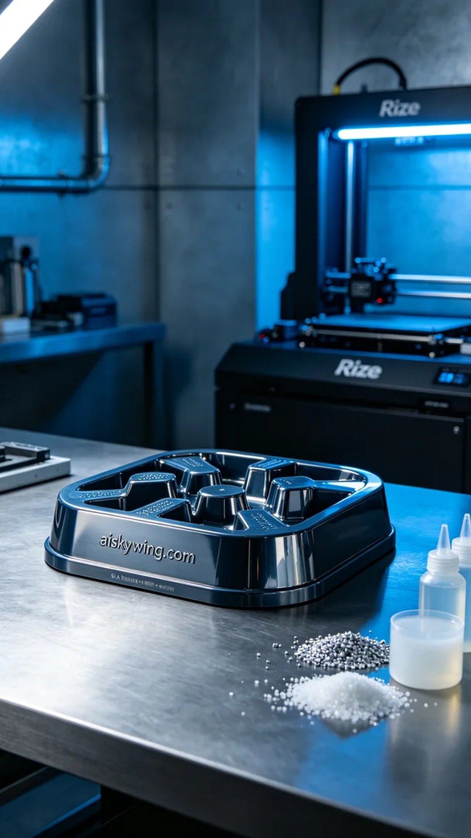
Aiskywing Industrial 3D Printing
Pet slow feeder divider


