0803-宠物指甲剪外壳3D打印记录
Pet nail clipper shell
🖨️ SLM金属打印
🖥️ 打印机: Rize
📦 材料: 摆放着未成型的液态光敏
在Twitter上，有人因无法找到合适的工具而向我们求助，最终决定制作这个宠物指甲剪外壳。每一个细节都值得我们用心去打磨。
On Twitter, someone reached out to us for help because they couldn't find the right tool, and ultimately decided to create this pet nail clipper case. Every detail is worth our careful refinement.
________________________________________________________________________________
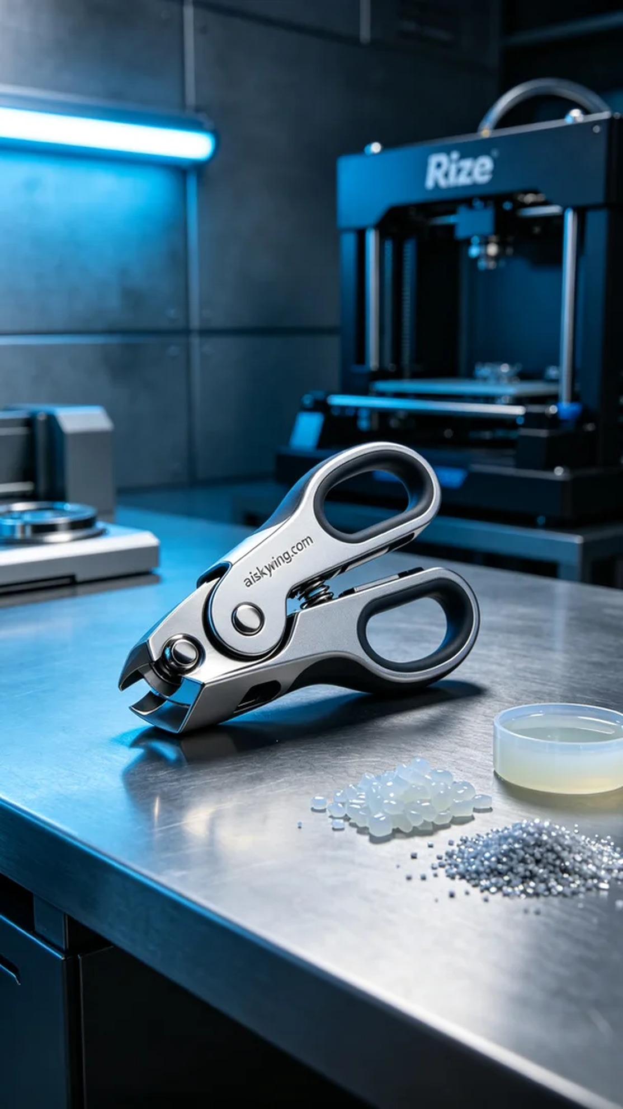
Recently, someone reached out via Twitter, looking for a reliable tool for pet grooming. We decided to create this pet nail clipper shell, knowing that every detail deserves our utmost attention.
To create the exquisite pet nail clipper shell, we opted for liquid photopolymer resin as our primary material. This material boasts excellent flow and moldability, allowing for intricate structures and surface details during 3D printing. Additionally, it provides good strength and flexibility, which is crucial for everyday use. We utilized the Rize brand 3D printer to ensure high-quality printing results.
During the preparation phase, we meticulously set the printing parameters. Based on our experience, we adjusted the layer thickness to 0.1mm, set the printing temperature at 25℃, activated the laser at 120mW, and set the print speed to 30mm per second. The entire printing process was estimated to take about 6 hours, allowing for the perfect representation of every detail without sacrificing efficiency.
During the printing, the Rize printer operated smoothly. We regularly checked the machine's status to ensure there were no jams that could compromise quality. After each layer was completed, we closely inspected it to confirm a dry, smooth surface free of bubbles or defects. The entire process was efficient and effective, ensuring the final product met our expectations.
Following the printing, we performed essential post-processing steps. We cleaned the nail clipper shell thoroughly using alcohol solution to remove any residual resin. After cleaning, we meticulously sanded it to eliminate any minor unevenness. Next, we placed it in a curing device for rigorous curing treatment to ensure material strength and durability. Finally, we conducted a comprehensive inspection of the finished product to guarantee every detail was flawless.
Through this 3D printing experience, we successfully created an exquisite pet nail clipper shell, showcasing the fusion of modern industrial design and craftsmanship. Each practice session brings us closer to perfection, and we look forward to more exciting innovations in our future work.
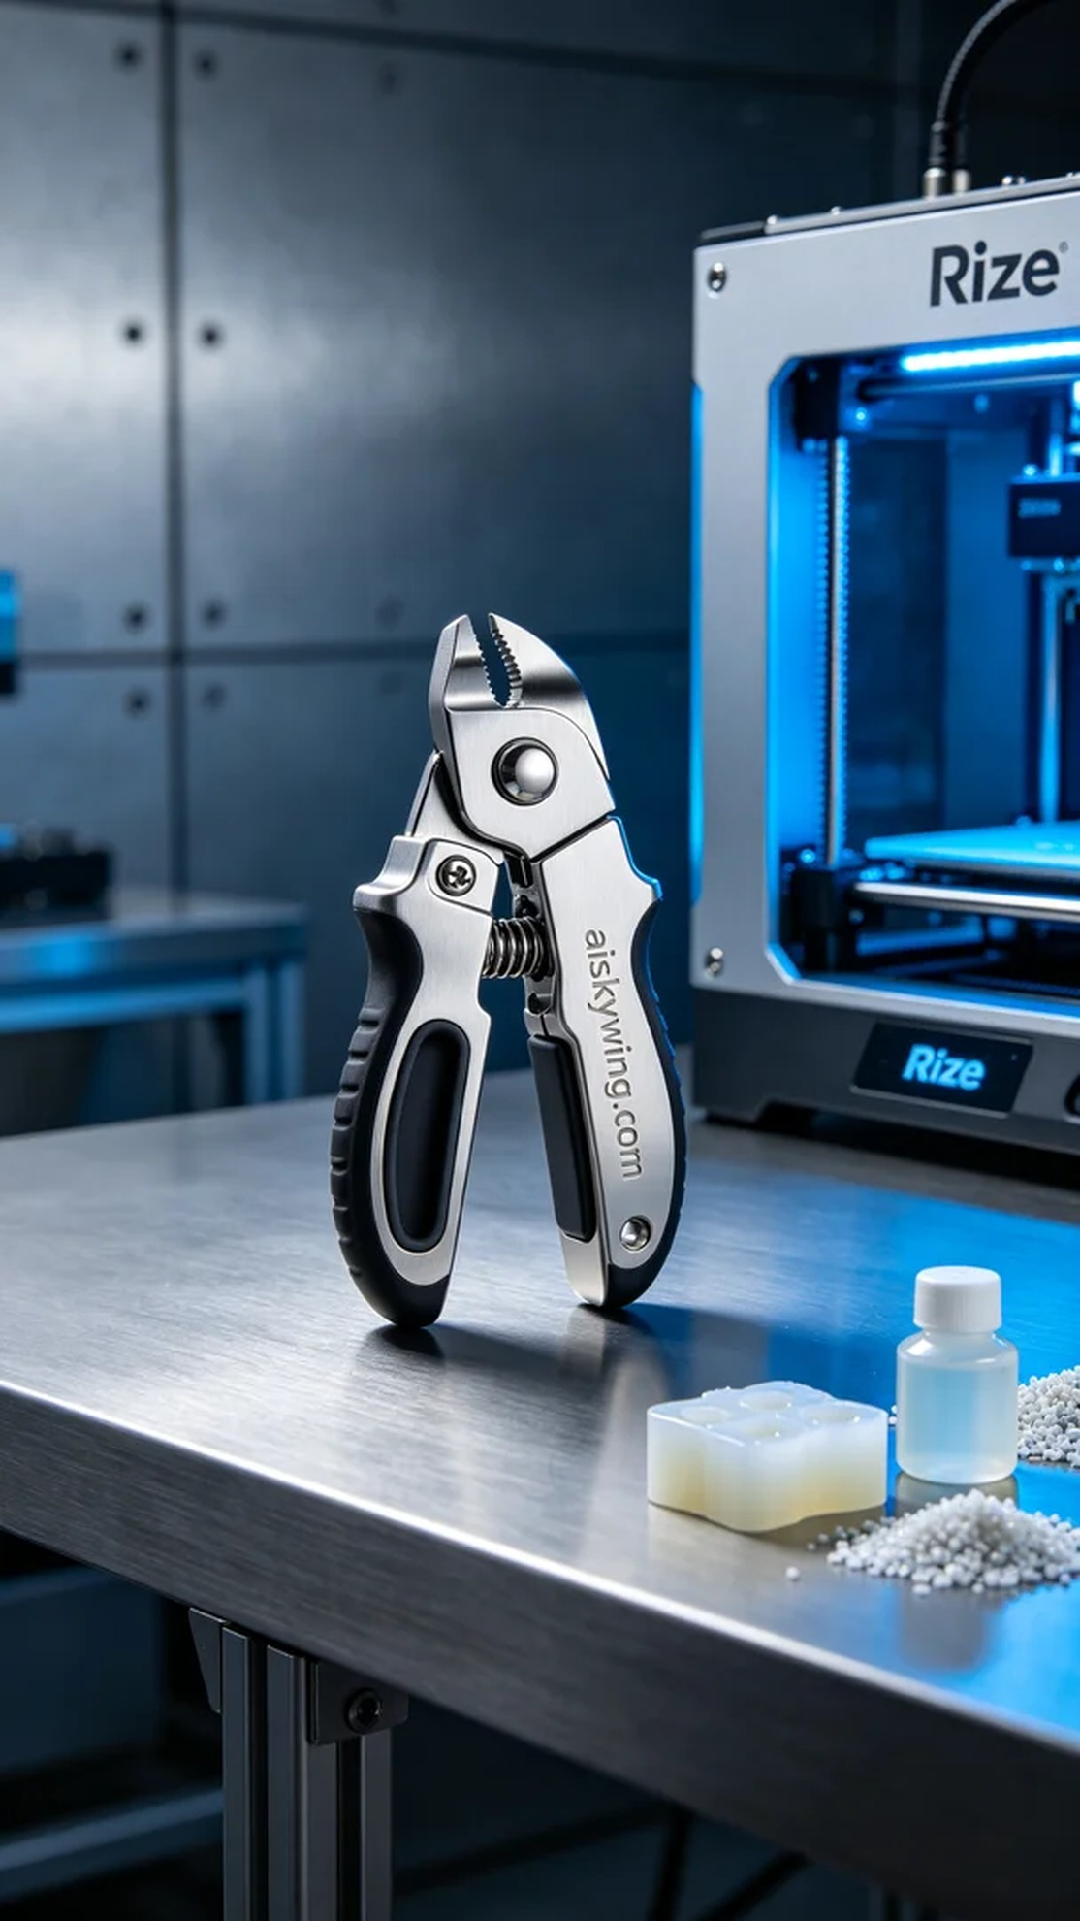
为了制作出精致的宠物指甲剪外壳，我们选择了未成型的液态光敏树脂作为主要材料。这种材料具有优良的流动性和成型性，能够在3D打印过程中呈现出细腻的结构和表面细节，同时具备较好的强度和韧性，以满足日常使用的需求。我们使用的打印设备是Rize品牌的3D打印机，确保我们能够达到高质量的打印效果。
在准备阶段，我们对打印参数进行了详细设置。根据我们的经验，我们将层厚调节到0.1毫米，打印温度设置为25℃，激光功率为120mW，打印速度为30毫米每秒。整套打印过程的预计时间为6小时，这样的设置能够确保每个细节的完美展现，同时又不失效率。
打印的过程中，Rize打印机的运行状态一切正常。我们定期检查设备的工作状态，以确保没有任何卡料现象，避免影响打印质量。每当一层完成后，我们都会仔细观察，确认表面干燥且光滑，没有出现气泡或其他缺陷。整个过程流畅而高效，确保最终产品达到预期标准。
接下来的后处理工序同样重要。在打印完成后，我们将指甲剪外壳进行清洗，使用酒精溶液彻底去除残留的树脂。清洗完毕后，进行细致的打磨，以消除微小的不平整感。随后，我们将其放入固化设备中进行严格的固化处理，以确保材料的强度和耐用性。最终，我们对成品进行全面检验，确保每个细节完美无瑕。
通过这次的3D打印体验，我们成功制作出了精致的宠物指甲剪外壳，展示了现代工业设计与精湛工艺的结合。每次的实践都让我们更加成熟，期待在未来的工作中，能有更多精彩的创新。
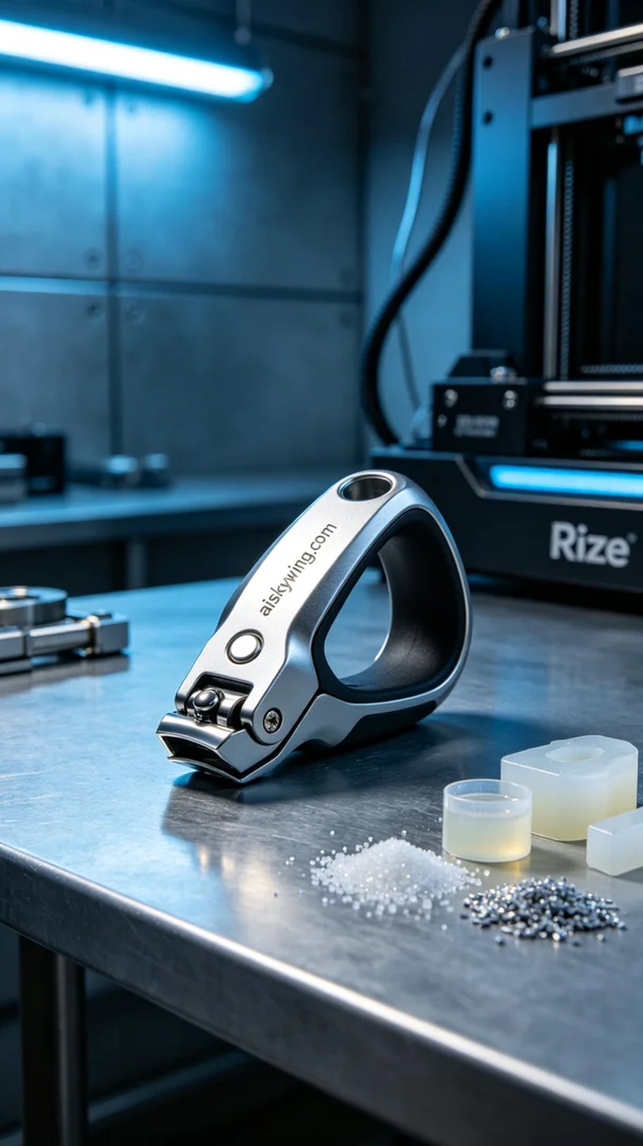
Aiskywing Industrial 3D Printing
Pet nail clipper shell


