0805-宠物梳子手柄的3D打印记录
Pet comb handle
🖨️ SLA光固化
🖥️ 打印机: Systems
📦 材料: SLA
在WhatsApp上，一位朋友问我有没有办法解决他们宠物美容的问题。于是，我决定制作这个宠物梳子手柄。
On WhatsApp, a friend asked me if there was a way to solve their pet grooming problem. So, I decided to make this pet comb handle.
________________________________________________________________________________
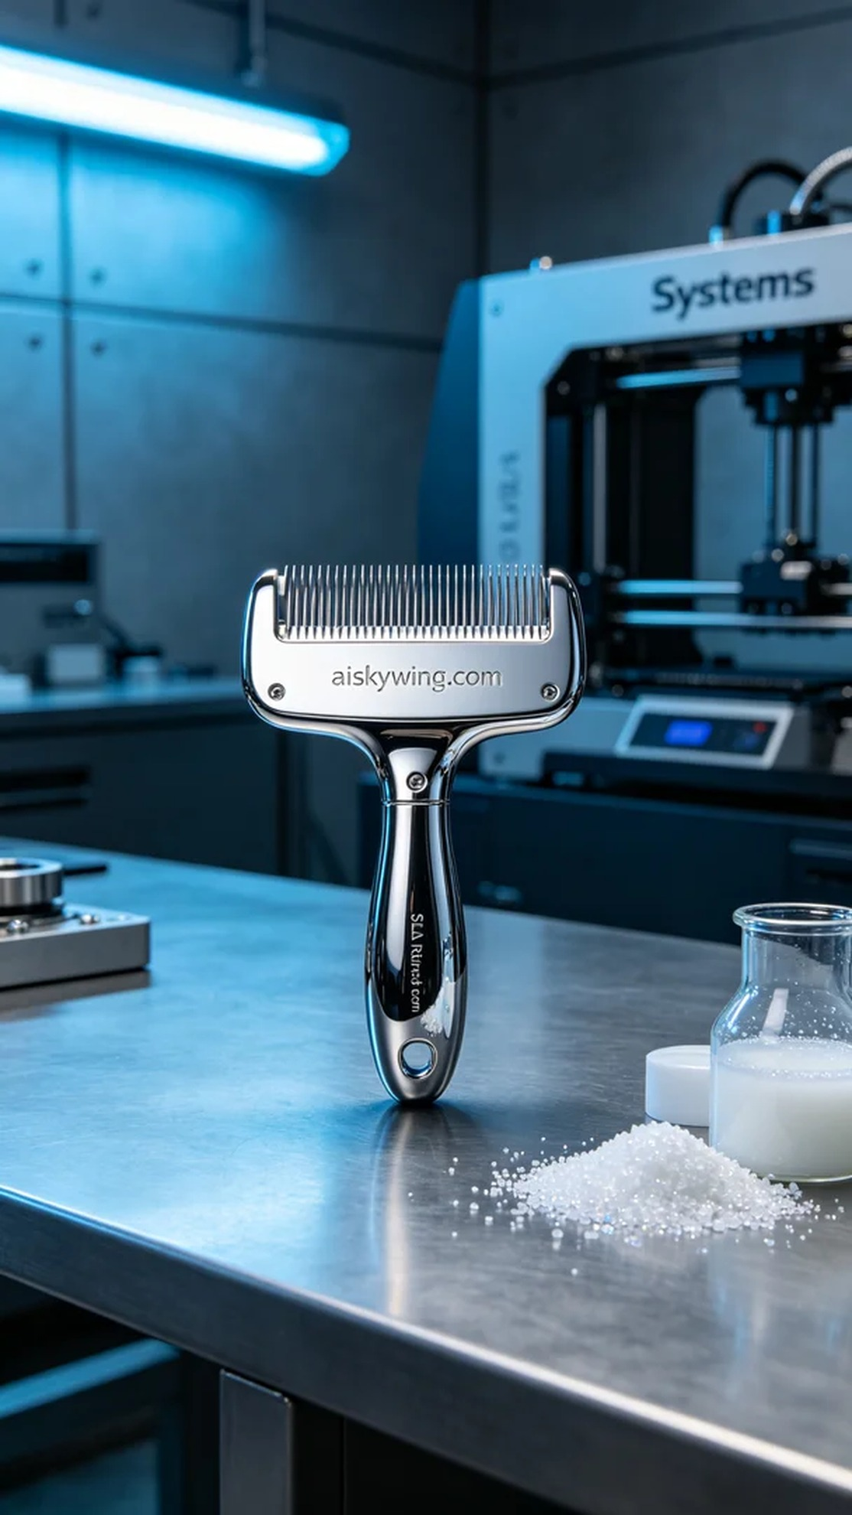
On WhatsApp, a friend asked me if there was a way to solve their pet grooming issues. So, I decided to create this pet comb handle.
During the production of the pet comb handle, someone expressed the need for a high-quality and durable product to address their grooming challenges. This product needed to be both aesthetically pleasing and functional, which is why we chose the SLA photopolymerization process for printing.
For preparation, we selected high-quality SLA resin as the raw material. The properties of this material allow for a smooth surface and clear details on the finished product. The Systems printer was set with a layer thickness of 0.05 mm to ensure detailed results, a temperature of 25 degrees Celsius, a power setting of 70%, and a printing speed of 40 mm per second, with an estimated print time of 4 hours.
During the printing process, the machine ran steadily, with resin curing layer by layer and strict quality monitoring. We checked the printing status regularly to ensure there were no light leaks or interlayer adhesion issues. Every detail was finely captured, resulting in a smooth handle shape.
Post-processing is a crucial step. We first immersed the printed part in a cleaning solution for about 15 minutes to remove any uncured resin. Then, the handle surface was meticulously polished to eliminate any burrs or imperfections. Finally, it was placed in a UV curing machine for 30 minutes to ensure optimal strength and durability.
After a series of meticulous production steps, the pet comb handle was finally completed. Its high-gloss mirror quality and precise assembly are satisfying, fully meeting the user's needs.
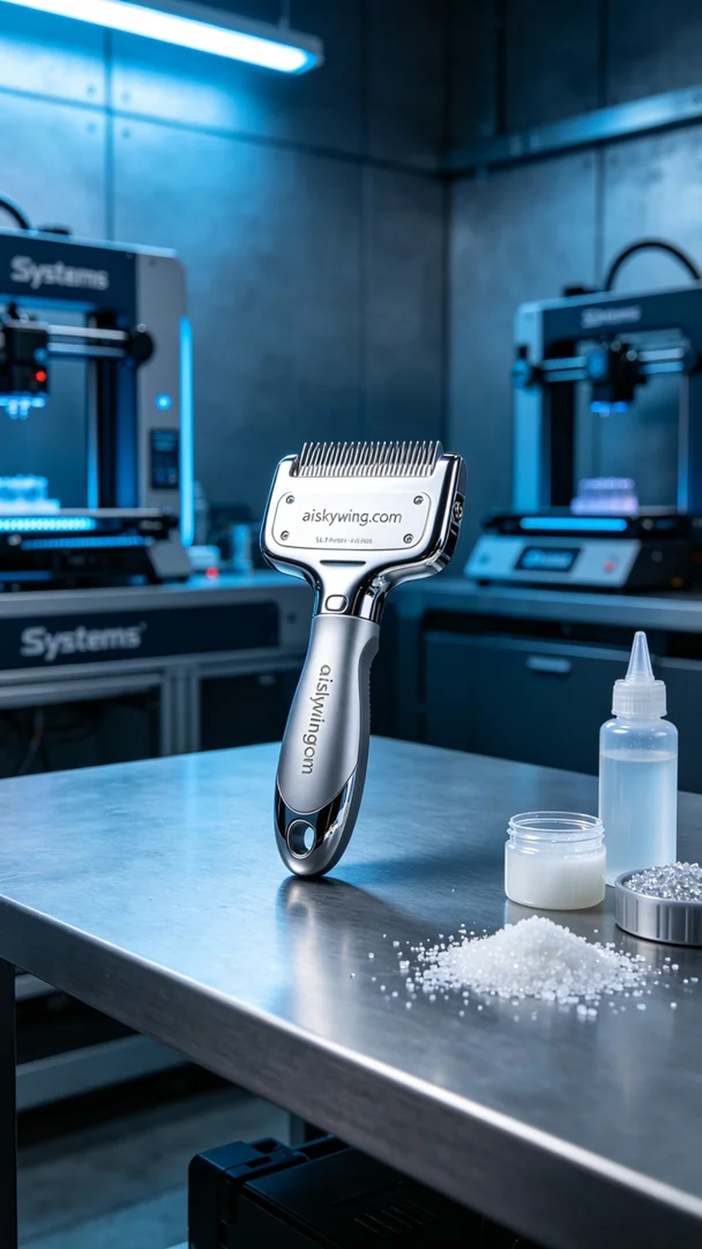
在制作宠物梳子手柄的过程中，有人希望我们能够提供一个高质量、耐用的产品，以解决他们在宠物美容时的困扰。这个产品不仅要美观，还要符合功能性需求，因此选择了SLA光固化工艺进行打印。
准备工作中，我们选择了优质的SLA光敏树脂作为原材料，这种材料的特性使得成品表面光滑且细节清晰。使用的Systems打印机，设置了层厚为0.05毫米，以确保打印效果细腻，同时将温度调至25摄氏度，功率设置为70%，打印速度保持在40毫米每秒，预计打印时间为4小时。
在打印过程中，设备运行稳定，树脂逐层固化，质量监控严格。我们定时检查打印状态，确保没有出现漏光或层间粘连等问题。每个细节都被精细捕捉，呈现出光滑的手柄造型。
完成后处理是一个重要步骤。我们首先将打印件浸入清洗液中，清洗时间约为15分钟，以去除未固化的树脂。随后，手柄表面经过细致打磨，确保没有毛刺和瑕疵。最后，将其放入UV固化机中固化30分钟，确保其强度和耐用性达到最佳状态。
经过一系列精细的制作流程，宠物梳子手柄终于完工。它的高光镜面质感和精密的装配令人满意，完全能够满足用户的需求。
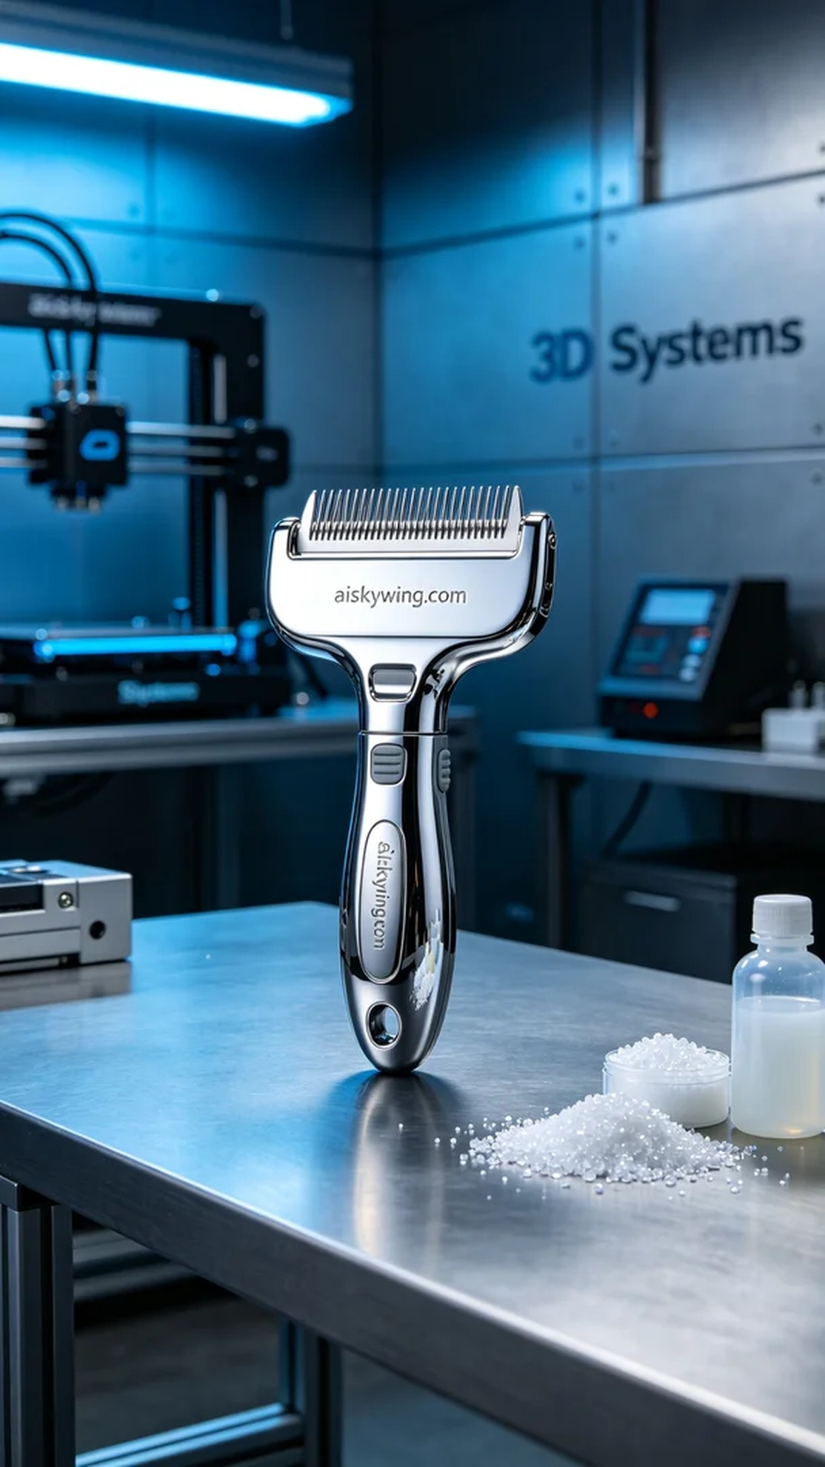
Aiskywing Industrial 3D Printing
Pet comb handle


