0809-D型密封圈生产记录
D-type sealing ring
🖨️ 硅胶复模
🖥️ 打印机: Voxeljet
📦 材料: 硅胶复模
人生的每一步都需要坚持，就像有人找到我们要求制作这个D型密封圈，解决他们在密封性能上的难题。
Every step in life requires persistence, just like when someone approached us to request the production of this D-shaped sealing ring to solve their sealing performance issues.
________________________________________________________________________________
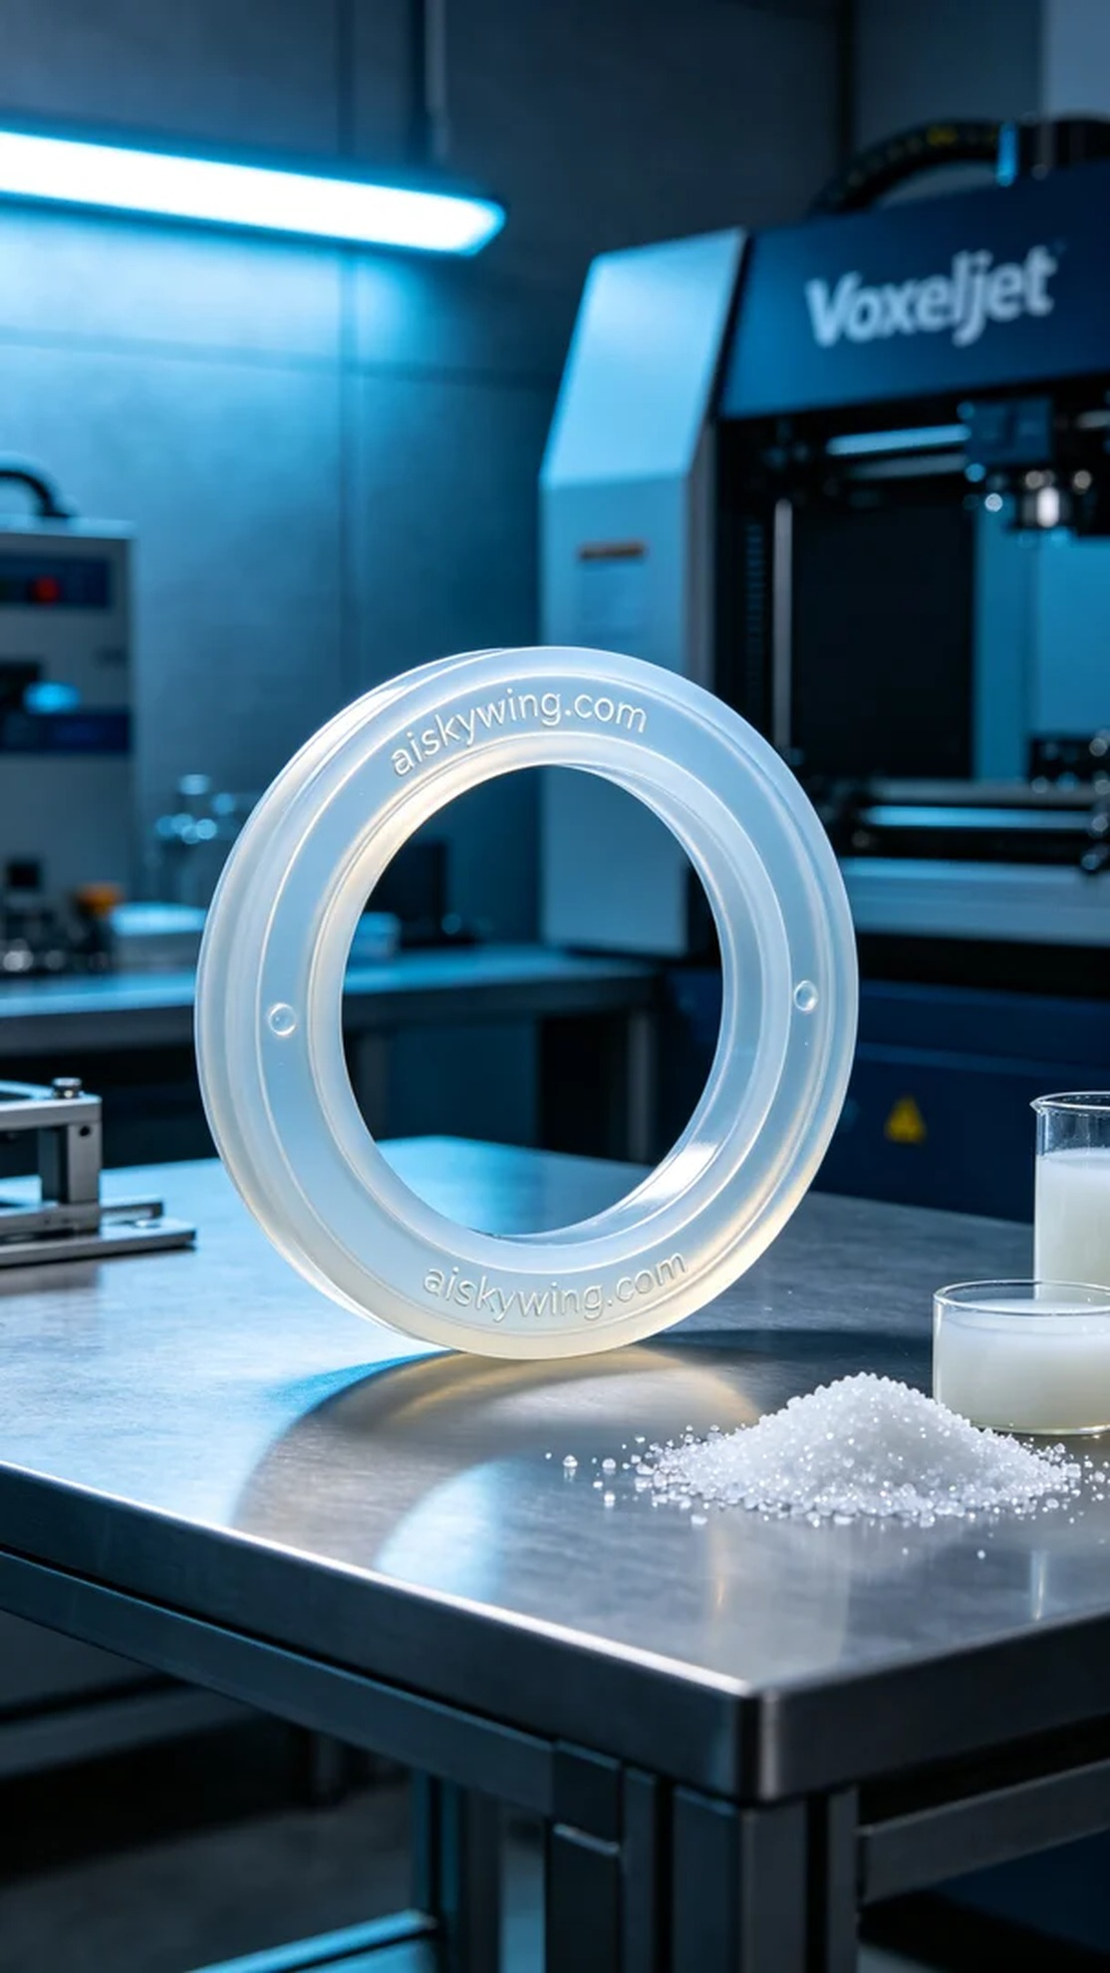
Someone on Twitter reached out for assistance regarding issues they encountered in their sealing system. This led us to take on the task of producing a D-type sealing ring, aiming to ensure it effectively prevents leaks and enhances product quality.
We chose medical-grade silicone for the raw material, which is not only translucent but also soft and elastic. To ensure optimal printing results, we used the Voxeljet printer, setting the layer thickness to 0.1 mm, a printing temperature of 25℃, with a power setting of 60%, and a printing speed maintained at 60 mm per hour. This ensures clear details and sufficient strength.
During the printing process, the Voxeljet operated smoothly for approximately 3 hours. We monitored the print quality in real-time to ensure that each layer was precisely added, especially focusing on the engraved "aiskywing.com" on the product surface to achieve perfection.
After printing, we carried out rigorous post-processing work. First, we cleaned the printed piece with a special cleaning solution to remove any uncured silicone. Then, we sanded the surface with fine sandpaper to ensure smoothness. Finally, the sealing ring was placed in a UV curing machine for about 30 minutes to enhance its durability and sealing performance. A final quality inspection was carried out to ensure that the product met our standards.
The freshly completed D-type sealing ring looks outstanding in an industrial setting, not only solving the issue but also showcasing our commitment to quality.
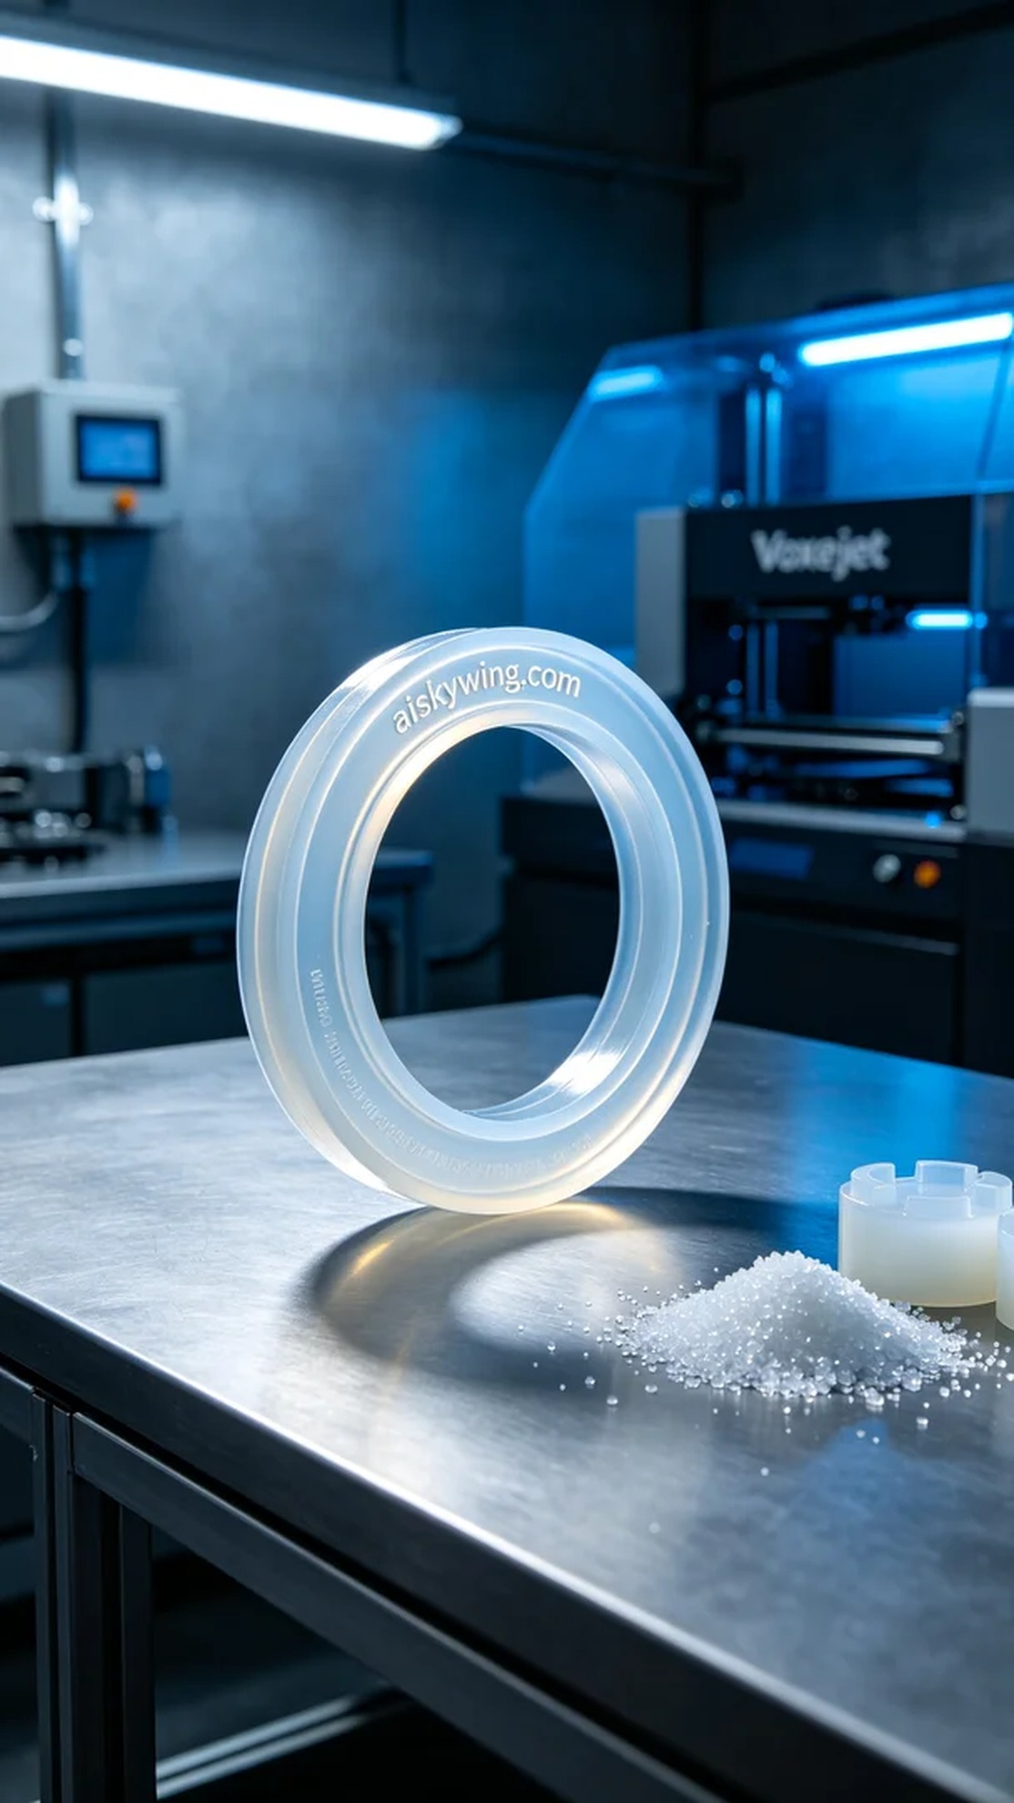
有人在Twitter上发帖寻求帮助，提到他们在密封系统中遇到的问题。于是我们接到了制作D型密封圈的任务，目标是确保它能有效防止泄漏，提升产品质量。
我们选择了医用级硅胶复模作为原材料，这种材料不仅半透明而且柔软，具备优良的弹性。为了确保打印效果，我们使用了Voxeljet打印机，设置了层厚0.1毫米，打印温度为25℃，功率调节到60%，打印速度保持在每小时60毫米。这样可以确保细节清晰且强度足够。
在打印过程中，Voxeljet的运行稳定，整个打印过程持续了约3小时。我们实时监控打印质量，确保每一层都能精确叠加，特别是产品表面“aiskywing.com”的雕刻部分，力求完美。
打印完成后，我们进行了严格的后处理工作。首先，用专用清洗剂对打印件进行清洗，去除未固化的硅胶。之后，使用细砂纸对表面进行打磨，确保光滑度。最后，将密封圈放入UV固化机中，进行约30分钟的固化处理，以增强其耐用性和密封性能。最后再次进行质量检验，确保产品符合标准。
刚完成的D型密封圈在工业环境下显得格外出色，它不仅解决了问题，还展现了我们对品质的追求。
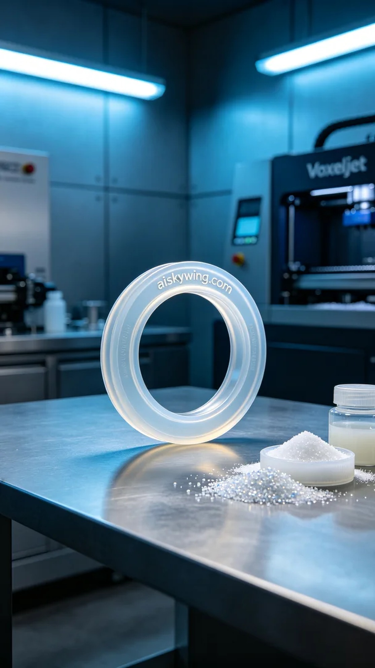
Aiskywing Industrial 3D Printing
D-type sealing ring


