0810-V型密封圈的3D打印记录
V-type sealing ring
🖨️ 硅胶复模
🖥️ 打印机: Systems
📦 材料: 硅胶复模
有时候咬牙坚持，不是为了证明什么。就像做这个V型密封圈，最近有人在LinkedIn上寻找解决方案，希望能解决他们的密封需求。
Sometimes gritting your teeth and persevering is not about proving anything. It's like making this V-shaped sealing ring; recently, someone has been looking for solutions on LinkedIn, hoping to meet their sealing needs.
________________________________________________________________________________
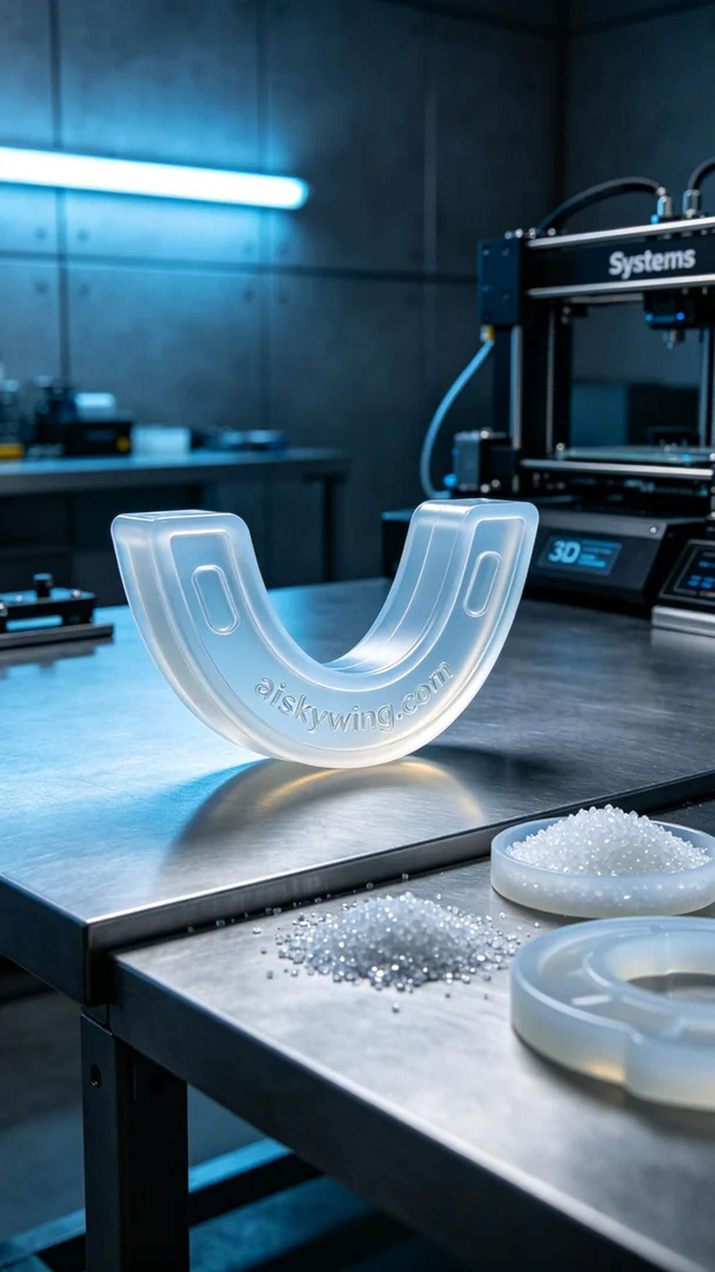
Sometimes, perseverance is not just about proving something. It's like creating this V-shaped sealing ring; recently, someone reached out on LinkedIn looking for a solution to their sealing needs.
During the preparation phase, we selected high-quality silicone molding material, which is transparent and soft, ensuring a good ergonomic fit. The 3D printer used is from the Systems brand, with printing parameters set at a layer thickness of 0.05 mm, a temperature of 25°C, a power of 400 watts, and a printing speed of 40 mm per second, with an estimated printing time of 4 hours. This configuration ensures the precision of each layer and the perfect blend of materials.
Throughout the printing process, the equipment operated steadily, and quality was monitored closely. Each phase was observed carefully to prevent material leaks or layer separation issues. After four hours of meticulous printing, the V-shaped sealing ring gradually took shape on the industrial table, showcasing its intended contours and design details.
After printing, post-processing is a crucial step that shouldn't be overlooked. First, we placed the printed piece in a cleaning tank to thoroughly remove any residual resin on the surface. Then, careful polishing was done to smoothen the surface, followed by curing to ensure the material's strength and durability. Finally, we conducted detailed inspections of the finished product to ensure every detail met the standards.
In the end, this V-shaped sealing ring not only successfully met the needs but also showcased our team's professionalism and commitment to quality. Only by taking care in our work can we present a great product to everyone.
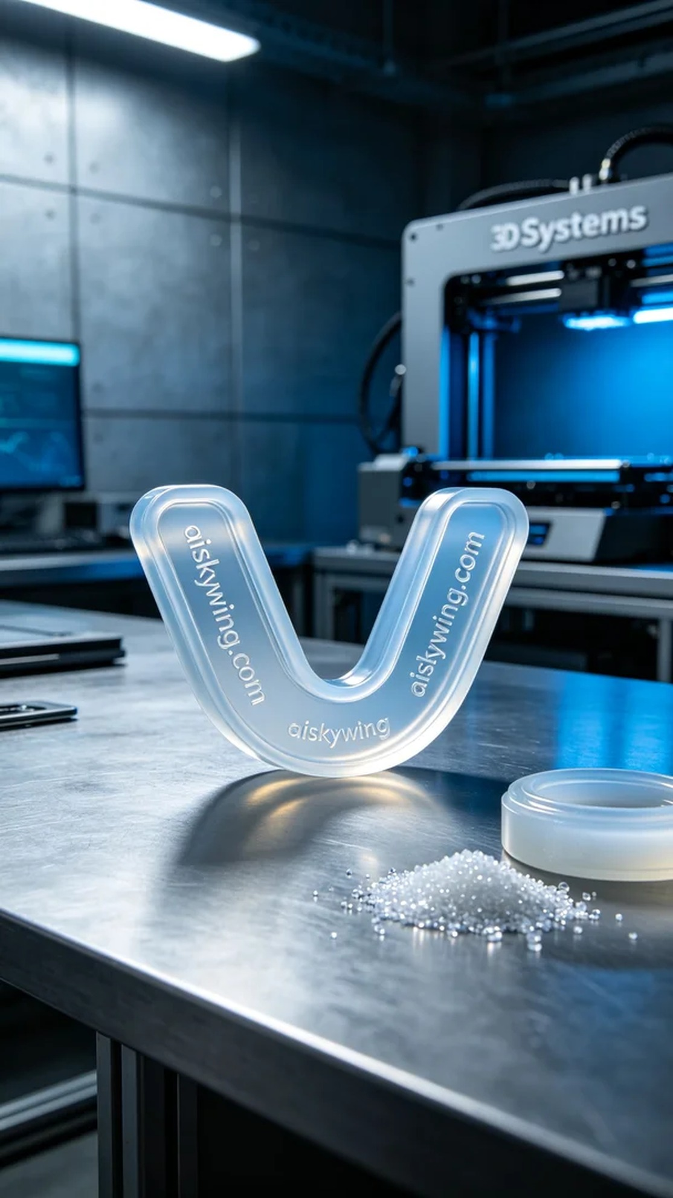
这段时间，有人因产品密封性能不足而烦恼，寻求我们的帮助。他们对V型密封圈的性能寄予厚望，希望能找到一种既柔软又耐用的解决方案。经过沟通，我们决定使用硅胶复模材质来满足他们的需求。
在准备阶段，我们选用了优质的硅胶复模材料，具备透明柔软的特性，能很好地贴合人体工学。使用的3D打印机是Systems品牌，打印参数设置为层厚0.05毫米，温度设定在25℃，功率为400瓦，打印速度保持在40毫米每秒，预计打印时间为4小时。这样的参数设置确保了每一层的精度和材料的完美结合。
打印过程时，设备稳定运行，系统监控确保了质量。每个打印阶段都仔细观察，确保没有出现材料泄漏或层间脱离的问题。经过四小时的细致打印，V型密封圈在工业桌面上逐渐成型，展现出其应有的轮廓和设计细节。
打印完成后，后处理是不可忽视的重要环节。我们首先将打印件放进清洗槽，用清洁液彻底去除表面的残留树脂。随后，通过细心打磨，使其表面更为光滑，接着进行固化，以确保材料的强度和耐用性。最后，对成品进行详细检验，确保每一个细节都符合标准。
最终，这个V型密封圈不仅成功满足了需求，还展现了我们团队的专业水平和对品质的追求。用心验收，才能将好的产品呈现给每一个人。
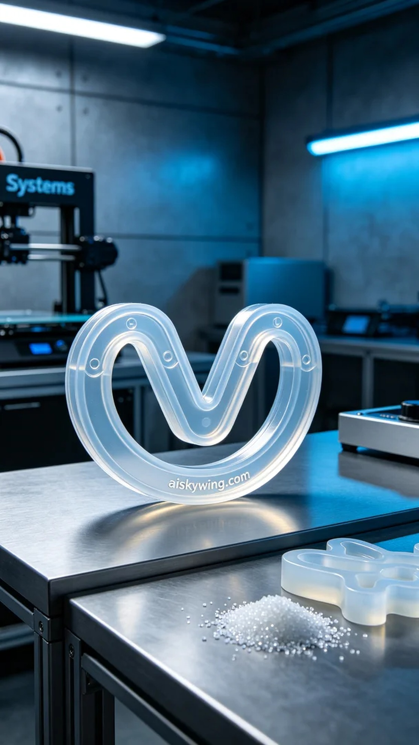
Aiskywing Industrial 3D Printing
V-type sealing ring


