0811-Y型密封圈3D打印生产记录
Y-shaped sealing ring
🖨️ 硅胶复模
🖥️ 打印机: Stratasys
📦 材料: 硅胶复模
生活中总有那么一些难题，让我们不得不寻求解决方案。就像在Facebook上，有人找到我们，想要制作这个Y型密封圈，以应对他们的需求。
In life, there are always some difficult problems that force us to seek solutions. Just like on Facebook, someone reached out to us wanting to create this Y-shaped seal to meet their needs.
________________________________________________________________________________
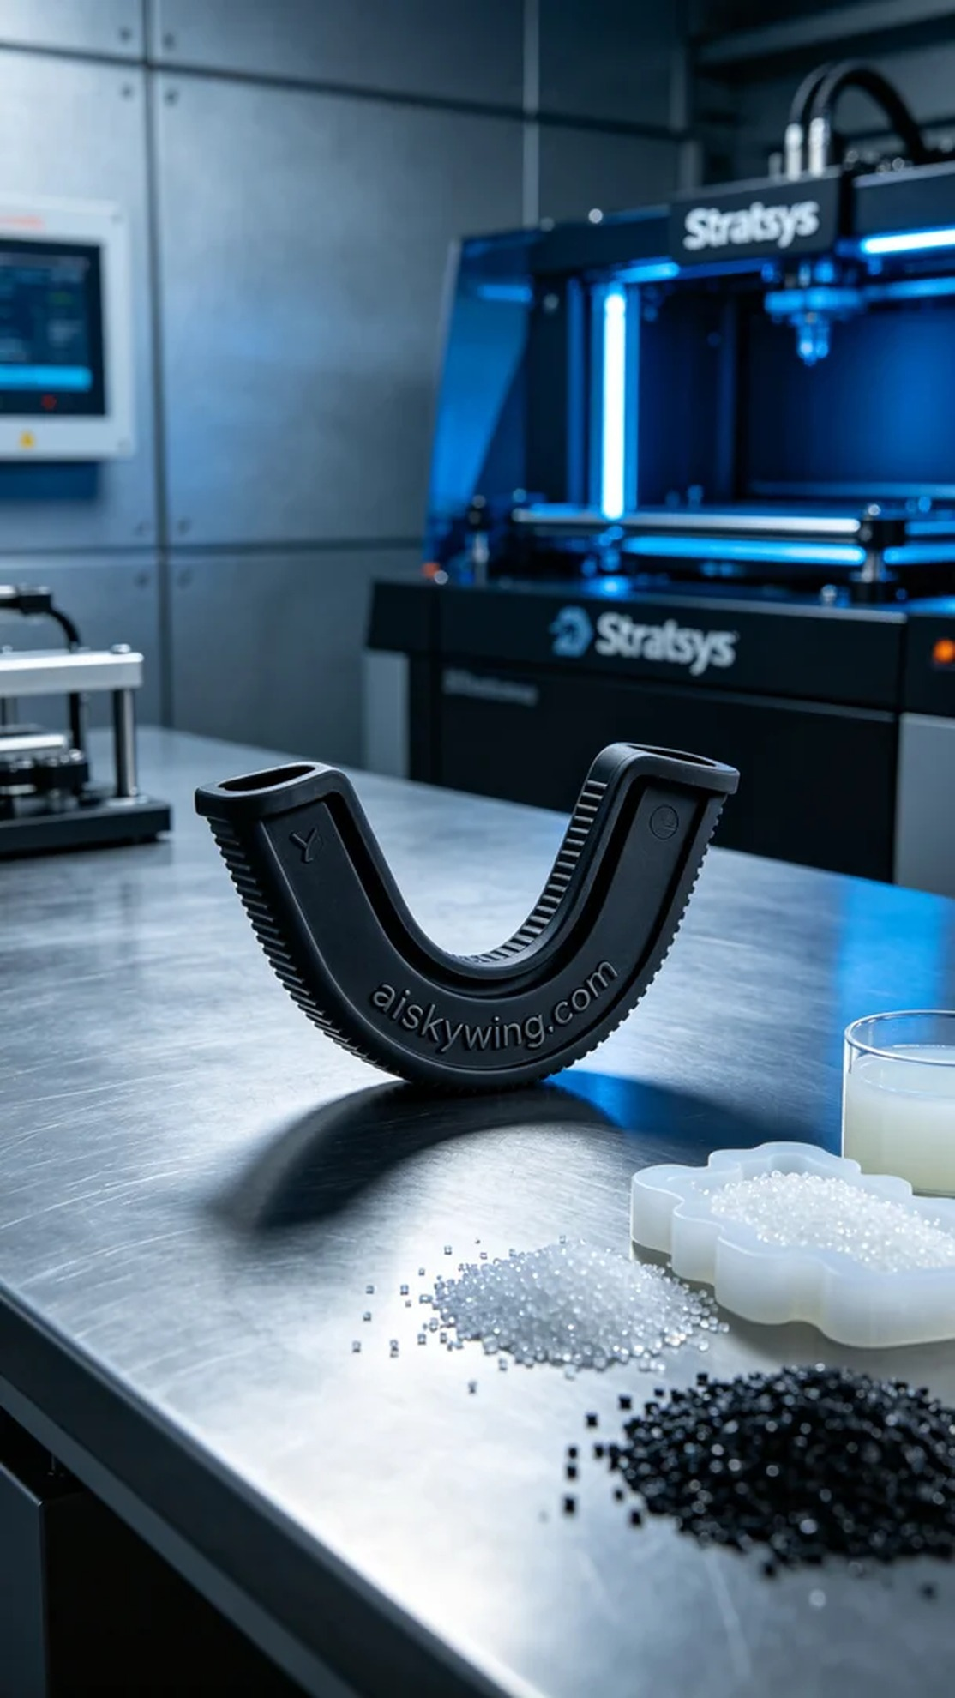
In our line of work, we often encounter challenges that require innovative solutions. Recently, someone reached out to us through Facebook, looking for a Y-shaped sealing ring to enhance their product's sealing performance. This part would be used in a new device, and they specifically requested a material that offers flexibility and durability.
During the preparation phase, we decided to use a Stratasys 3D printer for this project. The material selected was black silicone rubber, known for its excellent flexibility and anti-slip texture. The print parameters were set to a layer thickness of 0.1mm, printing temperature at 25°C, power adjusted to 80%, and a printing speed of 40mm/s, with an estimated print time of approximately 4 hours. After thorough adjustments and checks, we were ready to proceed.
The printing process went smoothly, with the Stratasys printer operating steadily. We closely monitored the printing progress to ensure that each layer was evenly deposited. Regular quality checks confirmed that there were no visible defects, and the engraved text "aiskywing.com" remained clear and well-defined throughout the print.
Upon completion of the printing, we moved on to the post-processing phase. We began by using a cleaning agent to wash the printed part, removing any residual liquid photopolymer resin from the surface. Next, we hand-sanded the edges to ensure smoothness, and finally, we cured the part in an oven to enhance its strength. A thorough inspection confirmed that the final product met all expected standards.
This production of the Y-shaped sealing ring turned out to be a great success, with the finished product not only looking exquisite but also meeting the functional requirements.
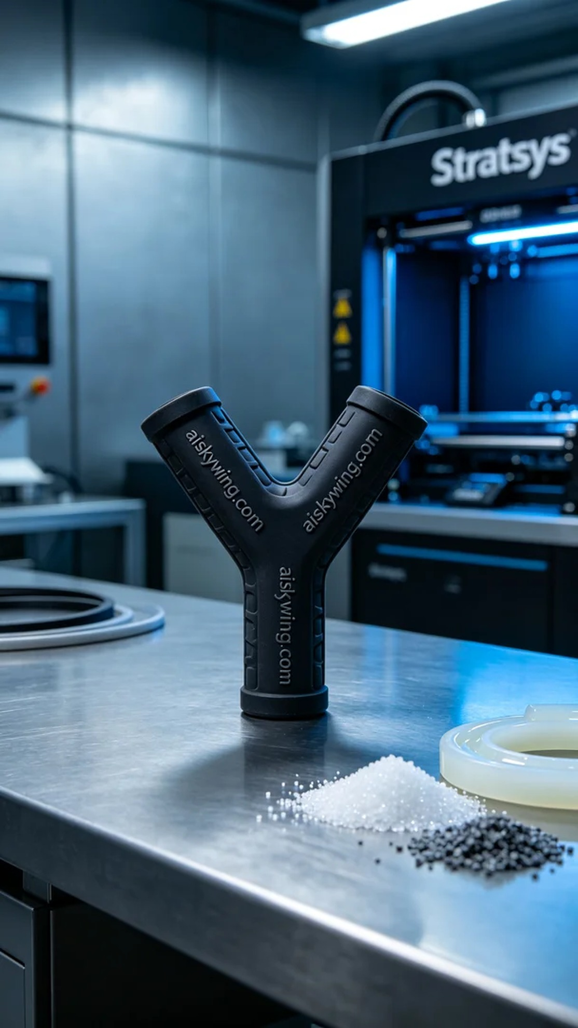
我们接到一个需求，有人希望制作一个Y型密封圈，主要是为了提升他们产品的密封性能。这个密封圈将被用于一个新型设备中，客户对材料的柔韧性和耐用性都有一定要求，因此我们决定采用硅胶复模材料来完成这项工作。
在准备阶段，我们选用了Stratasys的3D打印机进行打印。原材料为黑色硅胶复模，具有良好的柔性和防滑纹理。打印参数设置为：层厚0.1mm，打印温度设定在25°C，功率调整为80%，打印速度为40mm/s，预计打印时间约为4小时。经过仔细的调整和检查，我们将设备准备就绪。
打印过程非常顺利，Stratasys打印机运转平稳。我们密切监控打印进度，确保每一层都能均匀叠加。期间，我们定期检查打印件的质量，发现没有明显的缺陷，成品的边缘和表面都保持了良好状态，"aiskywing.com"的雕刻字样也显得十分清晰。
完成打印后，我们进入了后处理环节。首先使用清洗剂对打印件进行清洗，以去除表面残留的液态光敏树脂。随后进行手工打磨，确保边缘光滑，最后在固化炉中进行固化处理，令其强度进一步提升。最后，我们仔细检查了成品，确保其符合预期标准。
这次Y型密封圈的制作过程非常成功，完成的产品不仅外观精致，而且能满足使用需求，让我们倍感欣慰。
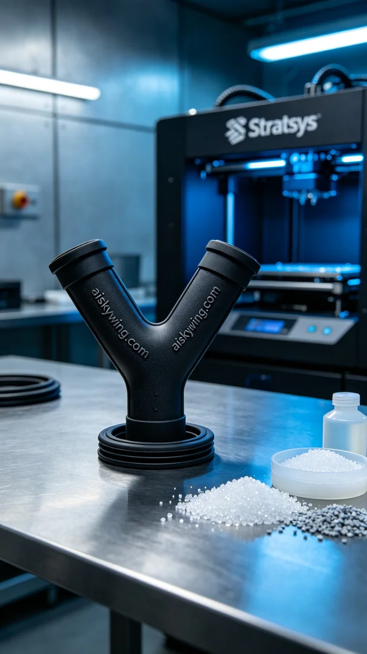
Aiskywing Industrial 3D Printing
Y-shaped sealing ring


