0812-义乳硅胶的3D打印生产记录
Silicone prosthesis
🖨️ 硅胶复模
🖥️ 打印机: Stratasys
📦 材料: 硅胶复模
生活再难，也别停下脚步。就像接下这个义乳硅胶的单子，有人因为这个特定需求，找到了我们。
No matter how hard life gets, don't stop moving forward. Just like when we took on this order for silicone prosthetics; someone found us because of this specific need.
________________________________________________________________________________
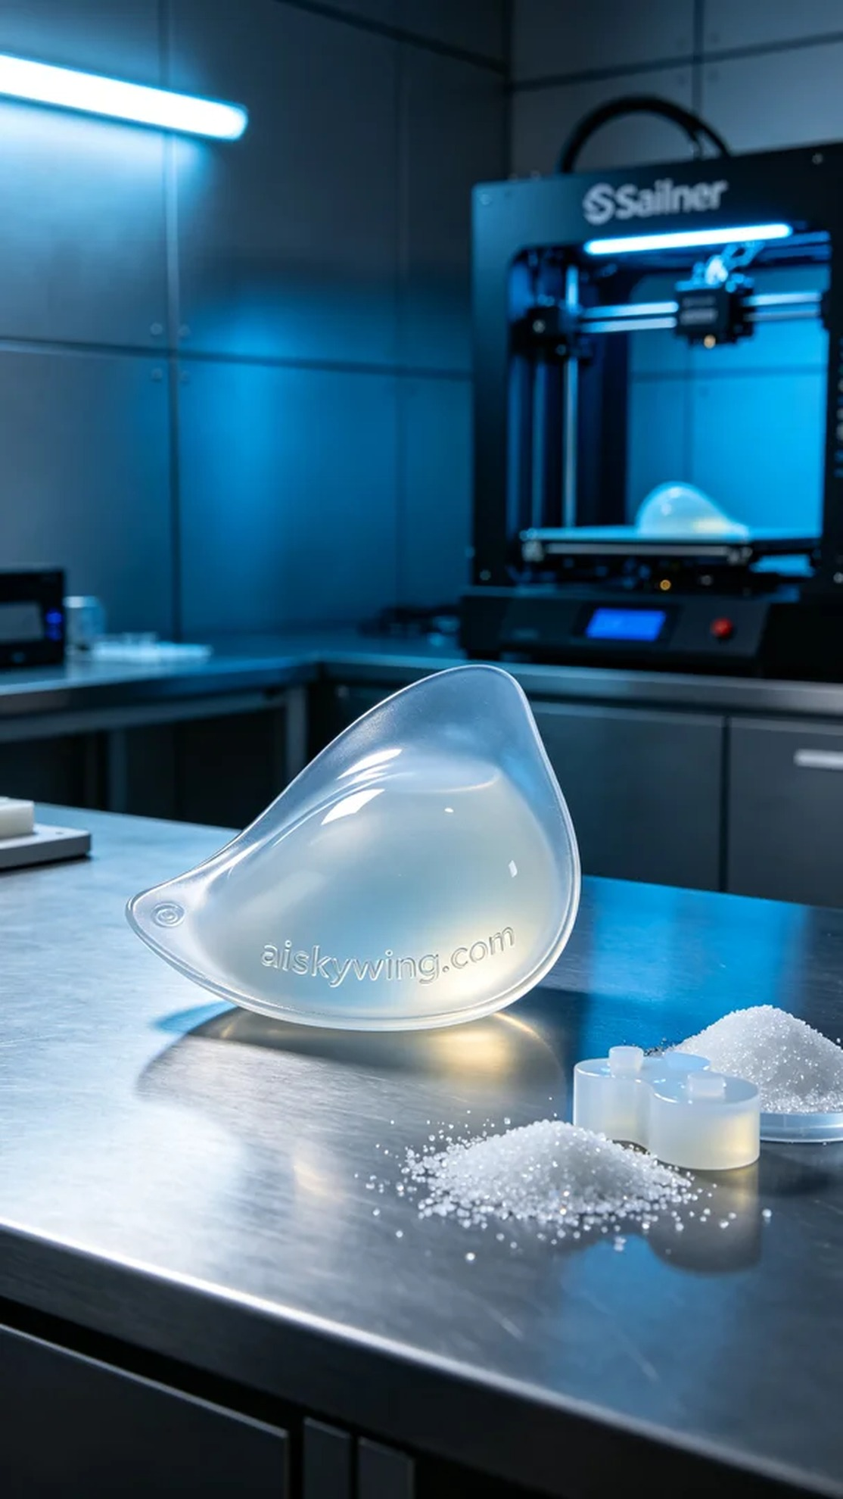
Today, someone reached out to us with a specific need for a silicone prosthetic breast. This request stemmed from their desire for body confidence, making the meticulous and precise production of the silicone prosthetic crucial for them.
We utilized silicone molding material, known for its transparency and softness, allowing it to fit the human curves perfectly. To ensure optimal results, we selected a Stratasys 3D printer, setting the layer thickness at 0.1mm, print temperature at 25℃, power adjusted to 80%, print speed at 40mm/s, with an estimated print time of 6 hours, focusing on precision as our primary goal.
During the printing process, the equipment operated smoothly while we continuously monitored the quality, ensuring each layer adhered firmly. As the print head moved above the material, the delicate reflection of industrial light created a perfect texture, and the silicone prosthetic gradually took shape.
After completing the print, we began the post-processing steps. First, we placed the printed piece in a cleaning tank, using a specialized cleaning solution to wash the surface, followed by manual sanding to eliminate any residual imperfections. We then cured it using UV light to ensure the silicone material's strength and elasticity, finishing with a meticulous inspection to ensure each product met high standards.
This production of the silicone prosthetic not only fulfilled a need but also represented a journey of merging confidence and technology. Our efforts ensured that every detail was perfectly presented.
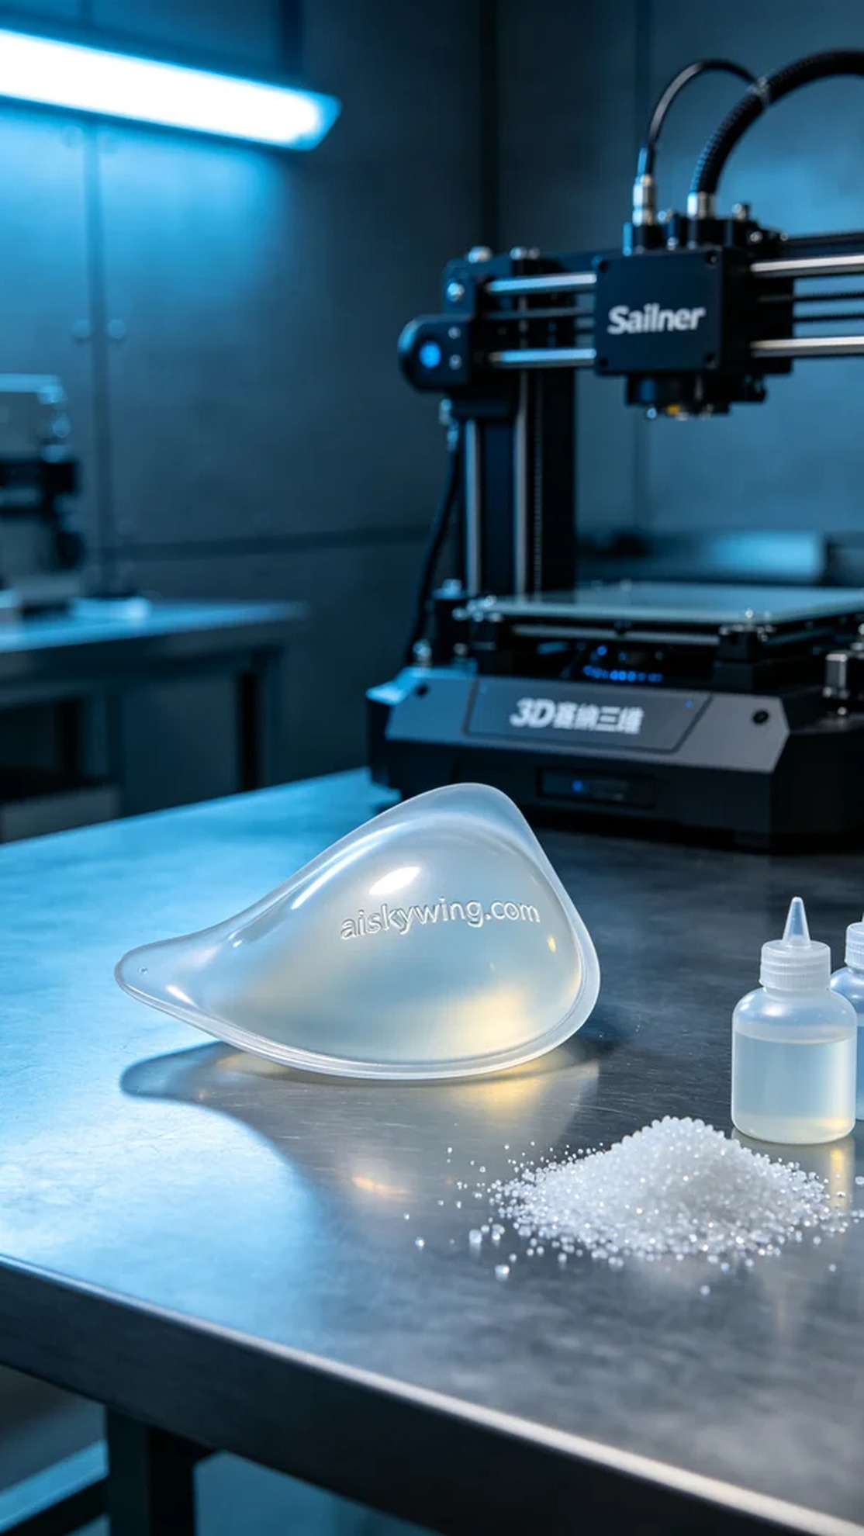
今天，有人找到我们，希望能用3D打印技术制作一个义乳硅胶。这个需求源于他们对于身体自信的渴望，制作义乳硅胶的细致与精确对于他们来说至关重要。
我们使用的是硅胶复模材料，这种材料具有透明柔软的特性，能够贴合人体曲线。为确保打印效果，我们选择了Stratasys品牌的3D打印机，设置层厚为0.1mm，打印温度为25℃，功率调节至80%，打印速度为40mm/s，预计打印时间为6小时，精准度是我们最关注的。
在打印过程中，设备运行平稳，过程中持续监控质量，确保每一层的结合都牢固。打印头在材料上方移动时，细腻的光线反射出工业气息，制造出完美的质感，义乳硅胶逐渐成型。
完成打印后，我们开始了后处理工序。首先将打印好的作品放入清洗槽，使用专用清洗液清洗表面，然后进行手工打磨，确保没有残留的瑕疵。接着进行固化，用紫外线灯照射，确保硅胶材料的强度和弹性，最后经过细致的检验，确保每一件产品都达到高标准。
这次的义乳硅胶制作不仅满足了需求，更是一次关于自信和科技结合的旅程。我们的努力，使得每一个细节都完美呈现。
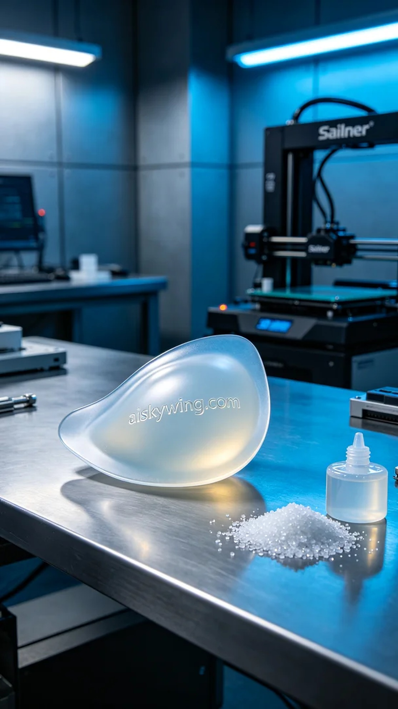
Aiskywing Industrial 3D Printing
Silicone prosthesis


