0813-传感器硅胶护套生产记录
Sensor silicone sleeve
🖨️ 硅胶复模
🖥️ 打印机: Rize
📦 材料: 硅胶复模
生活就像3D打印，不断重塑与创新。有人在LinkedIn上找到我们，询问关于传感器硅胶护套的定制需求，希望解决硅胶保护不足的问题。
Life is like 3D printing, constantly reshaping and innovating. Someone found us on LinkedIn, inquiring about custom requirements for silicone sensor covers, hoping to address the issue of inadequate silicone protection.
________________________________________________________________________________
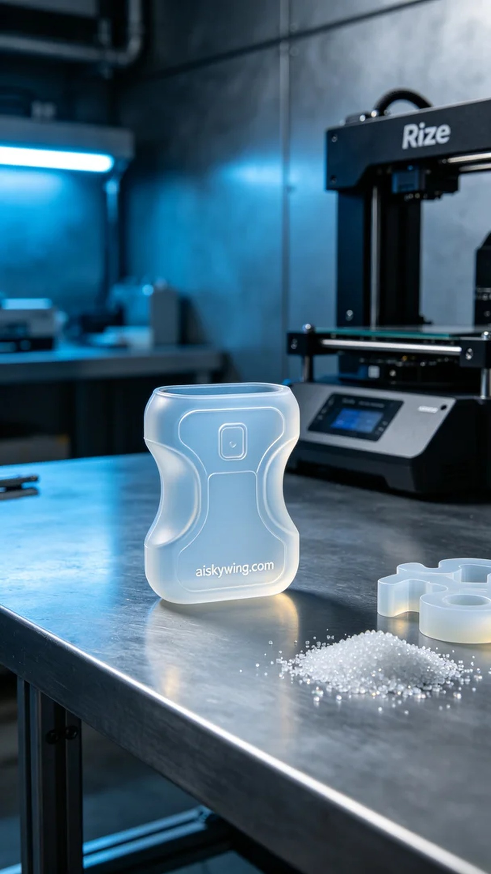
Life is like 3D printing, constantly reshaping and innovating. Someone found us on LinkedIn, inquiring about a customized solution for a sensor silicone cover, hoping to address concerns about insufficient protection.
To meet this need, we chose silicone molding material. This material is not only transparent and soft but also ergonomically designed to fit the sensor perfectly. In the preparation phase, we configured the Rize printer with a layer thickness of 0.1mm, a printing temperature of 60 degrees Celsius, a power setting of 75 watts, and a speed of 40 mm per hour, anticipating a total printing time of 6 hours.
During the printing process, the Rize printer operated at a steady pace, forming the material layer by layer. We monitored the device's status throughout, ensuring that the print quality met our expectations. Each layer was carefully observed to prevent bubbles or defects, ensuring the smoothness and durability of the final product.
After printing, we conducted a series of post-processing steps. First, the finished product was placed in a cleaning tank to remove excess liquid photopolymer resin. Next, we performed sanding to ensure a smooth surface. Finally, the item was put into a curing device for a 60-minute curing process, ensuring the durability and stability of the silicone cover. During the final inspection, we verified that all specifications met the standards.
In the end, we successfully delivered the sensor silicone cover, perfectly meeting the needs. This project not only improved our technical capabilities but also provided a safer protective solution for the client, leaving us feeling immensely proud.
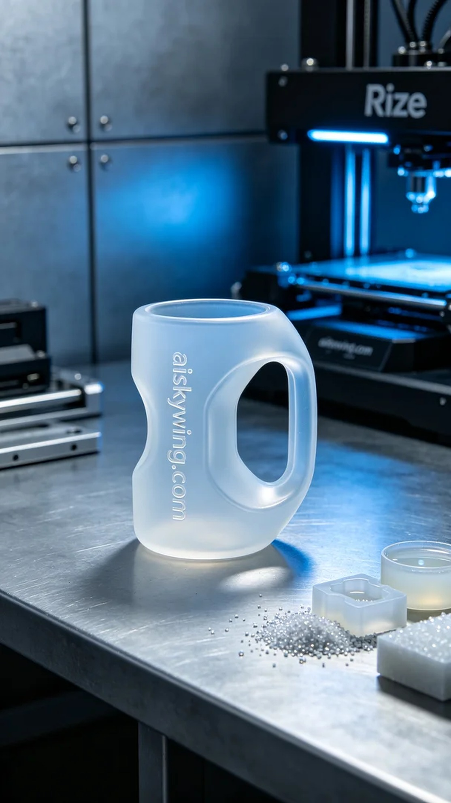
在一次偶然的机会，有人通过LinkedIn向我们求助，发现他们的传感器在使用过程中易受损，急需一款更加耐用且贴合的硅胶护套。他们希望通过我们专业的3D打印技术，解决这一困扰，确保传感器的安全和稳定。
为了满足这个需求，我们选择使用硅胶复模材料。这种材料不仅透明柔软，还具有人体工学设计，完美贴合传感器。准备工作中，我们使用Rize打印机设置了层厚为0.1毫米，打印温度保持在60摄氏度，打印功率为75瓦，速度设定在每小时40毫米，整个打印过程预计需要6小时完成。
打印过程中，Rize打印机以稳定的速度运行，材料逐层成型。我们全程监控设备的运行状态，确保打印质量达到预期标准。每一层都经过仔细观察，确保没有气泡或其他缺陷，确保成品的光滑度和耐用性。
完成打印后，我们进行了一系列的后处理工序。首先将成品放入清洗槽中，清除多余的液态光敏树脂。随后进行打磨，确保表面光滑。最后，将其放入固化设备中，经过60分钟的固化处理，确保硅胶护套的耐用性和稳定性。在最终检验时，确认护套各项指标都符合标准。
最终，我们成功地交付了这款传感器硅胶护套，完美地满足了需求。通过这次项目，我们不仅提升了技术水平，也为客户提供了更安全的保护方案，感到无比自豪。
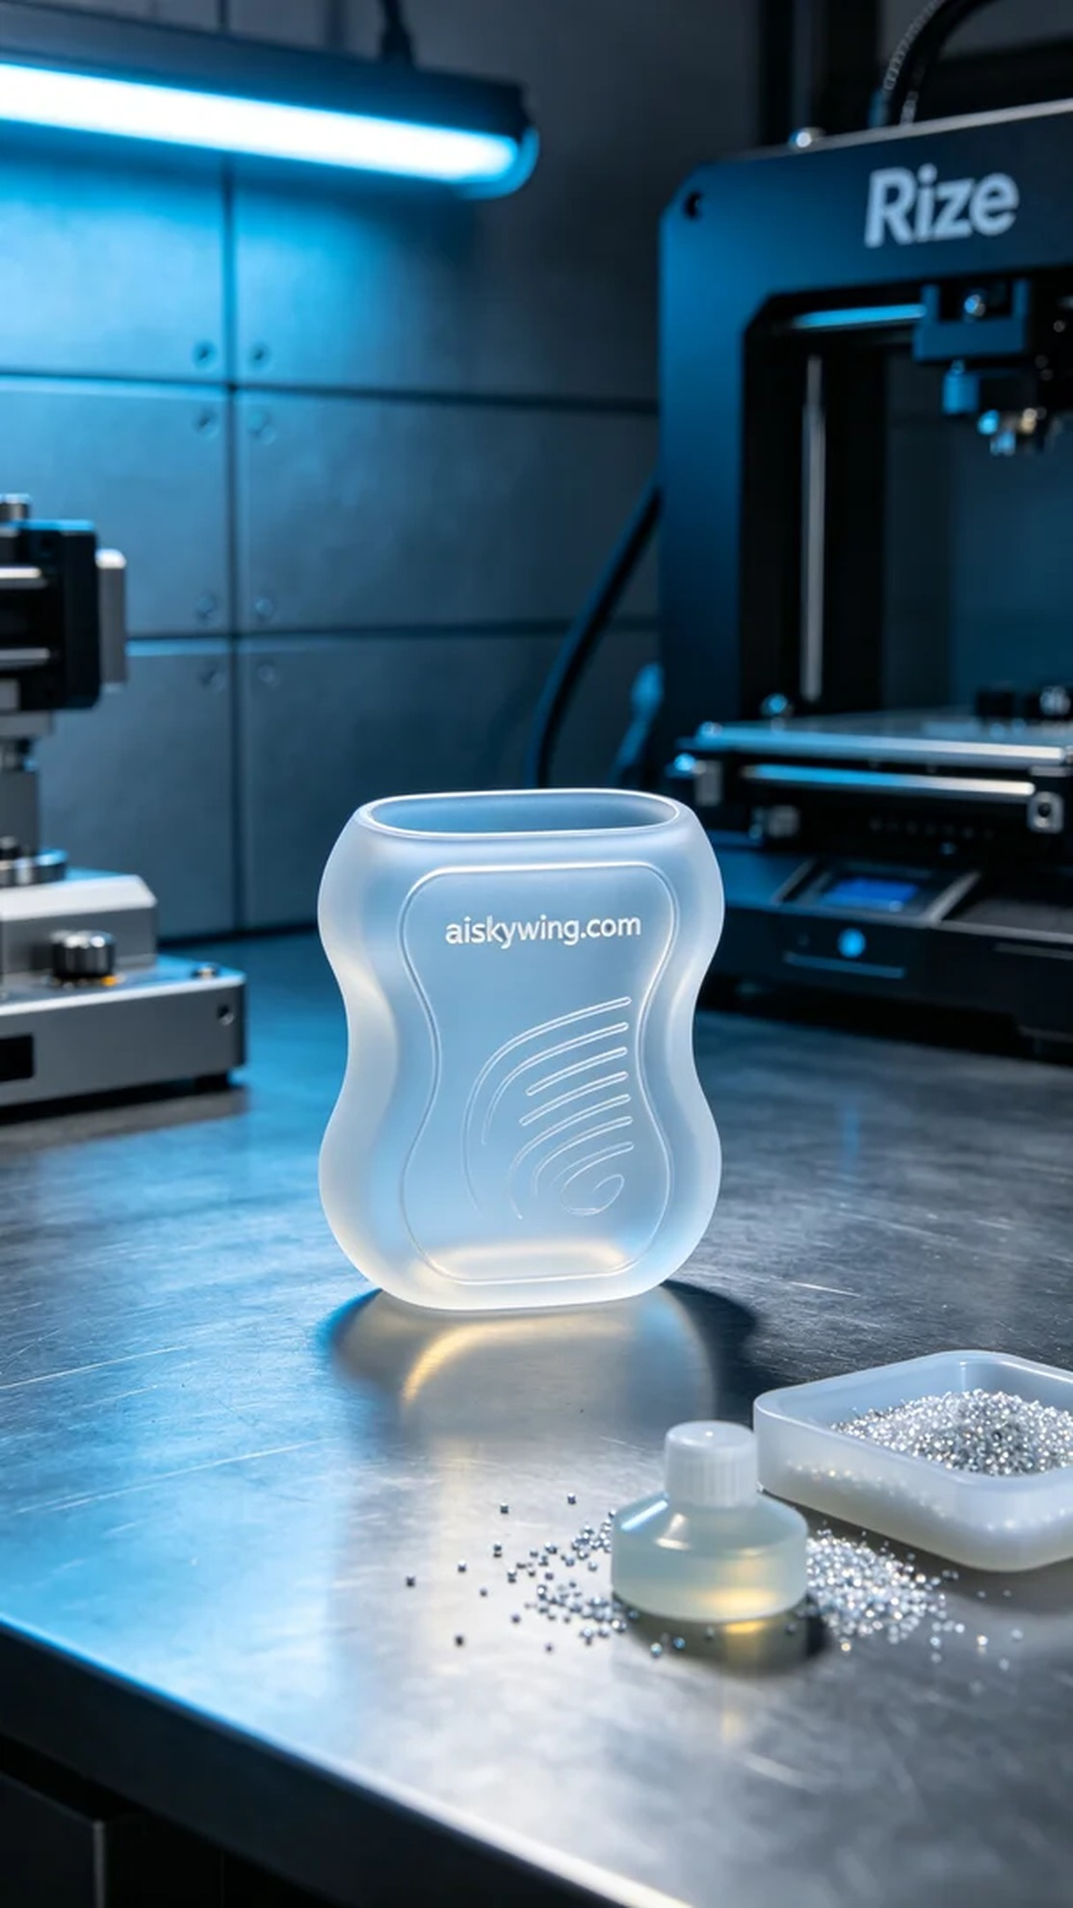
Aiskywing Industrial 3D Printing
Sensor silicone sleeve


