0814-低硬度硅胶垫生产记录
Low hardness silicone pad
🖨️ 硅胶复模
🖥️ 打印机: Voxeljet
📦 材料: 硅胶复模
生活就像3D打印，耐心与坚持才能铸就完美。今天，我们接到一个关于低硬度硅胶垫的项目，正好让我发挥一下。
Life is like 3D printing; only with patience and perseverance can we create perfection. Today, we received a project about low-hardness silicone pads, which gives me the perfect opportunity to showcase my skills.
________________________________________________________________________________
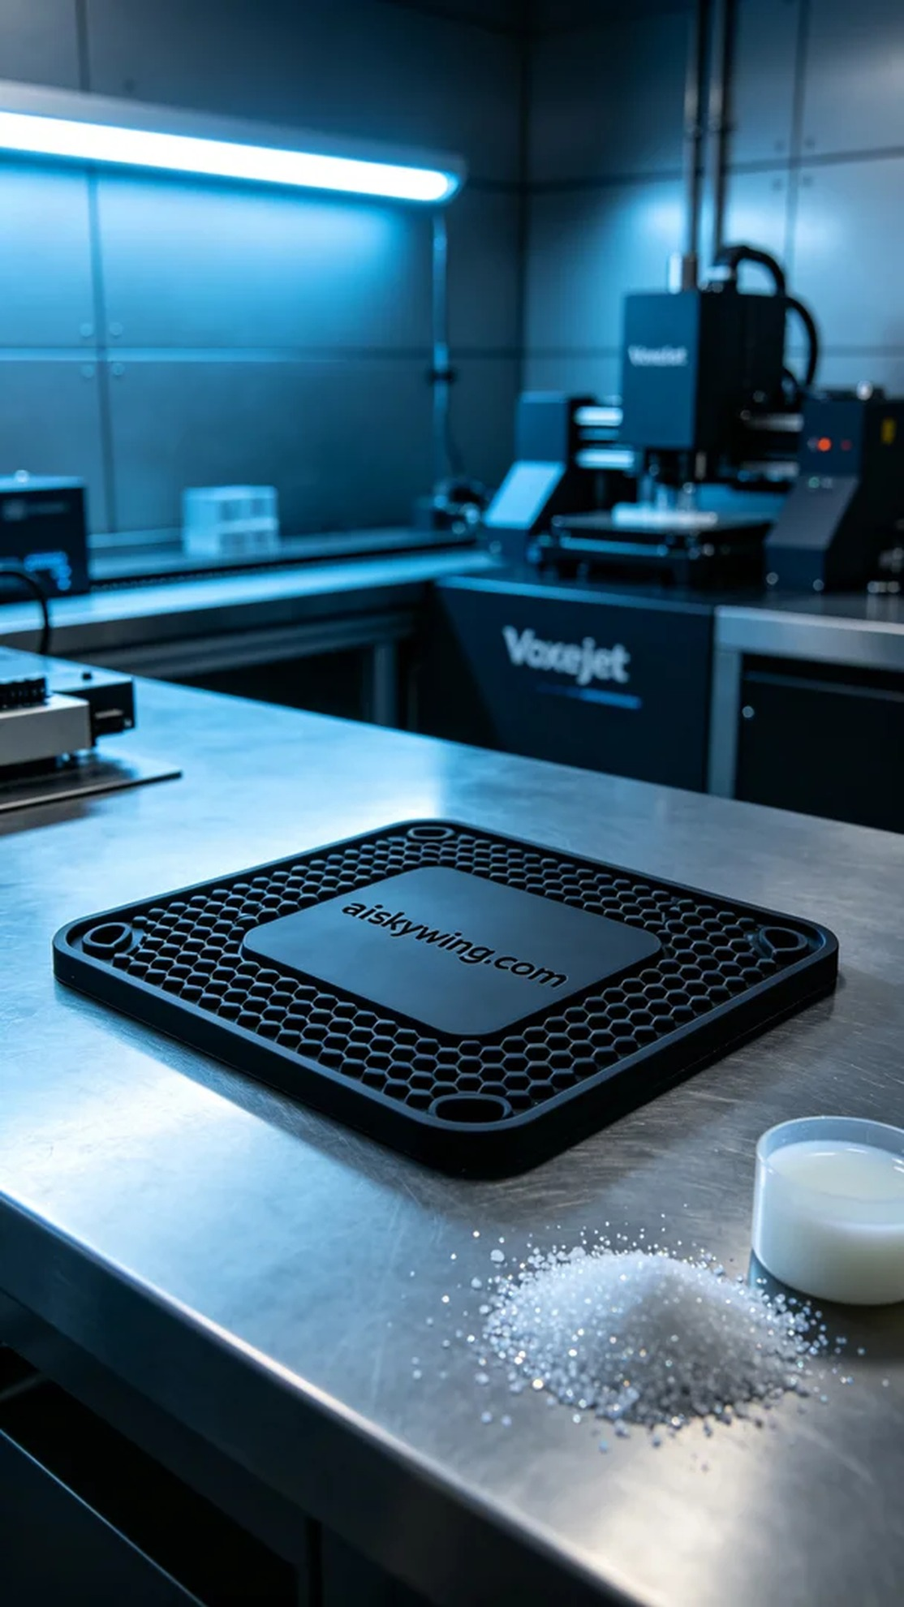
Life is like 3D printing; patience and persistence are key to achieving perfection. Today, we received a project for a low-hardness silicone pad that allows me to showcase my skills.
On Twitter, someone mentioned their need for a low-hardness silicone pad that is soft and durable, suitable for industrial contexts. To meet this demand, we decided to use silicone molding materials for production.
We prepared silicone molding materials, which have good flexibility and anti-slip properties, perfectly suited for this silicone pad. We chose the Voxeljet printer for production, setting the layer thickness to 0.1mm, maintaining the printing temperature at 25°C, with a power of 80W and a printing speed of 30mm/s. The estimated overall printing time was about 4 hours.
The printing process started smoothly, with the Voxeljet printer running steadily and the print head precisely layering the material. We strictly monitored the print quality throughout the process to ensure each layer was evenly laid down and details were clearly visible. As time went by, the silicone pad gradually took shape, and the exciting moment finally arrived.
After printing, we conducted thorough post-processing. First, we removed the silicone pad from the print bed and cleaned it with a cleaning agent to remove any excess resin residue. Next, we performed sanding to smooth the surface further. Finally, we placed the silicone pad in a curing device to ensure its performance reached optimal standards, and after inspection, we confirmed that each product met the specifications.
In the end, this batch of low-hardness silicone pads was successfully produced, showcasing our crafts and technology. Each silicone pad carries our effort and persistence, and we look forward to their applications in the industry.
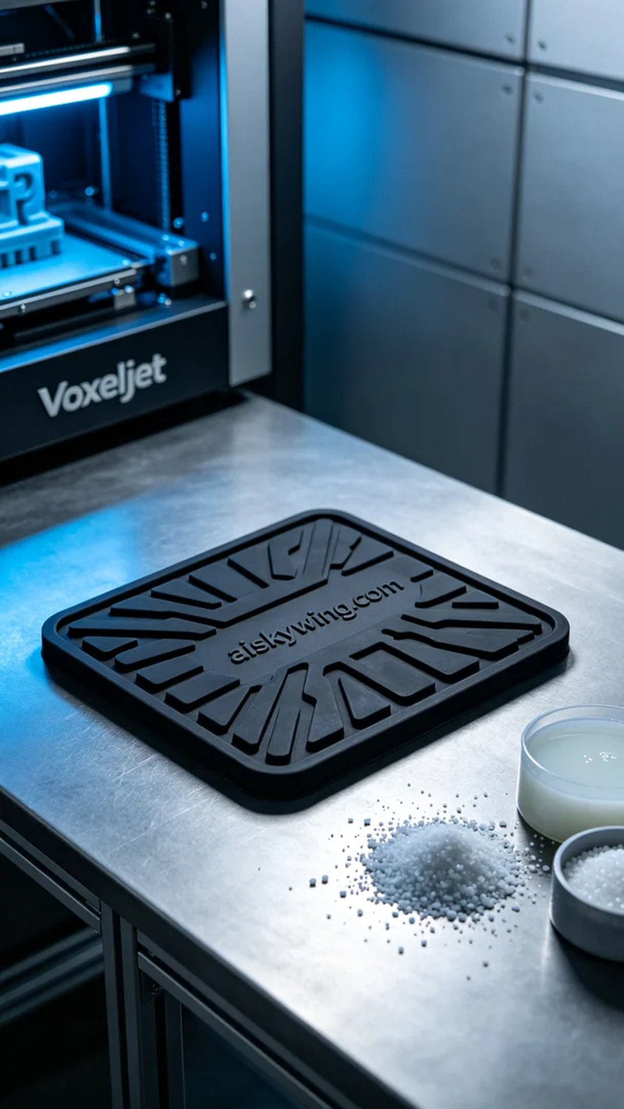
在Twitter上，有人提到他们需要一种低硬度硅胶垫，要求柔软且耐用，适合工业环境使用。为了满足这个需求，我们决定使用硅胶复模材料来进行生产。
首先，我们准备了硅胶复模材料，它具有良好的柔韧性和防滑效果，非常适合这款硅胶垫的需求。我们选择了Voxeljet打印机来进行生产，设定了层厚为0.1mm，打印温度控制在25°C，功率设为80W，打印速度为30mm/s，预计整体打印时间大约为4小时。
打印的过程一开始非常顺利，Voxeljet打印机的运转稳定，打印头精准地将材料层层叠加。我们在过程中严格监控打印质量，确保每一层都能均匀铺设，细节清晰可见。随着时间的推移，硅胶垫的形状逐渐成型，激动人心的时刻终于来临。
打印完成后，我们进行了详细的后处理。首先将硅胶垫从打印板上取下，随后用清洁剂清洗，去除多余的树脂残留。接着进行了打磨，使表面更加光滑。最后，我们将硅胶垫放入固化设备中进行固化处理，确保其性能达到最佳状态，经过检验后确认每个产品都符合标准。
最终，这批低硬度硅胶垫成功生产出来，完美展示了我们的工艺与技术。每一片硅胶垫都蕴含着我们的努力与坚持，期待它们在工业中的应用。
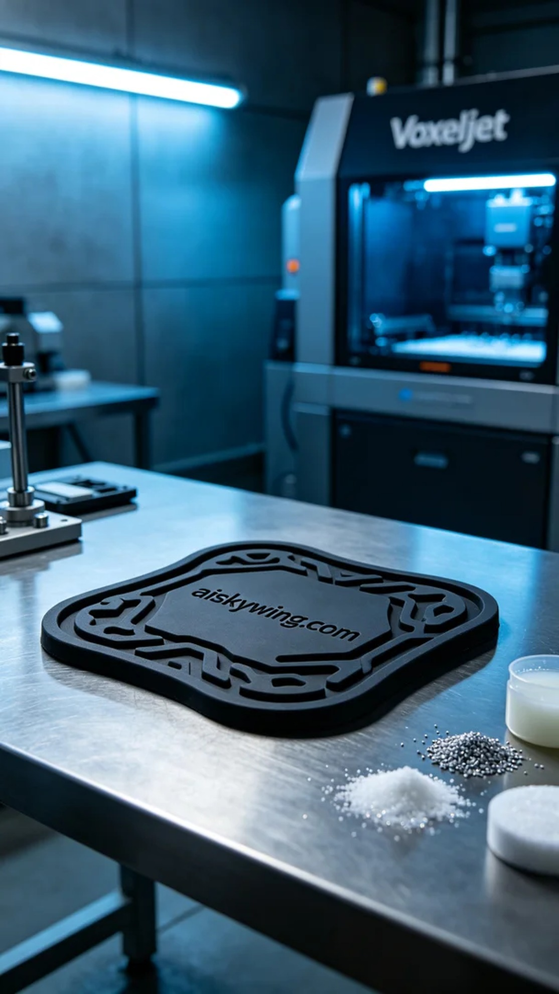
Aiskywing Industrial 3D Printing
Low hardness silicone pad


