0815-假肢接受腔内衬的生产记录
prosthetic socket内衬
🖨️ 硅胶复模
🖥️ 打印机: Stratasys
📦 材料: 硅胶复模
生活就像一场3D打印，有时候需要耐心等待出结果。最近，有人通过YouTube找到我们，想要一款假肢接受腔内衬，让我们为他解决这个问题。
生活就像一场3D打印，有时候需要耐心等待出结果。最近，有人通过YouTube找到我们，想要一款prosthetic socket内衬，让我们为他解决这个问题。
________________________________________________________________________________
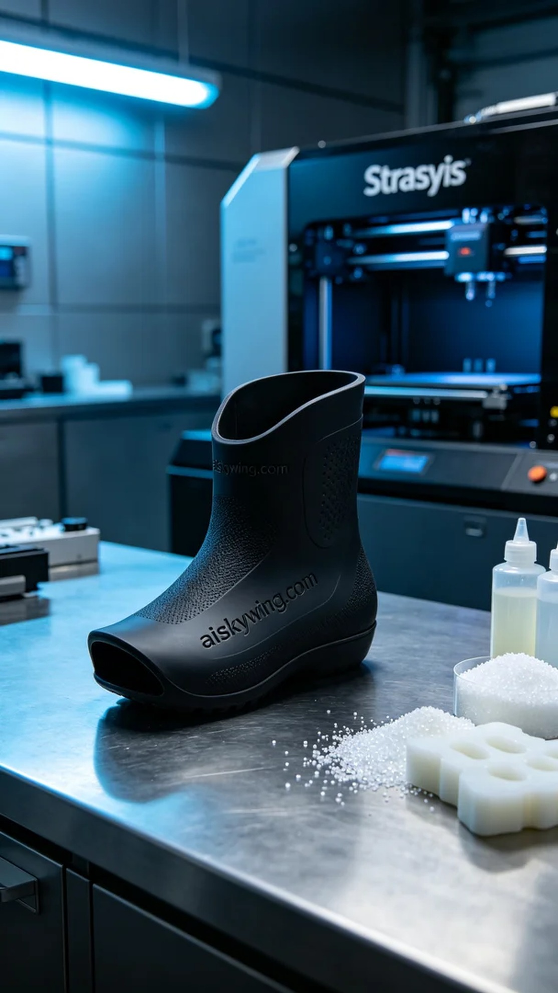
Life is like a 3D print; sometimes you have to patiently wait for the results. Recently, someone found us through YouTube, looking for a prosthetic socket liner, and we were eager to help solve this issue.
A friend reached out to us to customize a prosthetic socket liner, mainly because he wasn't satisfied with the products available on the market. He needed the liner to fit perfectly and be made from silicone cast material to ensure softness and durability.
In preparation, we selected silicone casting, which offers excellent elasticity and a non-slip texture. The printer used was a Stratasys, with settings adjusted to: layer thickness of 0.1mm, printing temperature at 60℃, power set at 50%, and a print speed of 40mm per second. These parameters helped us ensure that every detail in the print was clearly visible.
The printing process went smoothly, with the Stratasys printer operating steadily. We closely monitored the print quality throughout, and once finished, the prosthetic socket liner showcased a clear engraved logo and a soft touch, reflecting the cold industrial light, demonstrating a fusion of strength and technology.
Post-processing was equally important. First, we cleaned the finished part to remove any excess resin from the surface. Then we sanded it to ensure that every detail was perfectly displayed, followed by curing the product to enhance its durability. Finally, we meticulously inspected every detail to ensure the quality met our standards.
After this series of steps, the prosthetic socket liner was finally complete. Seeing it flawless brought us great satisfaction. This project not only represents our technical expertise but also our commitment to everyone striving for a better life.
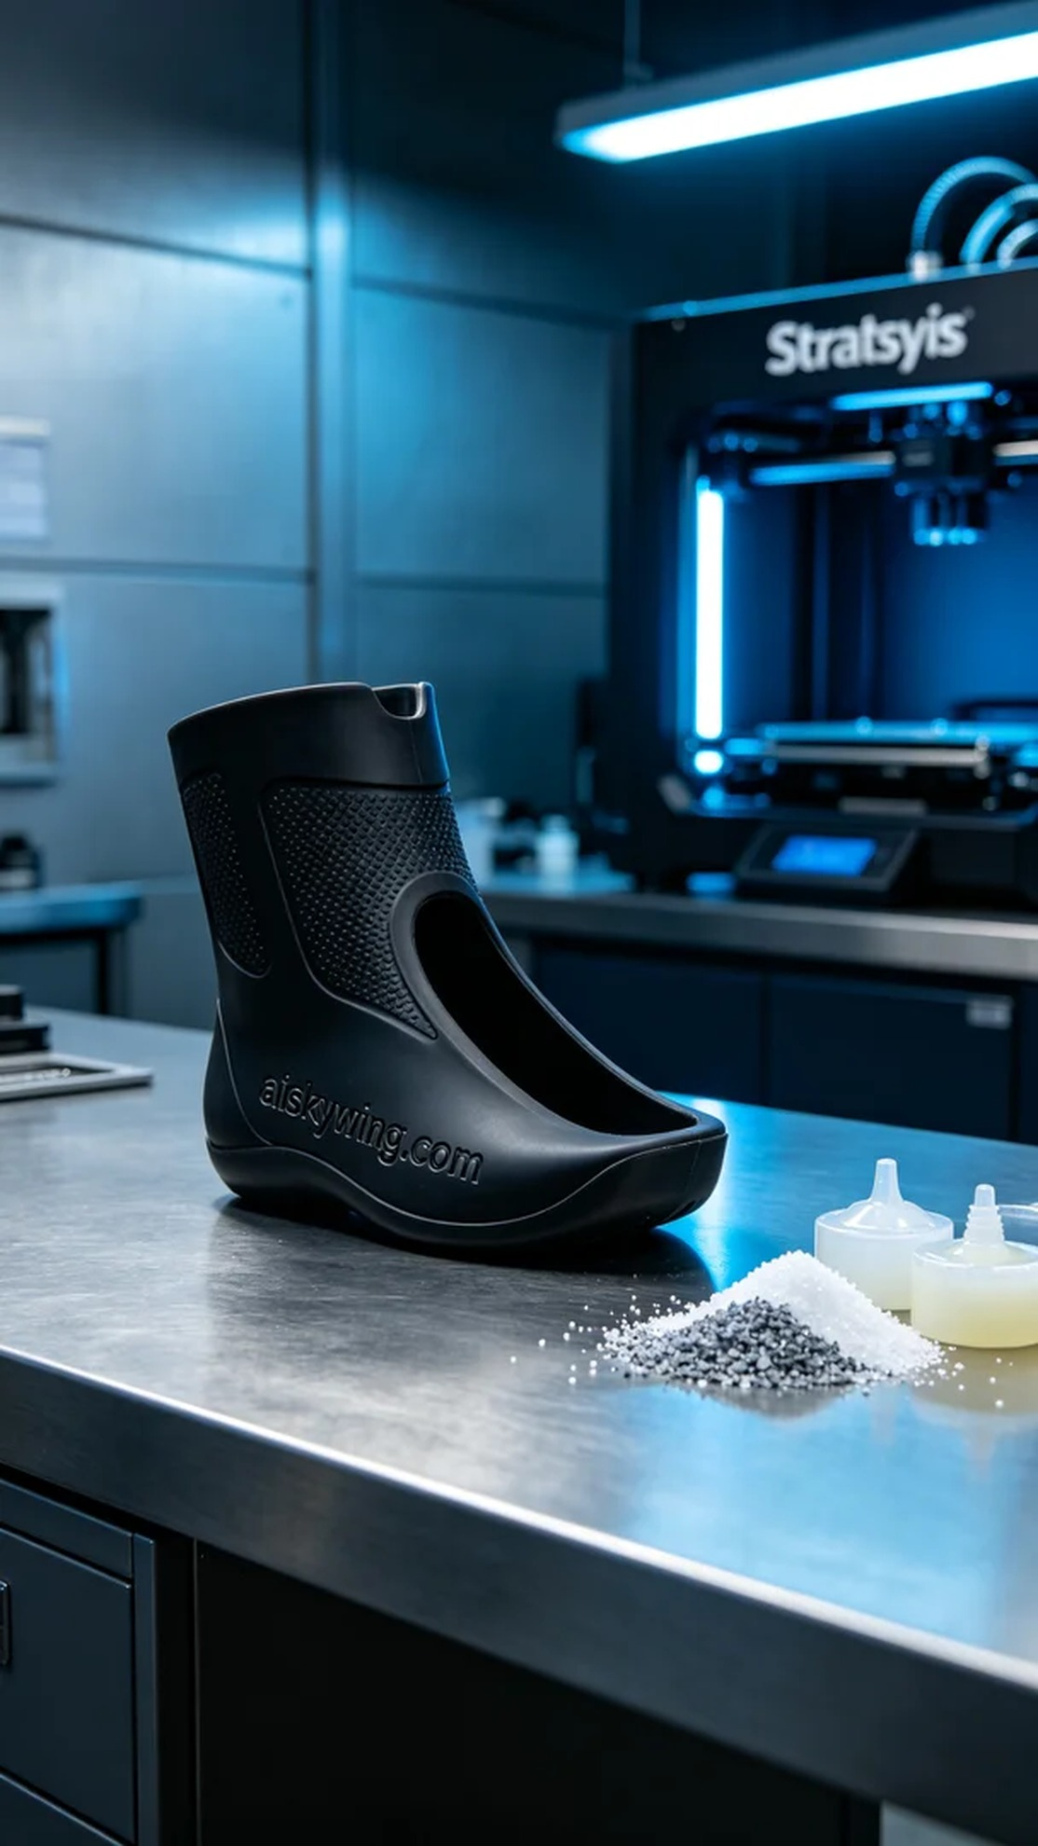
我们收到一位朋友的请求，想要定制一款假肢接受腔内衬，主要是因为他对市面上的产品不太满意，觉得舒适性和适配性都不够好。这款假肢接受腔内衬需要精确贴合，并且使用硅胶复模材质，以确保柔软和耐用性。
在准备工作上，我们选用的是硅胶复模，具备良好的弹性和防滑纹理。打印机使用的是Stratasys，打印参数设置为：层厚0.1毫米，打印温度设定在60℃，功率为50%，打印速度为40毫米每秒。通过这些参数，我们可以确保打印出的每一个细节都清晰可见。
打印过程非常顺利，Stratasys打印机稳定运行，整个过程中我们始终保持监控，查看打印质量。打印完成后，假肢接受腔内衬的表面雕刻了清晰的字样，手感柔和，反射出冷峻的工业光线，让人感到坚固与科技的结合。
后处理工序同样重要。首先将打印完成的部件进行清洗，以去除表面多余的光敏树脂。接着进行打磨，确保每个细节都能完美呈现，最后对产品进行固化，以增强其耐受性。最终，我们仔细检验每一个细节，确保质量达到要求。
经过这一系列工序，这款假肢接受腔内衬终于完成了。我们看到它完美无瑕，深感欣慰。这不仅是技术的结晶，也是对每一位追求美好生活的朋友的承诺。
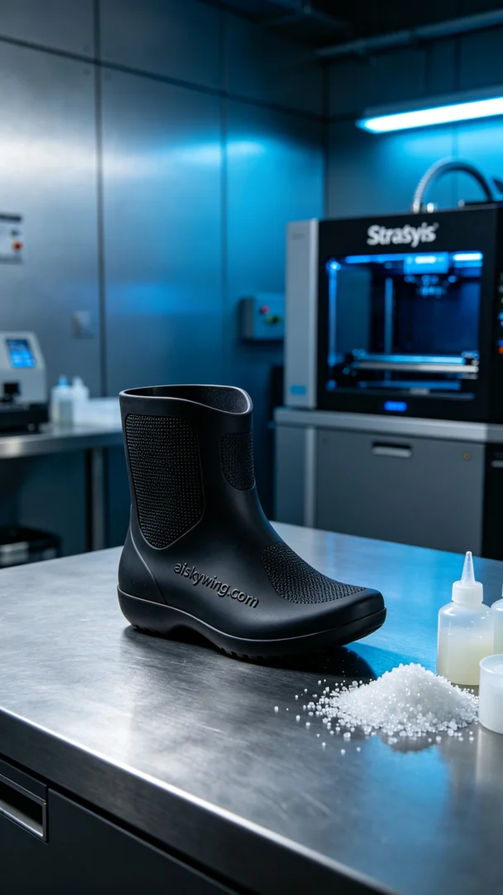
Aiskywing Industrial 3D Printing
prosthetic socket内衬


