0816-3D打印儿童玩具积木生产记录
Children's toy building blocks
🖨️ 硅胶复模
🖥️ 打印机: Mimaki
📦 材料: 硅胶复模
在Instagram上，有人因为寻找独特的儿童玩具积木而找到我们。这让我想起了生活中的坚持和创造的力量。
On Instagram, someone found us while searching for unique children's building blocks. This reminded me of the power of perseverance and creativity in life.
________________________________________________________________________________
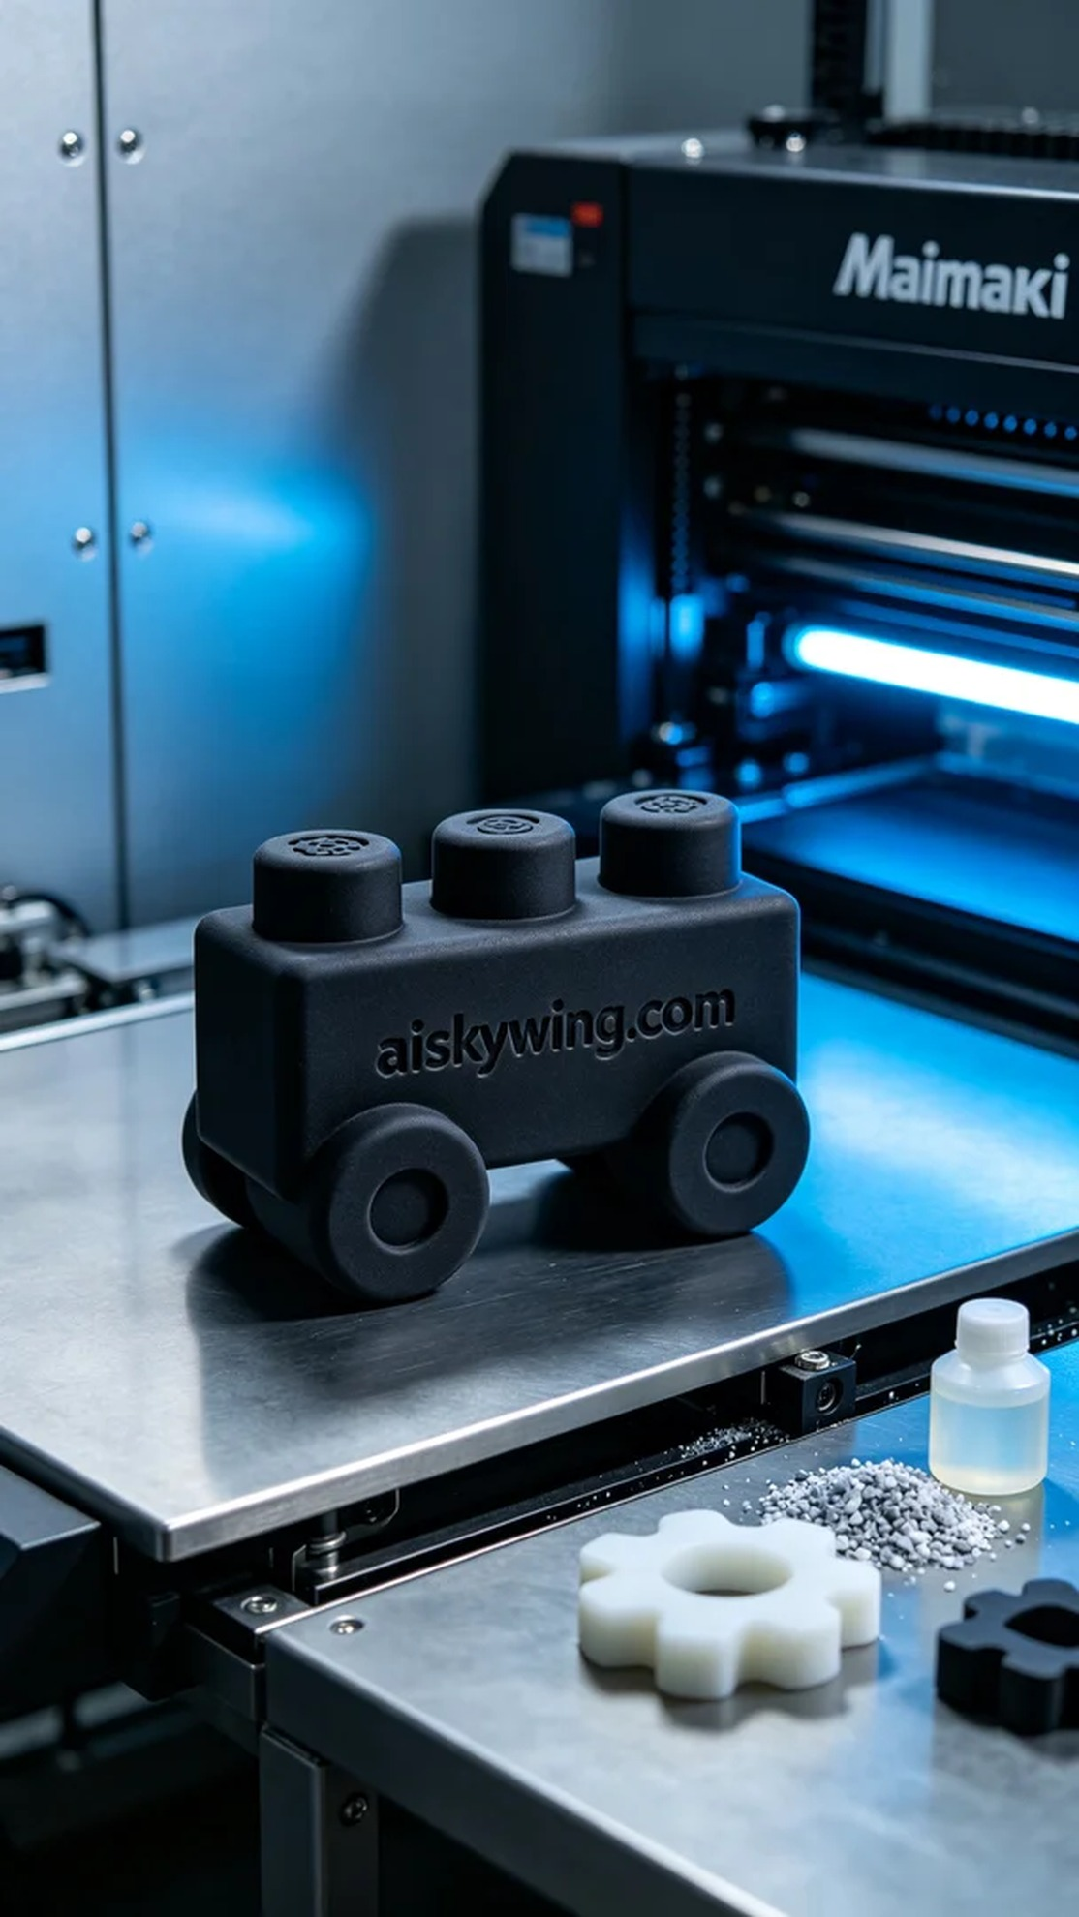
The project this time was to create a building block for a children's toy brand. Initially, someone found us on Instagram after seeing our work and hoped to produce a toy that was both beautiful and durable. This task made me feel the joy of childhood innocence and the infinite possibilities of creativity.
We chose silicone replica molding as our raw material. This material is not only soft and durable, but also has good non-slip texture. For equipment, we used a Mimaki brand 3D printer. The printing parameters were set with a layer thickness of 0.1 mm, a printing temperature of 60 degrees Celsius, a power of 80%, and a speed control of 40 mm per second, with an estimated printing time of about 4 hours.
During the printing process, the Mimaki printer operated steadily, with the liquid photo-sensitive resin accurately cured layer by layer under precise control of the nozzle. We kept monitoring the printing quality to ensure each layer was uniform and bubble-free, especially when carving the "aiskywing.com" text, which required meticulous attention to achieve perfection.
After printing, we entered the post-processing phase. First, we cleaned the printed piece to remove any uncured resin from the surface, followed by sanding to ensure a smooth surface and a comfortable feel. Finally, we cured it to enhance its strength and durability, with the last step being strict inspection to ensure each toy met our quality standards.
After a series of processes, this children's toy block finally presented itself before us. Creating such a product is not only a challenge to our technology, but also a beautiful promise to children.
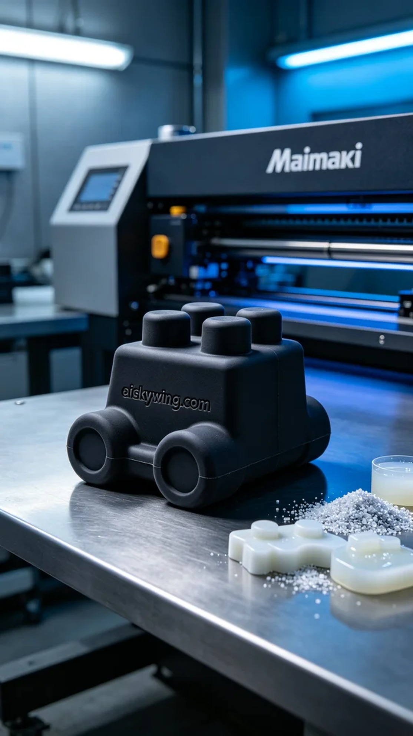
这次的项目是为一家儿童玩具品牌制作一个积木，起初有人在Instagram上看到我们的作品，便找到我们，希望能制作出一个既美观又耐用的玩具。这个任务，让我感受到孩童纯真的欢乐与创造的无限可能。
我们选择了硅胶复模作为原材料，这种材料不仅柔软耐用，还具备良好的防滑纹理。设备方面，我们使用了Mimaki品牌的3D打印机，设置的打印参数为层厚0.1毫米，打印温度设定为60摄氏度，功率为80%，打印速度控制在40毫米每秒，预计整个打印过程需要约4个小时。
打印过程中，Mimaki打印机稳定运行，液态光敏树脂在喷头的精确控制下逐层固化。我们始终保持对打印质量的监测，确保每一层都均匀且无气泡，特别是在雕刻“aiskywing.com”字样时，更是细致入微，力求完美。
打印完成后，我们进入了后处理阶段。首先对打印件进行了清洗，去除表面的未固化树脂，接着进行打磨，确保表面光滑、手感舒适。最后，将其进行固化处理，以提升强度和耐用性，最后一步是严格检验，确保每个玩具都符合我们的质量标准。
经过一系列的工序，这个儿童玩具积木终于如愿以偿地呈现在我们面前。创造出这样的产品，既是对技术的挑战，也是一份对孩子们的美好承诺。
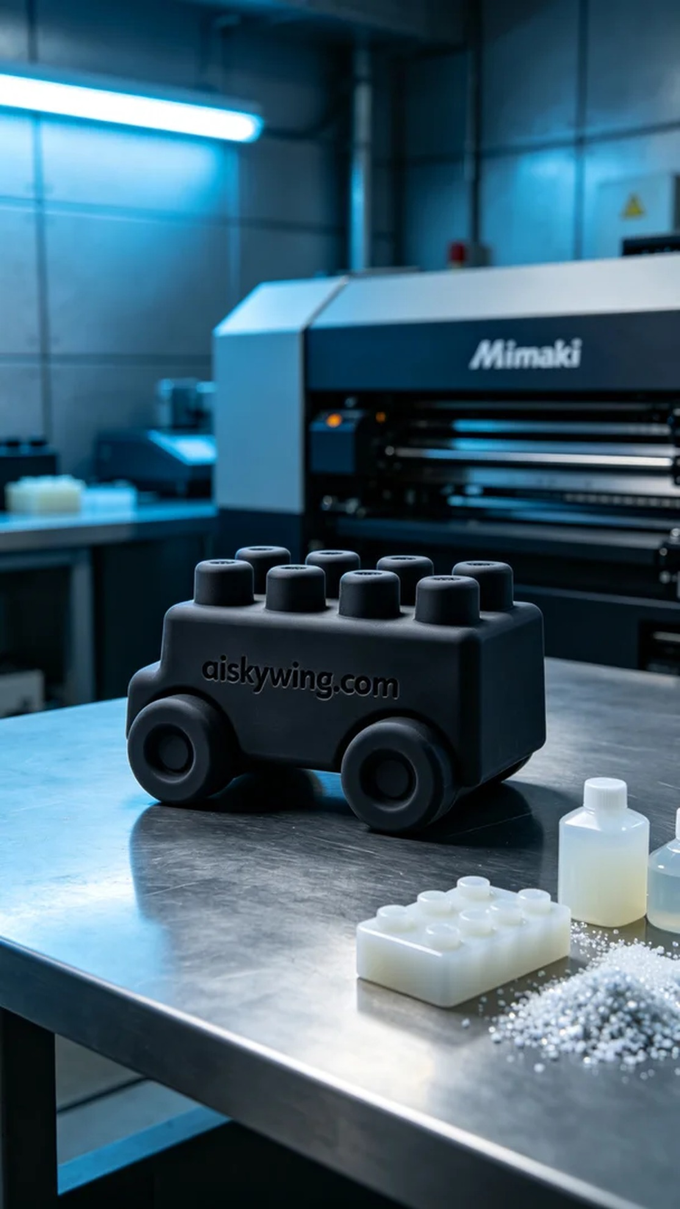
Aiskywing Industrial 3D Printing
Children's toy building blocks


