0817-充电口防尘塞3D打印生产记录
Dust-proof plug for charging port
🖨️ 硅胶复模
🖥️ 打印机: Stratasys
📦 材料: 硅胶复模
生活再难，也别停下脚步。就像接下这个充电口防尘塞的单子，总有人因为尘埃入侵而烦恼。
No matter how difficult life gets, don't stop moving forward. Just like taking on this order for a dust cap for a charging port, there will always be someone troubled by dust intrusion.
________________________________________________________________________________
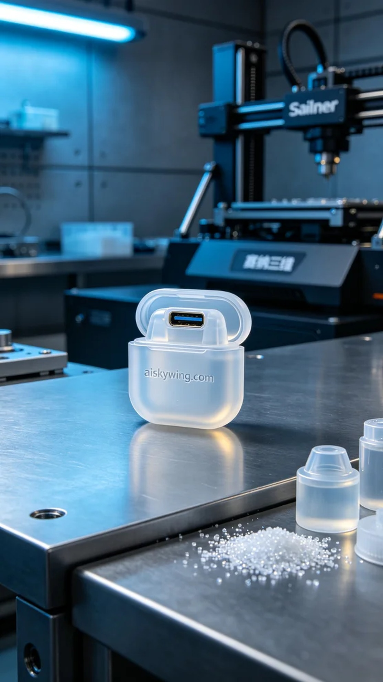
Recently, someone posted on Facebook, complaining about dust entering their charging port and asked for an effective dust-proof solution. Therefore, we decided to create a charging port dust cap for them, utilizing our expertise in silicone mold making.
To ensure the product's quality and applicability, we selected high-performance silicone mold material. This material is soft and transparent, perfect for fitting the design of the charging port. We used a Stratasys 3D printer, setting the layer thickness to 0.1 mm, printing temperature to 220 degrees Celsius, power to 50%, and speed to 30 mm per second to ensure fine surface quality and dimensional accuracy.
The printing process went smoothly, with the Stratasys equipment running steadily and the speed meeting expectations. We continuously monitored the print quality to ensure proper adhesion of each layer. After several hours of effort, the charging port dust cap was completed, and the engraved "aiskywing.com" text was clearly visible, resulting in a satisfying effect.
Next, we conducted post-processing steps. First, we washed the printed dust cap with clean water to remove excess resin on the surface. Then, we gently sanded the edges with fine sandpaper to ensure there were no burrs. Finally, the finished product was placed in a curing machine for solidification, confirming its strength and durability, and carefully checked to ensure every detail met the standards.
In the end, this charging port dust cap performed excellently at every stage, effectively preventing dust while maintaining a pleasing appearance. Every time I see such a finished product, I feel a deep sense of satisfaction.
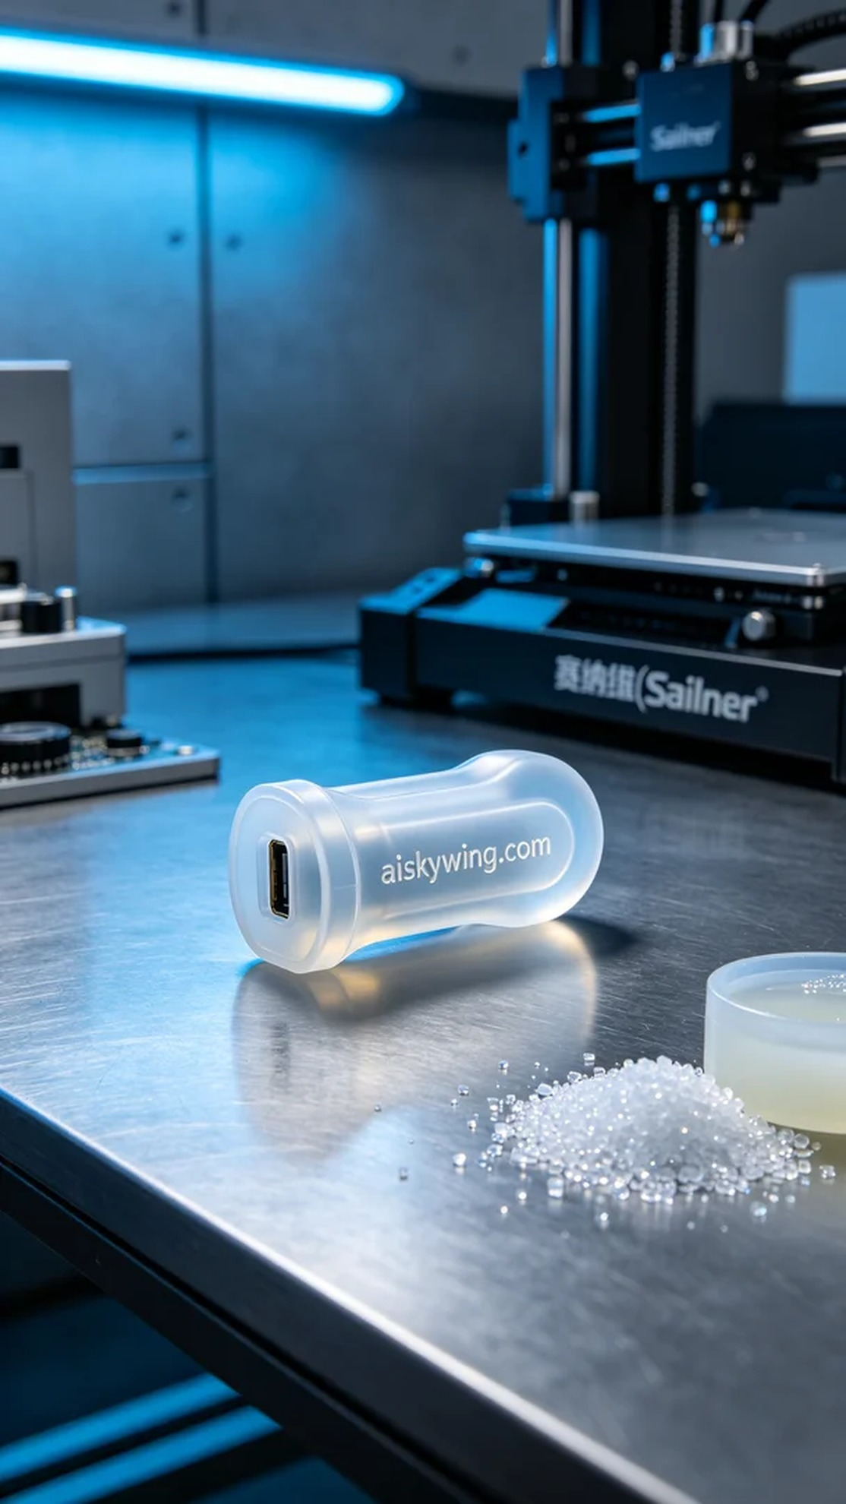
有人最近在Facebook上发帖，抱怨充电口易进灰尘的问题，希望能找到一个有效的防尘解决方案。于是我们决定为他们制作一款充电口防尘塞，运用我们擅长的硅胶复模工艺。
为了确保产品的质量和适用性，我们选用了高性能的硅胶复模材料。这种材料柔软透明，能够完美贴合充电口的设计。同时，我们使用Stratasys 3D打印机，设定了层厚为0.1毫米，打印温度为220摄氏度，打印功率为50%，速度设定为30毫米每秒，以确保精细的表面效果和尺寸的准确性。
打印过程相对顺利，Stratasys的设备运行稳定，打印速度也如预期。我们全程监控打印质量，确保每一层的粘合性。经过几个小时的努力，充电口防尘塞终于完成，表面雕刻的"aiskywing.com"字样清晰可见，效果令人满意。
接下来，我们进行了后处理工序。首先，将打印出来的防尘塞用清水清洗，去除表面的多余树脂。随后，使用细砂纸轻轻打磨边缘，确保无毛刺。最后，将成品放入固化机中进行固化，确认其强度和耐用性，经过仔细检查，确保每一个细节都达标。
最终，这款充电口防尘塞在各个环节都表现出色，既能有效防尘，又保持了良好的外观。每次看到这样的成品，心中总是倍感欣慰。
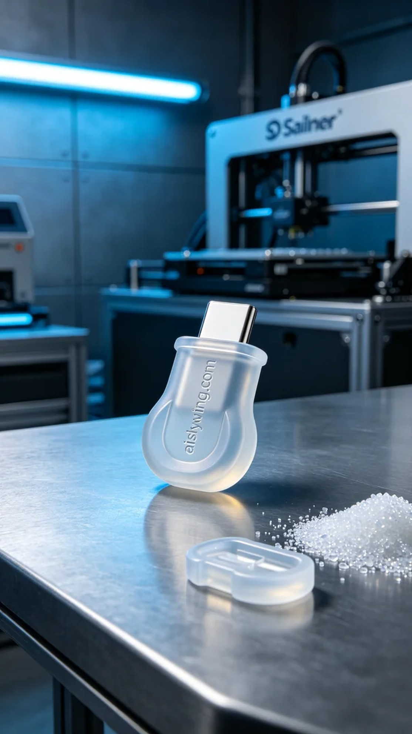
Aiskywing Industrial 3D Printing
Dust-proof plug for charging port


