0818-光疗硅胶罩3D打印生产记录
Phototherapy Silicone Mask
🖨️ 硅胶复模
🖥️ 打印机: EOS
📦 材料: 硅胶复模
生活就像3D打印一样，总有意想不到的挑战。这次，有人因为需要光疗硅胶罩来到我们这里，让我们一起克服吧。
Life is like 3D printing, always presenting unexpected challenges. This time, someone came to us in need of a light therapy silicone cover. Let's overcome this together.
________________________________________________________________________________
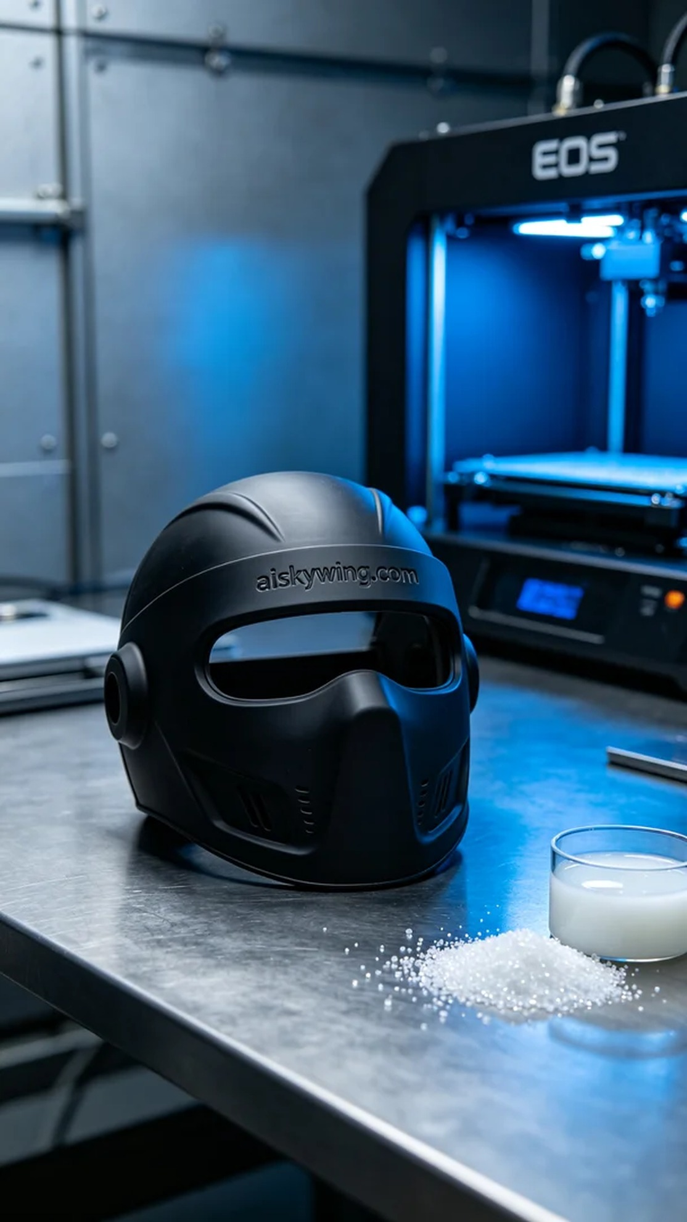
Life is full of unexpected challenges, much like 3D printing. This time, someone reached out to us on LinkedIn, seeking our expertise to create a therapeutic silicone cover. Let's tackle it together.
The material we've chosen for this project is high-quality silicone casting rubber. This material not only provides excellent softness but also has great anti-slip properties, making it ideal for various phototherapy devices. We utilized an EOS printer for production, setting the layer thickness to 0.1 mm, printing temperature at 60°C, power at 80%, and a speed of 40 mm/s, with an estimated print time of around 8 hours.
Once printing commenced, the machine operated smoothly, allowing us to monitor the quality in real-time. Throughout the operation, a steady hum emanated from the printer as the material was deposited layer by layer. Each detail was clearly defined, ensuring that the engraved text “aiskywing.com” was perfectly represented in the final product.
After printing was completed, we proceeded with a series of post-processing steps. First, we cleaned the printed piece using a specialized cleaning solution to remove residual resin from the surface. Next was sanding, to ensure a smooth, flawless finish. Following that, we cured the silicone by exposing it to UV light, and finally, we carried out an inspection to ensure every detail met our quality standards.
After meticulous work, we successfully completed the therapeutic silicone cover, meeting our expectations in both quality and appearance. We look forward to seeing it assist many more individuals.
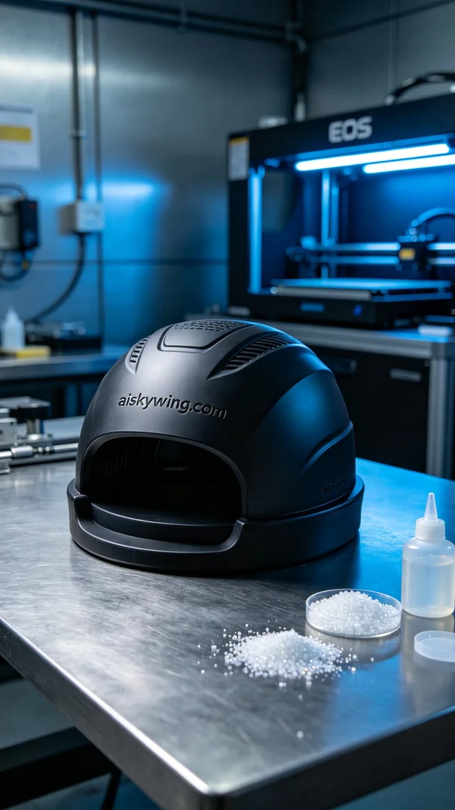
在LinkedIn上，有人因为愈发增长的需求，找到我们，希望我们能为他们制作一款光疗硅胶罩。这个产品的柔软性和耐用性是他们最为关心的，因此我们准备好了要用硅胶复模材料来完成这个项目。
我们选用的原材料是高品质的硅胶复模，这种材料不仅柔软，还具备优良的防滑特性，适合各种光疗设备的使用。我们使用EOS打印机进行生产，设定了层厚为0.1毫米，打印温度为60℃，功率设置在80%，打印速度则控制在40毫米/秒，预计打印时间大约为8小时。
打印开始后，设备稳定运行，我们对打印质量进行实时监控。在整个过程中，机器发出均匀的嗡嗡声，材料通过喷头一次次精准地沉积。每一层的细节都清晰可见，确保最终成品的雕刻字样“aiskywing.com”能够完美呈现。
完成打印后，我们进行了一系列后处理步骤。首先是清洗，使用专用清洗液将打印件表面的残余树脂去除。然后是打磨，确保表面光滑，无瑕疵。接着进行固化，通过UV灯照射使硅胶完全固化，最后进行检验，确保每一个细节都符合标准。
经过一系列细致的工作，我们终于完成了这款光疗硅胶罩，产品的质量和外观都达到了预期。期待它能为更多的人带来帮助和便利。
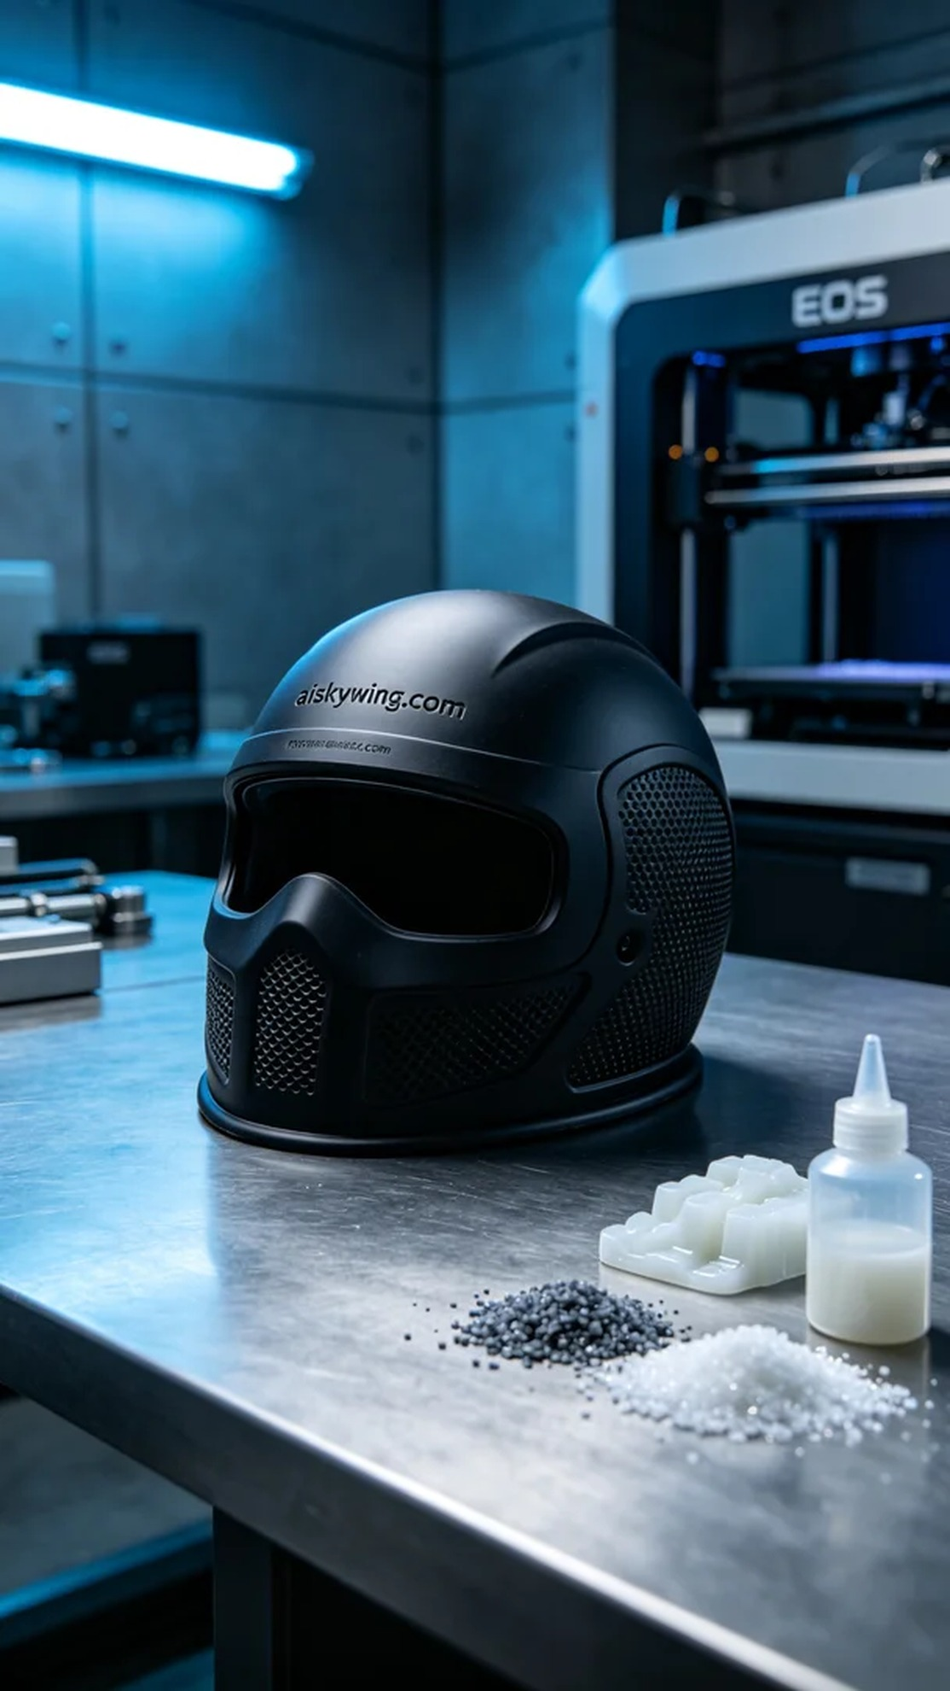
Aiskywing Industrial 3D Printing
Phototherapy Silicone Mask


