0819-喷水嘴支架3D打印生产记录
Nozzle bracket
🖨️ SLM金属打印
🖥️ 打印机: Stratasys
📦 材料: 摆放着未成型的液态光敏
生活总是充满挑战，就像在LinkedIn上接到这个喷水嘴支架的订单，面对的每一个问题都让我更加坚定。
Life is always full of challenges, just like receiving this order for a spray nozzle bracket on LinkedIn; every problem I encounter makes me more determined.
________________________________________________________________________________
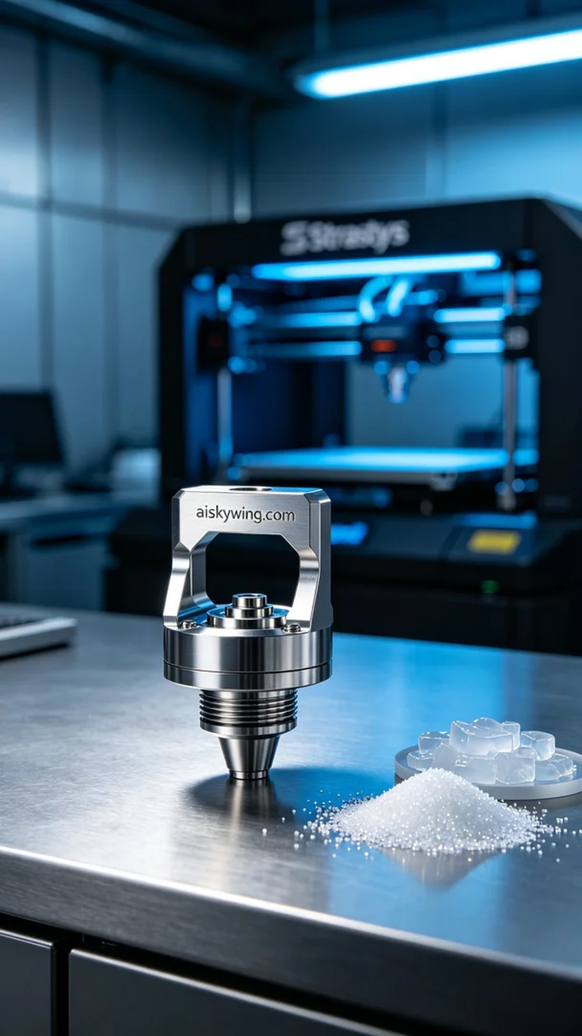
Life is always full of challenges, just like receiving the order for this nozzle bracket on LinkedIn. Each problem pushes me to become more steadfast in my work.
Someone approached us urgently needing a nozzle bracket to resolve production delays. This bracket not only had to be functional but also of high quality. Therefore, we decided to use SLM metal printing technology to ensure its performance and durability.
Before production, we prepared the liquid photopolymer resin materials. To ensure printing quality, we chose the Stratasys brand 3D printer. We set the layer thickness to 50 microns, controlled the temperature at 25 degrees Celsius, set the power at 80%, and established a print speed of 25 mm per second, with an estimated printing time of about 4 hours.
During the printing process, the Stratasys printer operated smoothly, evenly spraying the liquid material onto the printing platform. We continuously monitored print quality to ensure that each layer bonded properly, avoiding warping or other defects. On-site, we observed every detail closely to ensure the final product met expectations.
After printing, the post-processing steps are crucial. We placed the finished product in a cleaning solution to remove any residual resin on the surface, followed by sanding to make the bracket surface smoother. Next, we performed a curing process using UV lights to fully cure the material and enhance the strength of the bracket. The final step was a thorough inspection to ensure each product met our high standards.
In the end, after a series of meticulous processes, the nozzle bracket was completed on schedule, perfectly meeting the production requirements. Every effort pays off in the final product.
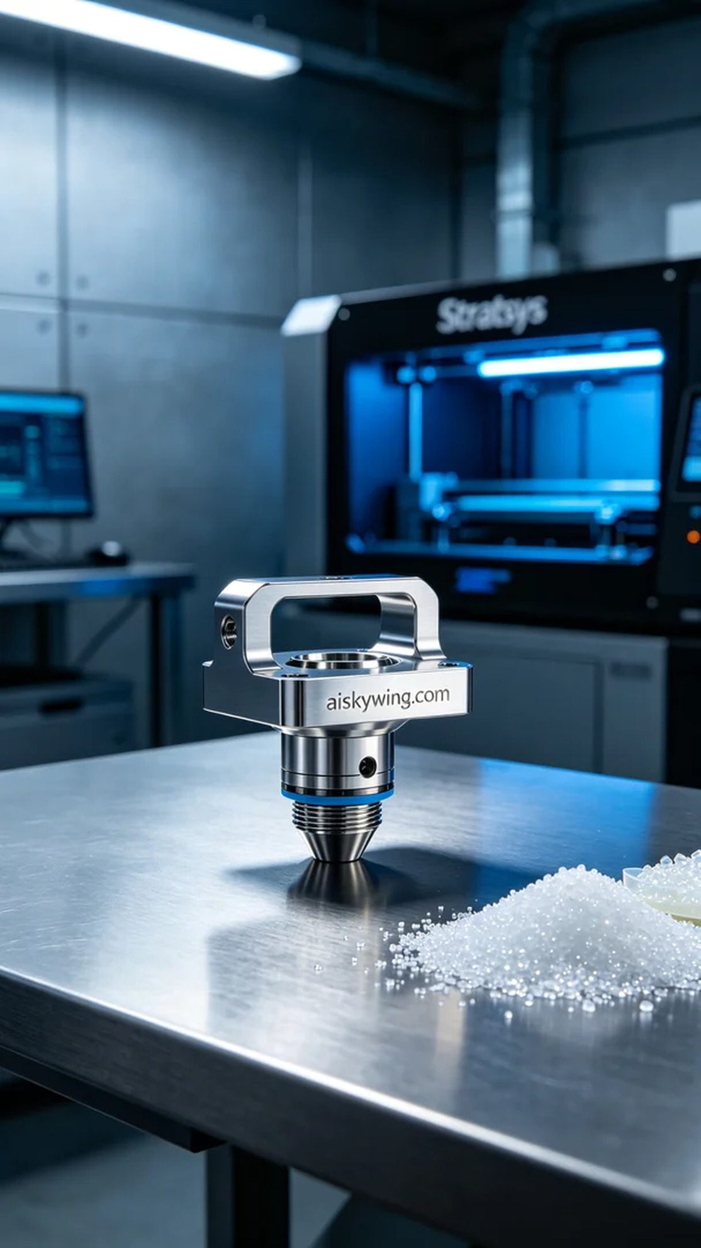
有人因为急需的喷水嘴支架找到了我们，想要解决生产中的供货延误问题。这个支架不仅要功能强大，还要求质量过硬，因此我们决定采用SLM金属打印工艺来制作，以确保性能和耐用性。
在生产前，我们首先准备了摆放着未成型的液态光敏树脂原材料。为了确保打印质量，我们选择了Stratasys品牌的3D打印机进行打印，设置的层厚为50微米，温度控制在25摄氏度，功率设置为80%，打印速度为25毫米每秒，预计打印时间大约需要4小时。
打印过程中，Stratasys打印机运行平稳，喷头将液态材料均匀喷涂到打印平台上。我们时刻监控打印质量，确保每一层的粘合牢固，避免出现翘边或其他缺陷。在现场，我们仔细观察每一个细节，确保最终成品达到预期效果。
打印完成后，后处理工序至关重要。我们将成品放入清洗液中，清除表面残留的树脂，然后进行打磨处理，使支架表面更加光滑。接着，我们进行了固化工序，使用UV灯照射，让材料充分固化，增强支架的强度。最后一项是严格的检验，确保每一件产品都符合我们的高标准。
最终，经过一系列精细的工序，喷嘴支架如期完成，完美符合了生产要求。每一份努力都能在成品中得到回报。
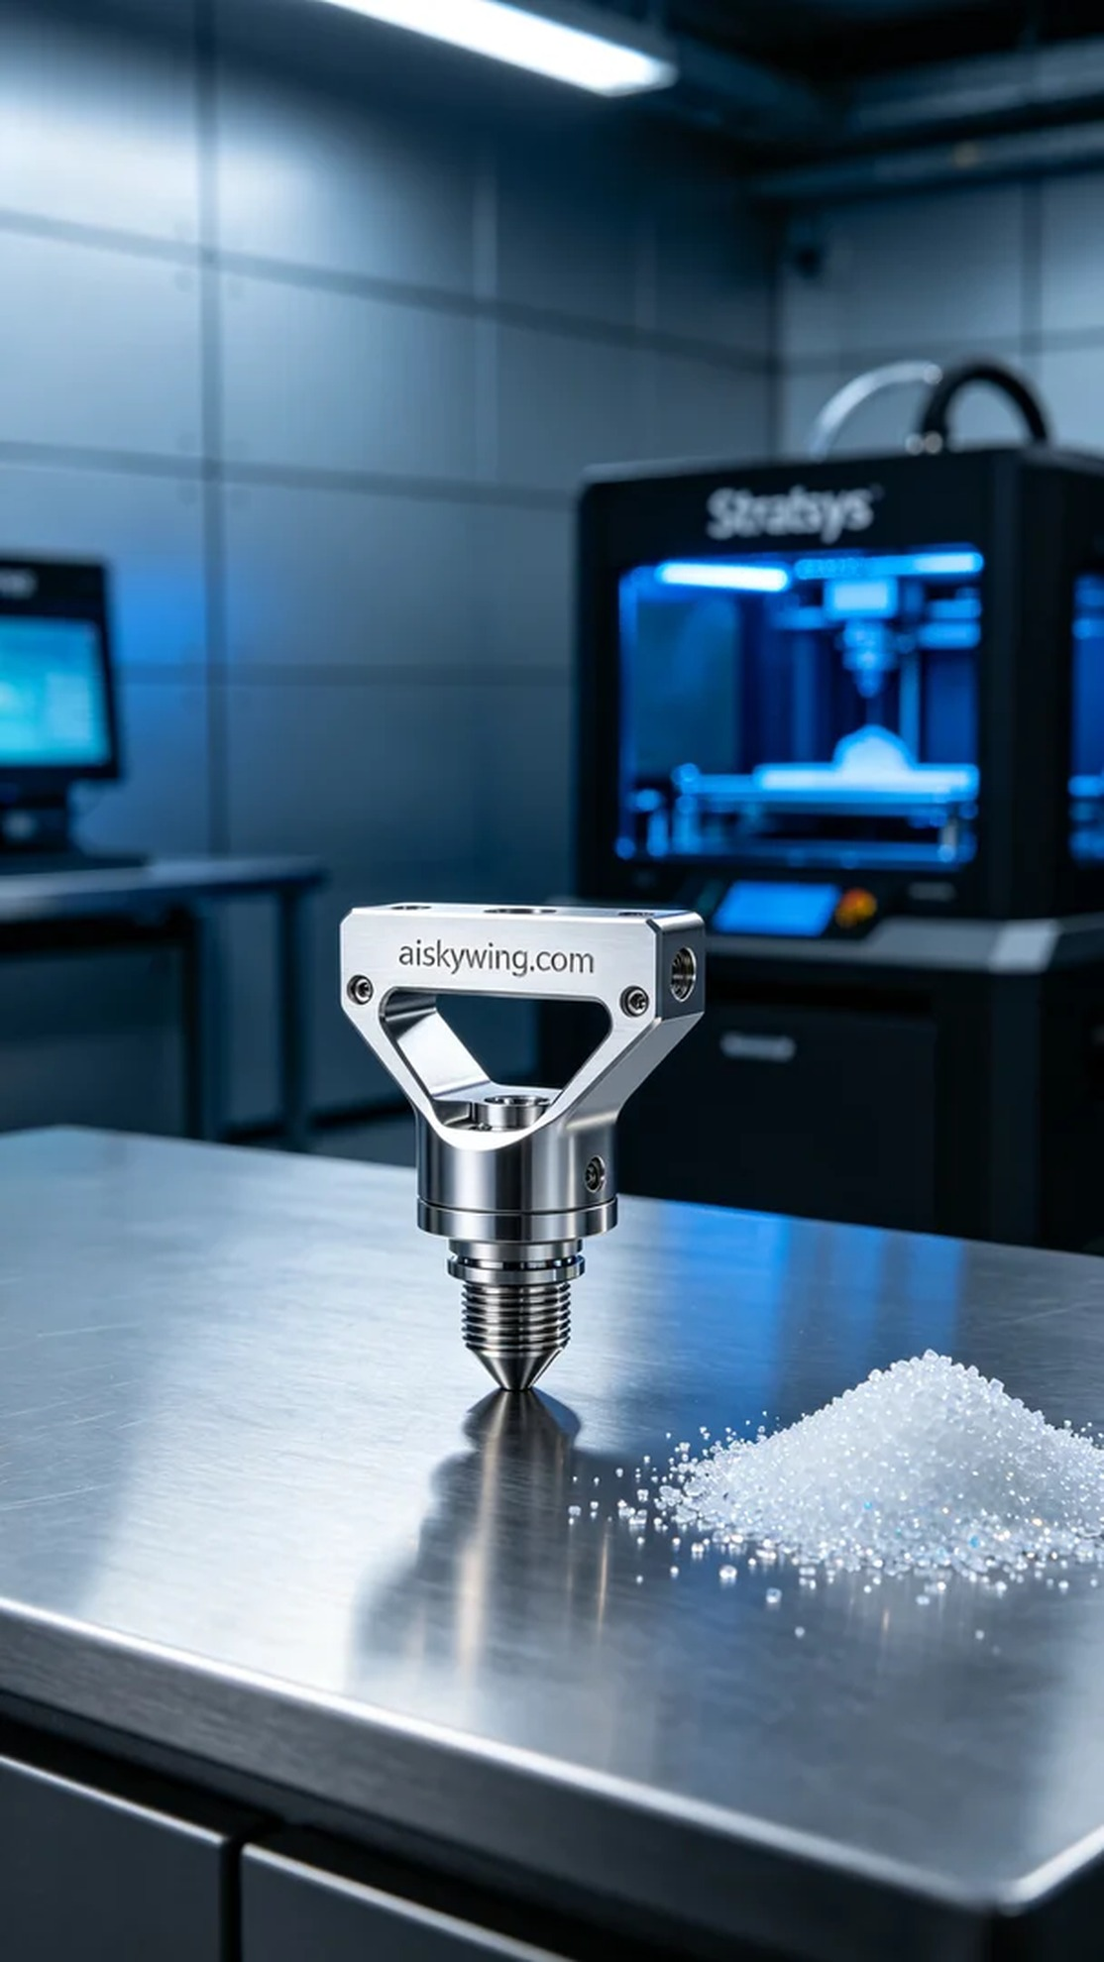
Aiskywing Industrial 3D Printing
Nozzle bracket


