0820-增速机外壳的3D打印制作记录
Gearbox housing
🖨️ CNC机加工
🖥️ 打印机: Rize
📦 材料: 摆放着未成型的液态光敏
生活就像这增速机外壳置于画面正中央的制作过程，充满挑战，但只要坚持，就能看到成果的辉煌。今天，我们在LinkedIn上接到了一个这样的项目。
Life is like the process of creating this speed booster casing placed right in the center of the picture—full of challenges, but as long as we persevere, we can witness the brilliance of the results. Today, we received a project like this on LinkedIn.
________________________________________________________________________________
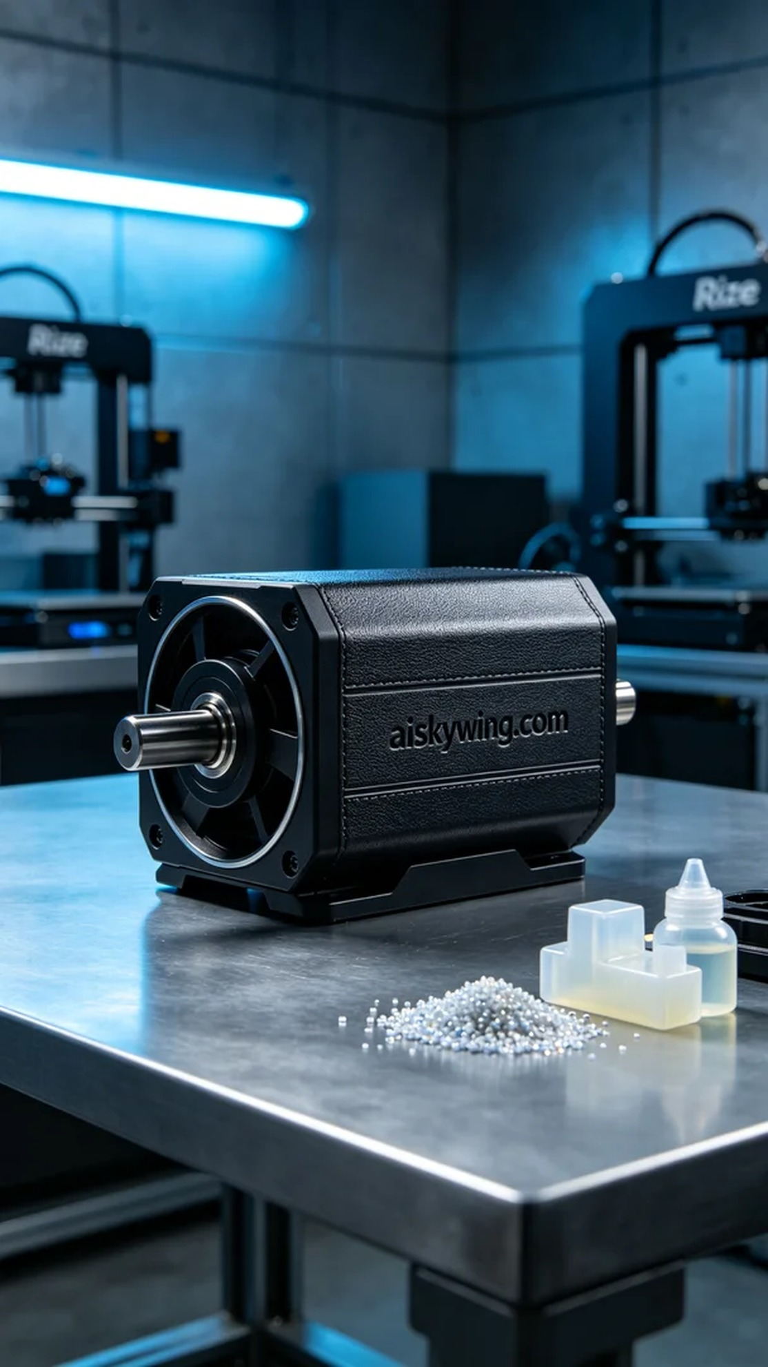
Someone reached out to us due to their urgent need for a high-quality speed controller housing. This project required precision and excellence, so we decided to utilize the Rize printer to ensure their needs were met.
The material we used was liquid photopolymer resin, which has excellent flow characteristics and fine surface treatment properties, making it ideal for printing complex components. In terms of equipment settings, we opted for a layer thickness of 0.1 mm, a printing temperature of 25°C, a power setting of 65%, and controlled the printing speed at 50 mm per hour, estimating a total printing time of approximately 8 hours.
During the printing process, the Rize printer's stability gave us a lot of confidence. The machine monitored quality in real-time, ensuring that each layer met our standards. Liquid photopolymer resin solidified layer by layer under UV light, and the entire process went smoothly with almost no defects.
After printing, we began the post-processing steps. First, we placed the formed housing into a cleaning solution to remove excess resin, followed by detailed sanding to make the surface smoother. Curing is an essential step to ensure the product achieves the best hardness and strength, and finally, we conducted strict inspections to ensure every detail was impeccable.
After a series of rigorous processes, the speed controller housing was successfully completed. Seeing the final product gave us great satisfaction, as it reflected not only our technical skills but also the hard work of our entire team.
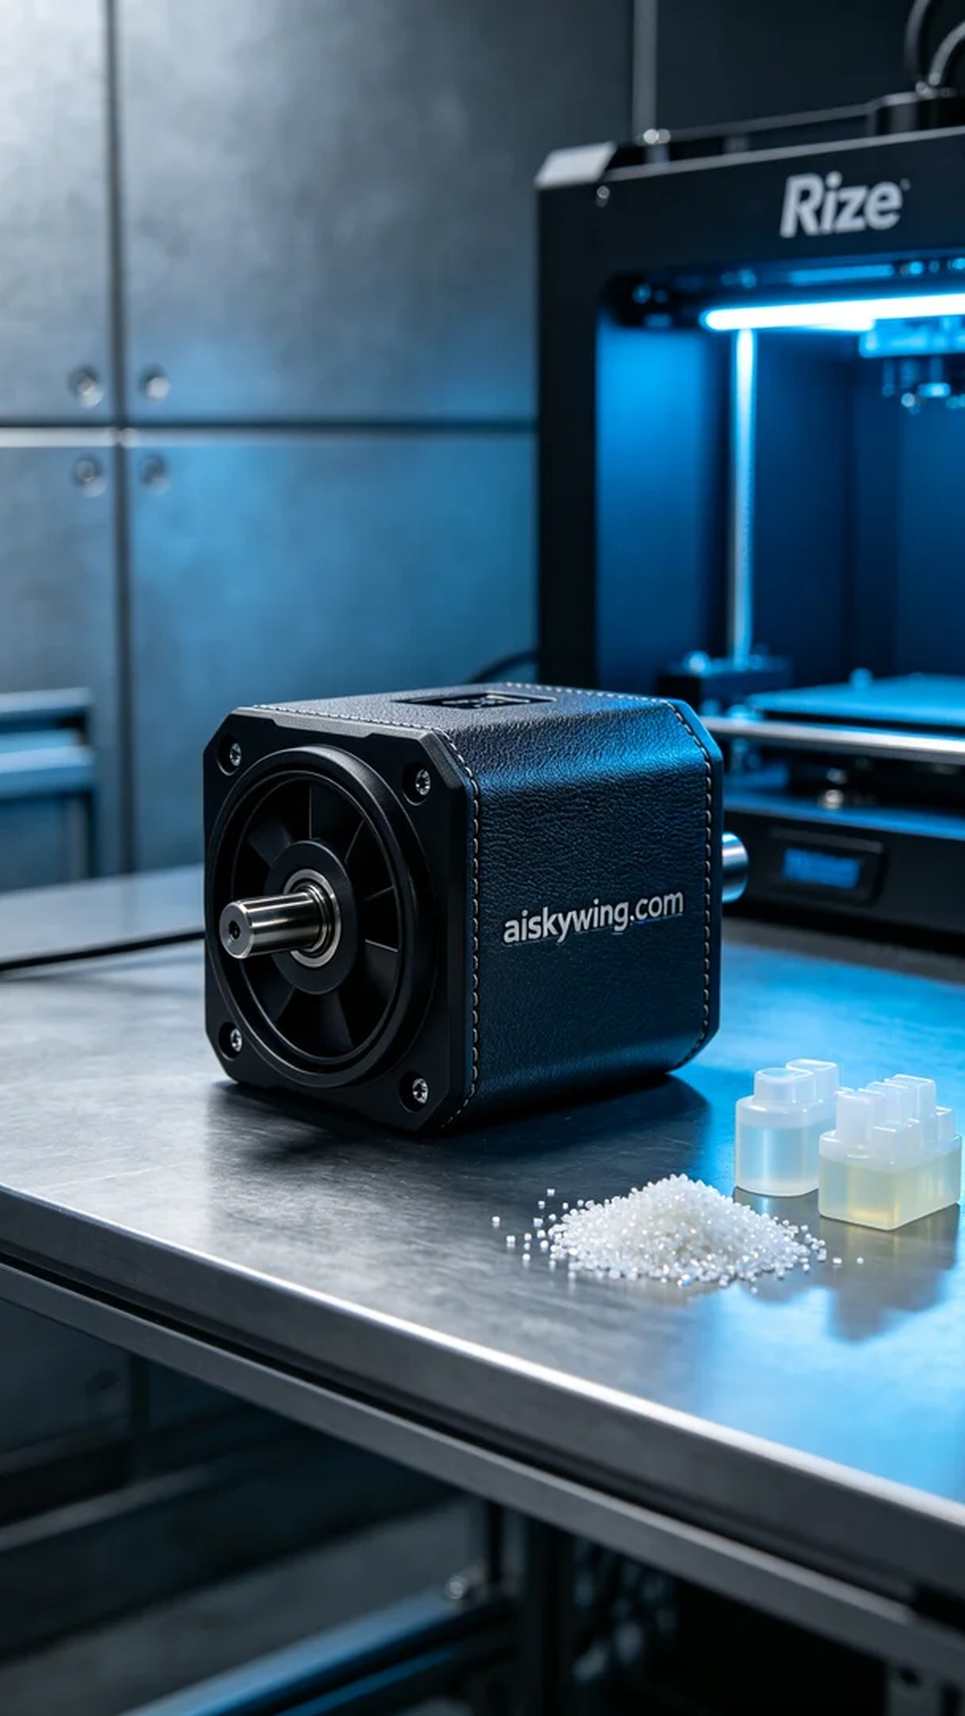
有人因为急需高质量的增速机外壳而找到了我们。这个项目要求精度高、质量好，而我们选择了Rize打印机进行3D打印，以确保满足他们的需求。
我们使用的原材料是液态光敏树脂，这种材料具有很好的流动性和细腻的表面处理特性，非常适合用于打印复杂的零部件。设备的参数设置方面，我们选择了0.1毫米的层厚，打印温度设定在25°C，功率为65%，打印速度控制在每小时50毫米，预计打印时间为8小时。
在打印过程中，Rize打印机的运行稳定性给我们带来了很大的信心。设备全程实时监控质量，确保每一层的打印效果都符合标准。打印过程中，液态光敏树脂在UV光的照射下逐层固化，整个过程非常顺畅，几乎没有出现任何缺陷。
打印完成后，我们开始了后处理工序。首先将成型的外壳放入清洗液中，清洗掉多余的树脂，随后进行细致的打磨，使表面更加平滑。固化处理是必不可少的一步，确保产品达到最佳的硬度和强度，最后经过严格的检验，确保每个细节都无可挑剔。
经过一系列严格的工艺流程，这个增速机外壳终于顺利完成。看到它的成品，心中倍感欣慰，这不仅是技术的体现，更是我们团队努力的结晶。
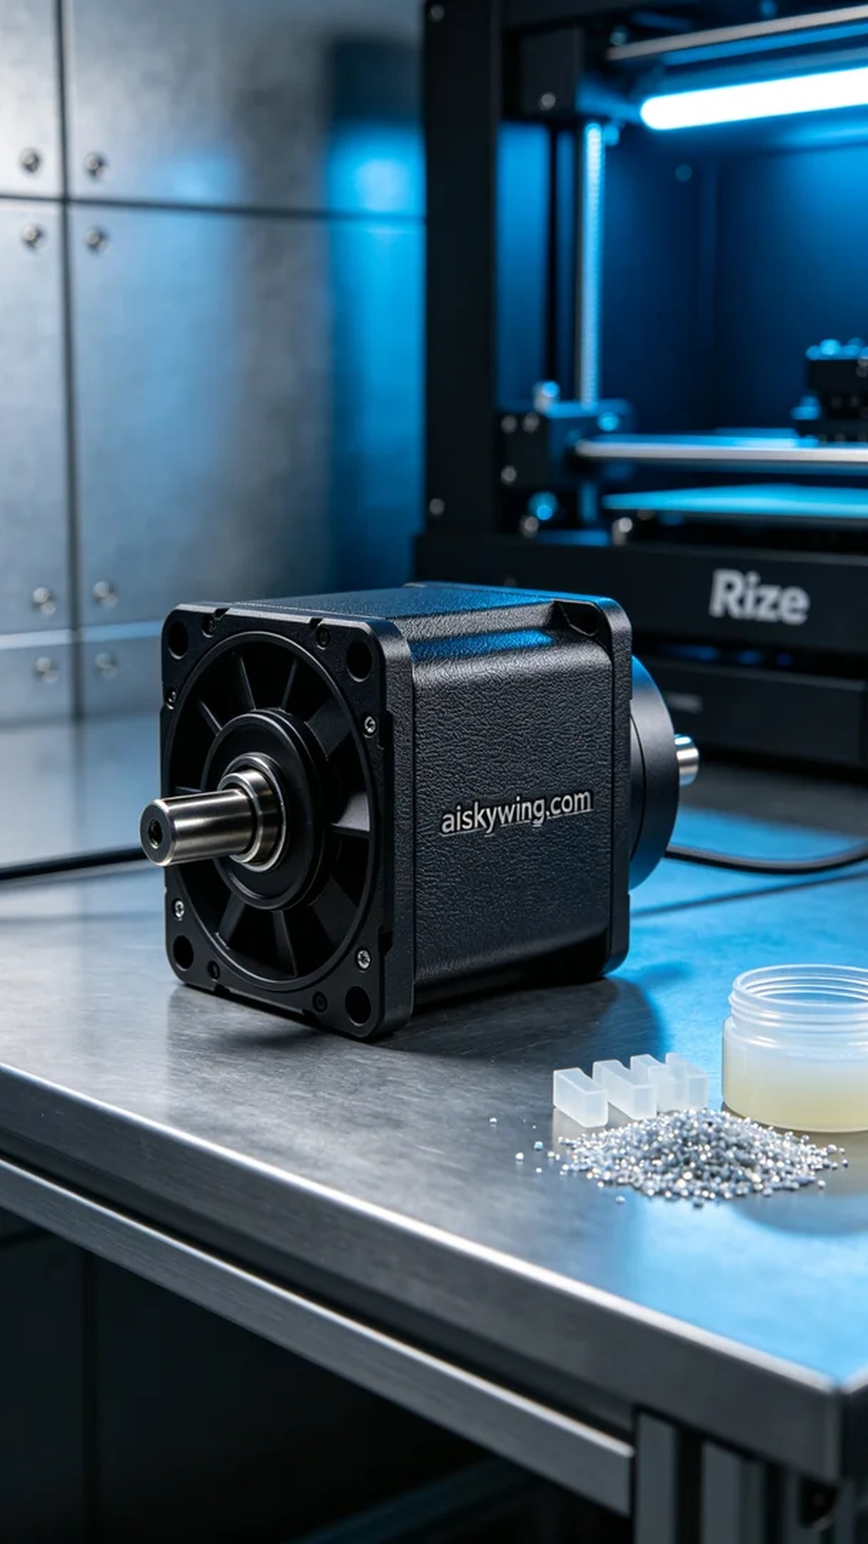
Aiskywing Industrial 3D Printing
Gearbox housing


