0821-备份模块外壳3D打印生产记录
Backup Module Shell
🖨️ SLM金属打印
🖥️ 打印机: EOS
📦 材料: 摆放着未成型的液态光敏
生活再难，也别停下脚步。就像接下这个备份模块外壳的单子，有人因为寻找高质量解决方案而找到我们，特别是在Instagram上看到我们的作品。
No matter how difficult life gets, don't stop moving forward. Just like when we took on this backup module shell project; someone found us while searching for high-quality solutions, especially after seeing our work on Instagram.
________________________________________________________________________________
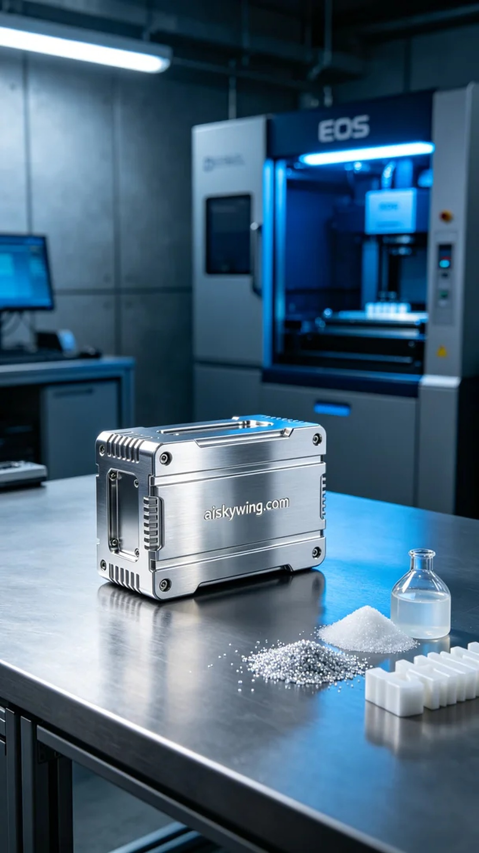
Life can be tough, but we shouldn't stop moving forward. Just like taking on the order for this backup module shell, someone found us while searching for high-quality solutions, especially after seeing our work on Instagram.
For this project, we chose unformed liquid photopolymer resin as the primary material and prepared to use the EOS brand 3D printer for SLM metal printing. To ensure exceptional printing quality, we set the following parameters: a layer thickness of 0.1mm, a printing temperature of 200°C, a laser power of 300W, and a printing speed of 50mm/s. These parameters were validated multiple times to ensure both quality and reduced post-processing effort.
During the printing process, the machine operated smoothly, and the entire process lasted about 8 hours. Throughout the print, we monitored the device's operational status to ensure that each layer met our expectations. We kept a close eye on the print temperature and environmental humidity to prevent any potential quality issues. The cooling system effectively controlled the printing temperature, ensuring proper material fusion.
Once printing was complete, we swiftly moved to the post-processing phase. First, we cleaned the unfinished resin using a solvent to ensure a smooth exterior; next, we sanded the surface with fine sandpaper to remove any irregular textures, enhancing both feel and visual appeal. Finally, the finished product was placed in a UV curing box to enhance its durability. After rigorous inspection, we found that the shell met all design requirements.
In the end, this backup module shell was successfully delivered to the person who needed it, thanks to the team's hard work. With meticulous processing, it not only performed exceptionally well but also achieved the desired high standard in appearance.
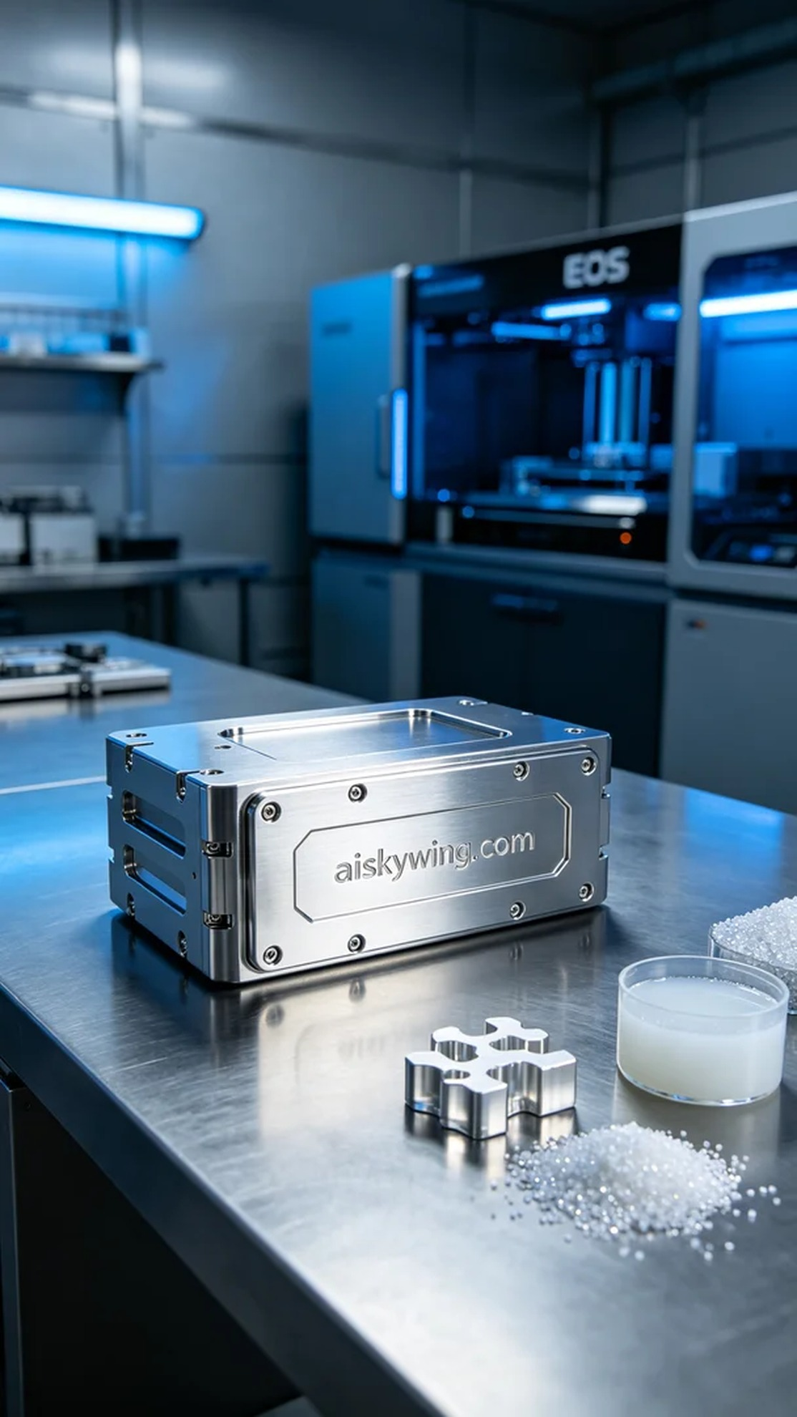
在社交媒体Instagram上，有人因为需要一个高精度、耐用的备份模块外壳而联系到我们。他们希望这款外壳能够展示出超凡的金属质感，同时也希望能够承受一定的工业环境。我们开始着手这个项目，目标明确，势在必得。
这次我们选用了未成型的液态光敏树脂作为主要材料，准备在EOS品牌的3D打印机上进行SLM金属打印。为了确保打印效果的优异，我们设定了以下参数：层厚0.1mm，打印温度为200°C，激光功率为300W，打印速度保持在50mm/s。这些参数经过我们的多次验证，能够确保打印质量并减少后续的加工难度。
打印过程中，机器运转良好，整个过程大约持续了8小时。在打印的同时，我们实时监控了设备的运行状态，确保每一层的打印都能达到预期的效果。我们随时注意到打印件的温度和环境湿度，确保防止任何潜在的质量问题。设备的冷却系统有效地控制了打印的温度，确保材料的充分融合。
完成打印后，我们迅速进入后处理阶段。首先，使用溶剂清洗掉未固化的树脂，确保外观光滑；接着用细砂纸进行打磨，去除表面的不规则纹理，提升手感和视觉效果。最后，将成品放入紫外线固化箱中固化，增强其耐用性。经过严格的检验，我们发现外壳的各项参数均符合设计要求。
最终，这个备份模块外壳在团队的努力下，成功交付给了需要它的人。经过精细的加工处理，它不仅具备了出色的性能，更是在外观上达到了预期的高标准。
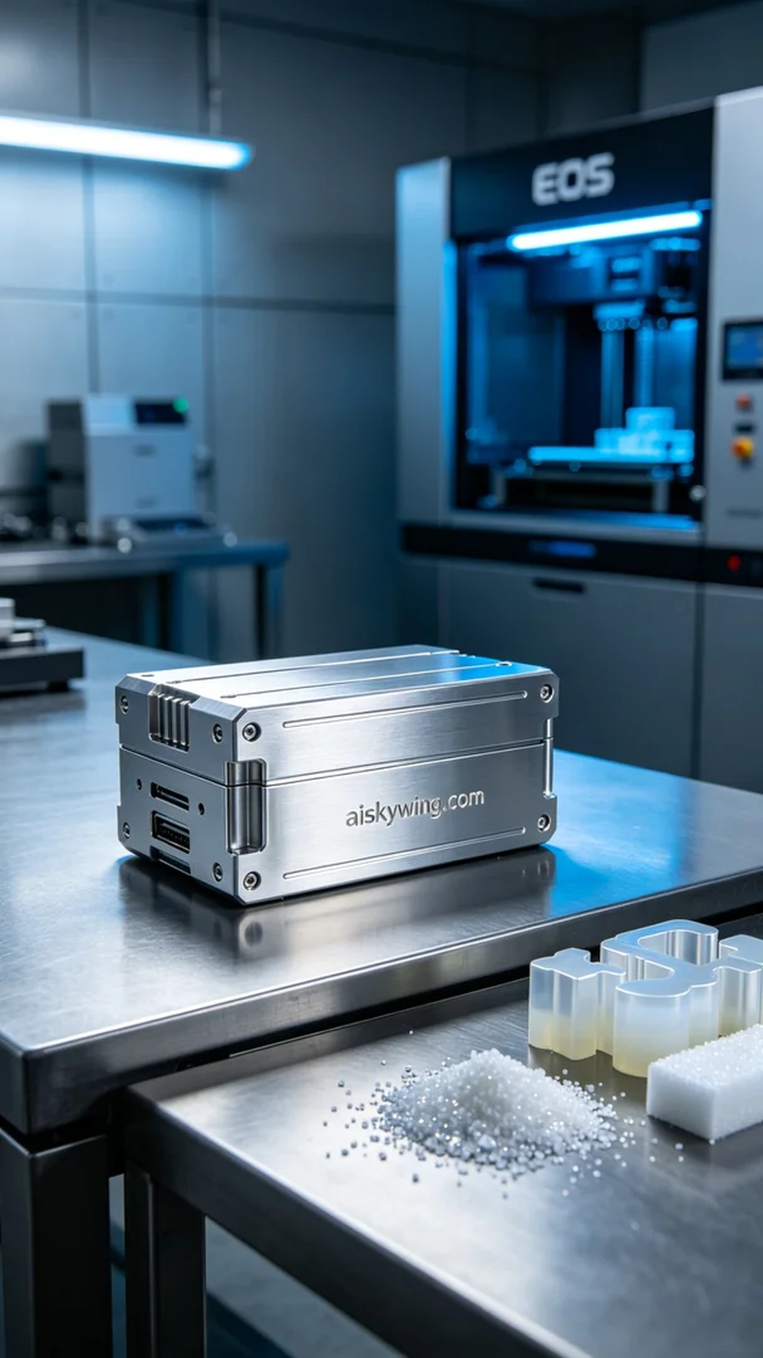
Aiskywing Industrial 3D Printing
Backup Module Shell


