0822-天窗导轨的3D打印生产记录
Sunroof guide rail
🖨️ CNC机加工
🖥️ 打印机: Rize
📦 材料: 高透明高耐温
生活再难，也别停下脚步。就像接下这个天窗导轨的单子，很多人在寻找更好的解决方案，我们也在努力前行。
No matter how difficult life gets, don't stop moving forward. Just like taking on this sunroof rail project, many are seeking better solutions, and we are also striving to move ahead.
________________________________________________________________________________
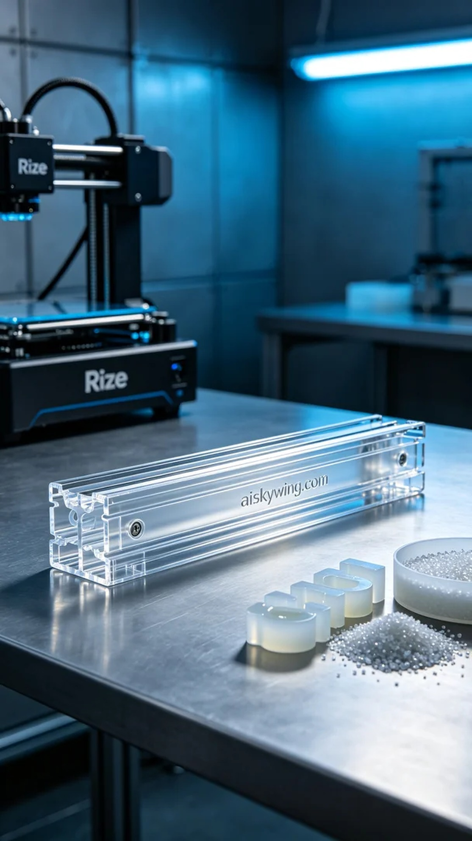
I came across someone on Instagram admiring our skylight rail, but behind that lies several technical challenges. People are looking for high-performance components, and we are working hard to meet those needs.
We selected high transparent and high-temperature resistant PC engineering plastic as the primary material. This material not only provides excellent light transmission but also withstands high temperatures, making it particularly suitable for industrial production. Next, I prepared the Rize printer and set the printing parameters: layer thickness at 0.1mm, printing temperature at 220°C, power at 60W, printing speed at 50mm/s, with an expected printing time of about 8 hours.
During the printing process, the Rize machine operated quite smoothly. We monitored the print quality in real-time to ensure every layer was precisely laid down. By observing the extrusion condition and the surface smoothness, we could promptly detect and adjust any potential issues to ensure the final result met our expectations.
After printing, post-processing is an essential step. First, we rinsed off the uncured resin with clean water, then hand-sanded the surface for a smoother finish. Next, we placed the skylight rail in a curing device, using UV light to solidify it and ensure material stability. Finally, after inspection, we confirmed that the skylight rail met all standard requirements, fully compliant with usage needs.
Everything went smoothly, and we successfully printed a high-quality skylight rail, ready to be delivered to those in need. Every detail was refined in this process, truly showcasing the charm of 3D printing.
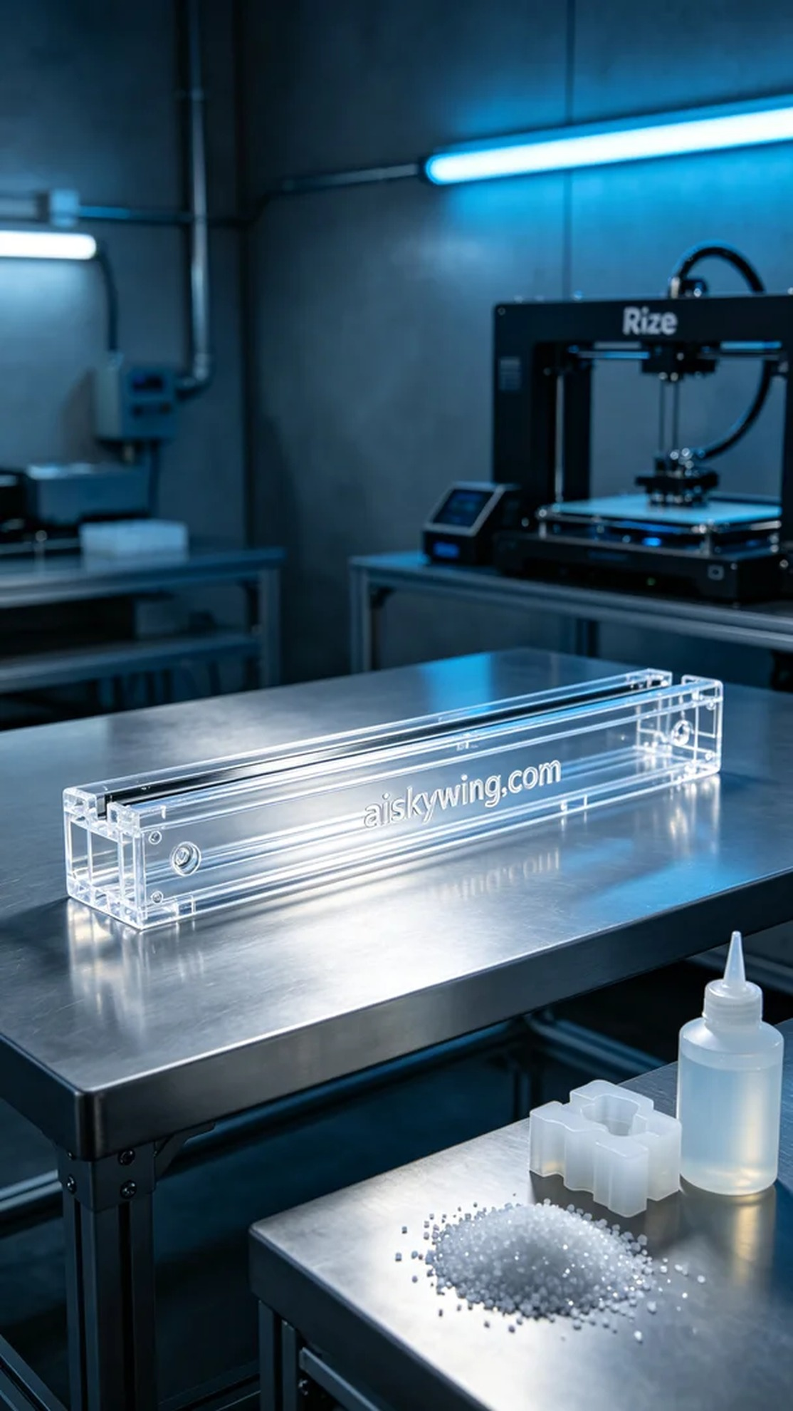
今天在Instagram上看到有人赞叹我们的天窗导轨，背后却藏着不少技术挑战。有人需要高性能的部件，而我们正是为了满足这样的需求而努力。
我们选择了高透明高耐温的PC透明工程塑料作为主要材料。这种材料不仅具备良好的透光性，还能承受高温，特别适合用于工业生产。接下来，我准备好Rize打印机，设定打印参数：层厚0.1mm，打印温度设定为220°C，功率60W，打印速度设定为50mm/s，预计打印时间大约在8小时左右。
打印过程中，Rize机器运行得相当顺利。我们实时监控打印质量，确保每层都精准无误。通过观察机头的挤出情况和表面光滑度，我们能够及时发现并调整任何可能出现的问题，确保最终效果如预期般完美。
完成打印后，后处理是不可或缺的一环。首先，我们用清水冲洗掉未固化的树脂，然后进行手工打磨，使其表面更加光滑。接着，我们将天窗导轨放入固化设备中，利用UV光源对其进行固化，确保材料性能稳定。最后，经过检验，我们确认天窗导轨的各项指标都达到了标准，完全符合使用要求。
一切顺利，最终我们成功打印出质量优良的天窗导轨，准备发给需要的人。每个细节都在这个过程中得到了淬炼，真正展现了3D打印的魅力。
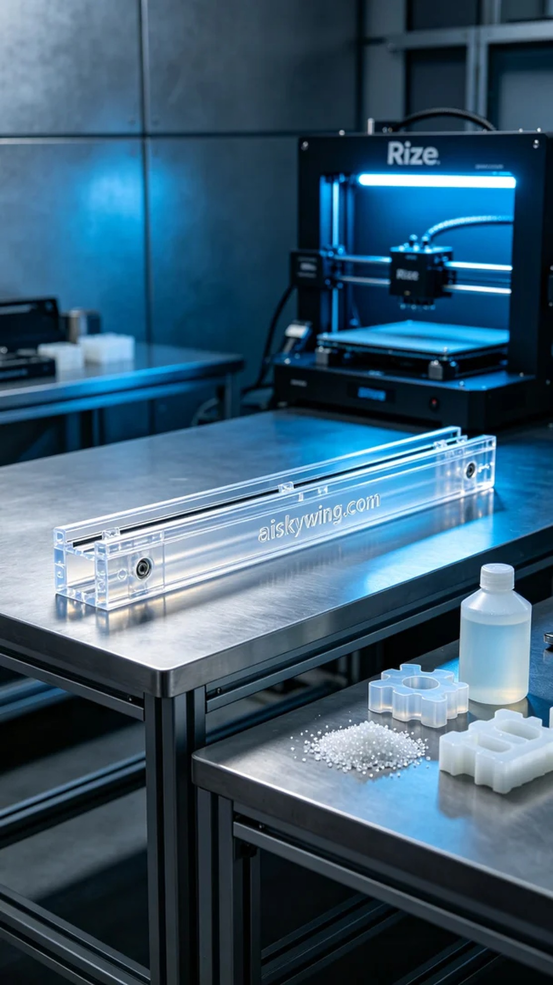
Aiskywing Industrial 3D Printing
Sunroof guide rail


