0823-安全带高度调节器3D打印记录
Seat belt height adjuster
🖨️ SLM金属打印
🖥️ 打印机: Rize
📦 材料: 摆放着未成型的液态光敏
生活的每一步都需要坚韧，就像在TikTok上看到的那个安全带高度调节器的制作过程，每一个细节都承载着我们的努力与坚持。
Every step in life requires resilience, just like the process of making the seatbelt height adjuster that I saw on TikTok, where every detail embodies our effort and perseverance.
________________________________________________________________________________
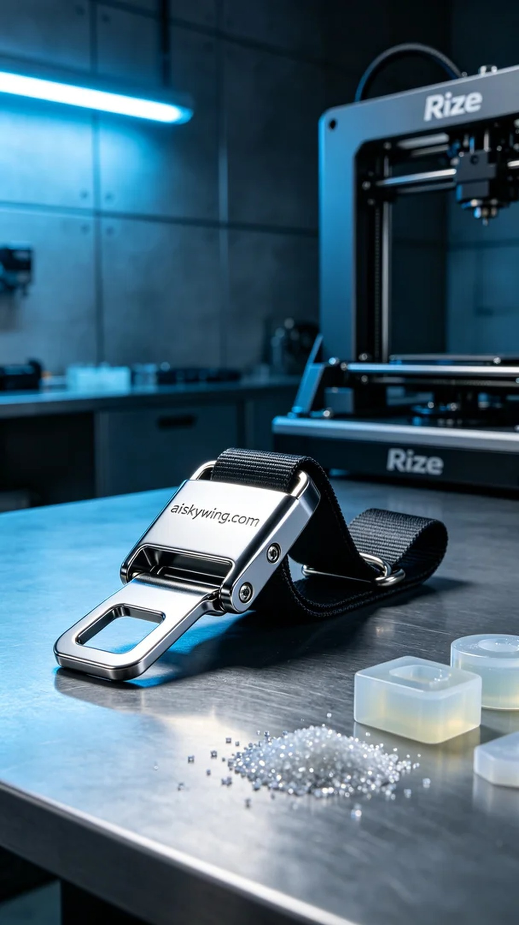
Every step in life requires perseverance, much like the process of creating the safety belt height adjuster seen on TikTok. Every detail reflects our efforts and dedication.
We used unformed liquid photopolymer resin as our raw material, which possesses excellent flowability and curing properties, perfect for complex structures. To ensure optimal printing results, we chose the Rize printer and set the parameters: layer thickness of 0.1 mm, temperature at 25 degrees Celsius, laser power of 200 mW, print speed of 50 mm/s, and an estimated print time of 4 hours.
During the printing process, the Rize printer operated steadily, with its quality monitoring system providing real-time feedback on the print status, ensuring that each layer was accurately placed. As the printing progressed, we observed the rich surface details emerge, with the engraved "aiskywing.com" clearly visible, creating an exciting moment.
After printing, the post-processing steps were equally crucial. We first performed a cleaning process to thoroughly remove any uncured liquid photopolymer resin. Then, we used fine sandpaper to polish the surface for smoothness. Finally, we conducted UV exposure to cure the product, enhancing its strength and durability. Each step was rigorously inspected to ensure a flawless final product.
After a series of meticulous processes, the safety belt height adjuster finally came into view. This result not only represents our pursuit of technology but also our commitment to user safety.
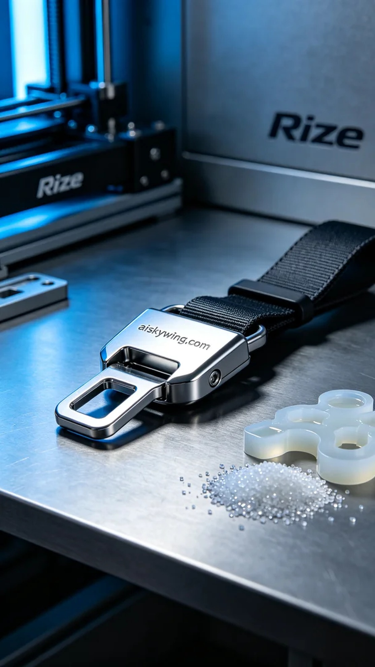
在TikTok上，有人因为寻求更安全的驾驶体验，找上了我们，希望能制作出一款安全带高度调节器。这款产品不仅仅具有实用性，还体现了我们在3D打印领域的专业技术。
我们使用的原材料是未成型的液态光敏树脂，具有优良的流动性和固化性能，适合复杂结构的打印。为了确保打印效果，我们选择了Rize打印机，设置了打印参数：层厚0.1毫米，温度为25度，激光功率200毫瓦，打印速度50毫米每秒，预计打印时间为4小时。
打印过程中，Rize打印机运行稳定，设备的质量监控系统实时反馈打印状态，确保每一层都精准到位。随着打印的进行，观察到表面细节丰富，雕刻的“aiskywing.com”字样逐渐显现，这一时刻令人振奋。
打印完成后，后处理工序同样重要。我们首先进行了清洗，将未固化的液态光敏树脂彻底清除。然后，使用精细砂纸打磨表面，确保光滑。最后，经过UV灯照射进行固化，增强了产品的强度和耐用性。每一步都经过严格检验，确保最终产品完美无瑕。
经过一系列的精细工序，安全带高度调节器终于呈现在眼前。这样的成果，不仅是对技术的追求，更是对用户安全的承诺。
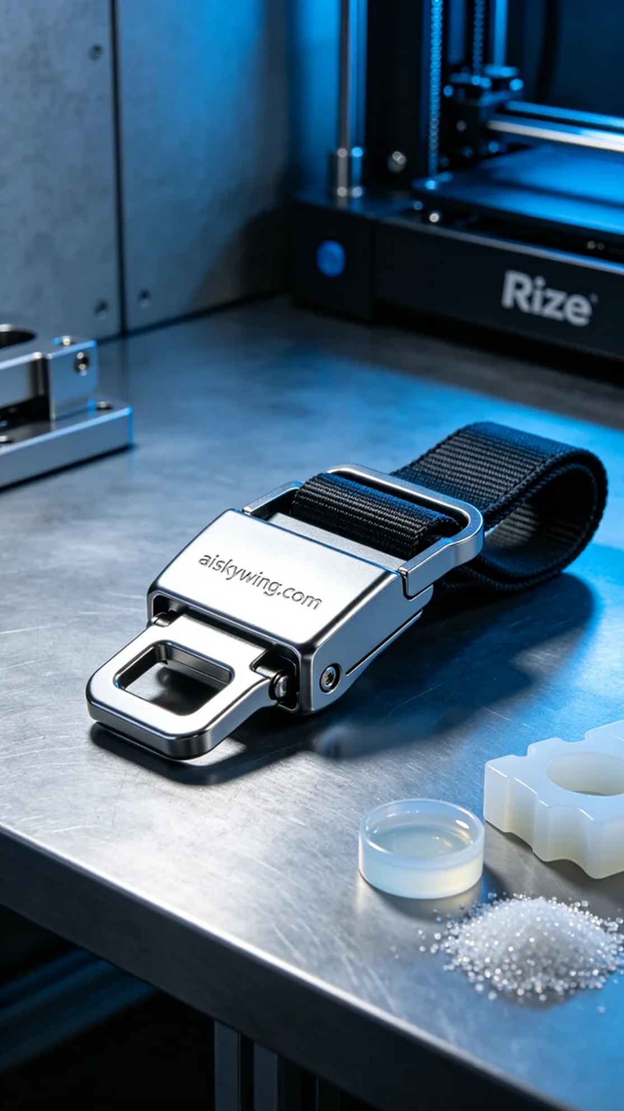
Aiskywing Industrial 3D Printing
Seat belt height adjuster


