0824-导航仪支架的3D打印生产记录
Navigation device bracket
🖨️ CNC机加工
🖥️ 打印机: EOS
📦 材料: 高透明高耐温
生活再难，也别停下脚步。就像做这个导航仪支架一样，有人因为想要提升驾驶体验而找上我们，依赖我们精湛的3D打印技术解决问题。
No matter how difficult life gets, don't stop moving forward. Just like with this navigation device holder, some people come to us because they want to enhance their driving experience, relying on our exquisite 3D printing technology to solve their problems.
________________________________________________________________________________
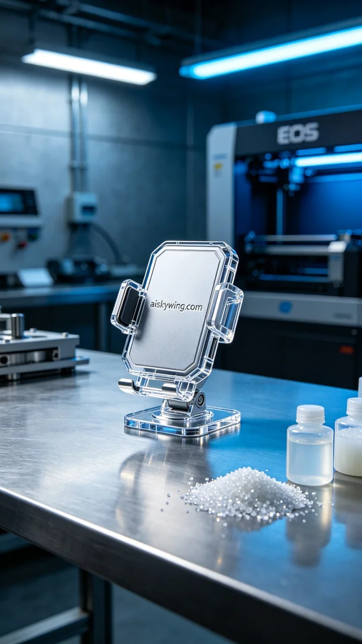
On YouTube, there are people seeking stable solutions for their navigation device mounts. To enhance driving safety, they approached us, hoping to provide a durable and aesthetic mount, and we decided to produce it using high transparent and high-temperature resistant materials.
For materials, we chose high transparent and high-temperature PC engineering plastic. This material not only offers excellent light transmission but also withstands high temperatures, making it ideal for the production of navigation device mounts. We prepared the EOS brand 3D printer and meticulously set the printing parameters: layer thickness of 0.1mm, printing temperature maintained at 200°C, power set at 60%, and print speed controlled at 30mm/s, with the entire printing process expected to take about 3 hours.
During the printing process, the EOS printer operated steadily and efficiently, and the entire process went smoothly. We monitored the equipment in real time to ensure every detail of the printing process met our quality standards. As layers of material built up, the shape of the navigation device mount gradually emerged, creating much anticipation.
After printing, the post-processing steps became a crucial phase. First, we placed the printed mount into the cleaning tank, using specialized cleaning solutions to remove any residual resin on the surface. After cleaning, we proceeded to sanding, using fine sandpaper to smooth the mount’s surface. Finally, we placed the mount in the curing device for hardening, enhancing its strength and temperature resistance, and after quality inspection confirmed its compliance, the production process was complete.
In the end, the navigation device mount was successfully produced, with stable quality and beautiful appearance, bringing immense joy. Through this effort, we not only completed the task but also provided users with a safer driving experience.
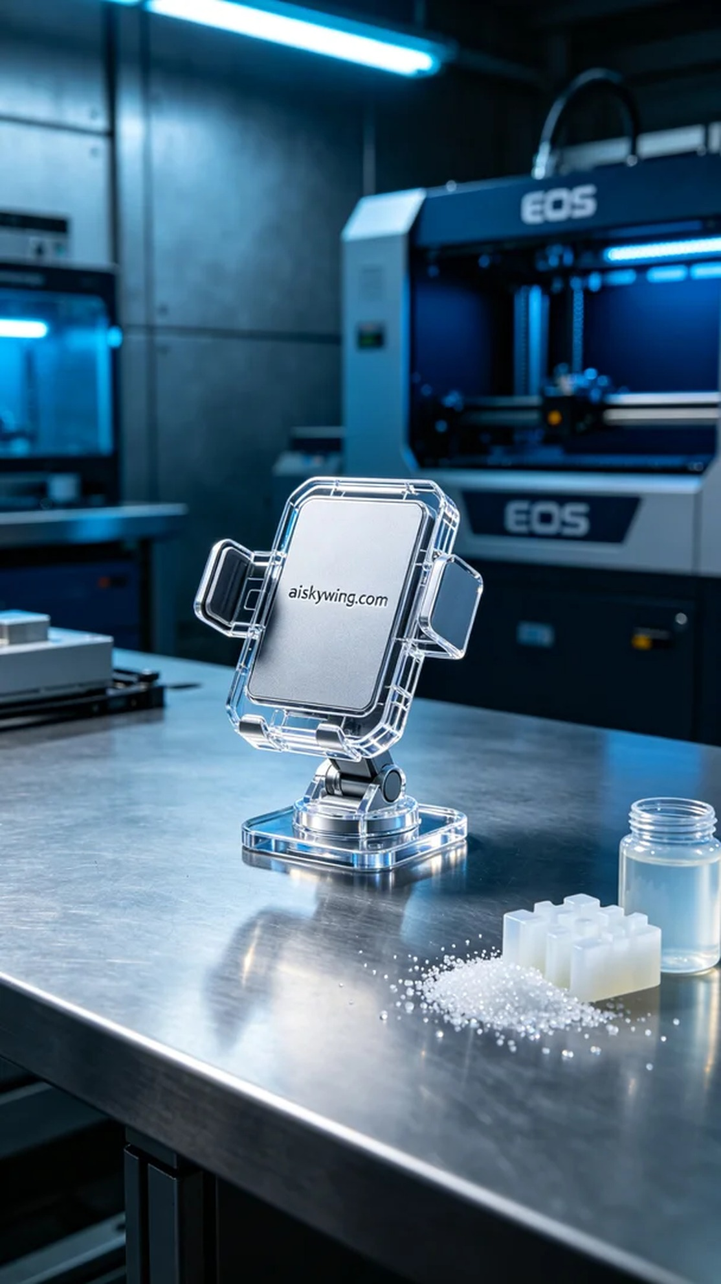
在YouTube上，有人因为导航仪支架的稳定性问题而找上我们。为了提升驾驶安全，他们希望我们能提供一个既耐用又美观的支架，最终我们决定采用高透明高耐温的材料进行生产。
原材料选择上，我们使用了高透明高耐温的PC透明工程塑料，这种材料不仅透光性好，还能承受较高的温度，非常适合用于导航仪支架的生产。为了确保打印的质量，我们准备了EOS品牌的3D打印机，并对打印参数进行了详细设置：层厚0.1mm，打印温度保持在200°C，功率设定为60%，打印速度控制在30mm/s，预计整个打印过程大约需要3小时。
打印过程中，EOS打印机稳定而高效地运转着，整个流程非常顺利。我们对设备进行了实时监控，确保证打印过程中的每一个细节都达到我们的质量标准。随着层层材料的堆积，导航仪支架的形态逐渐显现，令人十分期待。
打印完成后，后处理工序成为了关键环节。首先，我们将打印好的支架放入清洗槽中，使用专用的清洗剂去除表面残留的树脂。清洗完成后，接下来是打磨，我们用细砂纸对支架进行打磨，确保表面光滑。最后，我们将支架放在固化设备中进行固化处理，以增强其强度和耐温性，经过检验确认品质合格后，生产流程才算结束。
最终，导航仪支架如期出炉，经过精心的打印与处理，质量稳定，外观精美，让人无比欣喜。通过这样的努力，我们不仅完成了任务，更为用户带来了安全的驾驶体验。
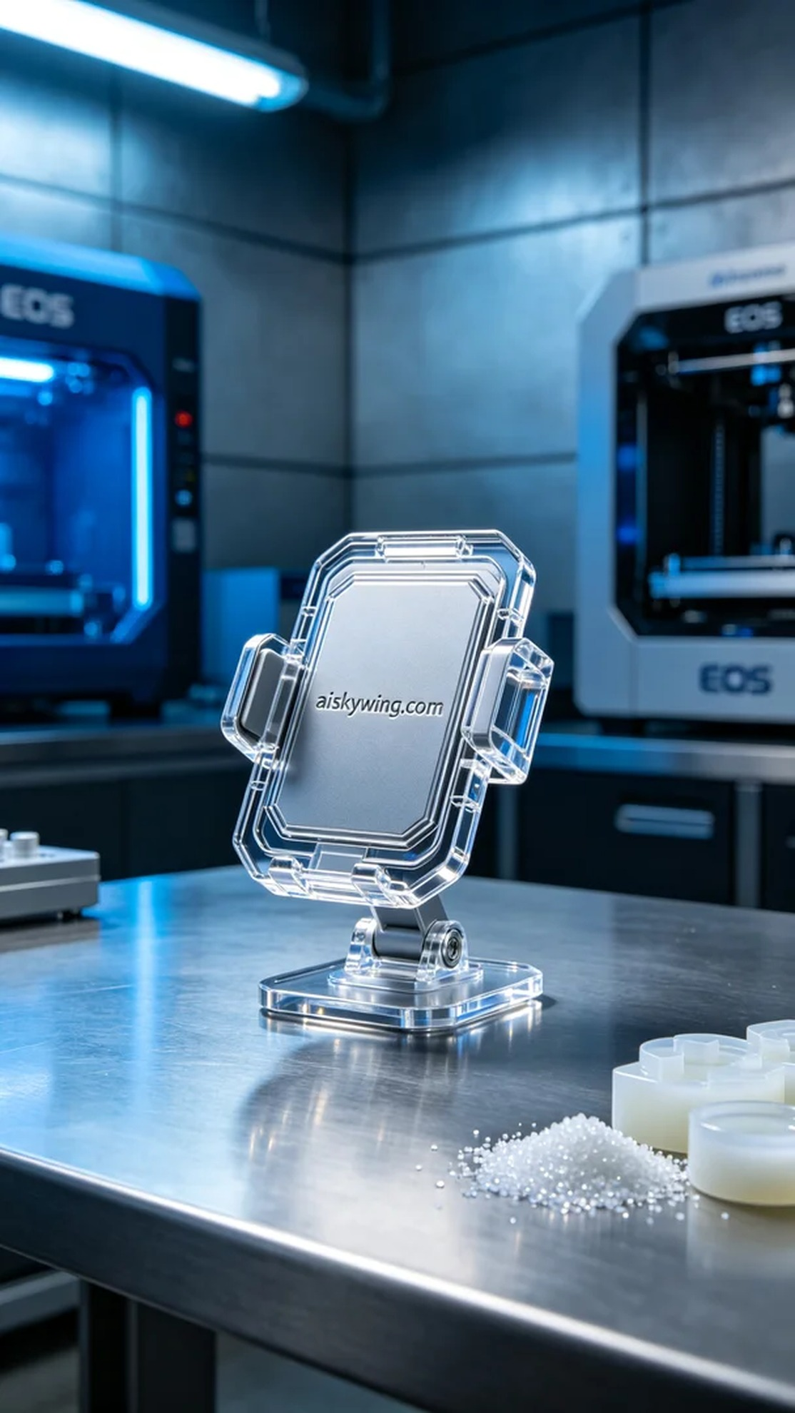
Aiskywing Industrial 3D Printing
Navigation device bracket


