0825-导轨生产过程记录
Rail
🖨️ CNC机加工
🖥️ 打印机: HP
📦 材料: 高透明高耐温
生活就像3D打印，有时候需要坚持和精细。最近，有人在TikTok上看到我们的导轨，找我们讨论如何实现他们的想法。
Life is like 3D printing; sometimes it requires persistence and precision. Recently, someone saw our rails on TikTok and reached out to us to discuss how to bring their ideas to life.
________________________________________________________________________________
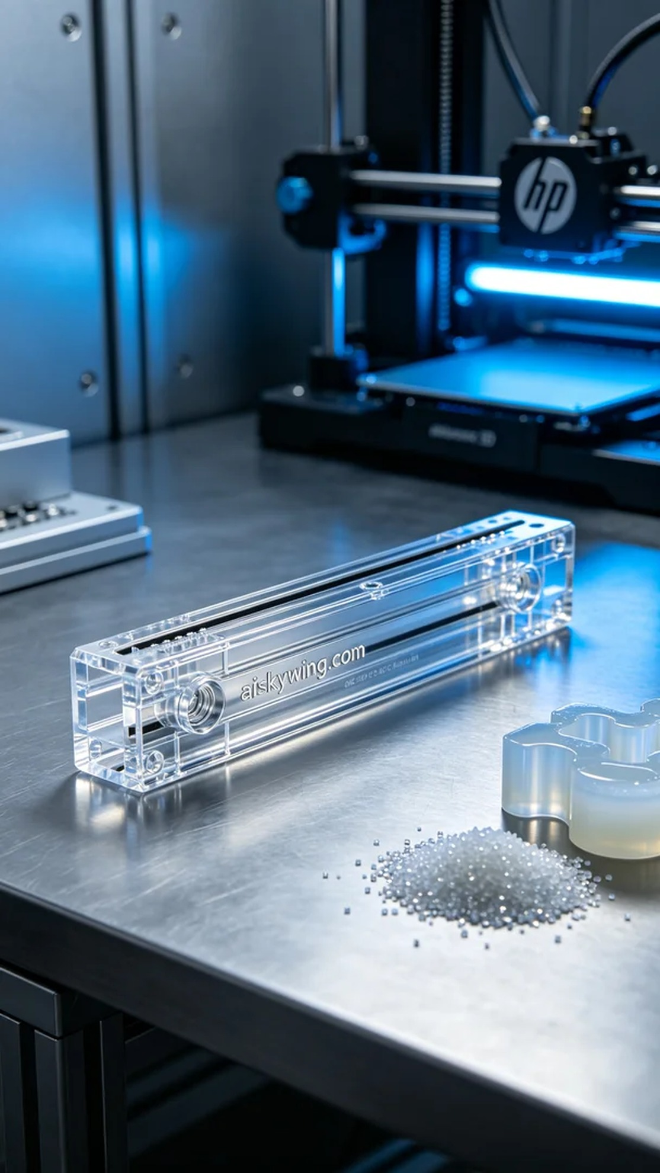
Life is like 3D printing; sometimes it requires persistence and precision. Recently, someone reached out to us after seeing our rail on TikTok, seeking advice on how to bring their vision to life.
To meet their needs, we chose high transparency and high-temperature resistant PC engineering plastic as our raw material. This material not only offers excellent clarity but also withstands high temperatures, making it suitable for CNC machining and 3D printing. The HP 3D printer we used allows us to fully utilize the benefits of this material. We set the printing parameters to a layer thickness of 0.1mm, printing temperature at 220℃, power at 60%, and printing speed at 30mm/s to ensure clear and precise results.
During the printing process, the HP printer ran smoothly, and we monitored everything closely. We conducted regular quality checks to ensure every detail of the rail met our standards. As the printing progressed, the shape of the rail emerged, reflecting the cool industrial light—truly gratifying.
After printing, we proceeded with post-processing. First, we used specialized equipment to clean the printed piece, removing excess resin. Next, we meticulously sanded it down to ensure a smooth surface. Finally, the rail underwent curing to enhance its durability. Each step was critical, and the final inspection ensured that every rail met our quality standards, showcasing our attention to detail.
In the end, the rail stood before us like a work of art, fulfilling both functional and aesthetic requirements. Seeing the exquisite finished product fuels our motivation for each project we undertake.
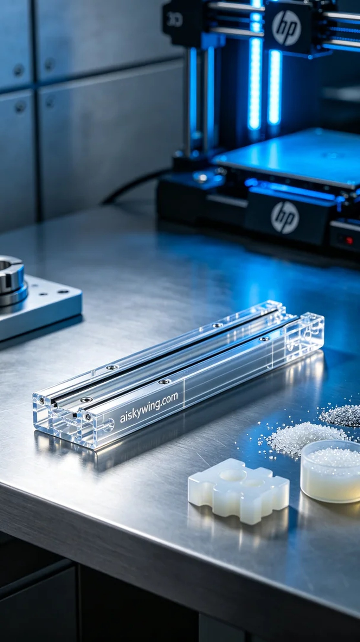
导轨在画面中稳稳地摆放，正是有人在TikTok看到我们之前的作品后，向我们寻求帮助。他们想制作一款高透明高耐温的导轨，能够在工业环境中优雅地展现其功能与美感。
为了实现这个目标，我们选择了高透明高耐温的PC透明工程塑料作为原材料。这种材料不仅透明度高，而且具有良好的耐高温性能，适合CNC加工和3D打印。我们使用的HP 3D打印机能够充分发挥这种材料的优势。在打印参数方面，我们设定了层厚为0.1mm，打印温度保持在220℃，功率设置为60%，打印速度为30mm/s。这些设置确保了打印效果的清晰和精确。
在打印过程中，HP打印机的运行平稳，整个过程都在我们的监控下进行。我们定期检查打印质量，确保导轨的每个细节都符合要求。随着打印逐渐深入，导轨的形状逐步显现，反射着冷峻的工业光线，令人欣喜。
打印完成后，我们进行了后处理工序。首先，使用专用设备清洗打印件，去除多余的树脂。接着，进行细致的打磨，确保表面光滑。最后，导轨需经过固化处理，以增强其耐用性。每一步都至关重要，最终的检验确保了每个导轨都达到我们的标准，细致入微。
最后，这款导轨如同艺术品般展现在我们面前，既满足了功能需求，又展现了高透明度的美感。每次看到精致的成品，都是我们工作的动力源泉。
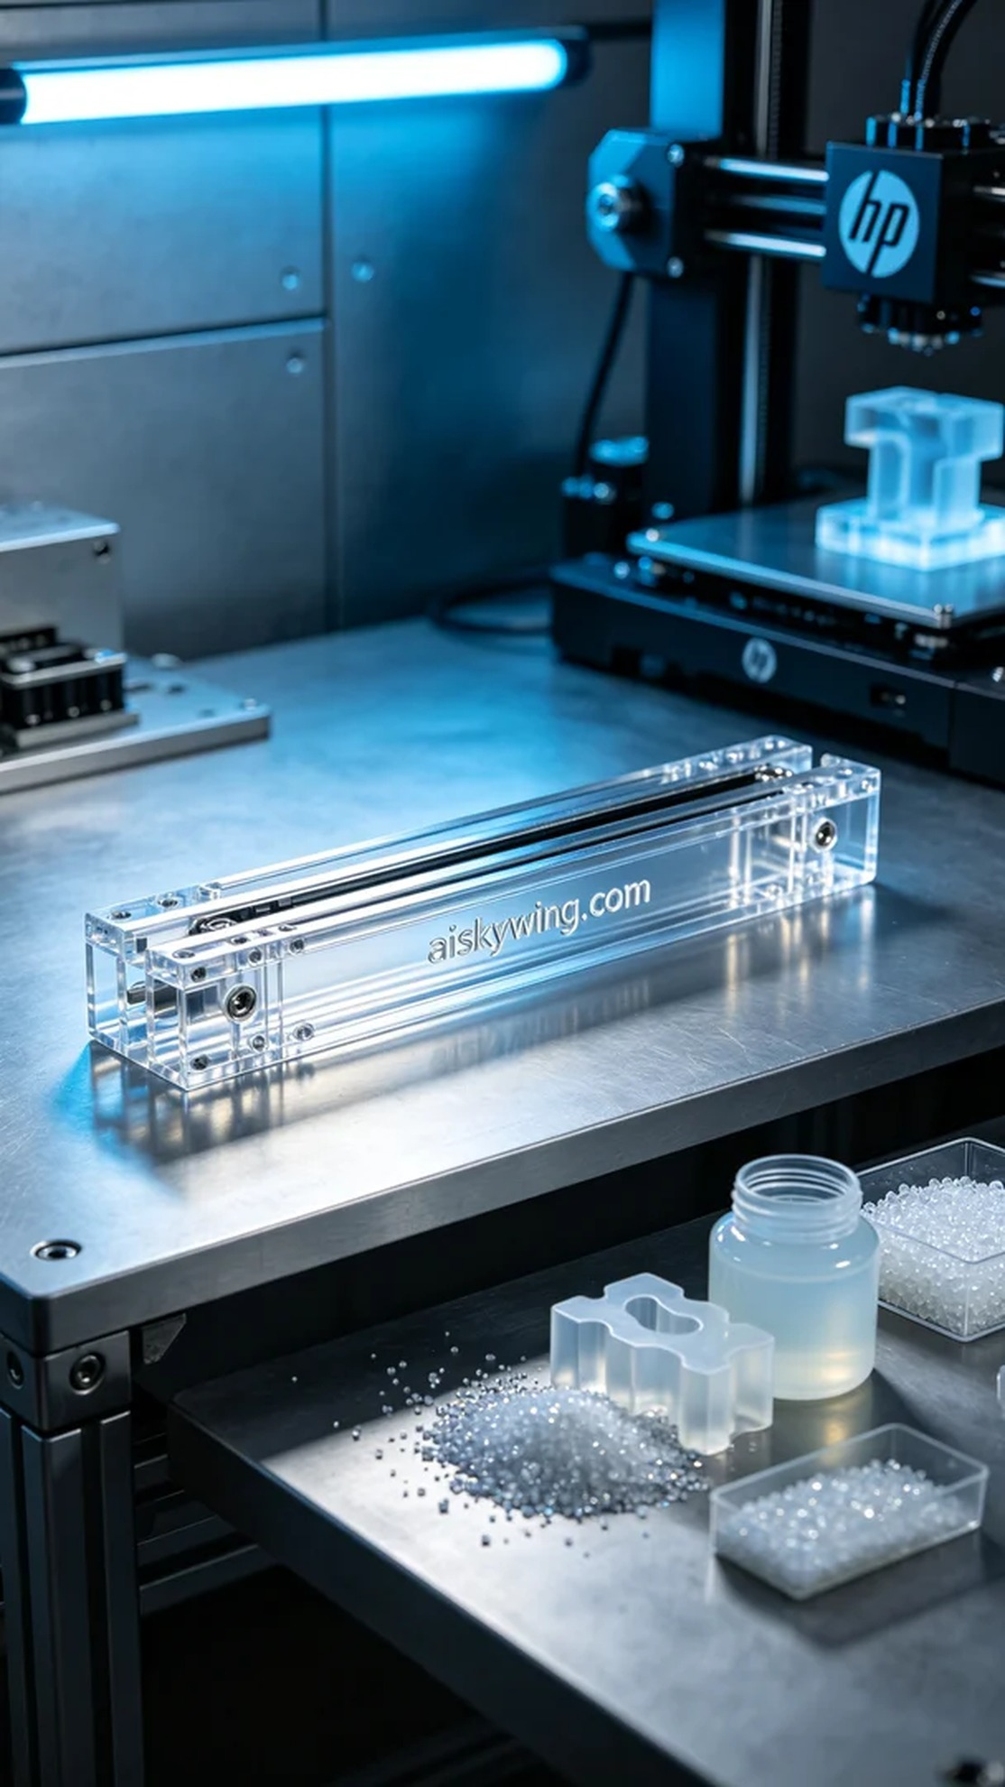
Aiskywing Industrial 3D Printing
Rail


