0827-导轨滑块的3D打印记录
Guide rail slider
🖨️ CNC机加工
🖥️ 打印机: EOS
📦 材料: 摆放着未成型的液态光敏
在Facebook上，有人找我们解决一个难题。接下这个导轨滑块的活，让我再次体会到坚持与专业的重要性。
On Facebook, someone approached us to solve a challenging problem. Taking on the task of this rail slider allowed me to once again appreciate the importance of persistence and professionalism.
________________________________________________________________________________
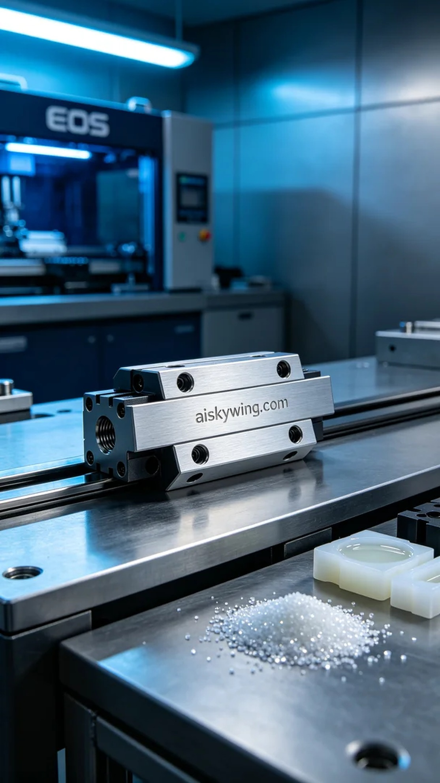
After someone reached out on Facebook with a request for a guide rail slider, we embraced the challenge, reminding ourselves of the importance of persistence and professionalism.
To meet the demand for the guide rail slider, we opted for a combination of CNC five-axis machining and 3D printing. The requirement was clear: the product needed to perform well in an industrial environment, combining precision with durability. After discussions, we decided to use unformed liquid photopolymer resin to ensure a fine surface finish and excellent mechanical properties.
In the preparation phase, we selected the EOS brand 3D printer, known for its high precision and stability. The print parameters were finely adjusted: layer thickness set to 0.05 mm, temperature at 25 degrees Celsius, power ranging from 50% to 60%, and print speed kept at 40 mm per second. The entire printing process was expected to take around six hours, ensuring that each component would meet optimal standards.
During the printing process, the EOS printer operated smoothly, as the liquid photopolymer resin solidified layer by layer under UV light. I maintained constant quality monitoring of the machine to ensure perfect layer adhesion and clarity, while also being cautious to avoid bubbles and impurities, guaranteeing the final product's quality.
Once printing was complete, we entered the post-processing stage. First, we cleaned off any uncured resin using specialized solvents, meticulously addressing every detail to ensure no residue remained. Next, we sanded the surface to achieve a smoother finish, standardizing the treatment. Following this, the product was placed in a curing chamber for thorough solidification, ensuring its strength and durability. Finally, we conducted stringent quality inspections to ensure every guide rail slider met our standards.
Through this project, we not only successfully produced the guide rail slider but also rekindled the realization of the power of professionalism and persistence. Every step paved the way for a better future.
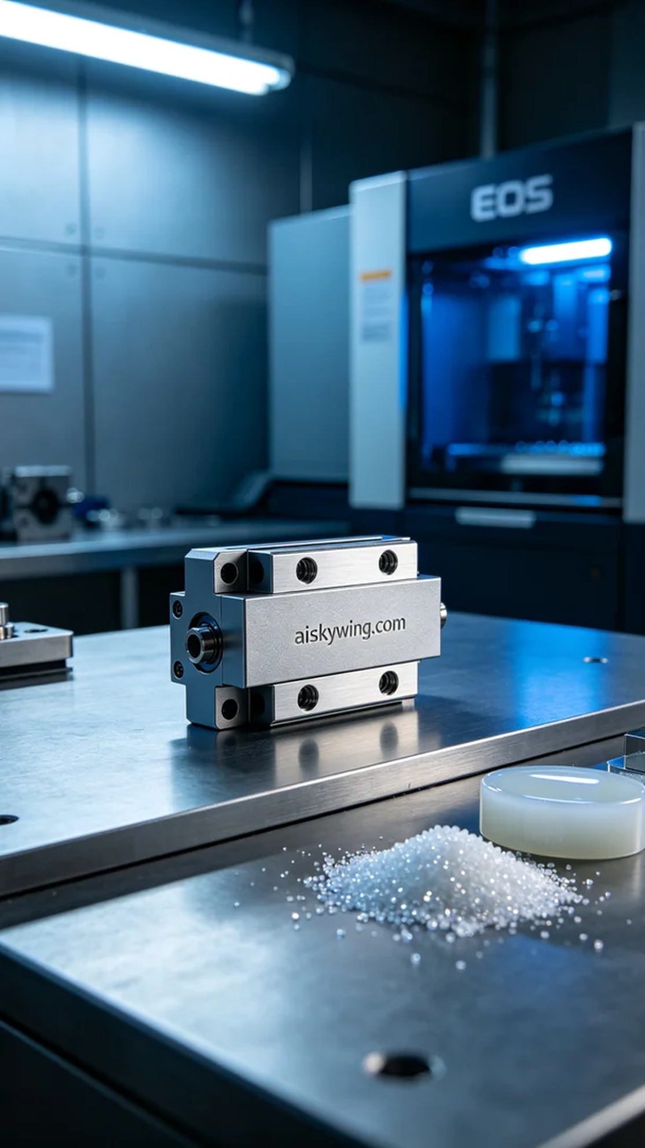
为了满足有人对导轨滑块的需求，我们决定采用CNC五轴加工与3D打印相结合的工艺。客户希望产品在工业环境中表现出色，既要精密又要耐用。经过讨论，我们决定使用未成型的液态光敏树脂，以确保细腻的表面和优秀的机械性能。
在准备阶段，我们选择了EOS品牌的3D打印机，这款设备以其高精度和稳定性而闻名。打印参数设定也进行了精细调整：层厚为0.05毫米，温度设定在25摄氏度，功率控制在50%至60%之间，打印速度保持在40毫米每秒。整个打印过程预计耗时约6小时，确保每一部件都能达到最佳效果。
打印过程中，EOS打印机稳稳地运转，液态光敏树脂在紫外光照射下逐层固化。我时刻保持对设备的质量监控，确保每层的附着力和清晰度无误，过程中也需注意避免气泡和杂质的产生，以保证最终的成品质量。
打印完成后，我们进入后处理阶段。首先，清洗掉未固化的树脂，使用专用清洗剂仔细清理每个细节，确保无残留。接着，我们对表面进行了打磨，使其更加光滑，并统一了表面处理。随后，将产品放入固化室进行充分的固化，确保其强度与耐久性。最后，进行严格的质量检验，确保每个导轨滑块都达到标准。
通过这次项目，我们不仅成功制作了导轨滑块，也重新认知到了专业与坚持的力量。每一步都在为更好的未来铺路。
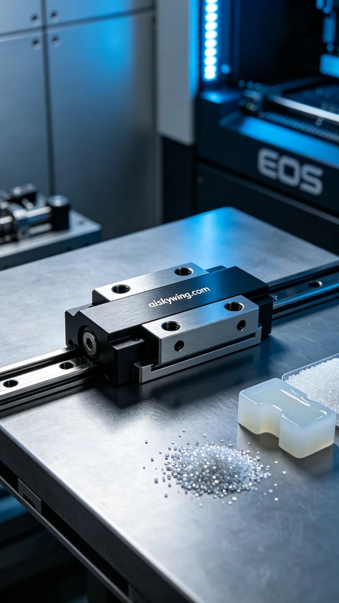
Aiskywing Industrial 3D Printing
Guide rail slider


