0828-尾灯装饰框3D打印生产记录
Tail Light Trim Frame
🖨️ CNC机加工
🖥️ 打印机: Mimaki
📦 材料: 摆放着未成型的液态光敏
在生活的每一个制造瞬间，我们都在追求完美。就像有人在Facebook上找到我们，希望制作一个尾灯装饰框...
In every moment of creation in life, we are pursuing perfection. Just like someone found us on Facebook, hoping to create a tail light decorative frame...
________________________________________________________________________________
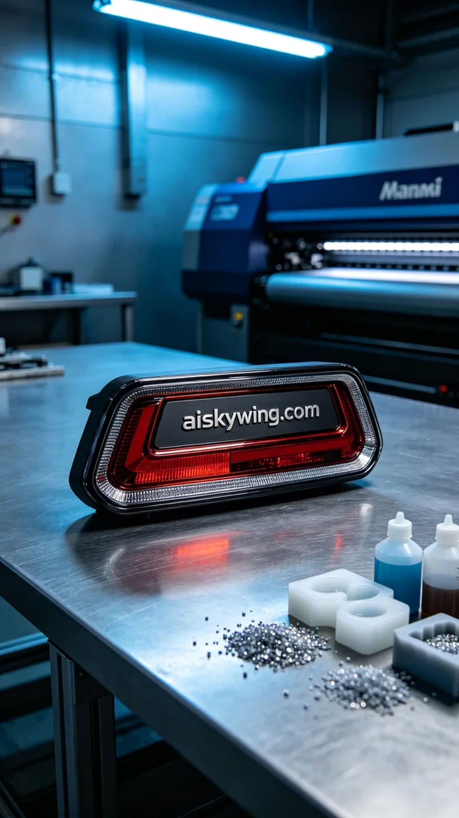
Someone reached out to us via Facebook, inquiring about how to create a high-quality tail light decoration frame. They wanted this product not only to be aesthetically pleasing but also to have exceptional precision and durability, which is exactly our specialty.
We chose unformed liquid photo-curable resin as the raw material, known for its high fluidity and excellent forming properties. To ensure the printing effect, we used a Mimaki 3D printer, setting the printing parameters to a layer thickness of 0.05mm, a temperature of 25°C, a power of 100%, and a printing speed of 60mm per second, which took approximately 6 hours to complete the printing task.
During the printing process, the machine operated smoothly, with the liquid photo-curable resin flowing evenly, ensuring the details and surface smoothness of the product. We regularly monitored the print quality to ensure each layer cured precisely, avoiding any defects and striving for perfection in every detail.
After printing, we conducted a series of post-processing steps. First, we thoroughly cleaned the tail light decoration frame using a cleaning agent to remove any excess resin residue. Next, we sanded the surface with fine sandpaper to achieve a smoother finish. Finally, we placed the product in a UV curing box to enhance its stability and durability in actual use, followed by a quality inspection to ensure every detail met the standards.
After a rigorous production process, this tail light decoration frame was successfully completed, presenting a satisfying result that is both elegant and durable, meeting the expectations of those who requested it.
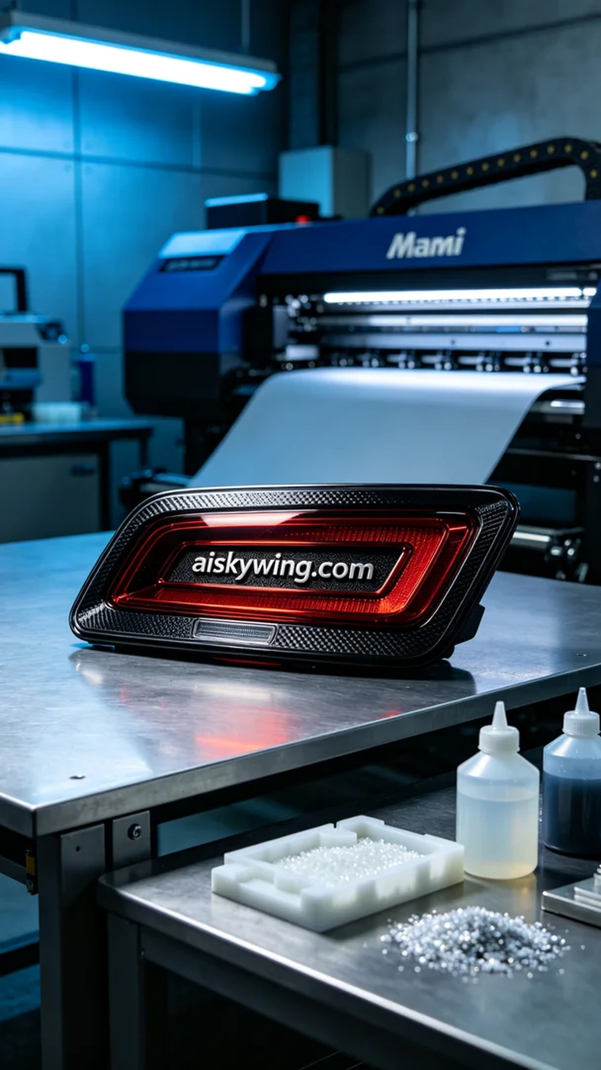
有人在Facebook上联系了我们，询问如何制作一款高品质的尾灯装饰框。他们希望这件产品不仅要美观，还要具备极高的精度和耐用性，正好是我们这边的强项。
我们选择了未成型的液态光敏树脂作为原材料，这种材料的优点在于其高流动性和优异的成型性能。为了确保打印效果，我们使用Mimaki品牌的3D打印机，调整打印参数为层厚0.05毫米，温度设定在25℃，功率100%，打印速度为60毫米每秒，这样大约需要6小时才能完成打印任务。
打印过程中机器运转平稳，液态光敏树脂均匀流动，保障了产品的细节和表面光滑度。我们定期监控打印质量，确保每一层的固化精准无误，避免出现任何瑕疵，努力做到每个细节都完美呈现。
完成打印后，我们进行了一系列后处理工序。首先，使用清洗剂对尾灯装饰框进行彻底清洗，去除多余的树脂残留。接着，采用细砂纸进行打磨，使得表面更加光滑。最后，将产品放入UV固化箱中固化，确保其在实际使用中的稳定性和耐用性，最后进行质量检验，确保每一个细节都符合标准。
经过一系列的严格制作流程，这款尾灯装饰框最终呈现出令人满意的效果，既美观大方，又经久耐用，达到了客户的预期。
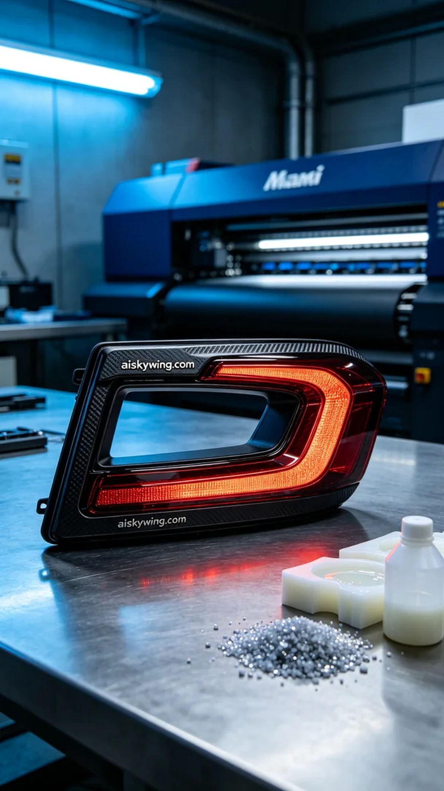
Aiskywing Industrial 3D Printing
Tail Light Trim Frame


