0829-尾灯装饰罩的3D打印之旅
Tail light decorative cover
🖨️ CNC机加工
🖥️ 打印机: EOS
📦 材料: 高透明高耐温
在这个快速变化的时代，唯有坚持才能开出花朵。就像我们为这款尾灯装饰罩置于画面正中央而奋斗，精益求精。
In this rapidly changing era, only perseverance can yield results. Just like our relentless pursuit of perfection as we place this tail light decorative cover at the center of the picture.
________________________________________________________________________________
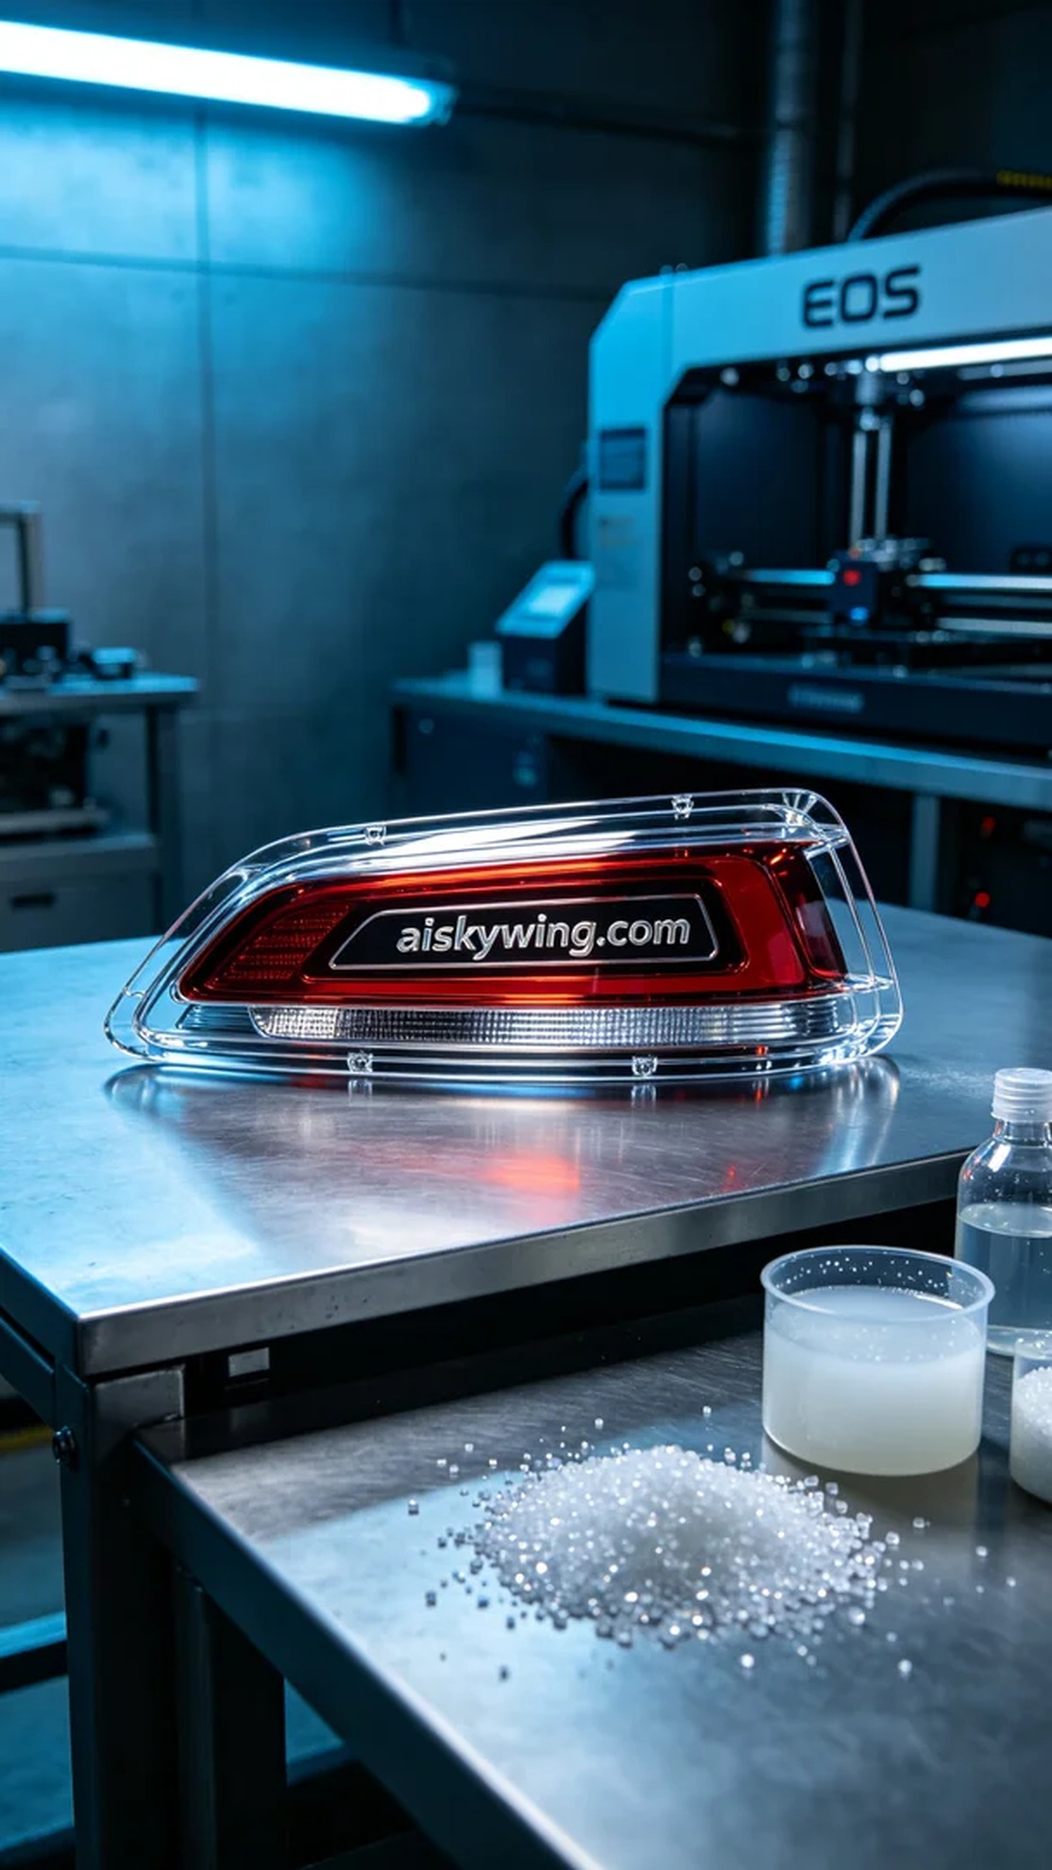
In a recent YouTube discussion, someone highlighted their need for a tail light decorative cover, particularly wanting it to perform well in high-temperature environments. This issue reminded me of our commitment to crafting this tail light decorative cover at the center of the image, focusing on both aesthetics and functionality.
The material used in this production is high-transparent, high-temperature PC engineering plastic, known for its excellent light transmittance and heat resistance. We utilized an EOS brand 3D printer, setting the layer thickness to 0.1 mm, the printing temperature at 210°C, a power of 80W, and a printing speed of 60mm/s, estimating the entire printing process to take around 3 hours.
During the printing process, the equipment ran smoothly. We continuously monitored the print quality to ensure that the adhesion and transparency of each layer met the design specifications. After several trials and adjustments, every detail of the tail light decorative cover was well presented, with the engraved "aiskywing.com" reflecting beautifully in the light.
Once the printing was complete, we conducted meticulous post-processing on the product. First, the decorative cover was soaked in a cleaning solution to remove any residual resin from the surface. Next, we polished it to enhance its surface smoothness, ensuring no defects remained, followed by curing to increase the material’s strength and durability. After thorough inspection, we confirmed that every detail met our standards.
Ultimately, this tail light decorative cover not only showcases an elegant appearance but also possesses strong practicality. Achieving a perfect balance between design and functionality is truly an exciting accomplishment.
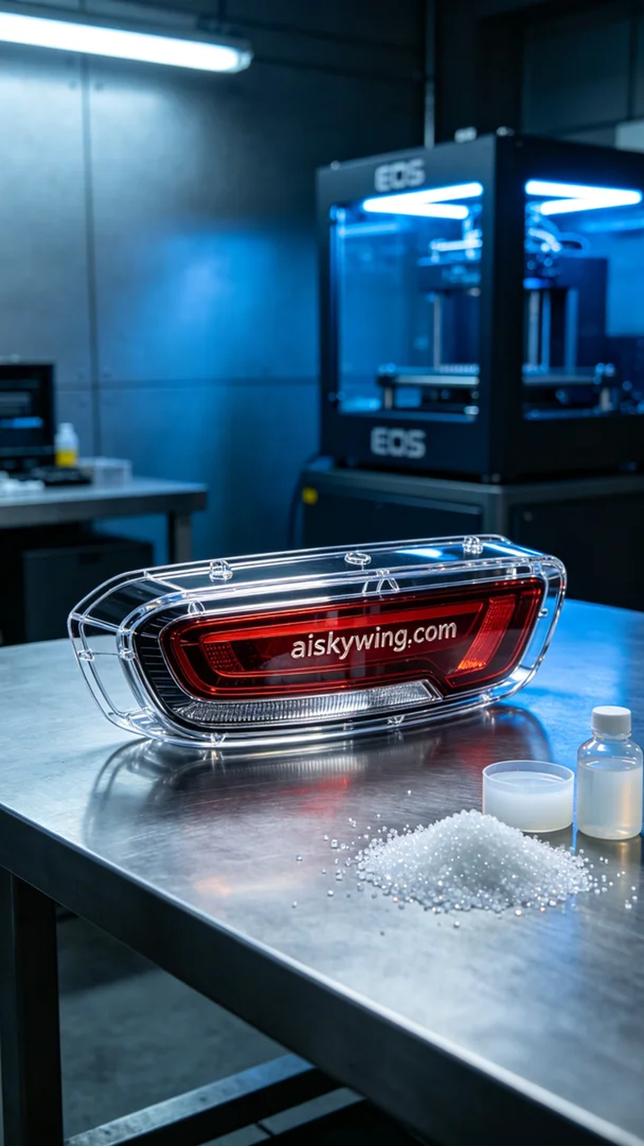
在YouTube上，有人提到他们对尾灯装饰罩的需求，尤其希望这款产品能在耐高温的环境中表现出色。这样的问题让我想起了我们制作这款尾灯装饰罩置于画面正中央的初衷，既要美观又要实用。
此次生产所用的原材料为高透明高耐温的PC透明工程塑料，这种材料具有优良的透光性和耐热性，能够有效抵御高温环境的影响。我们使用的是EOS品牌的3D打印机，设置层厚为0.1毫米，打印温度设定在210°C，功率为80W，打印速度为60mm/s，预计整个打印过程需要3小时完成。
在打印过程中，设备运行得非常顺利。我们时刻监控打印质量，确保每一层的粘附性和透明度都达到设计要求。经过多次试验与调整，这款尾灯装饰罩的每个细节都得到良好的呈现，雕刻的“aiskywing.com”字样也在光影中熠熠生辉。
打印完成后，我们对产品进行了细致的后处理。首先，将饰罩浸泡在清洗剂中，以去除表面的树脂残留。接着，通过打磨提升其表面光洁度，确保无瑕疵，最后进行固化处理，增强材质的强度与耐久性。经过彻底的检验，确认每一个细节都达到标准。
最终，这款尾灯装饰罩不仅展现出优雅的外观，更具备了强大的实用性。能够在设计与功能之间找到完美平衡，真是一件令人振奋的成就。
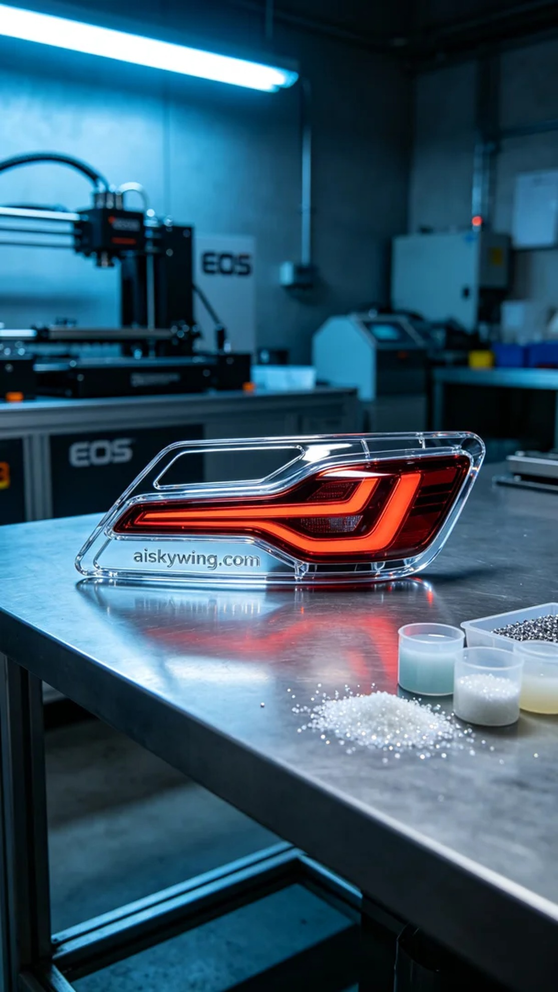
Aiskywing Industrial 3D Printing
Tail light decorative cover


