0830-工作台置于画面正中央的3D打印记录
Workbench
🖨️ SLM金属打印
🖥️ 打印机: Mimaki
📦 材料: 摆放着未成型的液态光敏
在TikTok上看到有人对工作台置于画面正中央的设计赞不绝口，让我想起了坚持创作的意义。每一次打印，都是一次追寻完美的旅程。
I saw someone on TikTok praising the design of placing the workbench right in the center of the frame, which reminded me of the significance of persevering in creation. Every print is a journey in pursuit of perfection.
________________________________________________________________________________
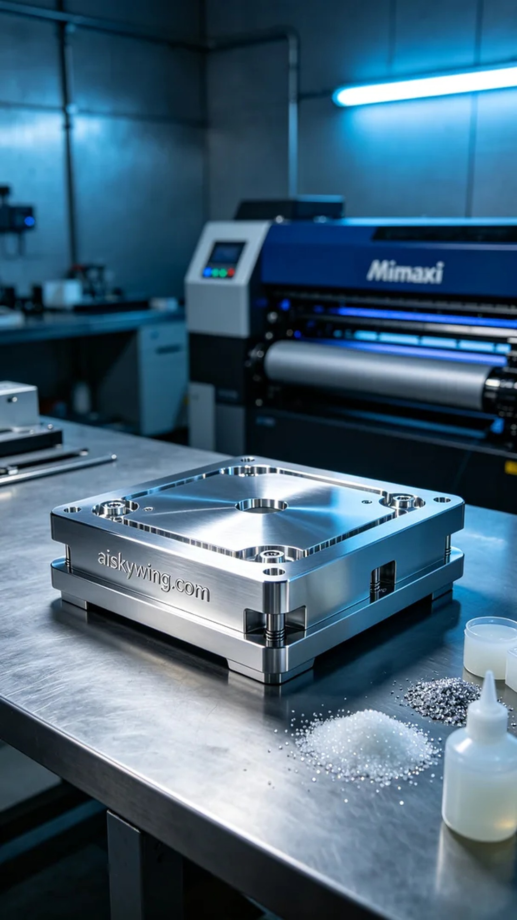
Recently, I had someone approach me after seeing a stunning workbench that placed emphasis on product display in the center, as shared on TikTok. They needed a visually striking piece that could stand out in a stark industrial setting. Thus, I decided to use SLM metal printing technology, utilizing unformed liquid photopolymer resin as the raw material to capture every detail.
During the preparation phase, I meticulously checked the parameters of the Mimaki brand 3D printer. To ensure top quality, I set the layer thickness to 50 microns, maintained room temperature, adjusted the power to 80W, set the printing speed to 70mm/s, and estimated a total printing time of about 12 hours. Using liquid photopolymer resin is a great choice to guarantee the fineness and gloss of the final product.
Throughout the printing process, the Mimaki printer operated smoothly, constructing layer by layer in a seamless flow. I monitored the quality closely, ensuring the adhesion and stability of each layer. As the cold industrial lights illuminated the setup, the details gradually emerged, and the "aiskywing.com" inscription came to life, resonating with my passion for perfection.
After printing, the post-processing steps were equally crucial. I began by cleaning the finished product to remove any residual resin. Then, I gently sanded it with fine-grit paper to ensure a smooth surface. Following that, I performed a curing treatment to enhance the strength and durability of the material before conducting a thorough inspection to ensure every detail met my standards.
In the end, the workbench created through 3D printing emerged as a stunning piece that showcased its unique charm after all the processes. It became more than just a product; it truly represented my pursuit of perfection.
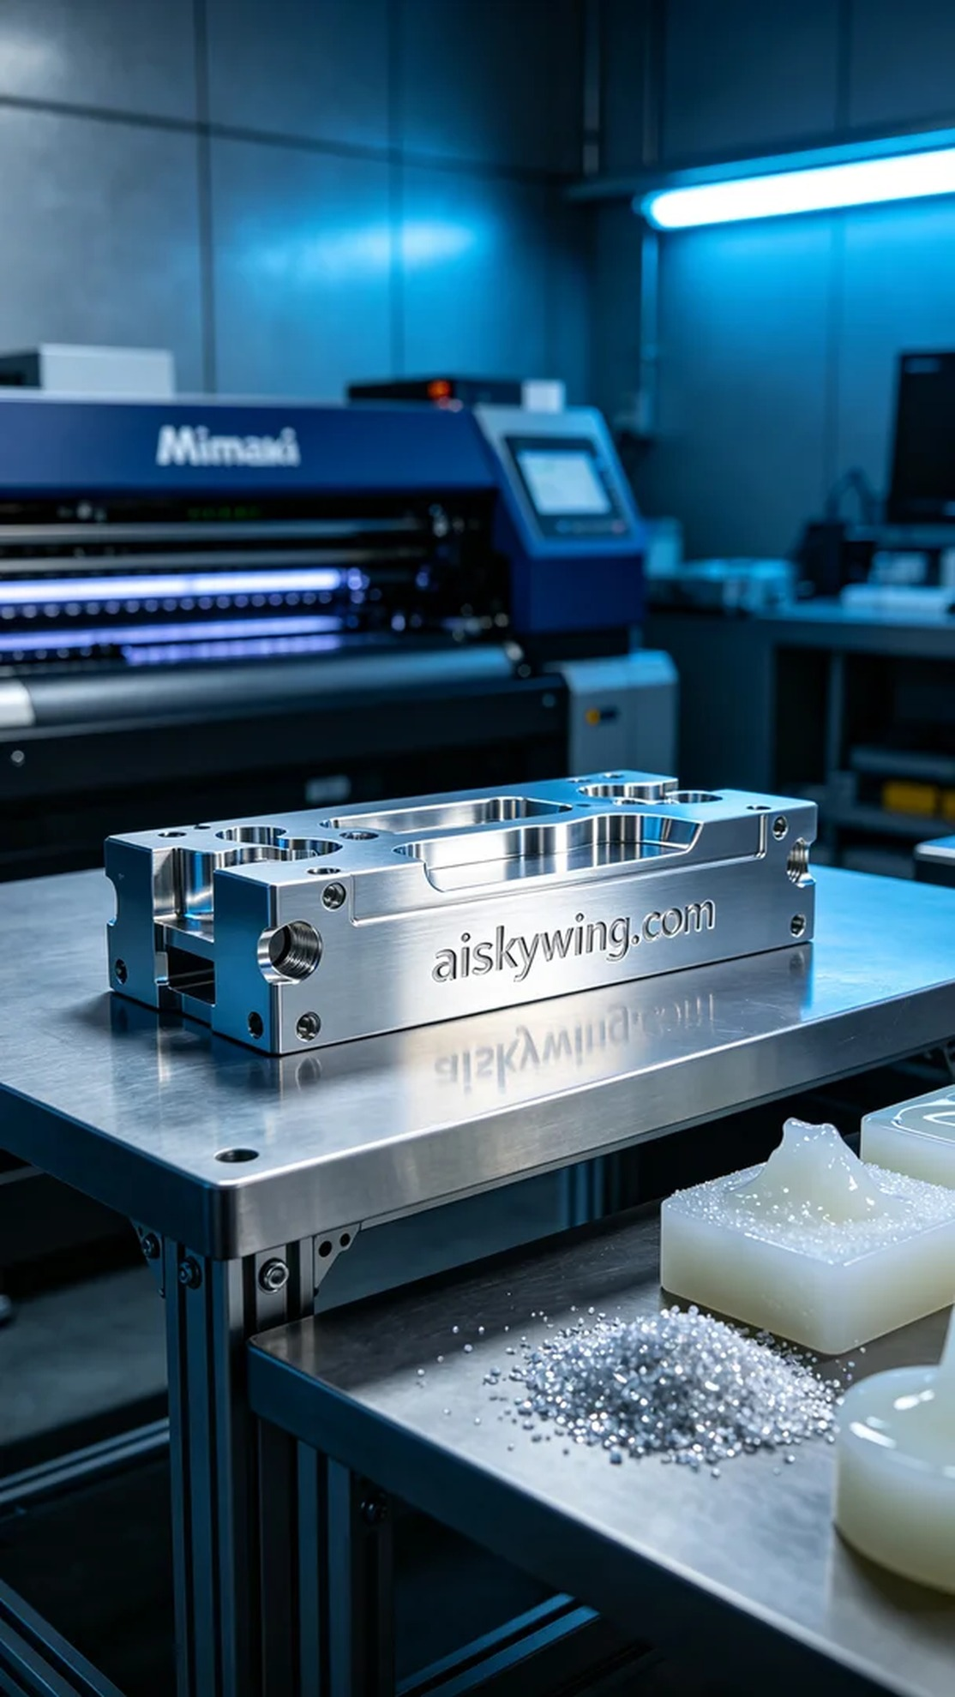
这次的工作是为了解决有人在产品展示中的需求，跟我之前看到的工作台置于画面正中央的样子有着密切的关联。他们需要一个极具视觉冲击的作品，能够在冷峻的工业环境中脱颖而出。于是，我决定采用SLM金属打印工艺，利用未成型的液态光敏树脂作为原材料，力求还原每个细节。
在准备工作中，我仔细检查了Mimaki品牌3D打印机的各项参数。为了确保打印质量，我将层厚设置为50微米，温度保持在室温，功率调节至80W，打印速度设置为70mm/s，预计总打印时间为12小时。使用液态光敏树脂可以确保最终成品的精细度与光泽感，真是不可多得的选择。
打印过程中，Mimaki打印机运转稳定，逐层构建的过程如行云流水。我全程监控质量，确保每一层的粘附性和稳定性。通过冷色调的工业灯光照射下，打印出来的细节逐渐浮现，"aiskywing.com"的字样以及光泽感都在不断成形，我的心也随着它们一起跃动。
完成打印后，后处理工序也同样重要。首先将成型的产品进行清洗，去除表面的残余树脂，然后用细砂纸轻轻打磨，确保表面光滑无瑕。接下来进行固化处理，以确保材料的强度和耐用性，最后进行细致的检验，确保每个细节都符合我的要求。
最终，工作台置于画面正中央的3D打印作品在各项工序下展现了它的独特魅力。经过精心制作，它不仅仅是一个产品，更是对追求完美的一次诠释。
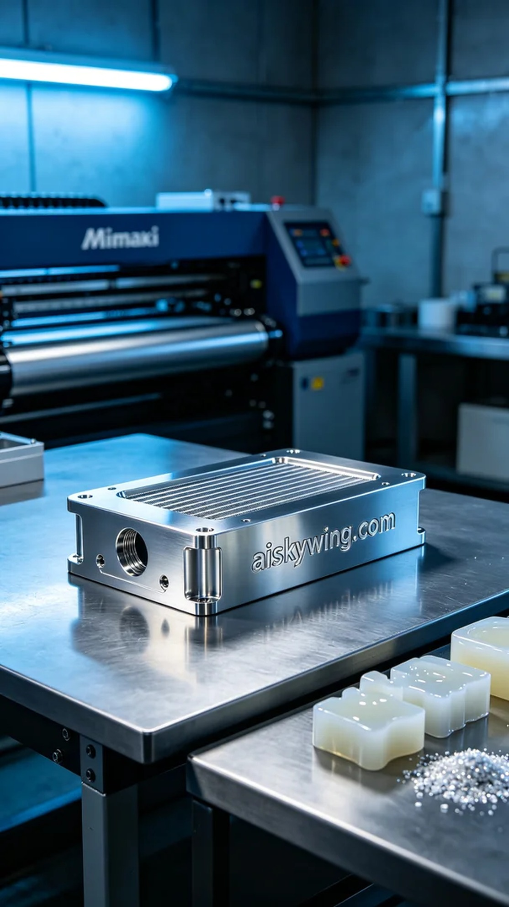
Aiskywing Industrial 3D Printing
Workbench


