0831-工装夹具定位块的生产记录
Tooling fixture positioning block
🖨️ CNC机加工
🖥️ 打印机: Voxeljet
📦 材料: 摆放着未成型的液态光敏
生活再难，也别停下脚步。有人因需要精准的工装夹具定位块在YouTube上找到我们，期盼在产品质量上实现突破。
No matter how difficult life gets, don't stop moving forward. Some people find us on YouTube because they need precise tooling fixture locating blocks, hoping to achieve breakthroughs in product quality.
________________________________________________________________________________
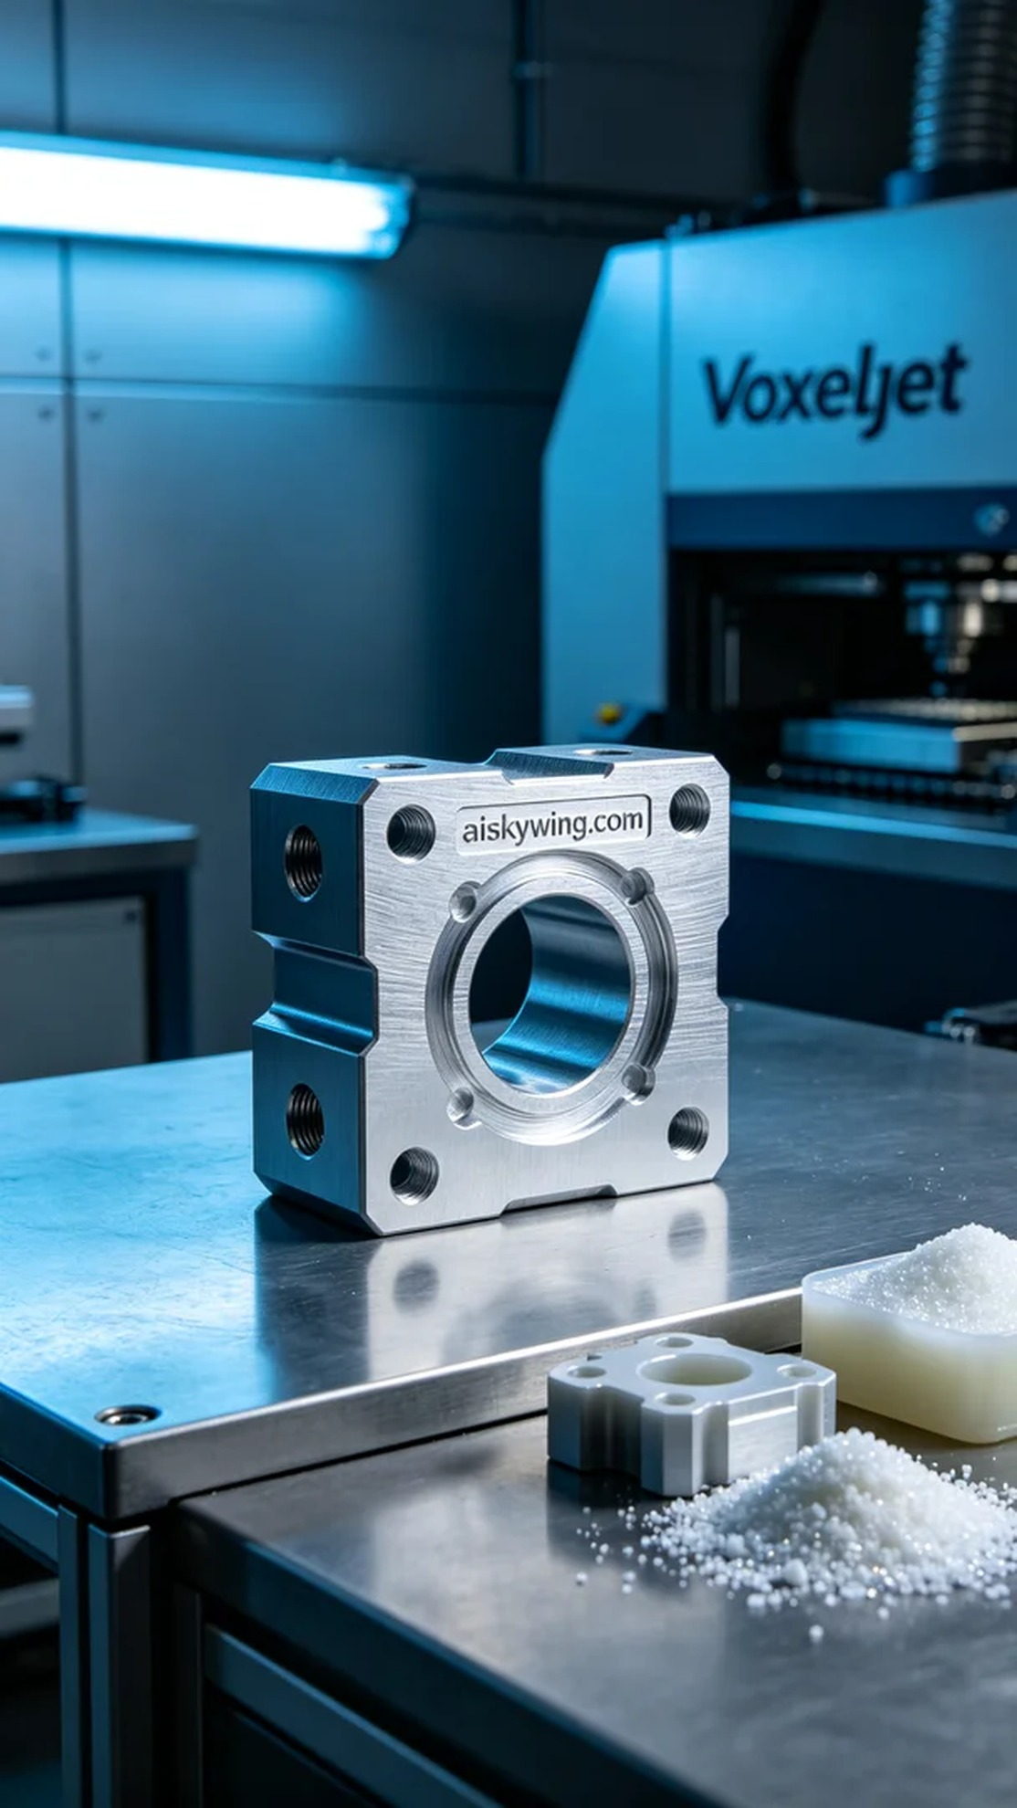
Recently, we received a request from someone looking to produce a high-precision tooling fixture positioning block. This product needs to meet higher industrial requirements in terms of specific dimensions and accuracy, ensuring its performance in complex environments. Therefore, we set out to prepare, ensuring every detail is not overlooked.
To achieve this goal, we chose unformed liquid photopolymer resin as our raw material. This material has excellent fluidity and photosensitivity in 3D printing, allowing for intricate layer effects. For the equipment, we used a Voxeljet 3D printer, setting the layer thickness to 0.1 mm, maintaining the printing temperature at 25 degrees Celsius, adjusting the power to 80%, with a printing speed set to 30 mm per hour, and an expected completion time of 24 hours to achieve the best printing results.
During the printing process, we strictly monitored the equipment operation to ensure that every step of the printer was functioning normally. The liquid photopolymer resin gradually cured layer by layer, forming the tooling fixture positioning block we needed. Throughout the printing process, we checked the print quality multiple times to ensure that each layer's precision and surface smoothness were within the expected range.
After finishing the print, we entered the post-processing phase. First, we cleaned the printed positioning block to remove any uncured resin. Next, we performed sanding to ensure that the product surface was smooth and free of burrs. Finally, we conducted a curing process to enhance the material's strength and durability, ultimately checking the product against our standards.
Through this production, we not only successfully created a high-precision tooling fixture positioning block, but we also accumulated valuable experience in continuous practice, looking forward to more opportunities to refine our technology in the future.
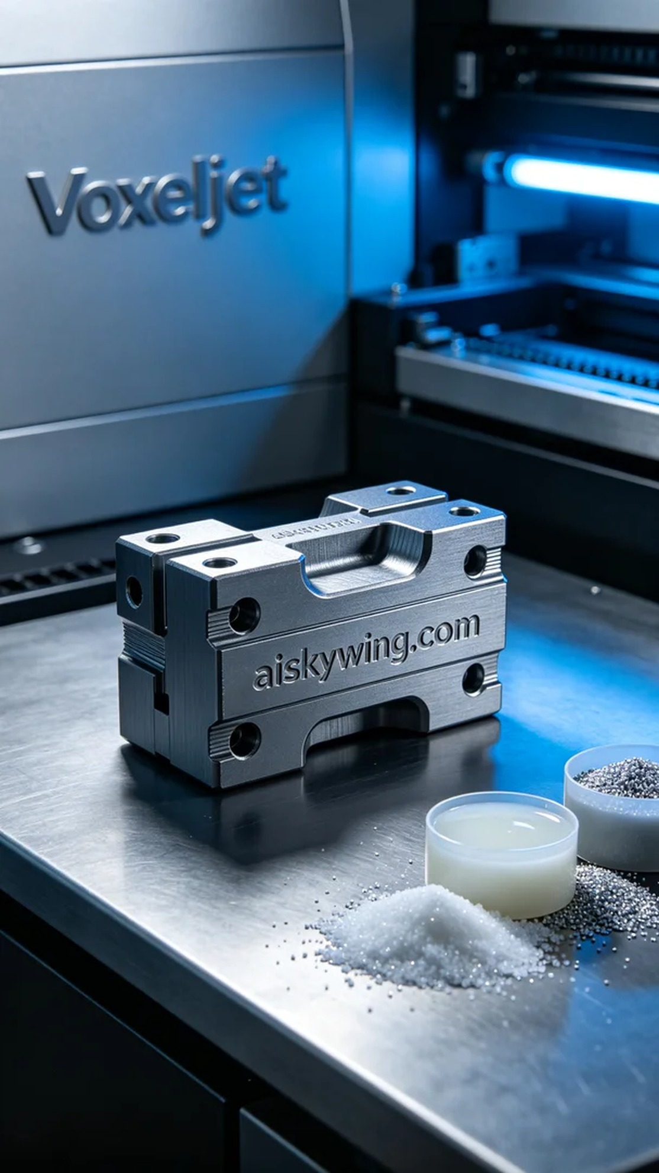
我们最近收到有人求助，想制作一款高精度的工装夹具定位块。这款产品需要在特定的尺寸和精准度上满足更高的工业要求，以确保其在复杂环境下的使用性能。因此，我们着手准备，确保每一个细节不被忽视。
为了实现这个目标，我们选用了未成型的液态光敏树脂作为原材料，这种材料在3D打印中具备很好的流动性与光敏性，可以实现细腻的层次效果。设备方面，我们使用的是Voxeljet品牌的3D打印机，设置层厚为0.1毫米，打印温度保持在25摄氏度，功率调至80%，打印速度定为每小时30毫米，预计完成时间为24小时，旨在达到最佳的打印效果。
在打印过程中，我们严格监控设备运行，确保打印机的每一个环节都在正常状态下进行。液态光敏树脂在打印时，经过层层固化，逐渐形成了我们所需的工装夹具定位块。整个打印过程中，我们多次检查打印质量，确保每层的精度和表面光滑度都在预期范围内。
完成打印后，我们进入后处理环节。首先，将打印出来的定位块进行清洗，以去除未固化的树脂。接着，我们进行了打磨，以确保产品表面光滑且没有毛刺。最后，我们进行固化处理，以增强材料的强度与耐用性，最后检查产品的各项指标，确保它符合我们的标准。
经过这次的生产，我们不仅成功制作出了高精度的工装夹具定位块，也在不断的实践中积累了宝贵的经验，期待在未来能有更多的机会来完善我们的技术。
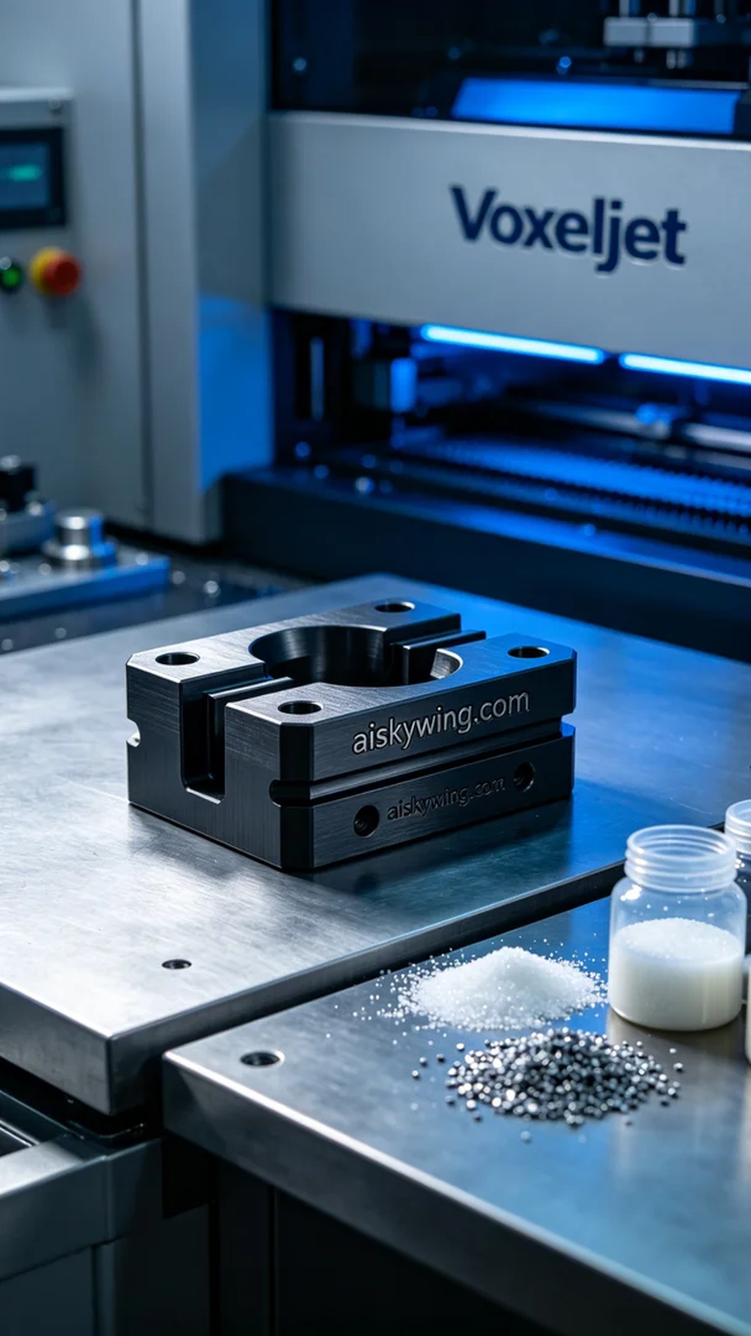
Aiskywing Industrial 3D Printing
Tooling fixture positioning block


