0832-底盘护板的3D打印生产记录
Chassis guard plate
🖨️ SLM金属打印
🖥️ 打印机: EOS
📦 材料: 摆放着未成型的液态光敏
生活就像3D打印，有时要经历不断的调整与修正。最近有人因需要一个底盘护板向我们求助，希望解决他们在产品开发中的难题。
Life is like 3D printing; it often requires constant adjustments and corrections. Recently, someone reached out to us for help with a chassis guard, hoping to solve a challenge they faced in product development.
________________________________________________________________________________
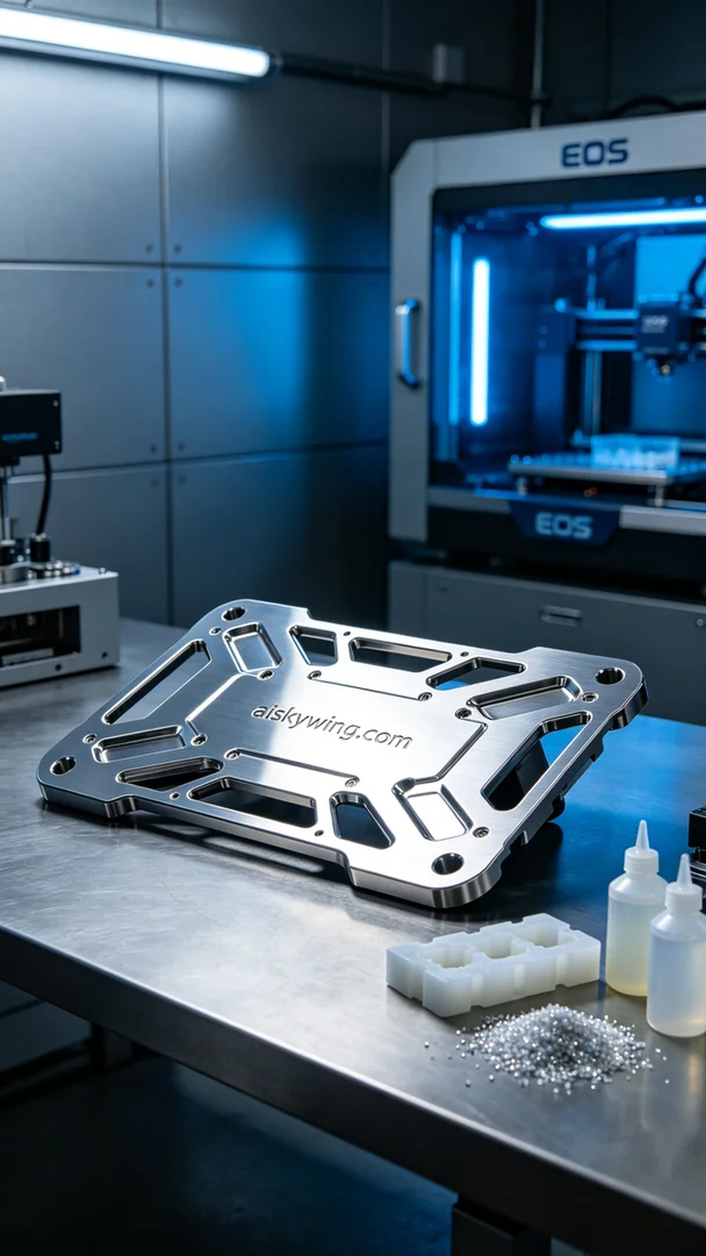
Life is much like 3D printing; sometimes, it requires constant adjustments and corrections. Recently, someone reached out to us needing a chassis guard, hoping to resolve issues in their product development.
To meet the demand for the chassis guard, we embarked on this 3D printing journey. Initially, they shared their concerns on Twitter, stating that their existing products lacked both strength and aesthetics, prompting us to create a superior guard.
We chose unformed liquid photopolymer resin as our raw material, which possesses excellent fluidity and forming precision, allowing for detailed design representation. Using the EOS brand SLM metal printer, we set the layer thickness to 0.1 mm, maintained a printing temperature of 180°C, set the power to 50W, adjusted the printing speed to 100mm/s, and estimated a printing time of 12 hours.
During the printing process, the machine operated smoothly as we carefully monitored the forming of each layer to ensure no bubbles or cracks appeared. By continuously adjusting the printing parameters, we maximized the product’s quality, ensuring the chassis guard could withstand high-strength usage.
After printing, we proceeded with detailed post-processing. First, we cleaned the finished product with a cleaning agent to remove any residual uncured resin; next, we sanded the surface to enhance adhesion and smoothness; finally, we placed the guard under UV light for curing to ensure its strength and durability, followed by a comprehensive quality inspection.
After a series of meticulous production and processing steps, the chassis guard was finally completed. This experience deepened my appreciation for the charm of 3D printing and the significance of precision craftsmanship, and I look forward to the next challenge!
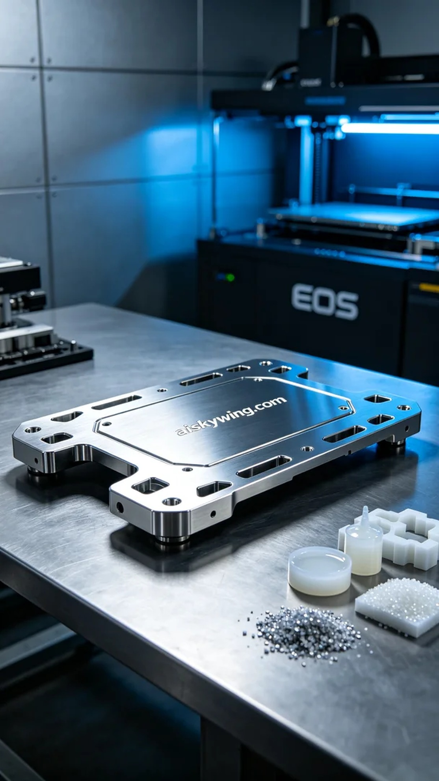
为了满足有人对底盘护板的需求，我们开始了这次的3D打印之旅。起初，他们在Twitter上反馈，现有产品的强度和美观性无法满足要求，因此我们决定为他们定制一款更加出色的护板。
我们选用了未成型的液态光敏树脂作为原材料，这种材料具备良好的流动性和成型精度，能够完美呈现设计细节。打印时，我们使用了EOS品牌的SLM金属打印机，设置层厚为0.1毫米，打印温度维持在180°C，功率设定为50W，打印速度为100mm/s，预计打印时间为12小时。
打印过程中，设备运转平稳，我们仔细监控每一层的成型情况，确保无气泡和裂纹出现。通过不断地调整打印参数，我们最大限度地提升了产品的质量，确保底盘护板能够承受高强度的使用。
完成打印后，我们进行了详细的后处理工序。首先用清洗剂对成品进行清洗，去除表面残留的未固化树脂；接着用砂纸对表面进行打磨，以增强附着力和光滑度；最后，将护板置于UV灯下进行固化，以确保材料的强度和耐用性，最后进行了全面的质量检验。
经过一系列精细的制作与处理，底盘护板终于完成。这次的经历让我更加明白了3D打印的魅力以及精细工艺的重要性，期待下一次的挑战！
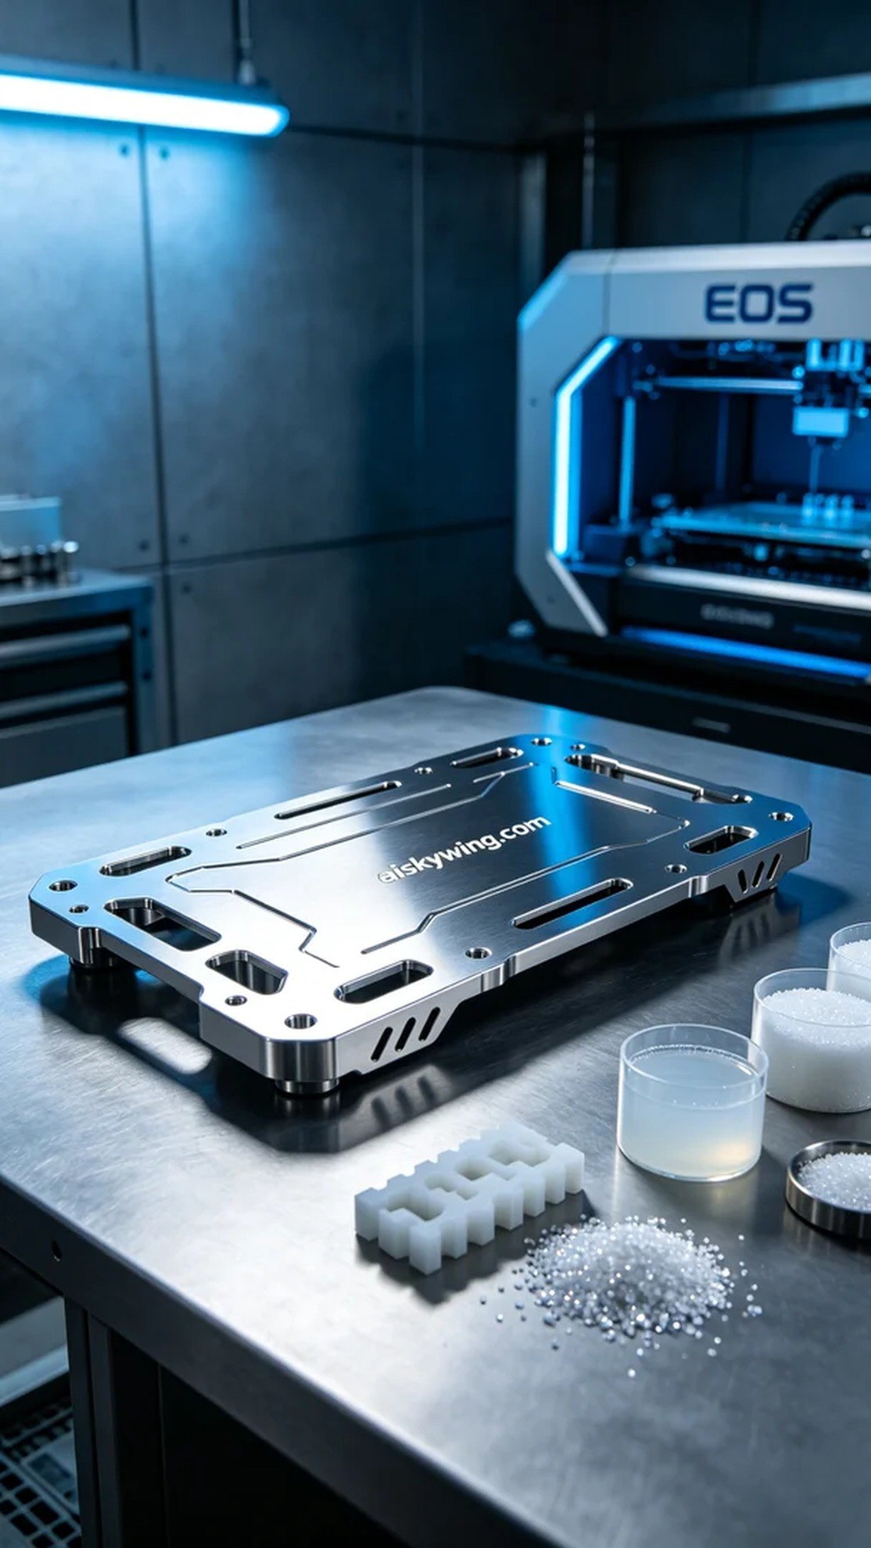
Aiskywing Industrial 3D Printing
Chassis guard plate


