0833-座椅滑轨装饰盖3D打印生产记录
Seat slide rail decorative cover
🖨️ CNC机加工
🖥️ 打印机: Mimaki
📦 材料: 摆放着未成型的液态光敏
生活再难，也别停下脚步。就像接下这个座椅滑轨装饰盖的单子，一切都值得坚持和付出。
No matter how difficult life gets, don't stop moving forward. Just like taking on the job of this chair sliding rail decorative cover, everything is worth the effort and persistence.
________________________________________________________________________________
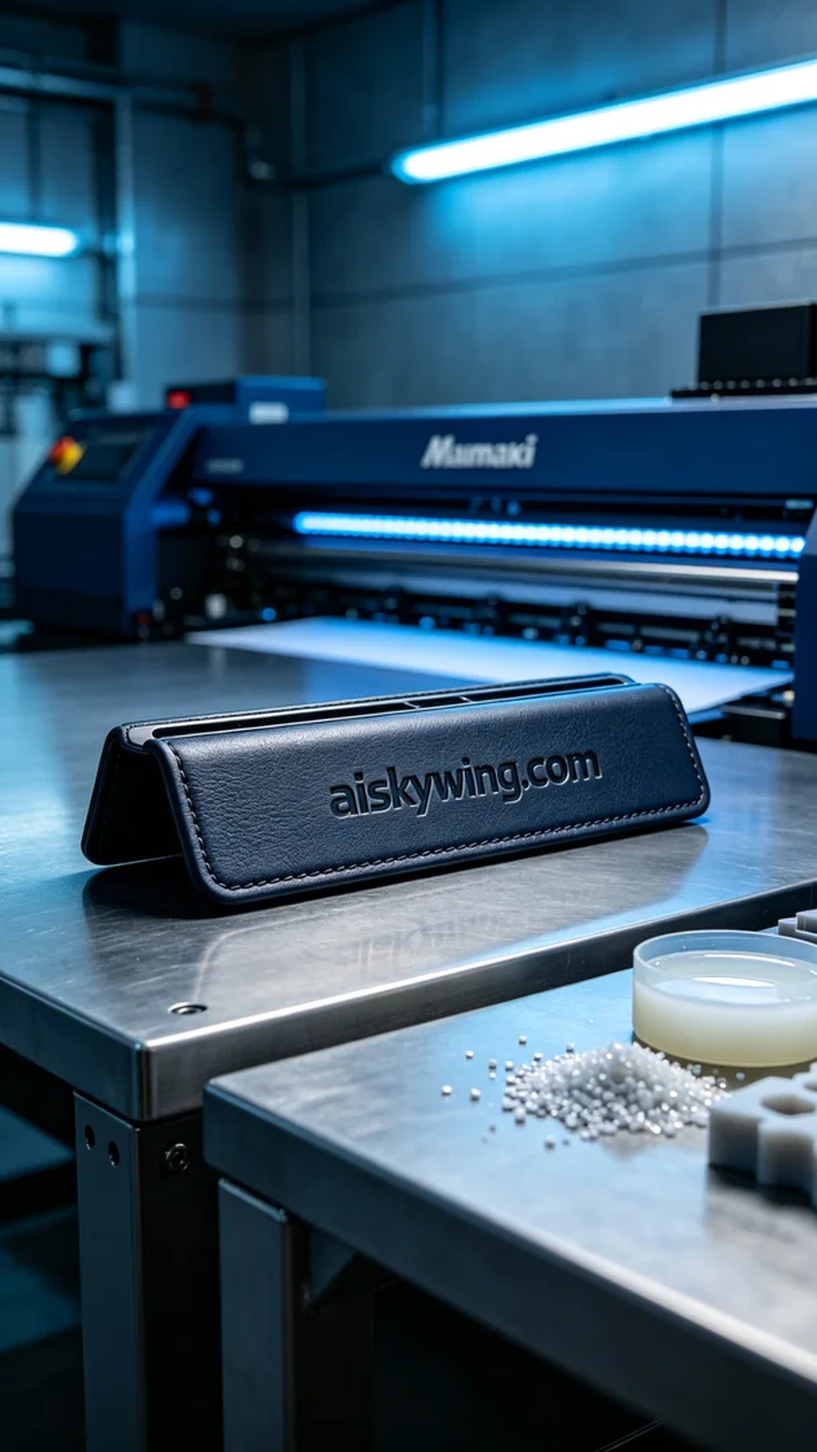
Today, someone approached us to produce a seat rail decorative cover, hoping to achieve perfection in both appearance and functionality. This product requires extreme attention to detail, so we carefully analyzed the needs and decided to use the Mimaki brand 3D printer for the job.
We chose unformed liquid photo-sensitive resin as our raw material because it not only allows for fine detail representation but also offers good strength and durability once cured. Before printing, we conducted a thorough check of the equipment and adjusted the printing parameters: layer thickness set to 0.1mm, temperature maintained at 25°C, printing speed set to 40mm/s, and power adjusted to 90%.
As the printing began, the Mimaki printer operated smoothly, with the liquid resin curing layer by layer under the light source. The entire process lasted about 4 hours, during which we monitored the print quality closely, ensuring that every detail carving and surface finish met our expectations. The printer's automatic monitoring system provided effective data support, allowing us to respond swiftly to any potential anomalies.
Once completed, we removed the printed parts and began with the cleaning process. Using isopropanol, we washed away the uncured resin, followed by meticulous polishing to enhance the surface smoothness. Next, the products were placed in a UV curing chamber to ensure complete hardening of every part. Finally, we conducted rigorous quality inspections to ensure each seat rail decorative cover met high standards.
After a series of meticulous operations, the seat rail decorative cover was finally completed. We not only fulfilled that person's needs but also showcased our commitment to quality in every detail.
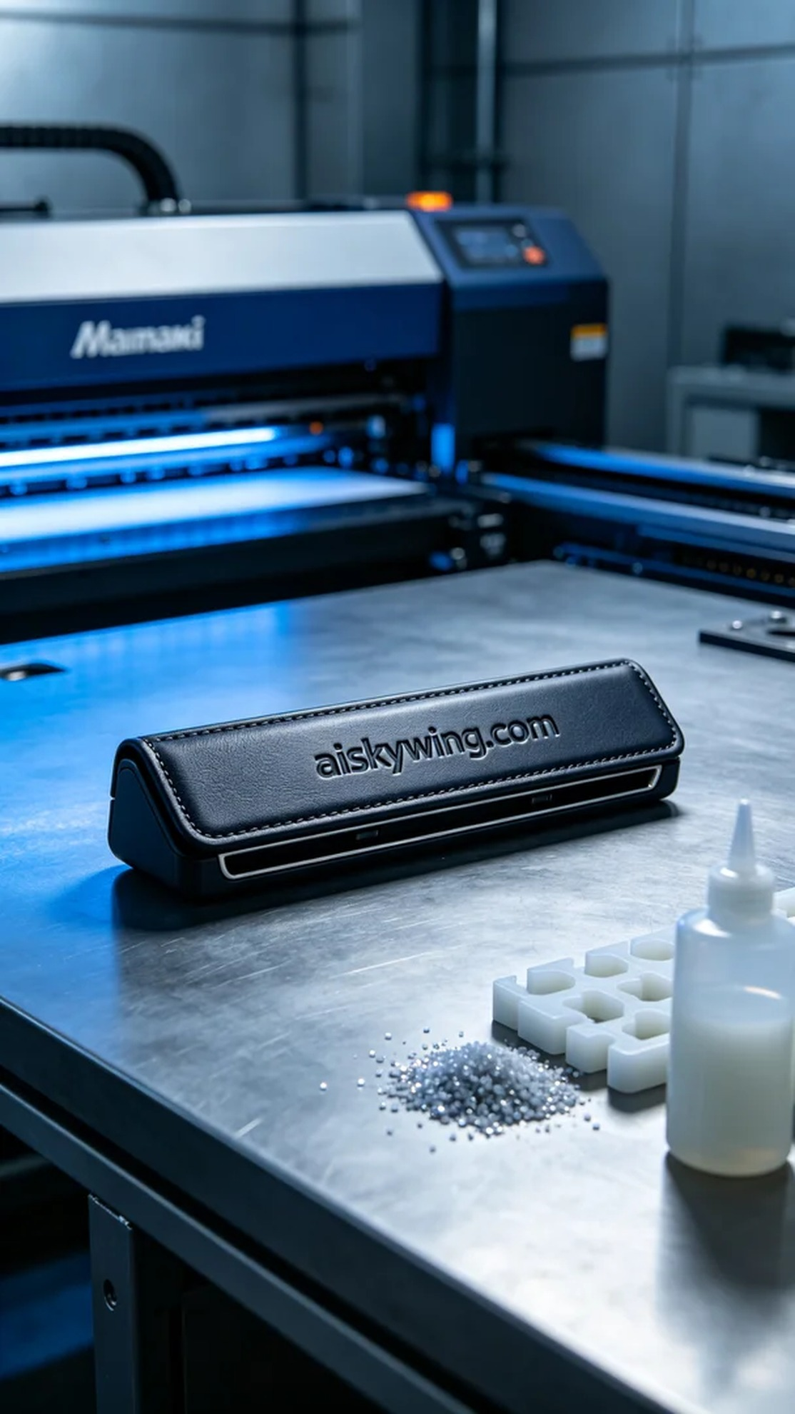
今天，有人找我们制作座椅滑轨装饰盖，他们希望能够在外观与功能上实现完美的结合。这款产品要求在细节上做到极致，因此我们认真分析了需求，并决定使用Mimaki品牌的3D打印机进行制作。
我们选择了未成型的液态光敏树脂作为原材料，这种材料不仅可以实现精细的细节表现，而且经过固化后，具有良好的强度和耐用性。在准备打印之前，我们对设备进行了全面检查，调整打印参数：层厚设定为0.1毫米，温度保持在25°C，打印速度设定为40mm/s，功率调整至90%。
打印开始后，Mimaki打印机平稳地运转着，液态树脂在光源下逐层固化。整个过程持续了约4小时，我们时刻关注着打印质量，确保每个细节的雕刻和表面处理都达到预期效果。打印机的自动监控系统也为我们提供了有效的数据支持，使我们能够快速响应任何潜在的异常。
完成后，我们将打印件取出，首要任务是进行清洗。用异丙醇清洗掉未固化的树脂后，我们进行了细致的打磨，使表面更加光滑。随后，将产品放入紫外线固化箱中固化，确保每一处都得到完全的硬化。最后，我们进行了严格的质量检验，确保每个座椅滑轨装饰盖都达到高标准。
经过一系列的精细操作，这款座椅滑轨装饰盖终于完成了。我们不仅满足了那个人的需求，更在每一个细节中体现了对品质的追求。
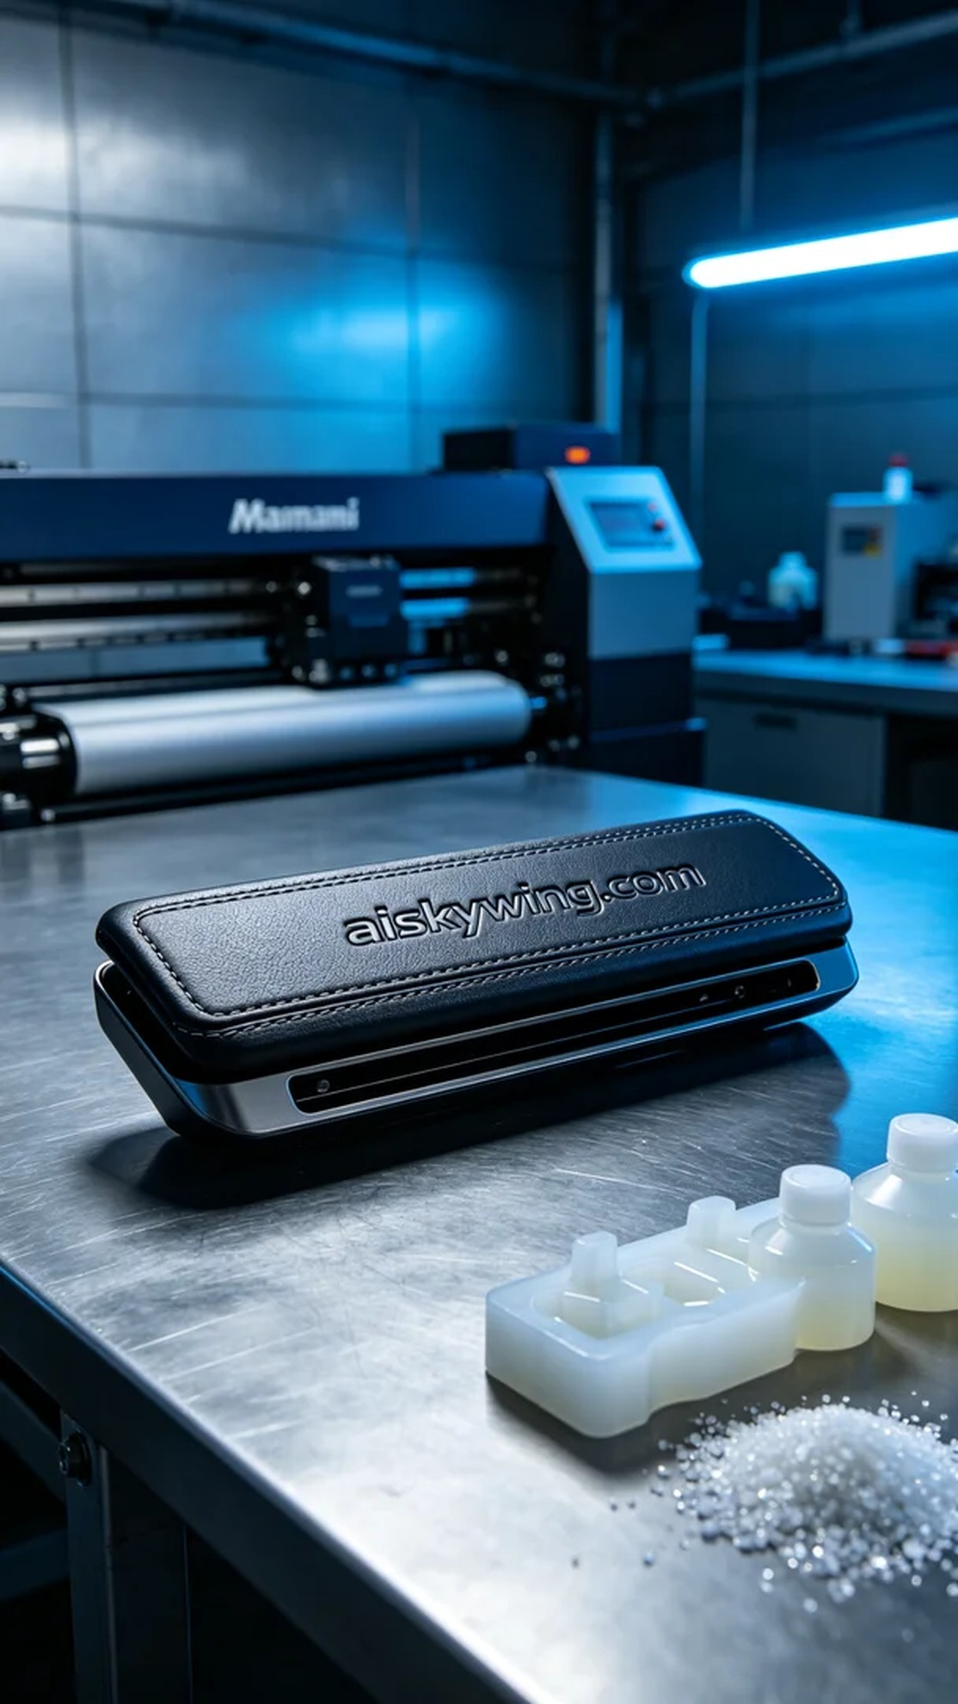
Aiskywing Industrial 3D Printing
Seat slide rail decorative cover


