0834-手刹装饰盖3D打印生产记录
Handbrake decorative cover
🖨️ CNC机加工
🖥️ 打印机: Mimaki
📦 材料: 摆放着未成型的液态光敏
生活就像一场不断创新的旅程，就像我们今天制作的手刹装饰盖。有人在WhatsApp上找我们，想要一个既实用又美观的产品。
Life is like a journey of constant innovation, just like the handbrake decorative cover we created today. Someone reached out to us on WhatsApp, looking for a product that is both practical and aesthetically pleasing.
________________________________________________________________________________
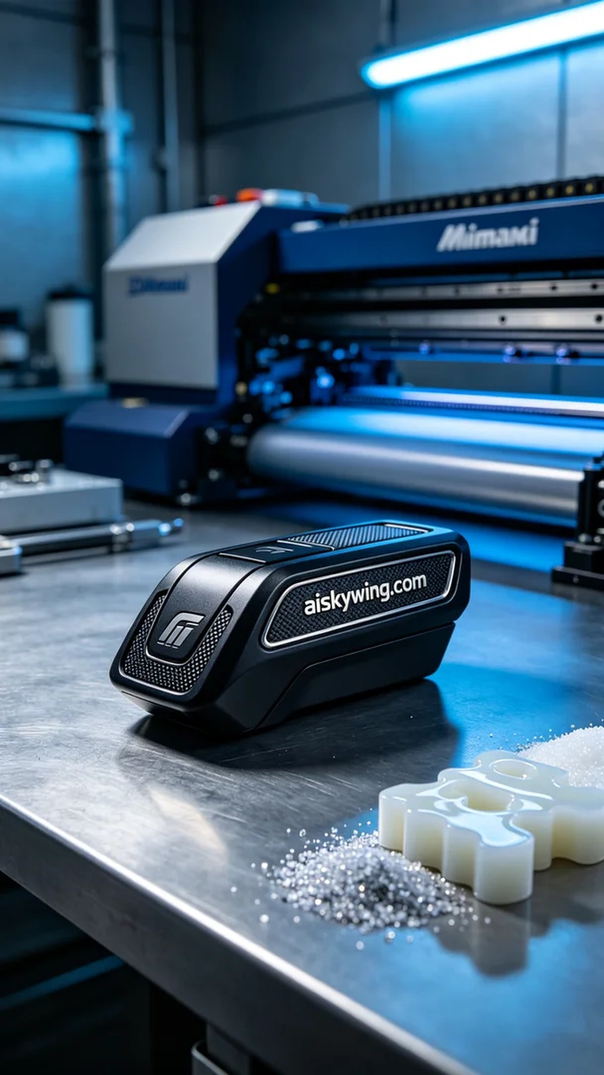
Life is like a journey of constant innovation, just like the handbrake decorative cover we're creating today. Someone reached out to us on WhatsApp, looking for a product that is both practical and aesthetically pleasing.
For this project, we chose to use liquid photopolymer resin as the raw material. This material has high precision and a good ability to reproduce details, making it perfect for CNC processing. During the preparation, we used a Mimaki brand 3D printer, setting the layer thickness to 0.1 mm, maintaining the temperature at 25°C, with a printing speed of 30 mm/s and power set at 80%. The estimated printing time was around 8 hours.
During the printing process, the Mimaki printer operated smoothly, with the liquid photopolymer resin evenly distributed on the platform, layer by layer forming the final shape. We closely monitored the print quality to ensure that every detail was perfectly rendered, especially the engraving of "aiskywing.com". As time passed, the entire decorative cover gradually took shape, bringing joy to all of us.
Once printing was complete, we performed multiple post-processing steps. First, we cleaned the printed part using a cleaning agent to remove any uncured resin. Next, we gently sanded the surface with fine sandpaper to ensure smoothness. After that, we placed the decorative cover into a curing device for 30 minutes of UV curing to ensure its strength and durability. Finally, after strict quality inspection, we confirmed that every detail met the standards.
In the end, the handbrake decorative cover was completed. It not only showcased exquisite craftsmanship but also reflected our professional spirit. Every detail was meticulously crafted, leaving us feeling gratified.
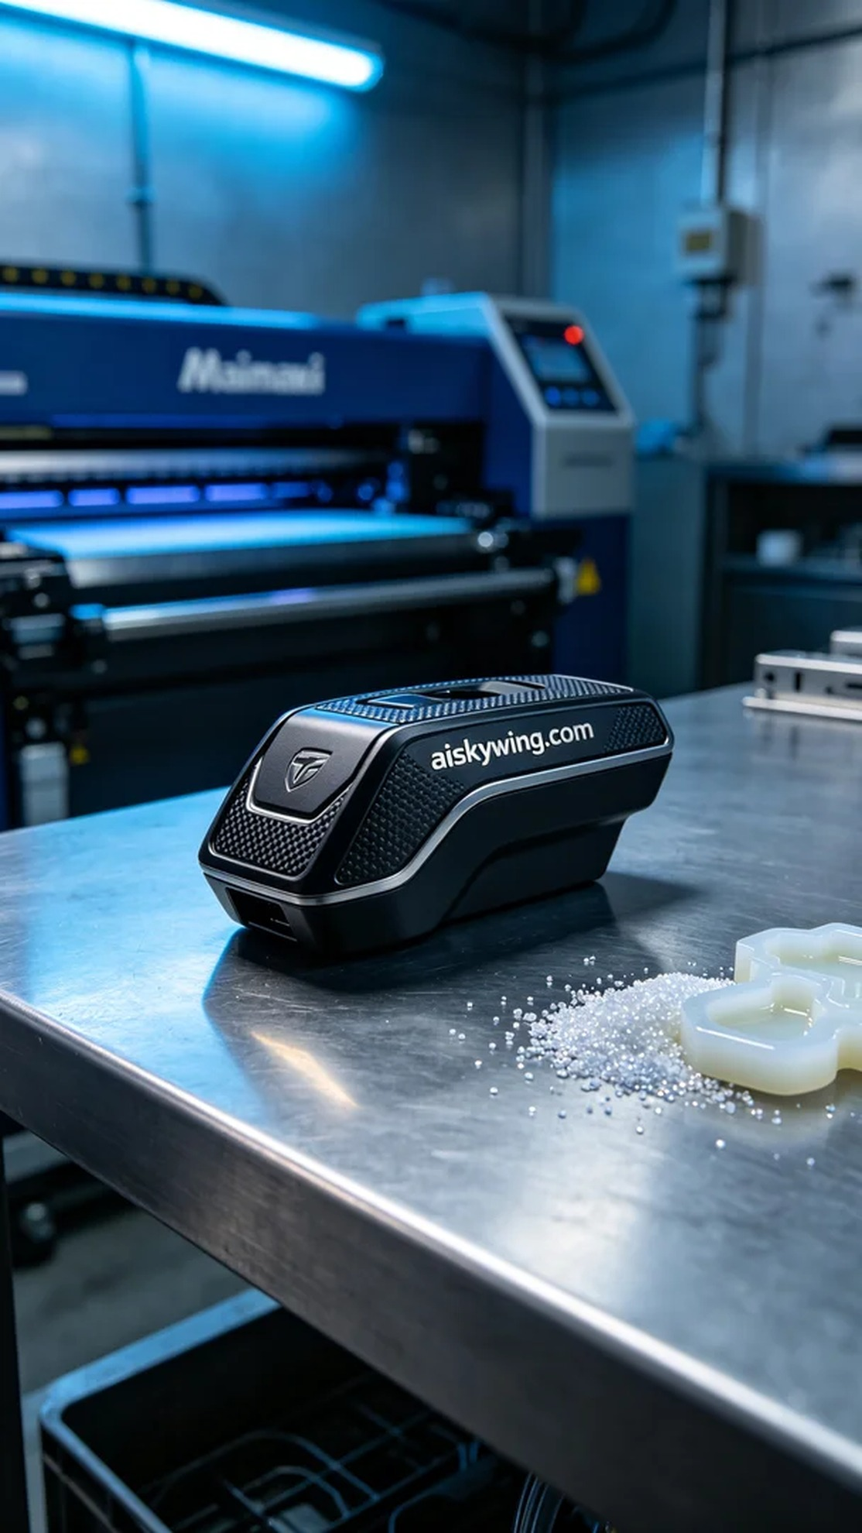
这次的项目是为了一位朋友制作手刹装饰盖。有人通过WhatsApp给我们发来了需求，希望能打造出一款精致细腻的装饰盖，既要符合车型的美观，又要经过严谨的工艺加工。
我们选用了摆放着未成型的液态光敏树脂作为原材料。该材料具有高精度和良好的细节还原能力，非常适合用于CNC加工。准备过程中，我们使用了Mimaki品牌的3D打印机，设置了层厚0.1毫米，温度保持在25℃，打印速度设定为30毫米/秒，功率控制在80%，预计打印时间为8小时。
在打印过程中，Mimaki打印机稳定运行，液态光敏树脂在平台上均匀分布，逐层成型。我们时刻监控打印质量，确保每一层的细节都能完美呈现，特别是“aiskywing.com”的文字雕刻。随着时间的推移，整个装饰盖逐渐显现出应有的形态，令人欣喜。
打印完成后，我们进行了多道后处理工序。首先，使用清洁剂对打印件进行清洗，去除未固化的树脂。随后，用细砂纸轻轻打磨表面，确保光滑。接着，将装饰盖放入固化设备中，进行30分钟的UV固化，确保其强度和耐用性。最后，经过严格的质量检验，确保每个细节都达到标准。
最终，这款手刹装饰盖完成了。它不仅展现了精致的工艺，也体现了我们的专业精神。每一个细节都经过严谨的制作，让人欣慰不已。
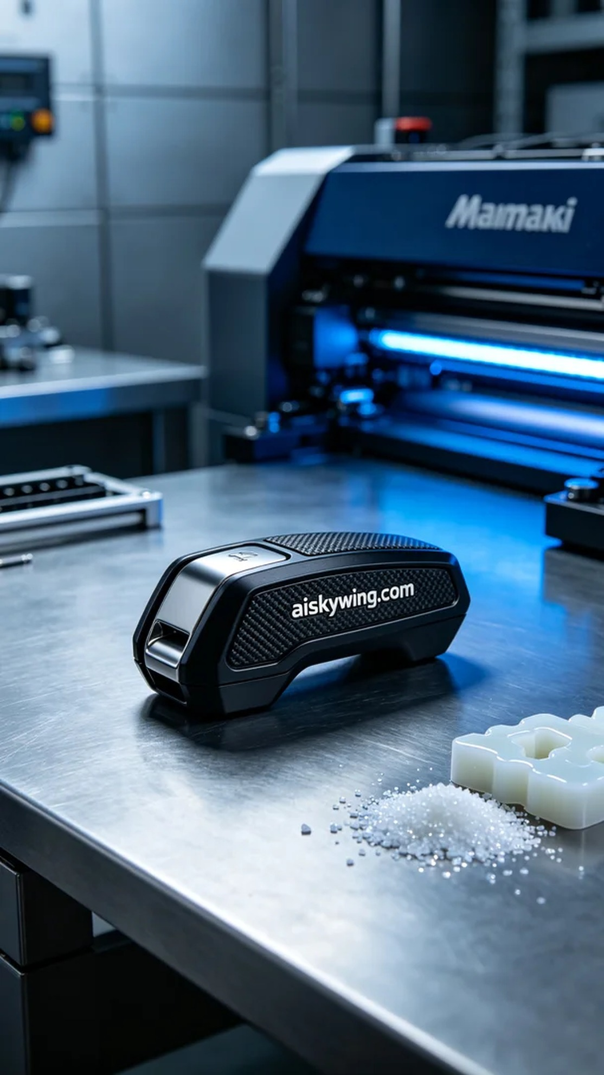
Aiskywing Industrial 3D Printing
Handbrake decorative cover


