0835-手套箱锁扣的3D打印生产记录
Glove box latch
🖨️ CNC机加工
🖥️ 打印机: Stratasys
📦 材料: 高透明高耐温
在Instagram上，许多人因手套箱锁扣的耐用性和设计问题找到了我们。接下来的工作，就是为他们提供理想的解决方案。
Many people have contacted us on Instagram regarding the durability and design issues of glove box locks. Our next task is to provide them with an ideal solution.
________________________________________________________________________________
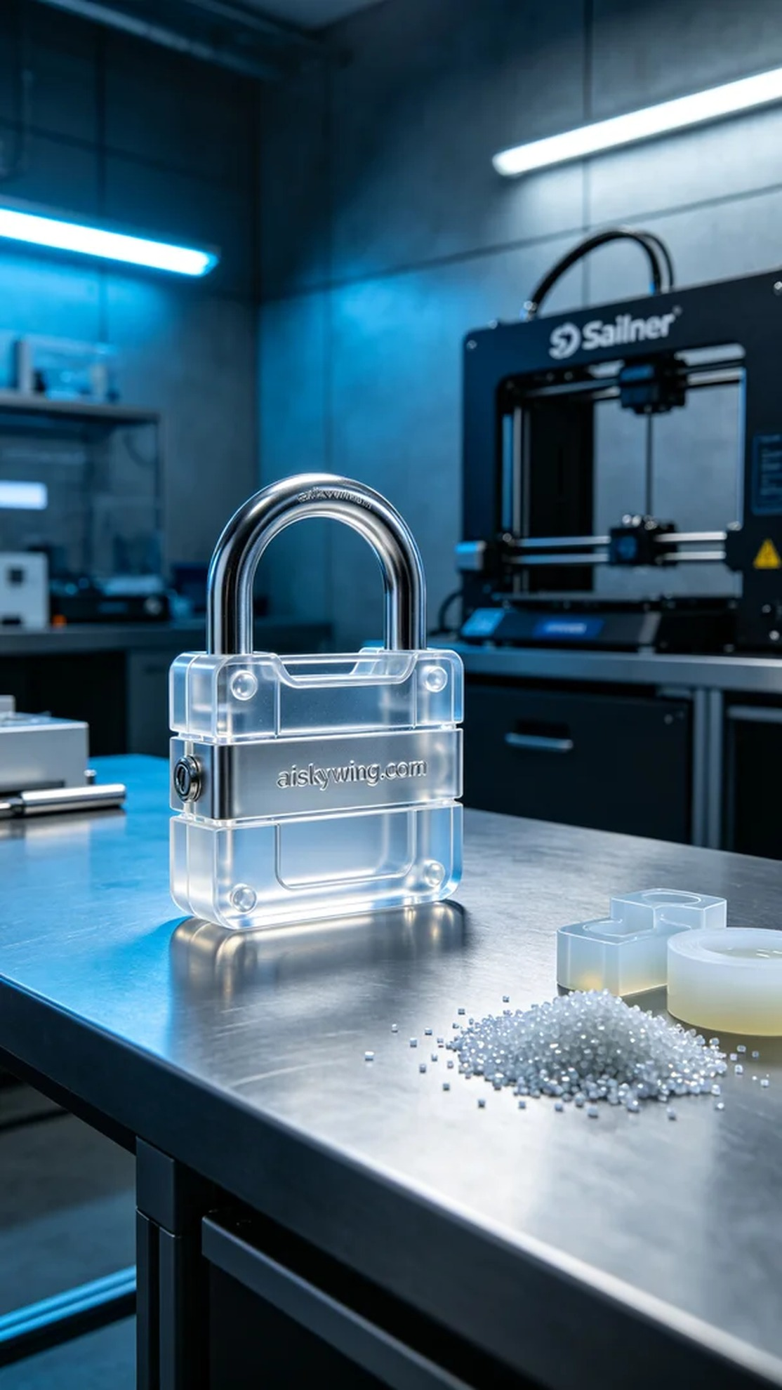
Recently, we received a project regarding a glove box latch. People reached out via Instagram, expressing concerns about the durability and design of the current latches they use. They hope we can provide a better alternative that addresses their high-temperature and transparency needs.
For this production, we chose high-transparent, high-temperature PC engineering plastic as the main material, ensuring the latch's strength and aesthetics during use. We utilized a Stratasys 3D printer and set the printing parameters to a layer thickness of 0.1mm, a temperature of 90°C, and a printing speed of 30mm/s, with an estimated total printing time of about 8 hours.
During the printing process, the equipment operated smoothly, and the quality monitoring system continuously checked the printing status. As each layer stacked, the outline of the latch gradually emerged. We kept a close watch on the printer's operation to ensure every detail was perfectly presented, especially the engraved “aiskywing.com” text on the surface.
After the printing was completed, we moved on to the post-processing stage. First, we placed the printed latch in an ultrasonic cleaner to remove any residual material on the surface. Next, we proceeded to sanding to ensure the edges were smooth and free of burrs. Finally, we cured the finished product under UV light to enhance its durability and conducted a thorough inspection to ensure it met all standards.
Through this project, we not only successfully completed the printing of the glove box latch but also further enhanced our craftsmanship and material application skills. Every detail matters to deliver a product that satisfies everyone involved.
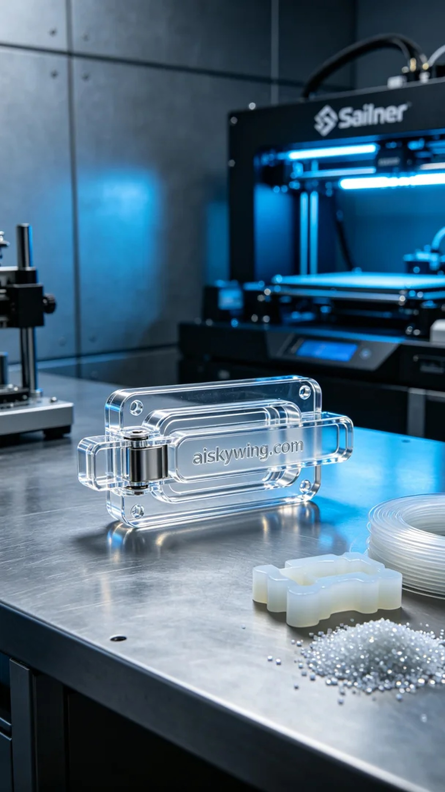
我们最近接到一个关于手套箱锁扣的项目，客户希望提升其锁扣的耐用性与精致度。通过Instagram的留言，他们表示目前使用的锁扣在耐高温和透明度上存在问题，因此希望我们能提供一款更优秀的替代品。
此次生产我们选择了高透明高耐温的PC透明工程塑料作为主要材料，保证锁扣在使用过程中的强度和美观。为了确保打印效果，我们使用的是Stratasys品牌的3D打印机，设置的打印参数为层厚0.1mm，温度设定在90°C，打印速度为30mm/s，预计总打印时间大约需要8小时。
在打印过程中，设备运转顺畅，质量监控系统实时监测着打印状态。随着每一层的叠加，锁扣的轮廓逐渐显现。我们不断观察打印机的运行，确保每个细节都能完美呈现，尤其是表面雕刻的“aiskywing.com”字样。
打印完成后，我们进入了后处理环节。首先将打印好的锁扣放入超声波清洗机进行清洗，以去除表面的残留材料。接着进行打磨，以确保边缘光滑无毛刺。最后，我们将成品放在UV灯下进行固化，增强其耐用性，最后进行严格的检验，以确保符合所有标准。
通过这次项目，我们不仅成功完成了手套箱锁扣的打印，还进一步提升了我们的工艺水平和材料应用能力。每一个细节都不容忽视，才能交出让所有人满意的作品。
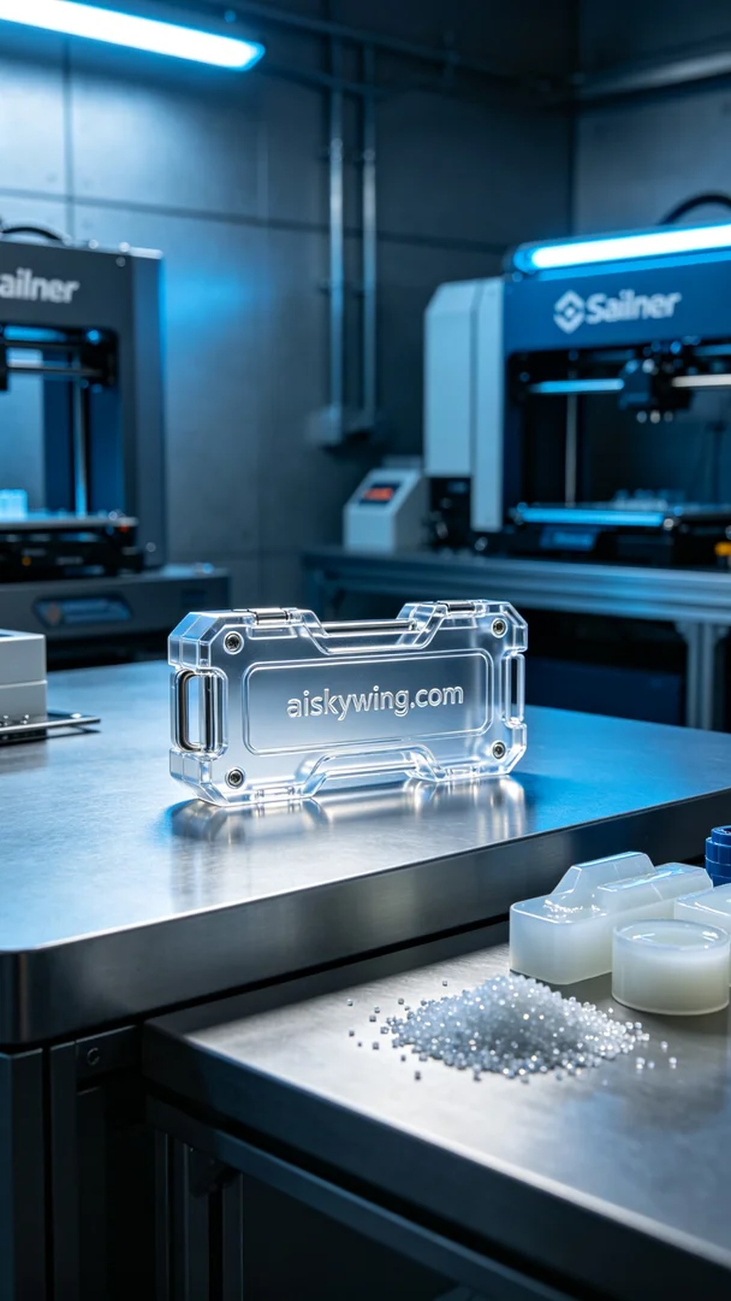
Aiskywing Industrial 3D Printing
Glove box latch


