0836-扶手箱铰链的3D打印记录
Armrest box hinge
🖨️ CNC机加工
🖥️ 打印机: Carbon
📦 材料: 摆放着未成型的液态光敏
生活有时像一场马拉松，关键在于每一步的坚持。就像有人在Instagram上看到我们，找到了这款扶手箱铰链。
Life is sometimes like a marathon; the key lies in persevering with every step. Just like someone saw us on Instagram and found this armrest hinge.
________________________________________________________________________________
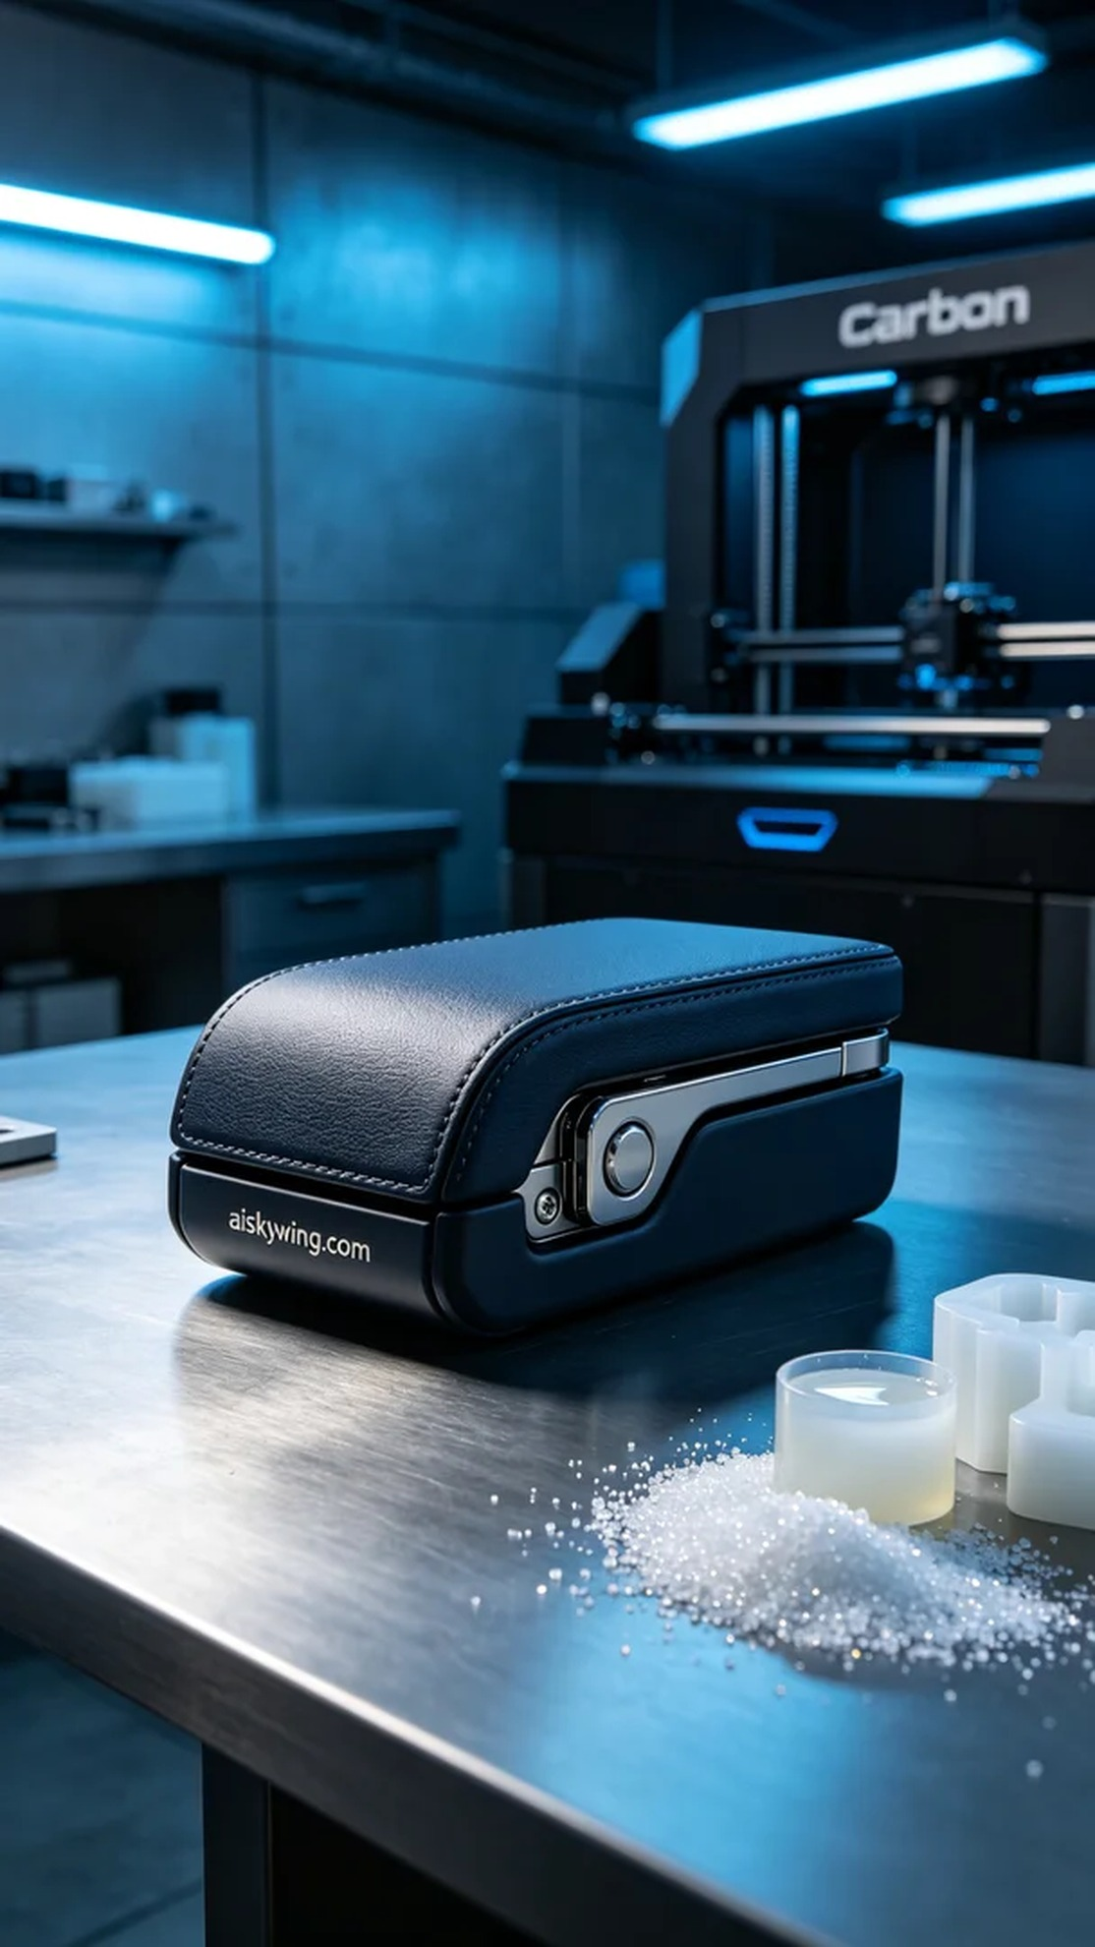
Sometimes, life feels like a marathon, and the key is to persist with every step. Just like when someone spotted us on Instagram and reached out for a custom order of the armrest box hinge.
For this project, we used liquid photopolymer resin, which offers excellent fluidity and moldability. This material is specially treated to ensure high strength and a superb surface finish. When operating our Carbon printer, we set a layer thickness of 0.1mm, maintained a printing temperature of 25°C, controlled the power at 40% for optimal curing, and set the printing speed to 80mm/s, estimating a total print time of 4 hours.
During the printing process, the Carbon printer operated smoothly, with the liquid resin being cured layer by layer. We closely monitored the print quality, ensuring that each layer adhered perfectly to the previous one, avoiding bubbles or defects and guaranteeing a strong and tight final product.
After printing, we moved on to post-processing. First, the finished product was washed using isopropyl alcohol to remove any excess resin from the surface. Next, we sanded the surface with fine sandpaper to eliminate any tiny imperfections, ensuring a smooth, tactile feel. Finally, a curing process was conducted using UV lights to ensure that every part of the resin was fully cured for strength and durability.
Through this meticulous and rigorous process, the armrest box hinge was ultimately presented in pristine condition. Every detail reflects our dedication and craftsmanship, leaving a sense of satisfaction.
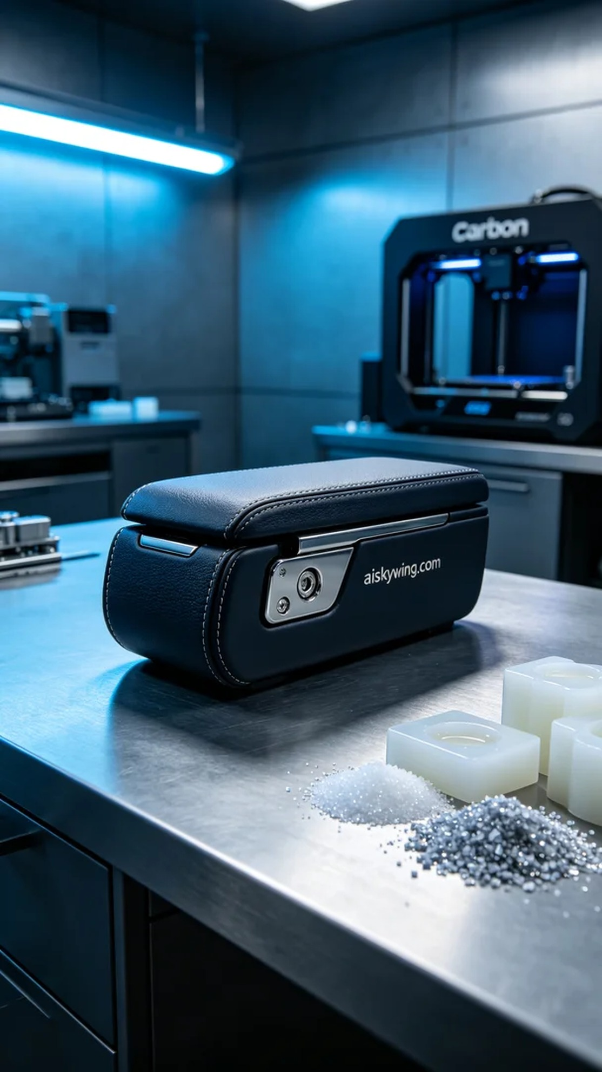
有人在Instagram上看到我们的作品，发现扶手箱铰链在市场上存在耐用性不足的问题，于是决定找我们进行定制生产。面对这样的需求，我们毫不犹豫地接下了这个项目。
我们使用的是摆放着未成型的液态光敏树脂，具备良好的流动性和成型性能。这种材料经过特别处理，能够保证高强度和优良的表面质量。在使用Carbon打印机进行打印时，我们设定了层厚0.1mm，打印温度为25°C，功率控制在40%以确保材料的最佳固化效果，打印速度设定为80mm/s，预计打印时间为4小时。
打印过程中，Carbon打印机的运行非常稳定，液态树脂通过光敏固化逐层成型。我们全程监控打印质量，确保每一层都能与上一层完美结合，避免出现任何气泡或缺陷，确保最终产品的紧密和牢固。
打印完成后进入后处理工序。首先对成品进行清洗，使用异丙醇将表面多余的树脂彻底清除。接着，通过细砂纸对表面进行打磨，消除任何微小的瑕疵，确保触感细腻光滑。最后，进行固化处理，采用UV灯照射，确保每个地方的树脂都能完全固化，保证强度和耐用性。
通过这一系列精细而严谨的工序，扶手箱铰链最终以完美的状态呈现。每一个细节都体现了我们的用心和工艺的严谨，让人倍感欣慰。
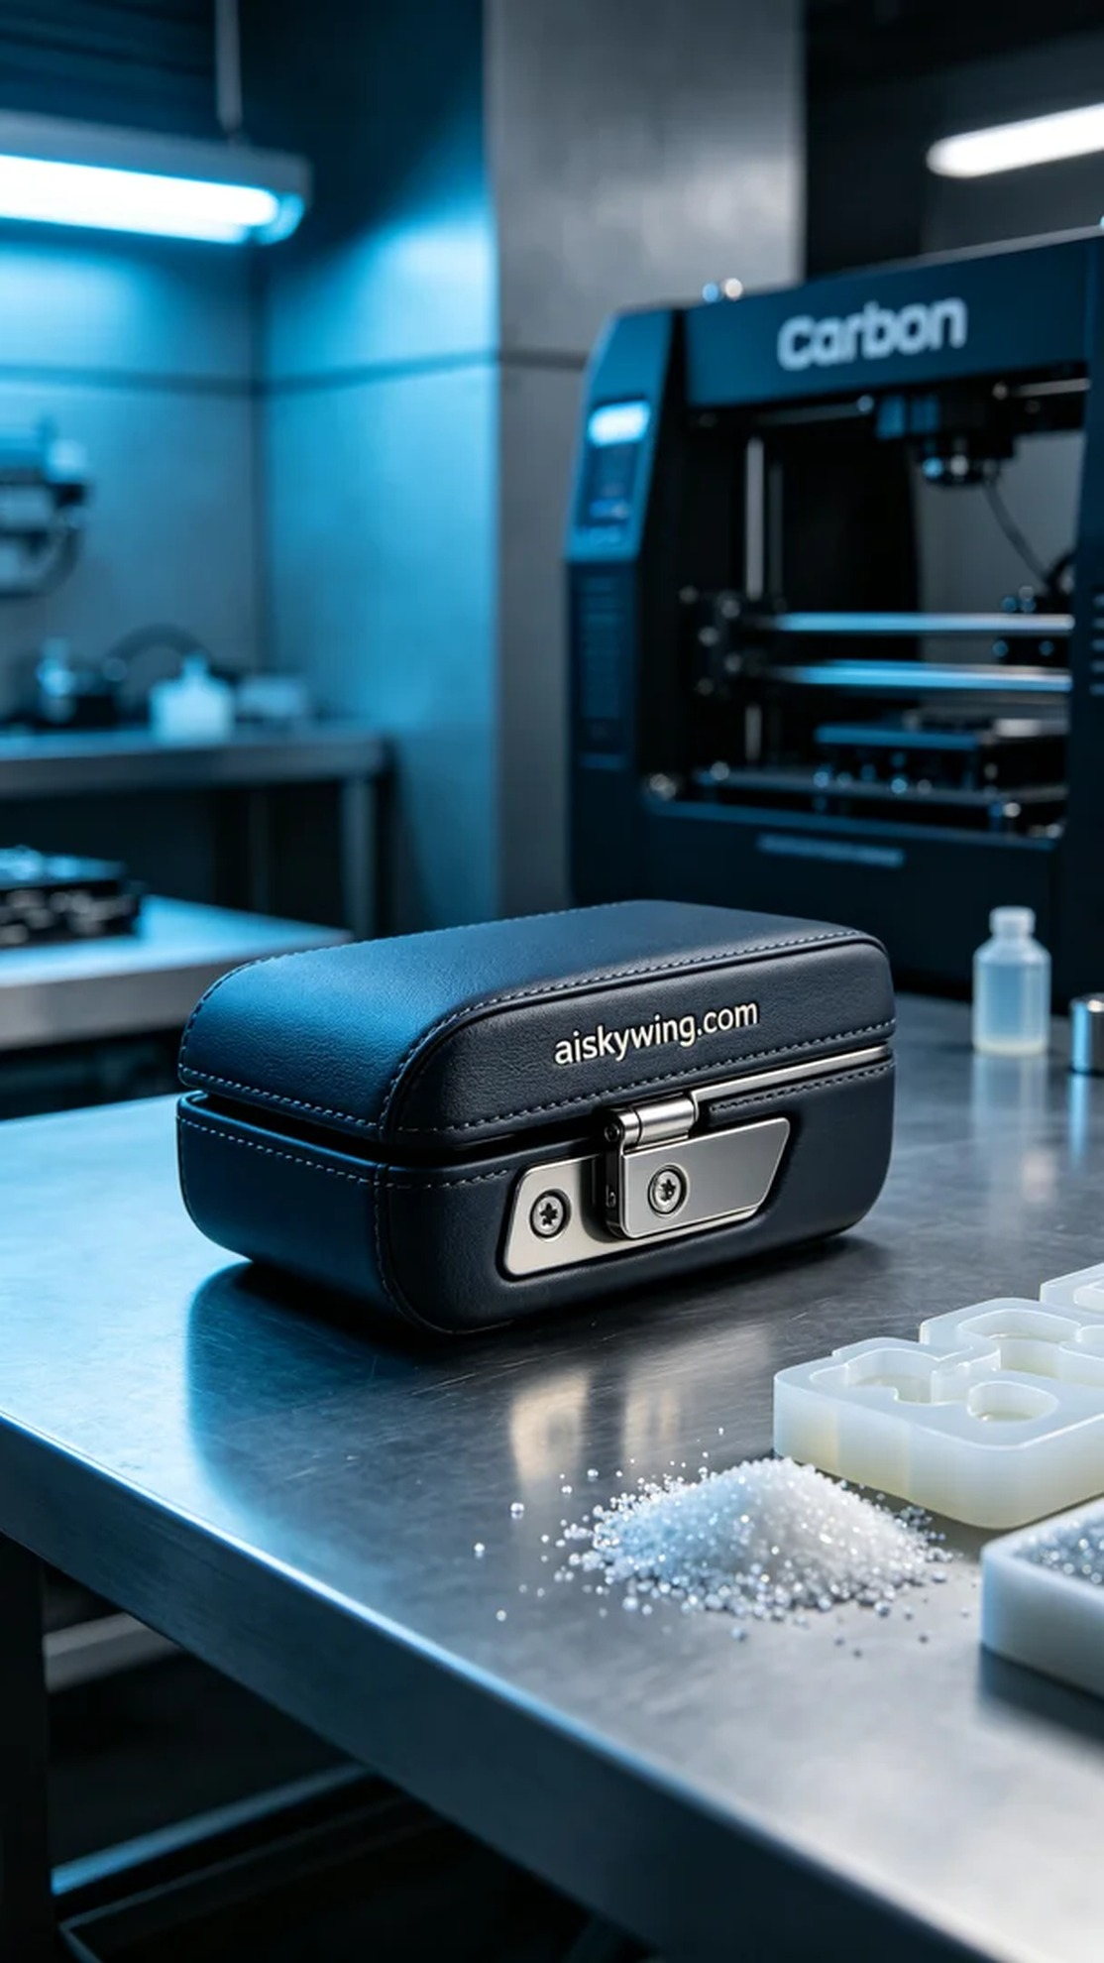
Aiskywing Industrial 3D Printing
Armrest box hinge


