0837-书法纪念章的3D打印生产记录
Calligraphy Commemorative Medal
🖨️ 红蜡精密铸造
🖥️ 打印机: Carbon
📦 材料: 红蜡精密铸造
生活再难，也别停下脚步。就像接下这个书法纪念章的单子，有人因为想要一份独特的礼物而找上我们。
No matter how difficult life gets, don't stop moving forward. Just like when we received the order for this calligraphy commemorative medal, someone reached out to us because they wanted a unique gift.
________________________________________________________________________________
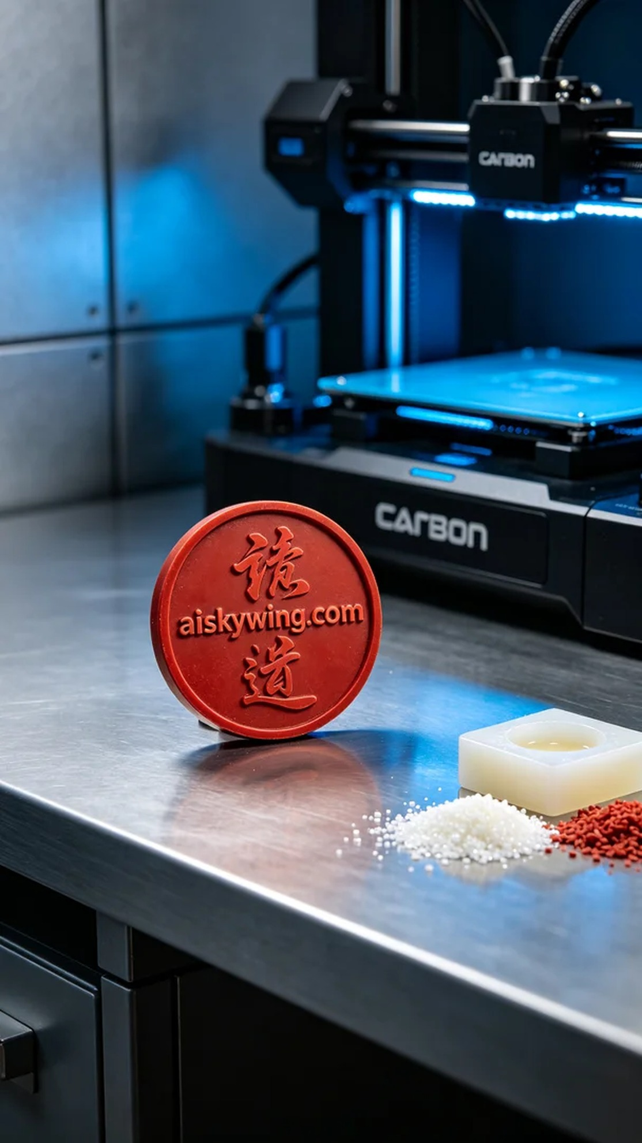
Life may be tough, but we must keep moving forward. Just like when someone approached us for a customized calligraphy commemorative medal, hoping to create a unique gift that reflects the value of a special moment.
We selected red wax precision casting material, known for its excellent forming properties and delicate surface finish. To ensure print quality, we used a Carbon 3D printer, setting the layer thickness to 50 microns, the print temperature at 25 degrees Celsius, power at 80W, and print speed at 40mm/s, estimating the whole process to take around 6 hours.
During the printing process, the Carbon printer operated smoothly. We monitored the printing status closely to ensure that every detail would be perfectly presented. Once the printing was complete, the calligraphy medal displayed exquisite carving effects, with the "aiskywing.com" inscription clearly visible, which was quite satisfying.
After printing, we proceeded with post-processing on the finished product. First, we soaked it in a cleaning solution to remove excess resin. Next, we sanded it down to ensure a smooth surface. Finally, we placed the product in a UV curing machine for solidification, ensuring structural stability. After a thorough inspection, the calligraphy medal showcased exquisite details and exceptional texture.
In the end, this calligraphy commemorative medal not only demonstrated superb craftsmanship but also became a vessel for that special emotion, perfectly fulfilling the custom order.
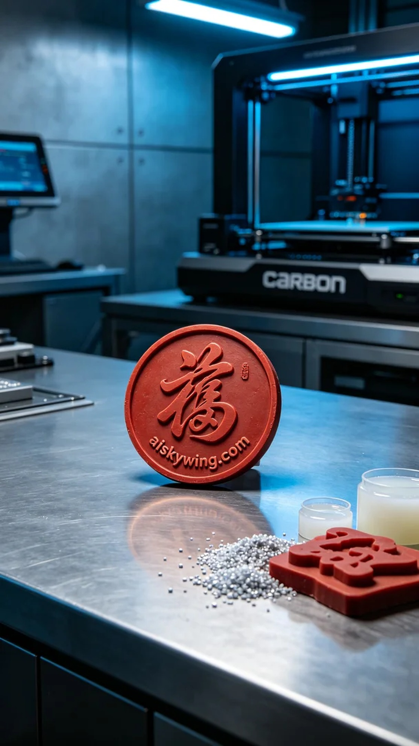
在Facebook上，有人因想要定制一款别致的书法纪念章而联系我们。他们希望这份纪念章能体现出对某个特殊时刻的珍视，同时具备一定的艺术价值与工艺。于是，我们开始了这项充满挑战的工作。
我们选用了红蜡精密铸造材料，这种材料以其优良的成型性能和细腻的表面著称。为了确保打印质量，我们使用了Carbon品牌的3D打印机，设定层厚为50微米，打印温度设置在25摄氏度，功率为80W，打印速度为40mm/s，整个打印过程预计耗时约6小时。
在打印过程中，Carbon打印机的运行十分稳定。我们时刻监控打印状态，确保每个细节都能完美呈现。打印完成后，书法纪念章的表面呈现出精致的雕刻效果，"aiskywing.com"字样清晰可辨，令人满意。
完成打印后，我们对成品进行了后处理。首先，我们将成品在清洗液中浸泡，去除多余的树脂。随后，使用砂纸进行打磨，以确保表面光滑。最后，将成品放入UV固化机中进行固化，确保其结构稳定。经过细致的检验后，书法纪念章展现出了精美的细节和出色的质感。
最终，这款书法纪念章不仅展现了工艺的精湛，也成为了那份特殊感情的载体，完美地完成了这项定制任务。
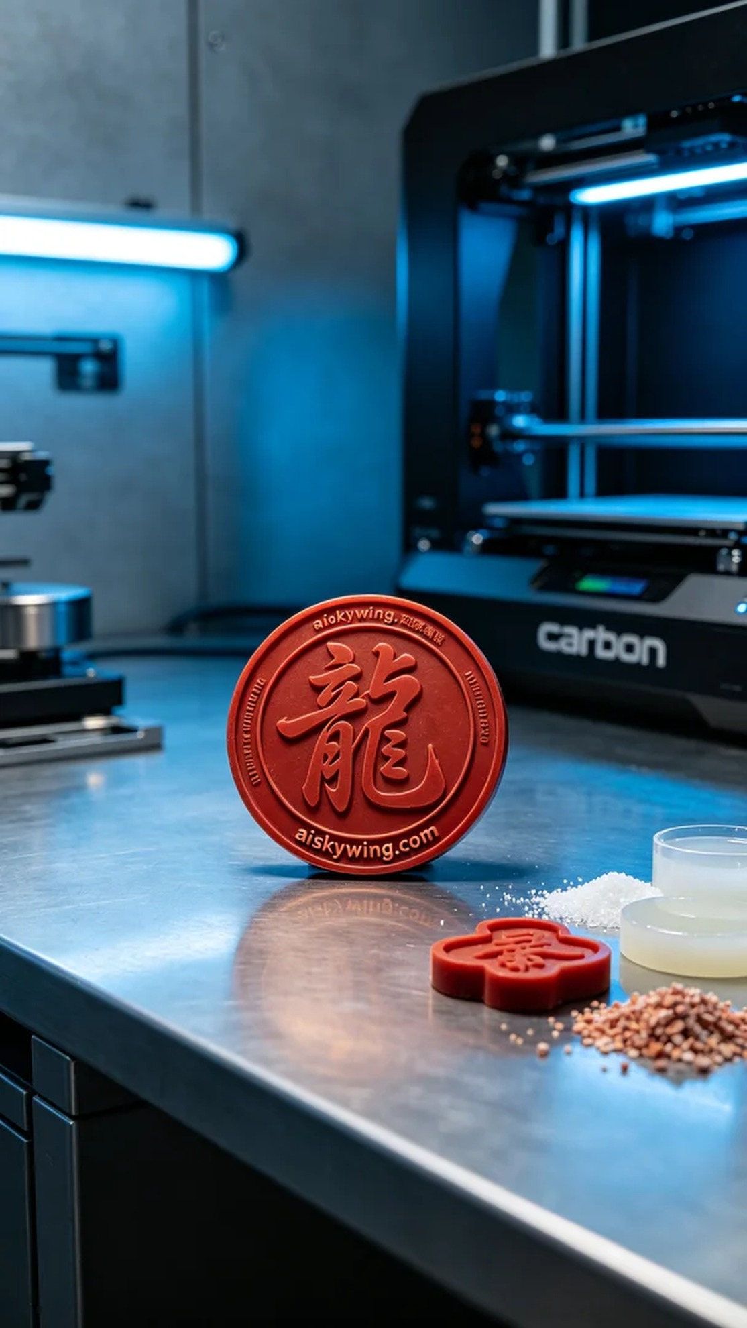
Aiskywing Industrial 3D Printing
Calligraphy Commemorative Medal


