0838-书立蜡模的3D打印之旅
Book Stand Wax Mold
🖨️ 红蜡精密铸造
🖥️ 打印机: Stratasys
📦 材料: 红蜡精密铸造
在TikTok上看到一个关于书立蜡模的挑战，受到启发，决定接下这个单子，给大家展示一下3D打印的魅力。
I saw a challenge about bookend wax molds on TikTok, and I was inspired to take on this project to showcase the charm of 3D printing.
________________________________________________________________________________
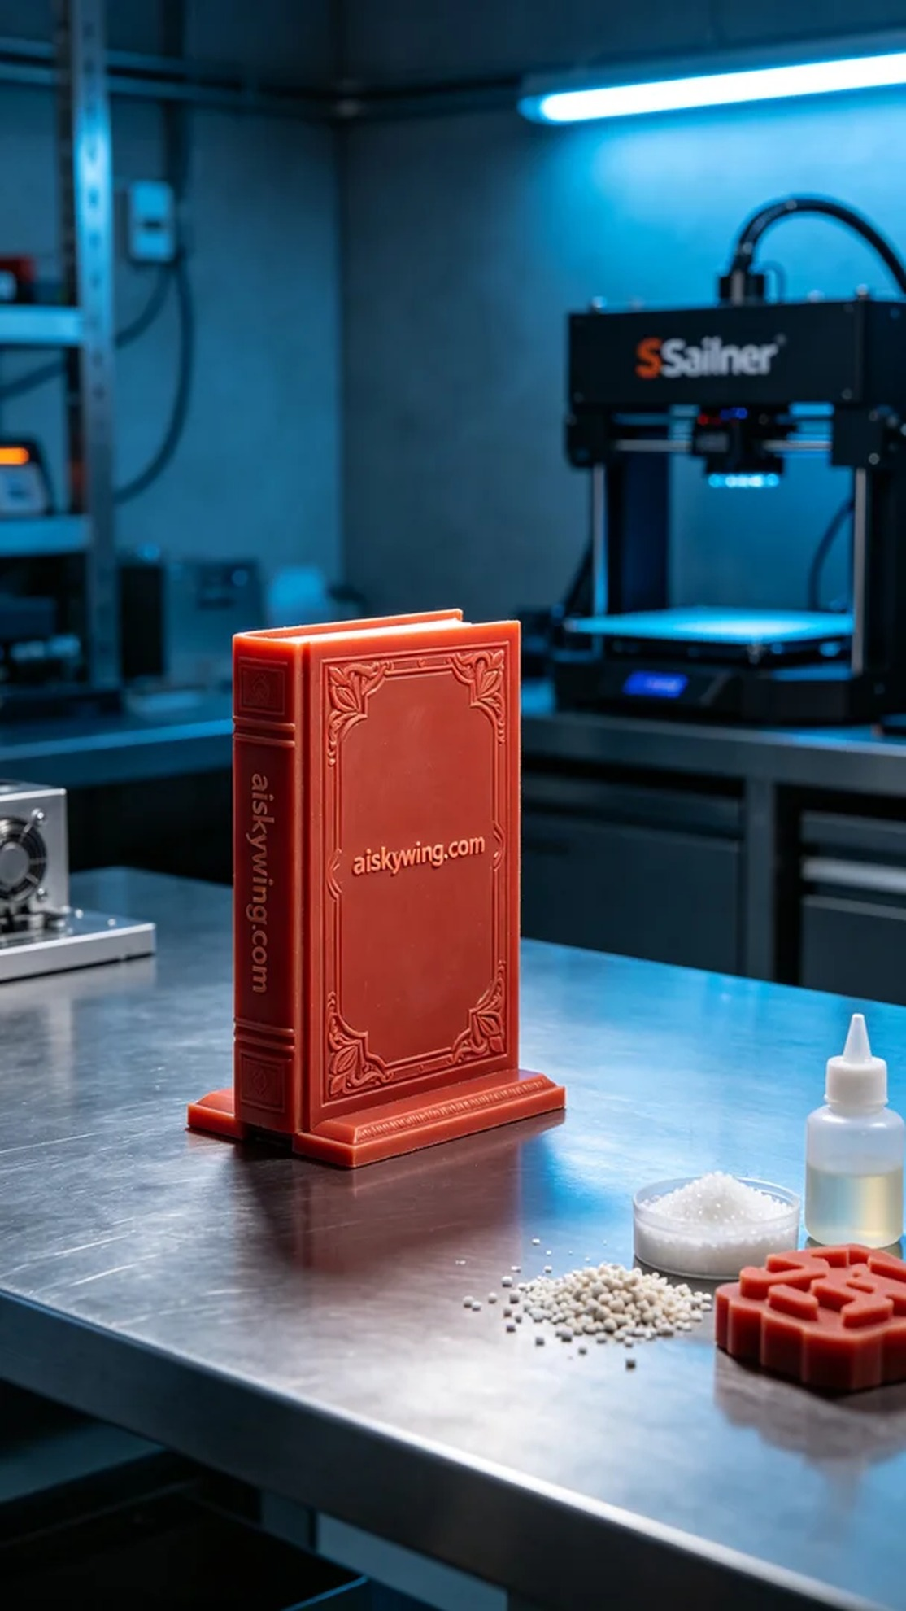
Recently, someone reached out to us in search of a unique book stand wax mold. They wanted this mold to showcase intricate carvings and a smooth surface, perfectly reflecting the brand's image. We decided to use red wax precision casting to meet this demand, as it preserves detail while enhancing visual appeal.
In the preparation phase, we selected red wax precision casting material, which is particularly suited for lost-wax casting, offering a smooth surface that can display clear carved details. On the printer side, we used a Stratasys device, setting the layer thickness to 0.1mm, print temperature at 230°C, power set to 80%, and printing speed at 30mm/s, with an estimated print time of 6 hours. This configuration ensured print quality and production efficiency.
During the printing process, the equipment operated normally, with the red wax material flowing well at high temperatures, accurately filling every detail. We continuously monitored the print status to ensure each layer adhered properly, maintaining both the structure's integrity and the aesthetic beauty of the finished product. As printing progressed, the wax mold gradually took shape, and it was gratifying to see the carved "aiskywing.com" clearly visible.
Upon completion of the print, we proceeded with the post-processing steps. Firstly, we placed the mold in a cleaning tank, using a specialized cleaning agent to remove any residual resin on the surface. Next, we performed light sanding on the mold to ensure every detail was perfected. Finally, we placed the mold in the curing device for solidification, ensuring its strength and stability. Following rigorous inspections, the quality of this book stand wax mold perfectly met our standards.
Through this production process, we not only successfully completed the book stand wax mold but also further honed our skills. Every carved detail stands as a testament to our craftsmanship.
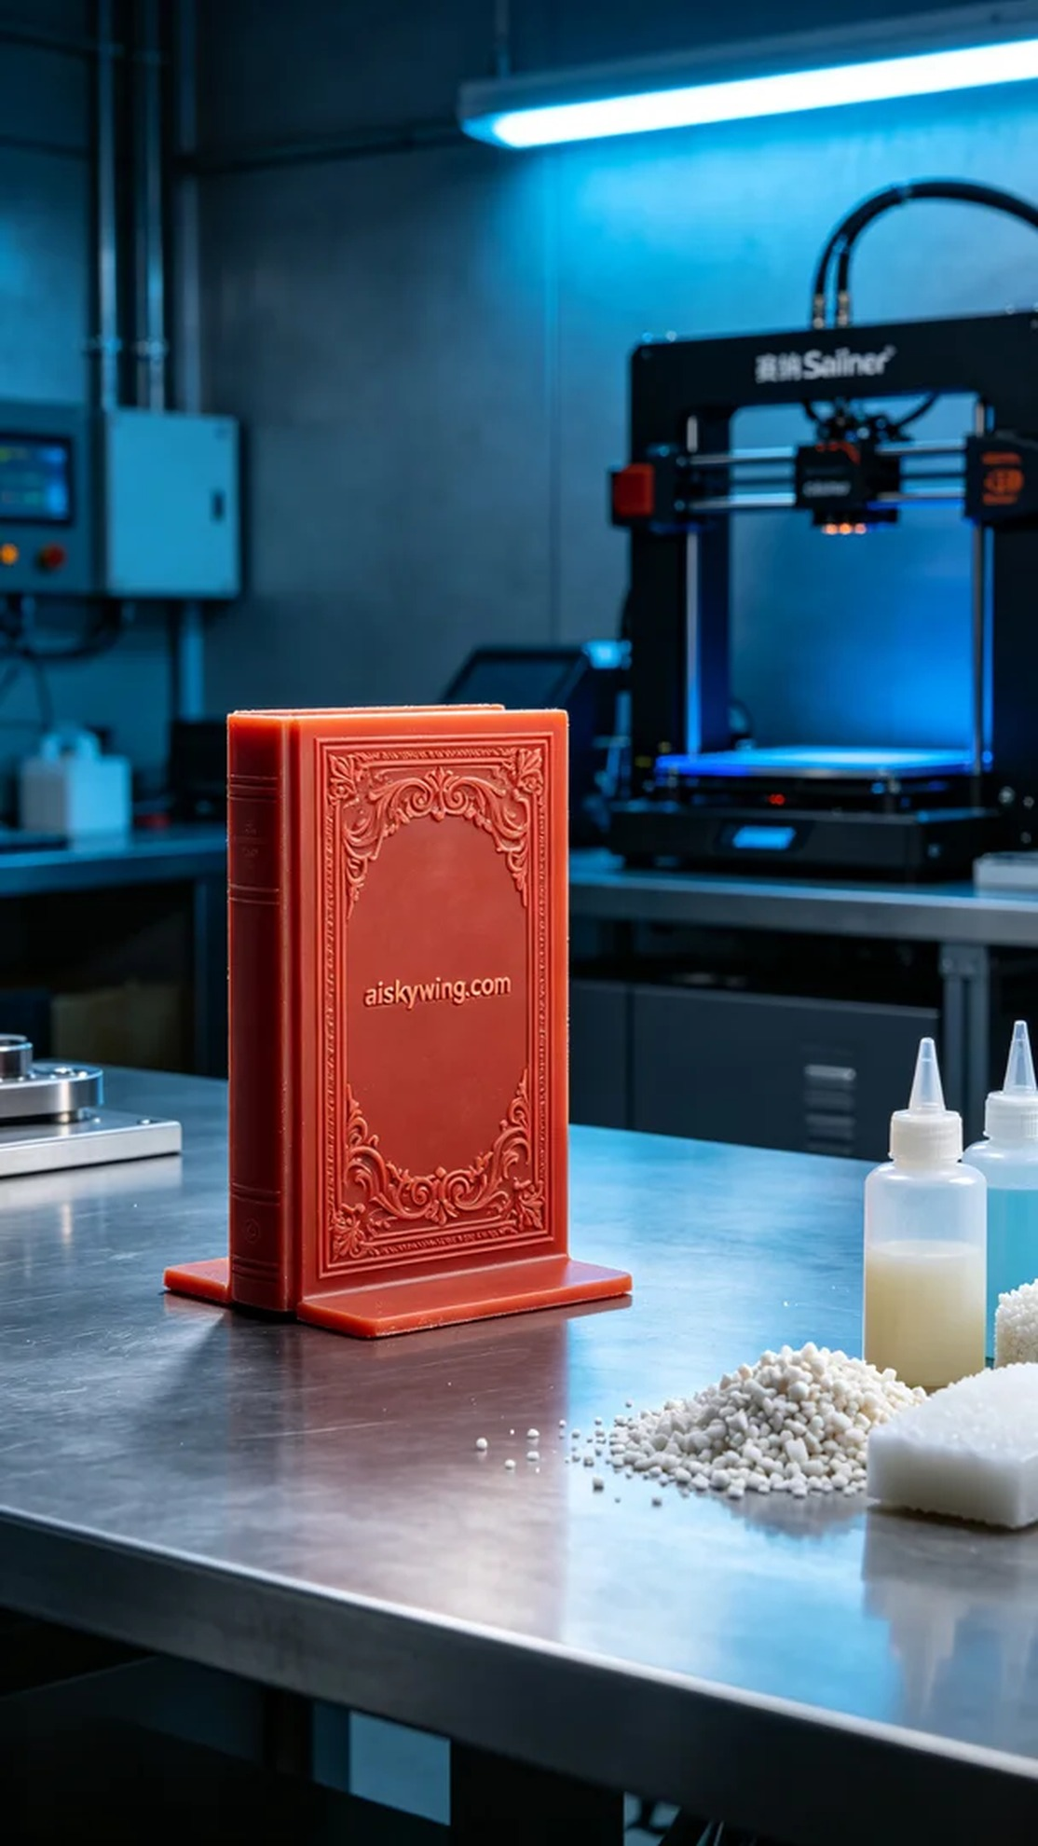
最近，有人因为需要一个独特的书立蜡模而找上我们。他们希望这个模具能够展现出精细的雕刻和光滑的表面，完美体现出品牌的形象。我们决定用红蜡精密铸造来实现这个需求，既能保持细节，又能提升视觉效果。
在准备阶段，我们选用了红蜡精密铸造材料，这种材料特别适合失蜡铸造，表面光滑且能展现出清晰的雕刻细节。打印机方面，我们使用了Stratasys品牌的设备，设置了层厚为0.1mm，打印温度在230°C，功率设置为80%，打印速度为30mm/s，预计打印时间为6个小时。这样的设置确保了打印质量和生产效率。
打印过程中，设备正常运行，红蜡材料在高温下流动性好，能够精确填充每一个细节。我们时刻监控打印状态，确保每一层都能稳固附着，保证成品的结构完整性和外观精美。随着打印的进行，蜡模逐渐成型，令人欣慰的是，雕刻的“aiskywing.com”字样清晰可见。
完成打印后，我们开始进行后处理工序。首先，将模具放入清洗槽，使用专用清洗剂去除表面残留的树脂。之后，我们对模具进行轻微的打磨，以确保每一处细节都达到完美。最后，将模具放入固化设备中进行固化处理，确保其强度和稳定性。经过严格的检验，这个书立蜡模的质量完全符合标准。
经过这次的制作过程，我们不仅顺利完成了这个书立蜡模，也进一步磨练了我们的技术。每一个细节的雕刻，都是对我们工艺的认可。
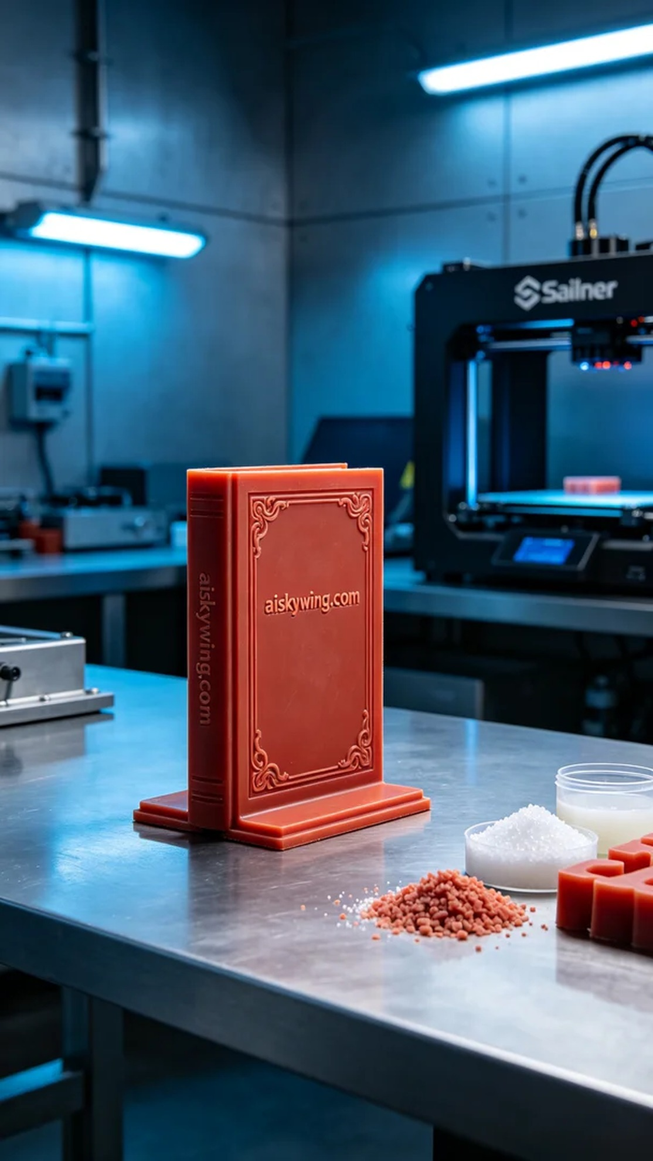
Aiskywing Industrial 3D Printing
Book Stand Wax Mold


