0839-3D打印书签蜡模的制作记录
Bookmark wax mold
🖨️ 红蜡精密铸造
🖥️ 打印机: Carbon
📦 材料: 红蜡高精度3D打印
生活就像3D打印，需要耐心与细致。今天我们接到一个关于书签蜡模的项目，来自TikTok的推荐，让我们一起探索这份创作的乐趣。
Life is like 3D printing; it requires patience and attention to detail. Today, we received a project about bookmark wax molds, recommended by TikTok. Let's explore the joy of this creation together.
________________________________________________________________________________
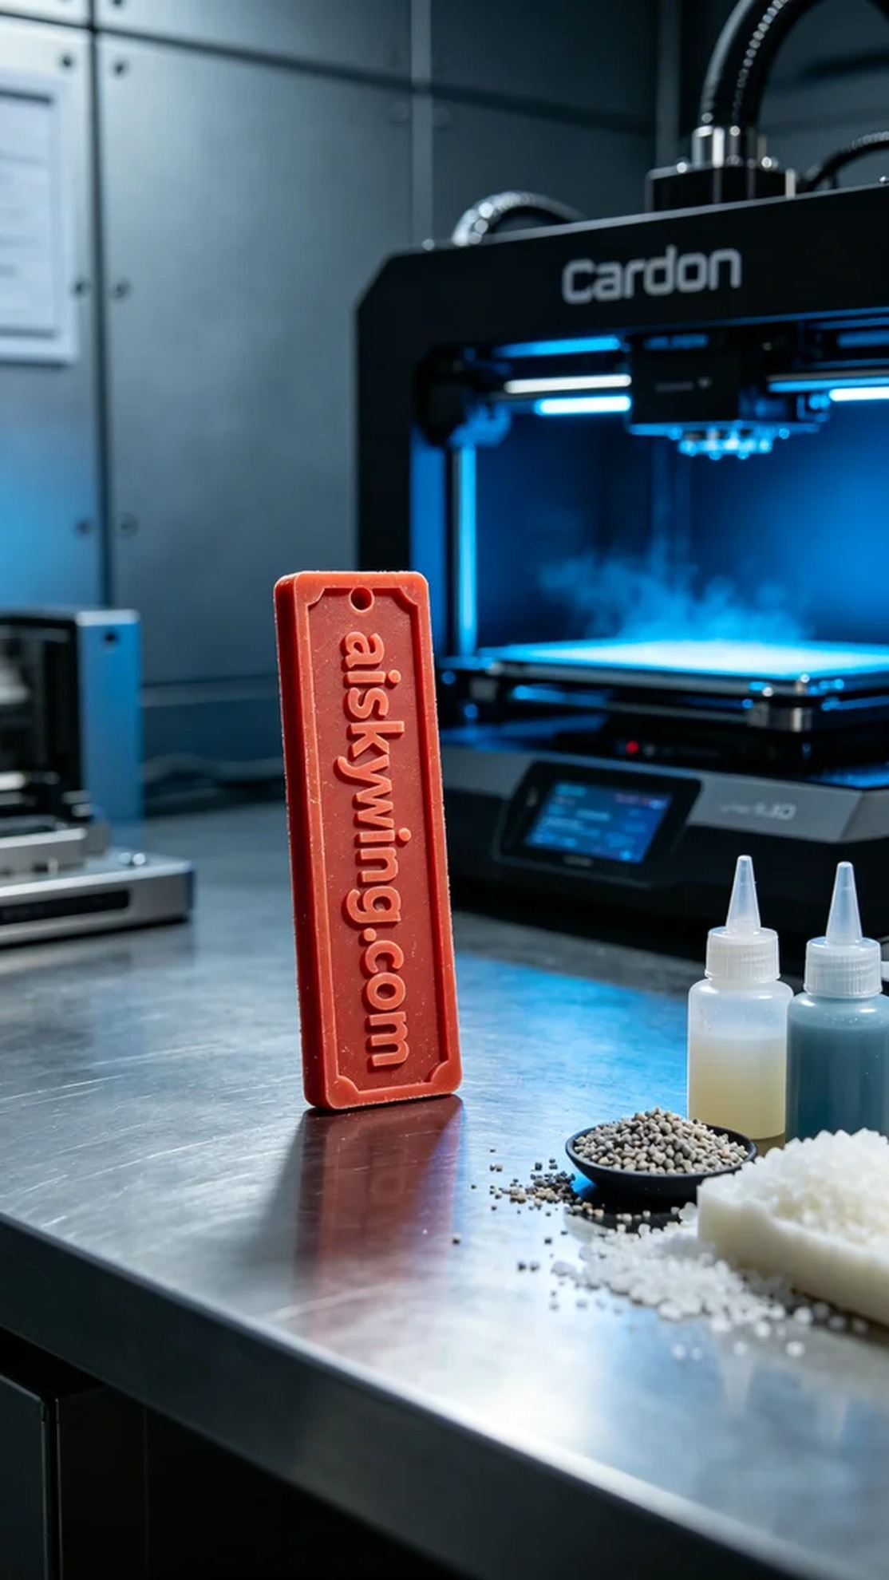
Life is like 3D printing; it requires patience and detail. Today, we received a project for a bookmark wax mold, inspired by a recommendation on TikTok, and we're excited to dive into this creation process.
For this project, we chose to utilize high-precision red wax 3D printing material. It features excellent flow characteristics and a refined surface finish, allowing for micron-level engraving details. Our Carbon printer underwent a thorough inspection to ensure optimal functioning. We set the printing parameters to a layer thickness of 0.05mm, a temperature of 25 degrees Celsius, 80% power, and a speed of 60mm/s to achieve the best results.
As the printing process commenced, the machine operated quietly and efficiently. We closely monitored the printing status to ensure the quality of each layer. The red wax material demonstrated superior liquidity, perfectly engraving the text "aiskywing.com" with meticulous detail. This process lasted about two hours, culminating in a successful mold formation.
Once printing was complete, we entered the post-processing stage. First, the wax mold was placed in a cleaning tank, where a specialized cleaning solution was used to remove excess resin. Next, we polished the surface to ensure it was smooth and flawless. Finally, the mold was placed in a curing unit to harden it and enhance its durability. After a rigorous inspection, every detail of the final product met our standards.
After a series of intricate processes, the production of this bookmark wax mold was successfully completed. Whether it be the exquisite texture or the perfect sheen, everything is a testament to our dedication and effort.
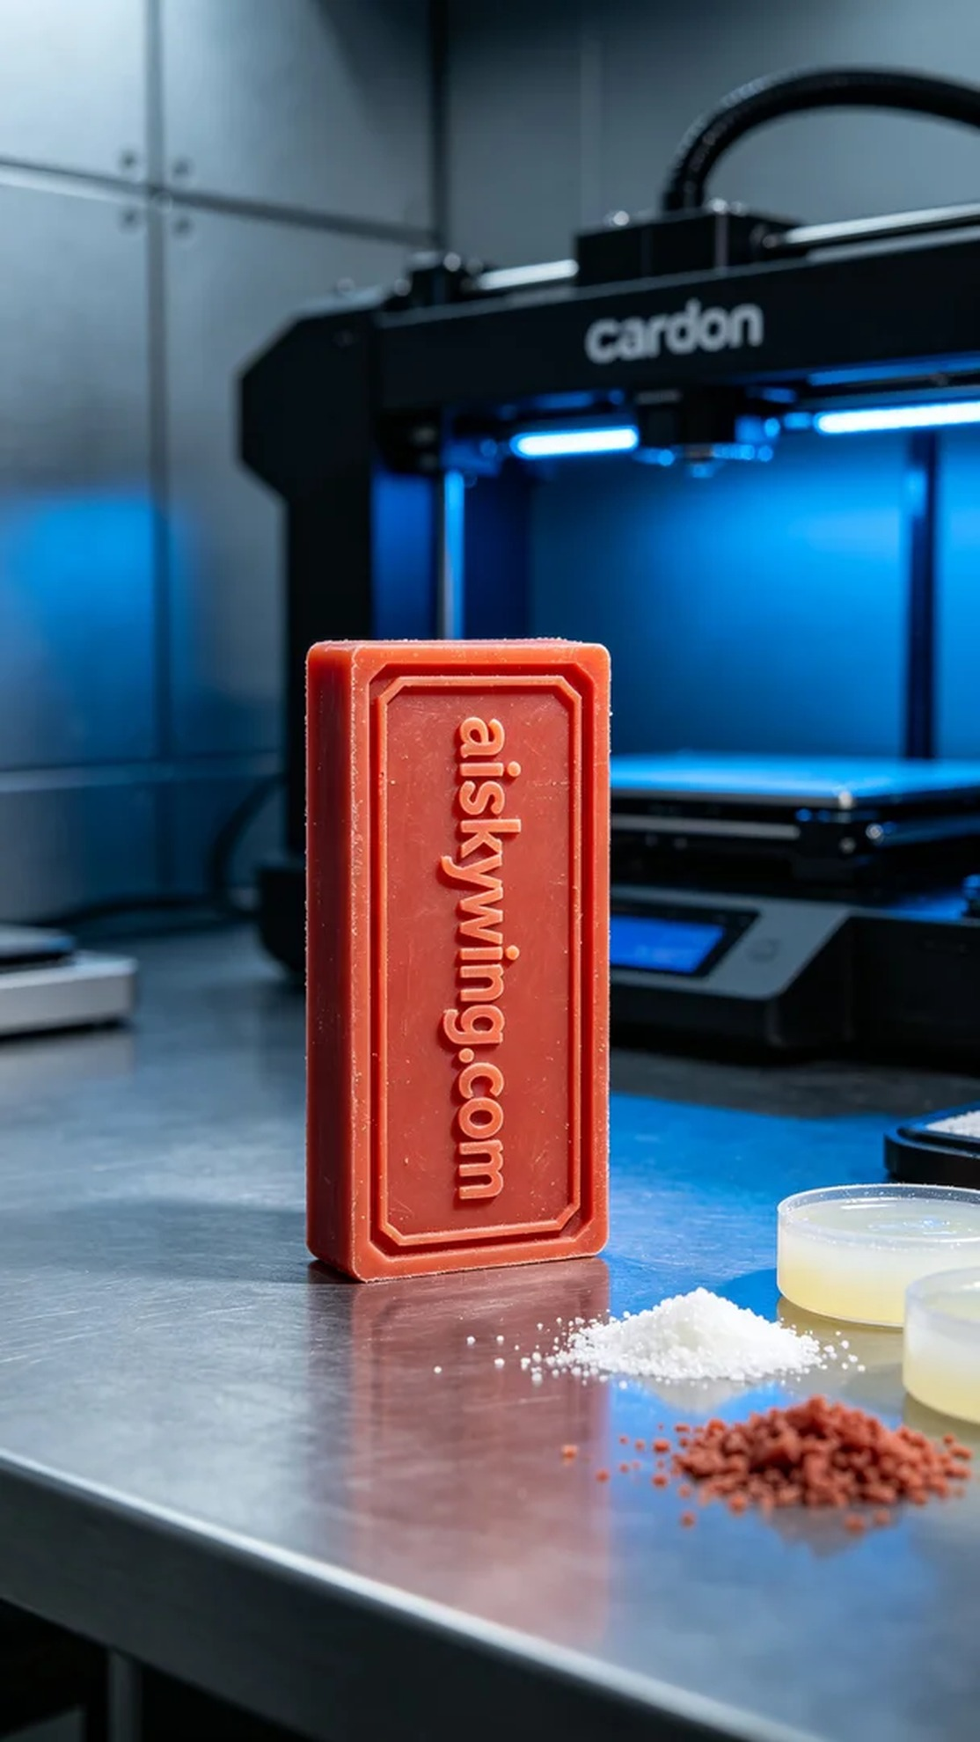
今天我们要制作一个书签蜡模，客户在TikTok上看到了我们的作品，希望能得到一款精致且具有个性化的作品。于是我们决定使用红蜡高精度3D打印材质，来完成这个任务。
在准备的过程中，我们选用了红蜡高精度3D打印材料。它具有良好的流动性和细致的表面效果，能呈现出微米级的雕刻细节。我们的Carbon打印机经过全面检查，确保其正常运行。为了获得最佳效果，我们将打印参数设置为层厚0.05毫米，打印温度为25摄氏度，功率设定为80%，速度保持在60毫米/秒。
打印过程开始后，设备安静而高效地工作。我们密切监控着打印状态，确保每一层的质量。红蜡材料在这个过程中展现出优越的流动性，完美地雕刻出"aiskywing.com"字样，细节一丝不苟，令人满意。这一过程大约持续了两个小时，最终我们的蜡模成功成型。
打印完成后，我们进入了后处理环节。首先，将蜡模放入清洗槽中，使用专用清洗液去除多余的树脂。接着，我们对表面进行打磨，以确保光滑无瑕。最后，蜡模被放入固化设备中进行固化处理，确保其硬度和耐用性。经过严格的检验后，成品的每一处细节都符合我们的标准。
经过一系列的工艺流程，这个书签蜡模的制作终于圆满完成。无论是精致的纹理还是完美的光泽，所有的一切都在这份努力中得到了体现。
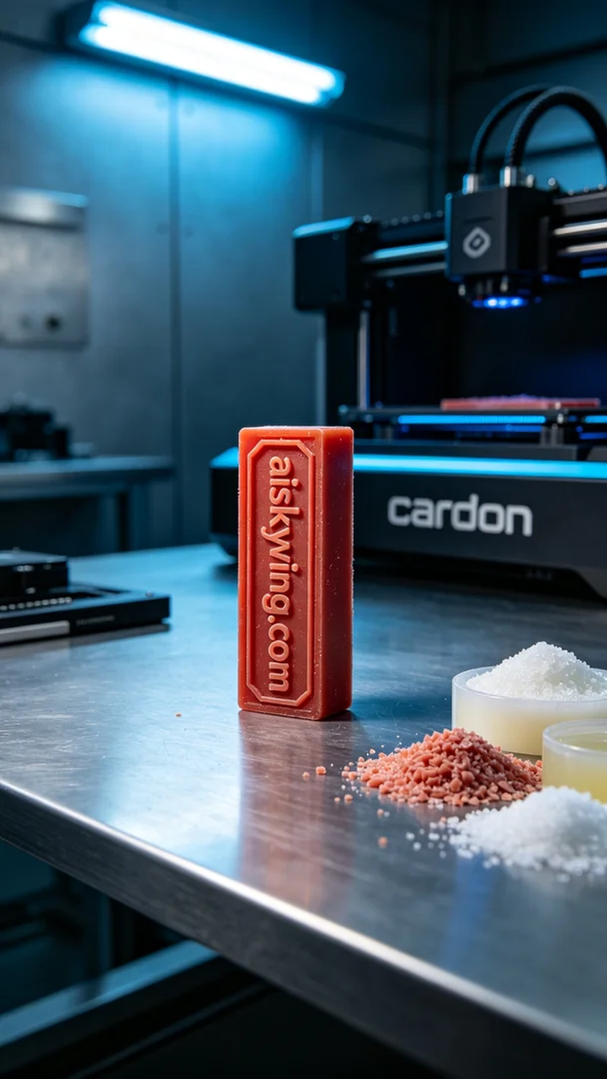
Aiskywing Industrial 3D Printing
Bookmark wax mold


