0840-人物雕塑的3D打印记录
Character Sculpture
🖨️ 红蜡精密铸造
🖥️ 打印机: Rize
📦 材料: 红蜡高精度3D打印
在TikTok上，有人看到我做的这个人物雕塑，惊叹不已，便找上我，希望打造出同样精致的作品。
On TikTok, someone saw the character sculpture I made and was amazed, so they reached out to me hoping to create a similarly exquisite piece.
________________________________________________________________________________
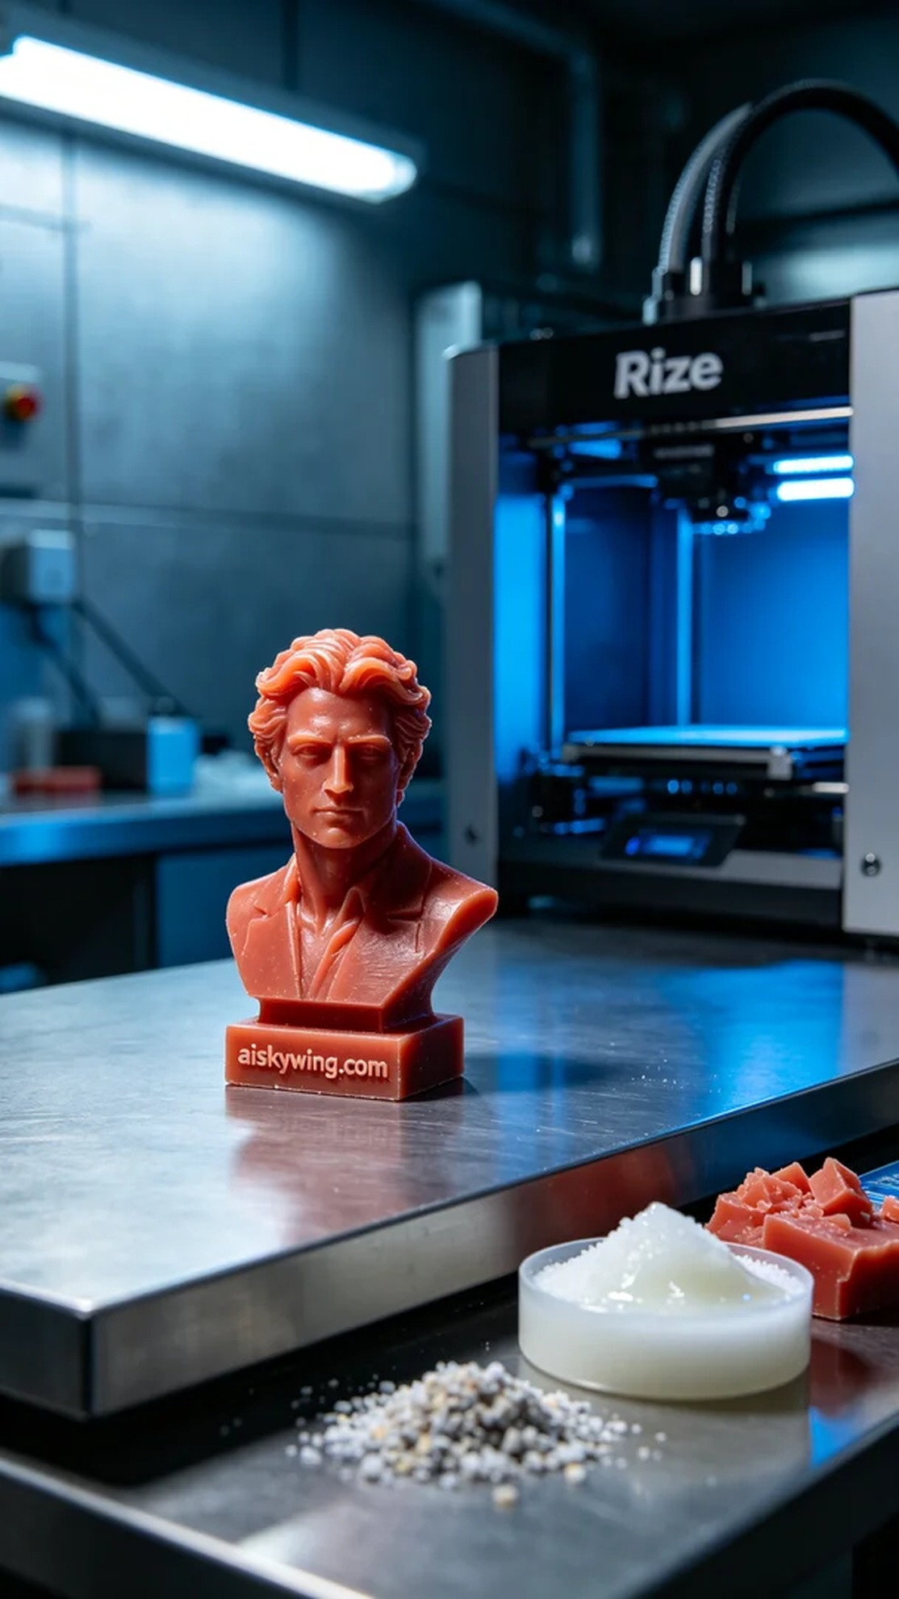
This project involved a detailed human sculpture, initiated by someone who saw my work on TikTok and wanted to create a similar piece. They emphasized the importance of craftsmanship and realism. Therefore, I decided to utilize high-precision red wax 3D printing material and prepared my trusted Rize printer for this task.
For materials, I opted for high-precision red wax 3D printing material, known for its excellent surface gloss and outstanding performance in micro-level detail carving. To ensure quality, I set the printing parameters to a layer thickness of 0.1mm, a printing temperature of 60 degrees Celsius, power adjusted to 70%, and a speed of 50mm per second. The entire printing process was expected to last around 8 hours.
As the printing process began, the Rize printer ran smoothly. I monitored the print status in real-time, ensuring there were no defects. The machine's cooling system worked effectively, preventing deformation or shrinkage of the red wax material during printing. Upon completion, I meticulously checked the overall effect, and I was very pleased with the clarity of the details.
Post-processing was key to achieving perfection. First, I placed the printed sculpture in a cleaning tank, using warm water and a specialized cleaning agent to remove any residues. After cleaning, I smoothed the surface with fine sandpaper, ensuring every corner was flawless. Finally, to enhance the sculpture's stability and gloss, I performed a curing treatment, ensuring the final product showcased the best possible result under light, followed by a thorough inspection.
In the end, the sculpture not only turned out beautifully but also met all expectations regarding detail and texture. This experience reinforced my belief in the charm and potential of 3D printing.
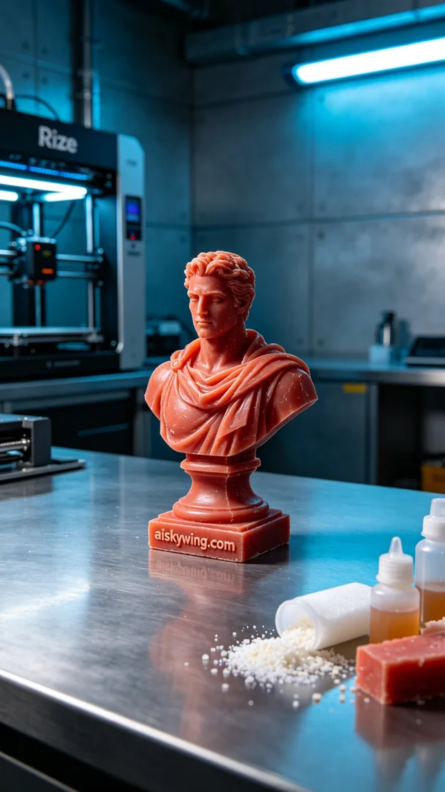
这次的项目是一个人物雕塑，目标是实现高精度的细节表现。有人在TikTok上看到我的作品，想要我帮助他们完成一个类似的雕塑，强调了细致的工艺与真实的质感。于是，我决定使用红蜡高精度3D打印材质，准备好我最信赖的Rize打印机来执行这个项目。
在材料方面，我选择了红蜡高精度3D打印材料。这种材料不仅能提供出色的表面光泽感，而且在微米级别的细节雕刻方面表现突出。为确保打印质量，我将打印参数设置为层厚0.1毫米，打印温度设为60摄氏度，功率调节至70%，速度保持在50毫米每秒，整个打印过程预计持续约8个小时。
打印过程开始后，Rize打印机稳定地运转着。通过实时监控，我观察到每一层的打印状态，确保没有任何瑕疵产生。同时，机器的冷却系统保持良好，使得红蜡材质在打印过程中不出现变形或收缩的问题。打印结束后，经过仔细检查，整体效果让我十分满意，细节清晰可见。
后处理是实现完美的关键步骤。首先，我将打印好的雕塑放入清洗槽中，使用温水和专用清洗剂去除表面的残留物。清洗完成后，雕塑还需要打磨，我用细砂纸轻轻打磨表面，确保每个角落都光滑如新。最后，为了增强雕塑的稳定性和光泽感，我进行了一次固化处理，确保成品在光线下呈现出最好的效果，最后进行全面检验。
最终，这个雕塑不仅完成得非常顺利，细节与质感都达到了预期效果。通过这次经历，我更加坚信3D打印的魅力与潜力。
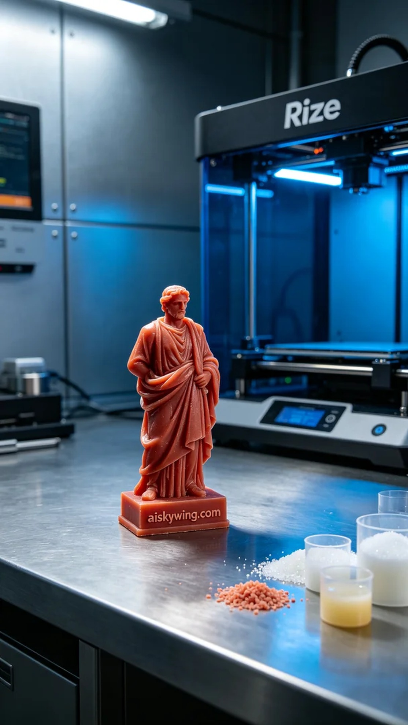
Aiskywing Industrial 3D Printing
Character Sculpture


