0841-蜡模的极致工艺之旅
Corporate Logo Wax Mold
🖨️ 红蜡精密铸造
🖥️ 打印机: Systems
📦 材料: 红蜡高精度3D打印
在Instagram上，有人想要一款极致精细的企业标志蜡模，正是这个企业标志蜡模置于画面正中央的挑战，让我感受到3D打印的奥妙与魅力。
On Instagram, someone wanted an exquisitely detailed wax model of a corporate logo. The challenge of placing this wax model of the logo right in the center of the frame made me appreciate the wonders and charm of 3D printing.
________________________________________________________________________________
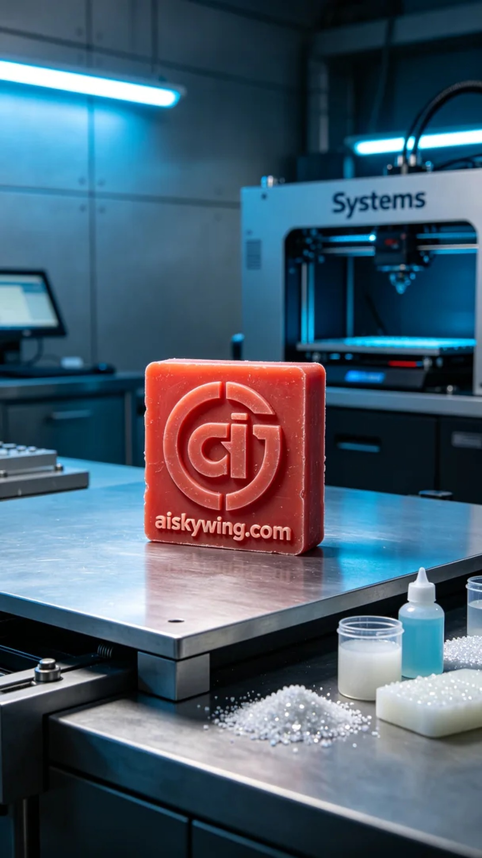
A request for an exquisite corporate logo wax model came from someone seeking assistance on Instagram. They wanted a model with a smooth surface and rich details to represent their unique brand. Thus, I decided to utilize high-precision red wax 3D printing technology to meet this challenge.
To ensure optimal printing results, I prepared high-quality red wax material and selected a Systems brand 3D printer. During parameter setup, I set the layer thickness to 0.05 mm, temperature to 60℃, power to 75%, and maintained a printing speed of 30 mm per second. The entire printing process was estimated to take about 5 hours, aiming for clear visibility of every detail.
Throughout the printing process, the equipment operated smoothly, and I closely monitored each layer's quality to avoid bubbles or impurities. As time passed, the wax model gradually took shape, reflecting the stark light, and I marveled at the beauty of it all.
After printing, I began the post-processing workflow. First, I placed the wax model in a cleaning solution to remove surface residues, and then carefully sanded it to enhance its smoothness. Next, I cured the wax model to ensure its stability and durability, followed by a thorough inspection to guarantee that every detail was flawless.
After a series of meticulous operations, I finally completed the exquisite corporate logo wax model. Seeing it shine under the light with its waxy luster filled me with a sense of accomplishment.
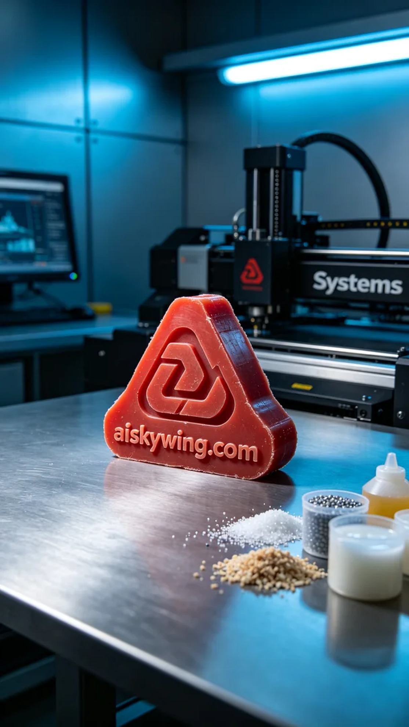
制作企业标志蜡模的请求来自于一位在Instagram上寻求帮助的朋友。他希望能打造一个表面光滑、细节丰富的蜡模，呈现出其企业的独特形象。于是，我决定利用红蜡高精度3D打印技术来解决这个问题。
为了确保打印效果，我准备了高质量的红蜡材料，选择了Systems品牌的3D打印机。设定打印参数时，我将层厚设为0.05毫米，温度控制在60℃，功率调至75%，打印速度保持在30毫米每秒。预计整个打印过程大约需要5小时，力求每个细节都清晰可见。
在打印过程中，设备的运行状态十分平稳。我仔细监控每一层的打印质量，确保没有出现任何气泡或杂质。随着时间的推移，蜡模逐渐成型，表面反射出冷峻的光线，我感受到了这一切的美妙。
打印完成后，我开始了后处理工序。首先，我将蜡模放入清洗液中进行清洗，去除表面的残留物，然后小心地用砂纸打磨，提升光滑度。接下来，将蜡模固化，以确保其稳定性和耐用性，最后对其进行全面检验，确保每个细节都完美无瑕。
经过一系列精细的操作，最终完成了这款精美的企业标志蜡模。看到它在光线下闪耀的蜡质光泽，我心中充满了成就感。
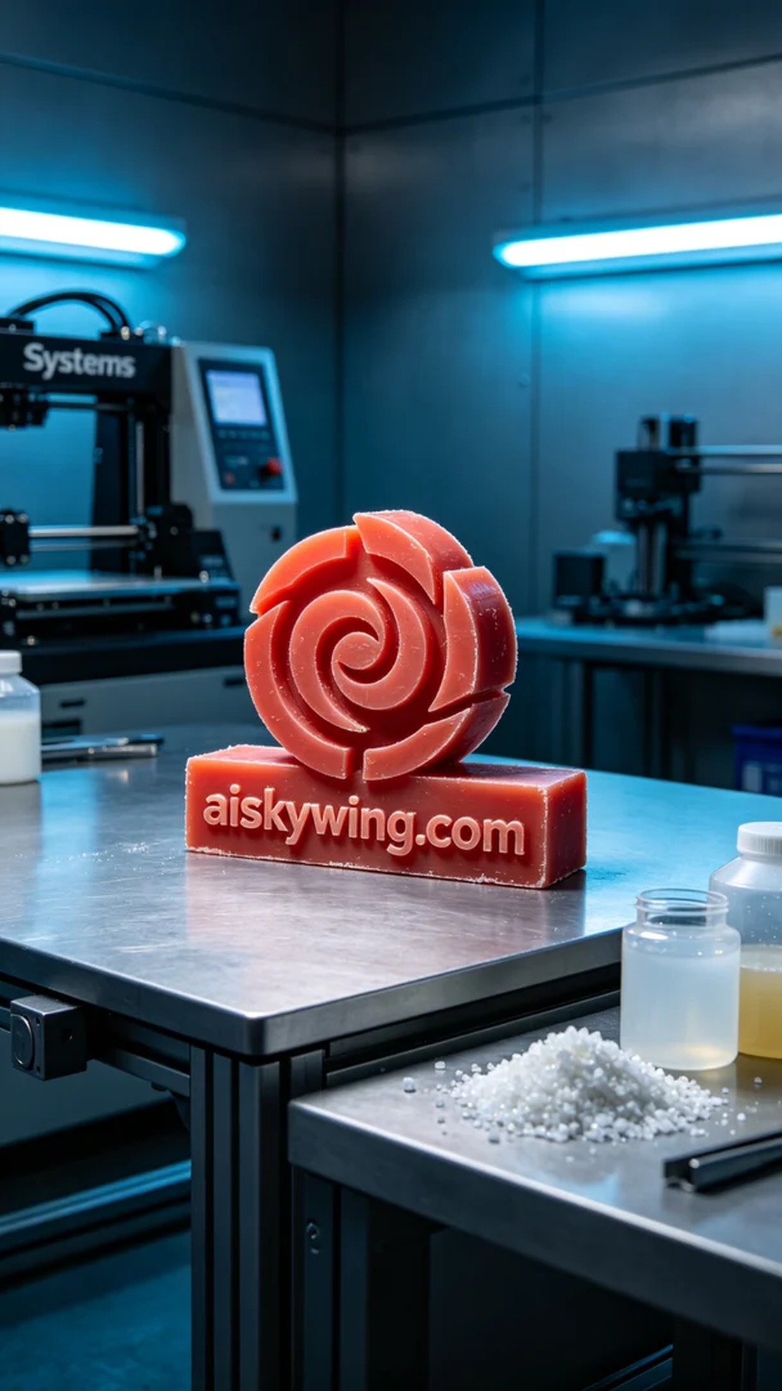
Aiskywing Industrial 3D Printing
Corporate Logo Wax Mold


