0842-体育纪念章3D打印生产记录
Sports Commemorative Medal
🖨️ 红蜡精密铸造
🖥️ 打印机: Xjet
📦 材料: 红蜡高精度3D打印
生活就像一场比赛，胜者总是在艰难中坚持。有人通过WhatsApp找上我们，希望制作一枚体育纪念章，展现运动精神与荣耀。
Life is like a competition; the winners are those who persevere through difficulties. Someone reached out to us via WhatsApp, hoping to create a sports medal that embodies the spirit and glory of sports.
________________________________________________________________________________
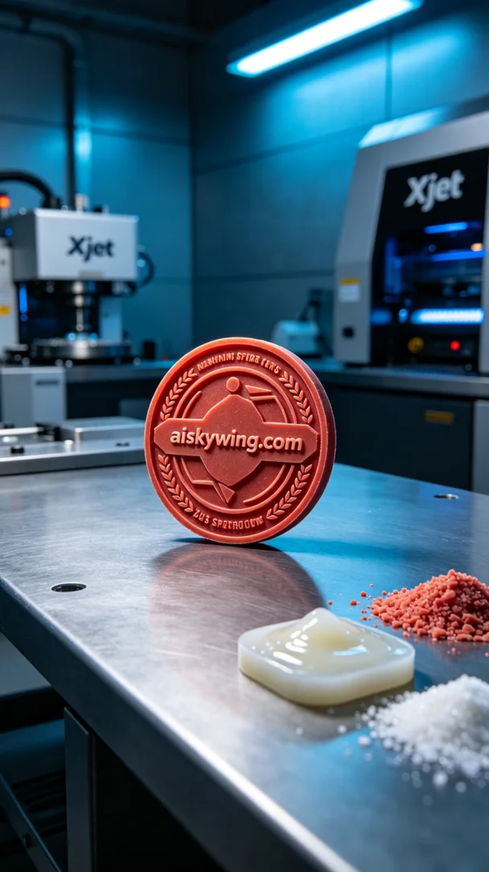
Life is like a competition; winners persist through difficulties. Someone reached out via WhatsApp, seeking to create a sports medal that embodies the spirit and glory of athletic achievement.
We received a request for a sports medal, as someone believes it would convey their love and pursuit of sports. To achieve this goal, we decided to use high-precision red wax 3D printing technology to ensure every detail was flawless.
When preparing the materials, we opted for red wax as our 3D printing medium, known for its excellent gloss and fine engraving effects, making it ideal for displaying the complex details of the badge. The Xjet printer was thoroughly checked to ensure it was functioning properly. The printing parameters were set with a layer thickness of 0.05 mm, a printing temperature of 30 degrees Celsius, a power setting of 50 watts, a printing speed of 40 mm per second, and an estimated total print time of 8 hours.
As the printing process commenced, we closely monitored the equipment's operation to ensure smooth movement of the print head and that each layer formed as expected. The entire process was conducted under cool-toned lighting, highlighting the waxy sheen of the material and the intricate engraving details. With each layer added, the medal gradually took shape, and the quality was assured.
After printing, we meticulously executed multiple post-processing steps. First, the finished product was immersed in a cleaning solution to remove any residual materials. Next, we hand-sanded the edges for a precise finish, ensuring no burrs or imperfections remained. Subsequently, we cured the piece to enhance its hardness and durability. Finally, we conducted strict inspections to ensure every detail met our high standards, confirming that the finished product was indeed a work of art.
After a long day of work, this sports medal was finally completed, perfectly embodying the spirit of athletics. Each print is a testament to our dedication and craftsmanship.
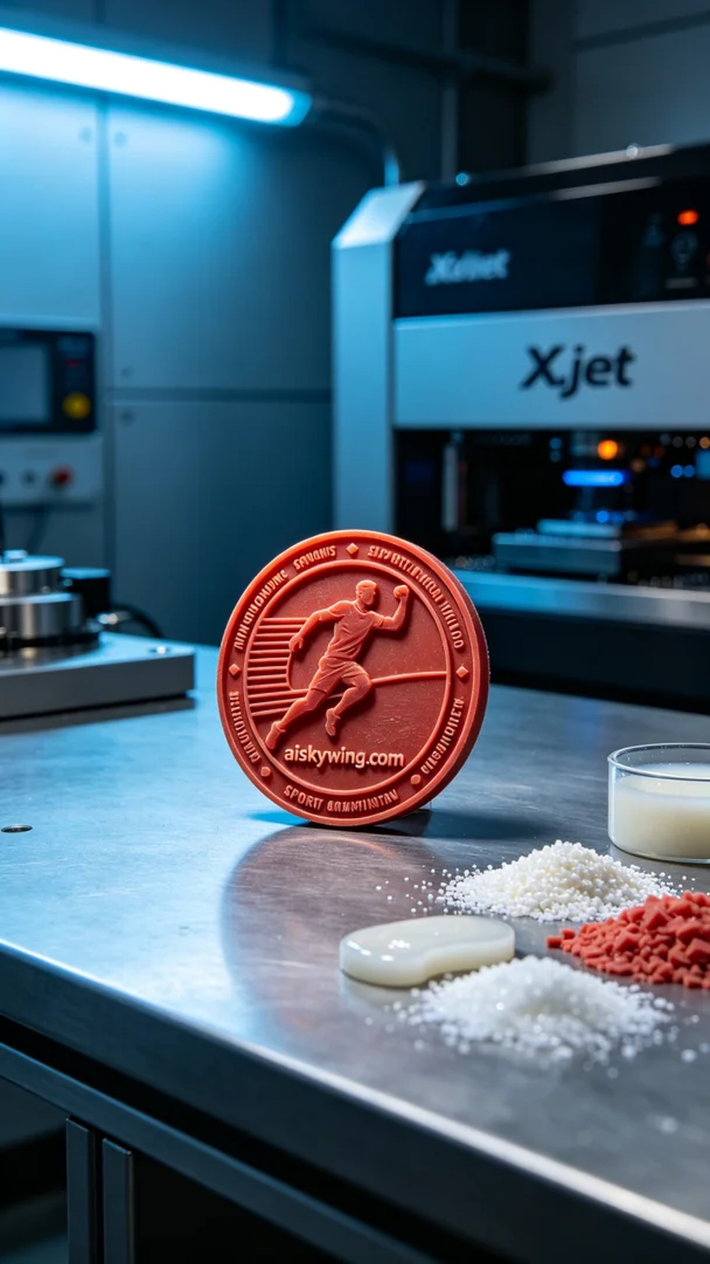
我们接到一个需求，希望制作一枚体育纪念章。有人觉得这枚纪念章能传达他们对运动的热爱与追求。为了达到这个目标，我们决定使用红蜡高精度3D打印技术，以确保每一个细节都完美无瑕。
在准备材料时，我们选择了红蜡作为3D打印的原材料，这种材料具有优良的光泽和精细的雕刻效果，非常适合展现徽章的复杂细节。使用的Xjet打印机经过彻底检查，确保其正常运转。打印参数设置为：层厚0.05毫米，打印温度设定在30摄氏度，功率为50瓦，打印速度调整为40毫米每秒，预计打印总时间为8小时。
打印过程开始后，我们密切监控设备运行状态，确保打印头的移动顺畅，每一层的成型都达到了预期。整个过程在冷色调的光线下进行，充分展现了材料的蜡质光泽和细腻的雕刻细节。随着每一层的叠加，纪念章逐步显现出它的轮廓和字样，质量得到了很好的保障。
打印完成后，我们进行了多道后处理工序。首先，将成品放入清洗液中，去除表面的残留物。接着，通过手工打磨，细致修整每个角落，确保没有毛刺或瑕疵。然后，将其固化，以增强材料的硬度和耐用性。最后，我们进行了严格的检验，确保每一个细节都符合标准，成品无疑是一件艺术品。
经过一整天的努力，这枚体育纪念章终于在我们手中完成，完美地展现了运动的精神。每一次打印，都是对工艺的磨练与提升。
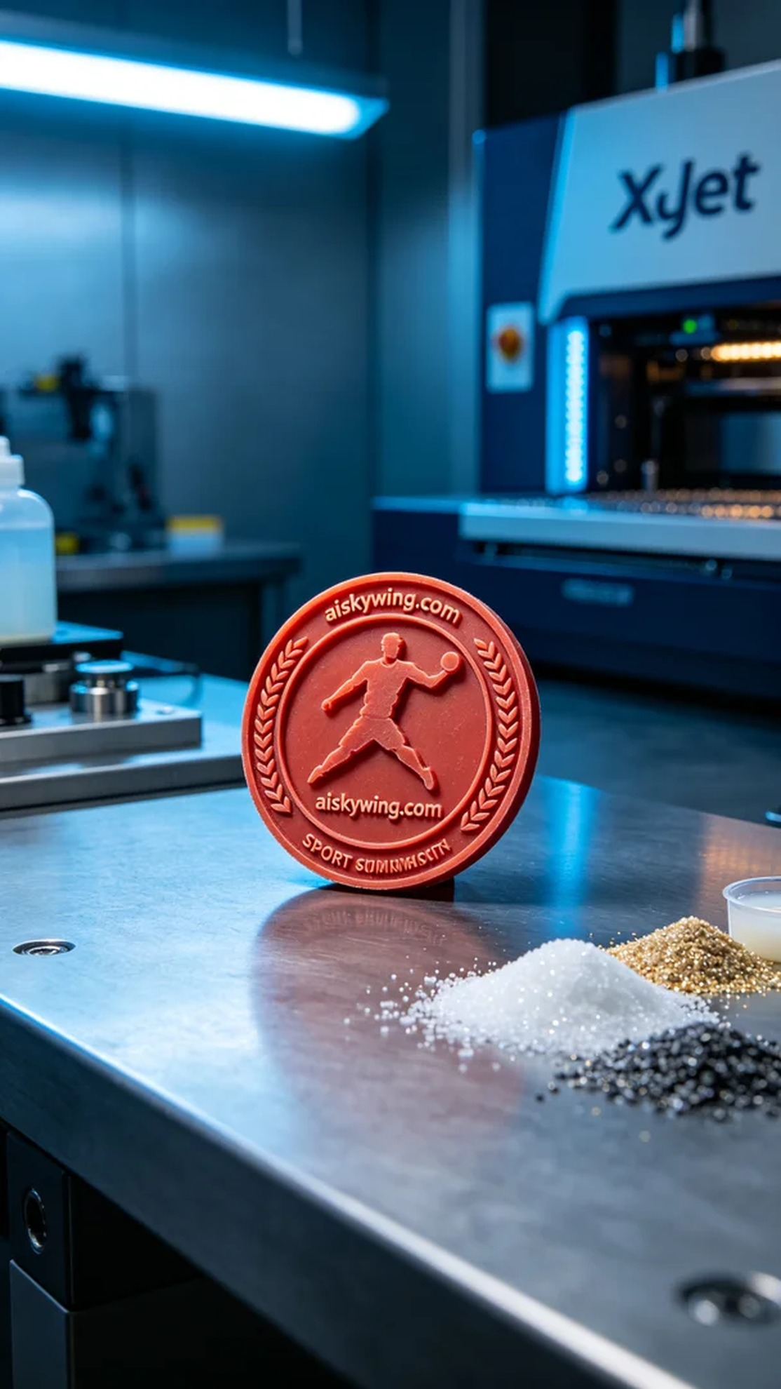
Aiskywing Industrial 3D Printing
Sports Commemorative Medal


