0843-入职纪念章3D打印记录
Onboarding Commemorative Medal
🖨️ 红蜡精密铸造
🖥️ 打印机: Voxeljet
📦 材料: 红蜡精密铸造
生活就像一场旅程，总有新的起点。就像接下这个入职纪念章的单子，有些事值得我们铭记和庆祝。
Life is like a journey, always presenting new beginnings. Just like taking on this onboarding commemorative badge, there are some things worth remembering and celebrating.
________________________________________________________________________________
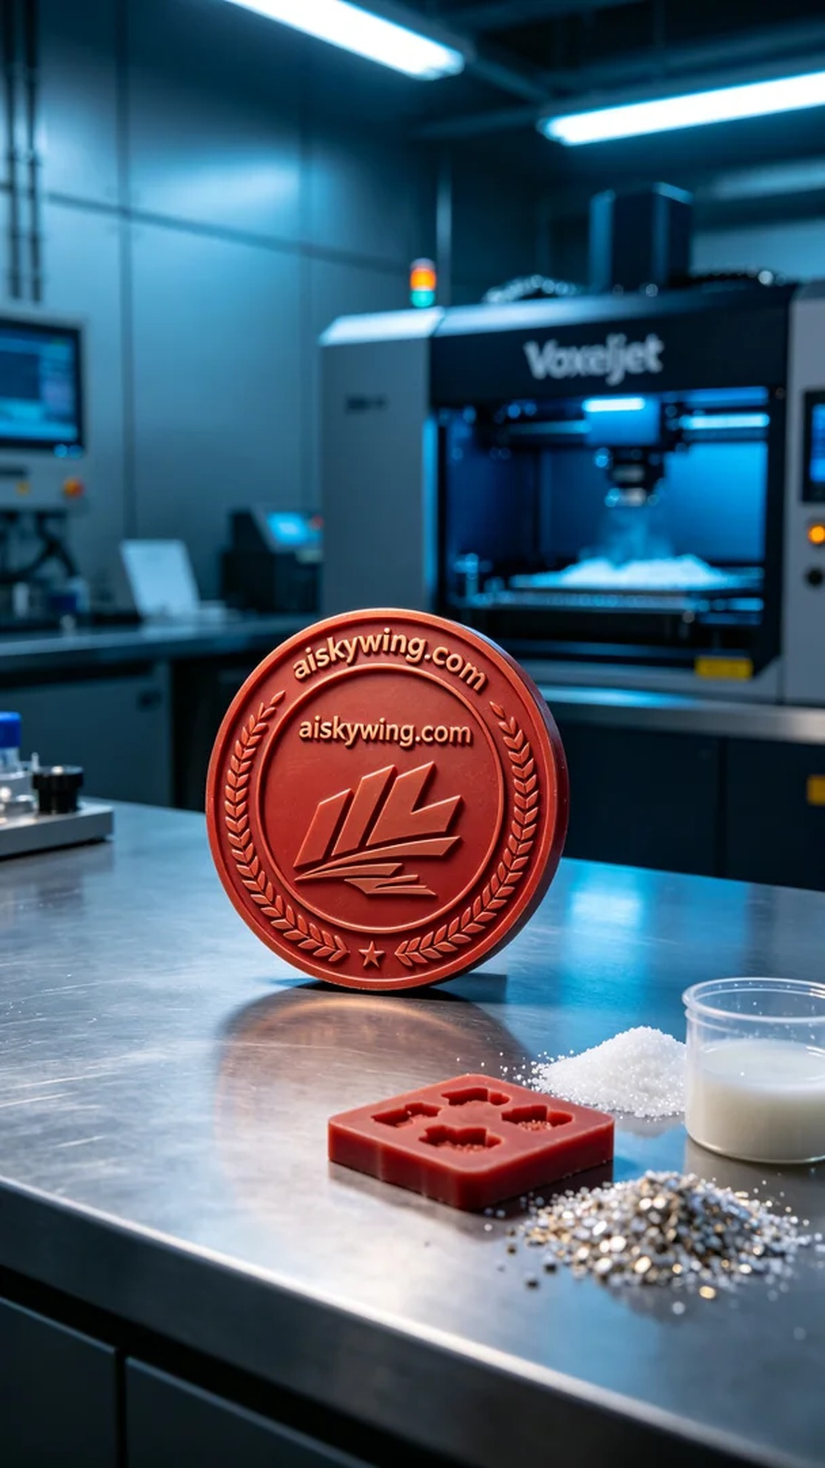
Life is like a journey, always bringing new beginnings. Just like taking on this order for an onboarding commemorative badge, some things are worth remembering and celebrating.
Today, someone reached out to us on LinkedIn, looking to customize a commemorative badge for their onboarding occasion. They wanted to capture this special moment in a high-quality, personalized way. After thorough communication, we decided to use the red wax precision casting process to ensure the badge would have both texture and detailed representation.
We prepared high-purity red wax precision casting material, known for its excellent flowability and high precision, making it suitable for complex shapes. When using the Voxeljet printer, we set a layer thickness of 0.1 mm, maintained a printing temperature of 60°C, with a power setting of 70% and a print speed of 30 mm per second, anticipating a total print time of 5 hours. This parameter combination ensured the details and smooth surface of the final product.
During the printing process, the Voxeljet printer operated steadily, layering and forming the badge. We constantly monitored the device's status to ensure there were no abnormalities, guaranteeing print quality. As the final layer of material cured, the contours and intricate engravings of the onboarding badge gradually came to life.
After printing was complete, we moved into the post-processing phase. We began by washing the finished product to remove any excess material, then used sanding tools for fine polishing, ensuring each edge was smooth and flawless. After that, we cured the badge to enhance its durability and conducted a rigorous inspection, ensuring every detail was perfect.
Through this series of meticulous processes, we successfully produced the onboarding commemorative badge, allowing this special moment to be etched in memory as a beautiful keepsake.
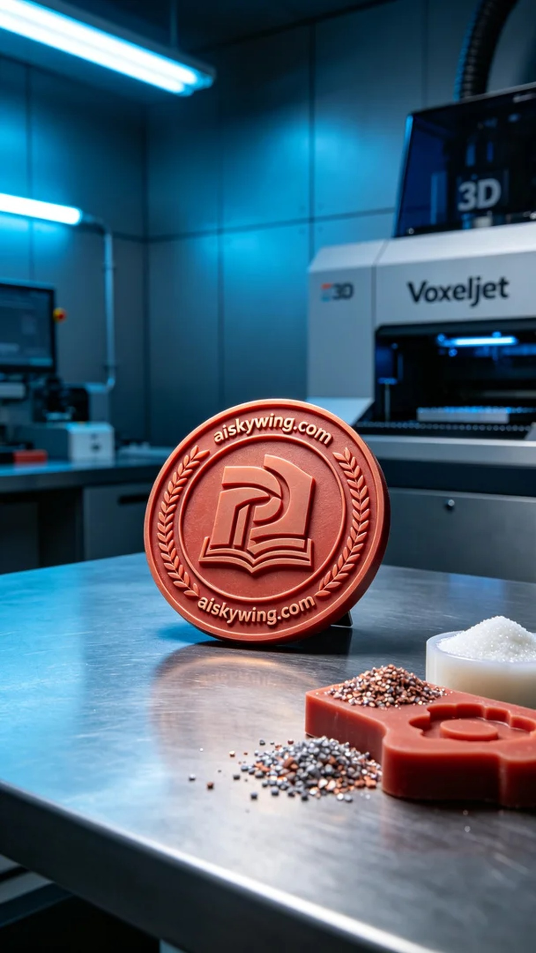
今天，在“LinkedIn”上，有人因希望定制一款入职纪念章而联系到我们。他们希望能将这一特殊时刻以一种高质量、个性化的方式铭记于心。经过详尽沟通，我们决定使用红蜡精密铸造工艺进行生产，以确保纪念章既有质感，又能充分展现细节。
我们准备了高纯度的红蜡精密铸造材料，这种材料以其卓越的流动性和高精度著称，适合复杂的造型。使用Voxeljet打印机进行打印时，我们设置了层厚0.1毫米，打印温度保持在60°C，功率设定为70%，打印速度为30毫米每秒，预计总打印时间为5小时。这样的参数组合确保了成品的细节和表面光滑度。
在打印过程中，Voxeljet打印机稳定运行，逐层叠加成形。过程中我们始终监控设备的状态，确保没有出现任何异常，保障打印质量。随着最后一层材料的固化，整个入职纪念章逐渐显现出它的轮廓和细腻雕刻。
打印完成后，我们进入后处理工序。首先对成品进行清洗，去除表面多余的材料，然后使用打磨工具精细打磨，确保每个边角都光滑无瑕。接着，我们将其进行固化，以增强产品的耐用性，并最后进行严格检验，确保每一处细节都完美无缺。
通过这一系列精细的工艺，最终我们成功地完成了入职纪念章的制作，让这一特别的时刻得以铭刻在心，成为美好的回忆。
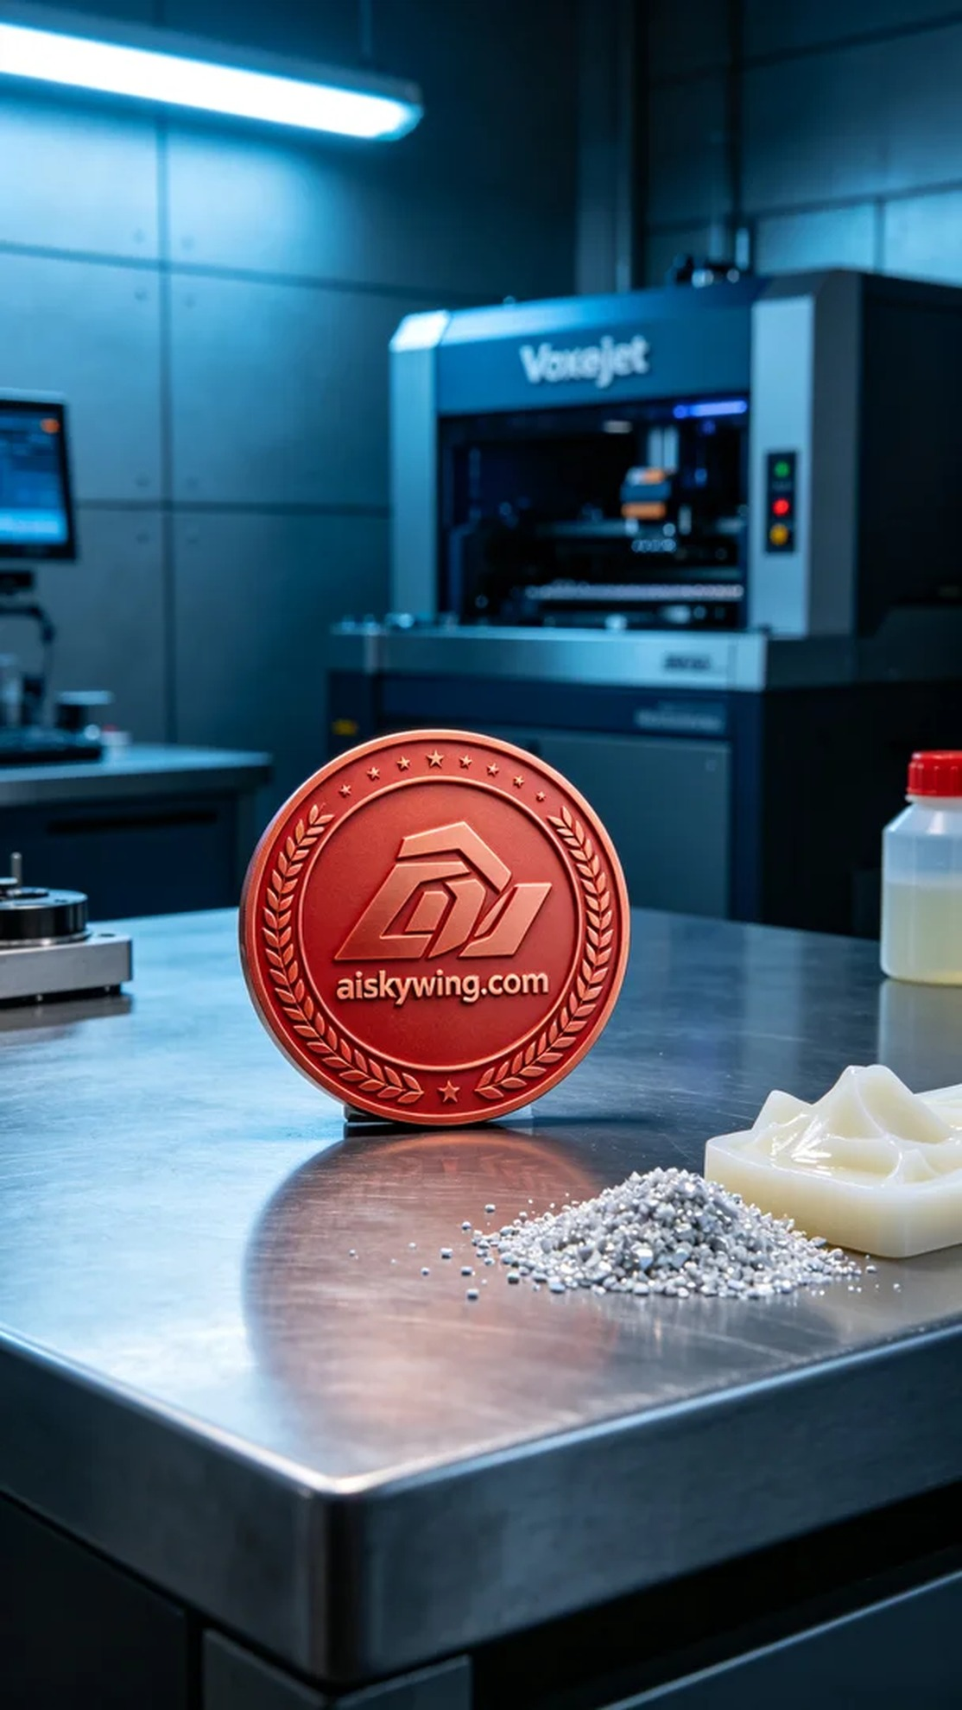
Aiskywing Industrial 3D Printing
Onboarding Commemorative Medal


