0844-精准雕刻之美：写实雕塑制作
Realistic sculpture
🖨️ 红蜡精密铸造
🖥️ 打印机: Systems
📦 材料: 红蜡高精度3D打印
生活就像3D打印，每一步都需要耐心和精准。有人通过TikTok找到了我们，希望能制作出这个写实雕塑，以展现他们的独特设计。
Life is like 3D printing; every step requires patience and precision. Someone found us through TikTok, hoping to create this realistic sculpture to showcase their unique design.
________________________________________________________________________________
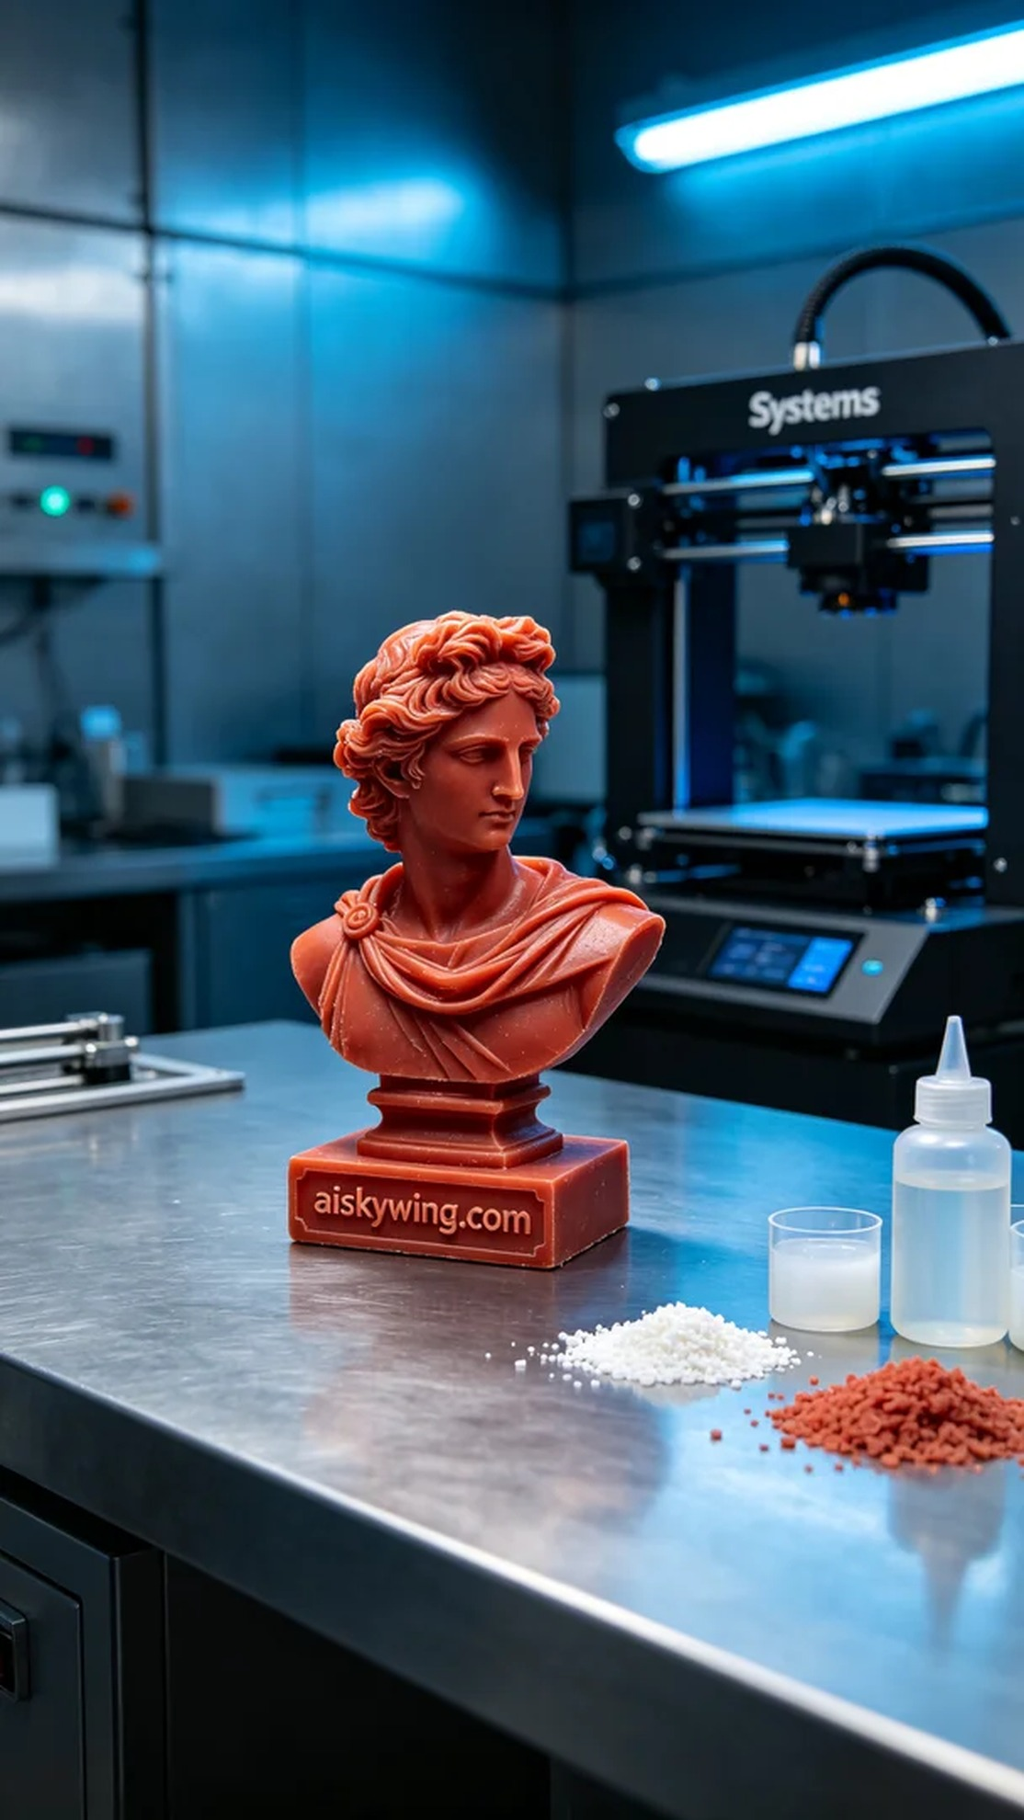
Life is like 3D printing; every step requires patience and precision. Someone found us through TikTok, hoping to create a realistic sculpture that showcases their unique design and artistic vision.
We opted for high-precision red wax 3D printing material, known for its excellent detail representation and gloss, making it perfect for precision casting. To ensure optimal printing quality, we set the Systems printer to a layer thickness of 0.05mm, maintaining a temperature of 30°C, with a power setting of 60W and a printing speed of 30mm/s. The estimated total print time was around 10 hours, laying a solid foundation for the subsequent steps.
Once the printing began, the Systems printer operated smoothly. We closely monitored the process to ensure every detail was perfectly rendered. As time passed, the sculpture gradually took shape, revealing high-quality craftsmanship and technical prowess in every tiny engraving and overall design. During this time, we paid attention to light reflection, making the surface of the sculpture more vibrant under the cold industrial lighting.
After printing was completed, we moved on to the post-processing stage. First, we removed the printed piece and cleaned it to eliminate excess resin. Then, we meticulously sanded the sculpture to ensure smoothness and delicacy on its surface. The curing stage was also crucial, as we cured the model under specific conditions to enhance its hardness and durability. Finally, we conducted rigorous inspections on every detail to ensure the finished product met the expected standards.
Through this production process, we not only created a realistic sculpture but also deeply appreciated the charm and professionalism of 3D printing. Every step conveyed a blend of craftsmanship and emotion, and I believe this piece will bring them joy and surprise.
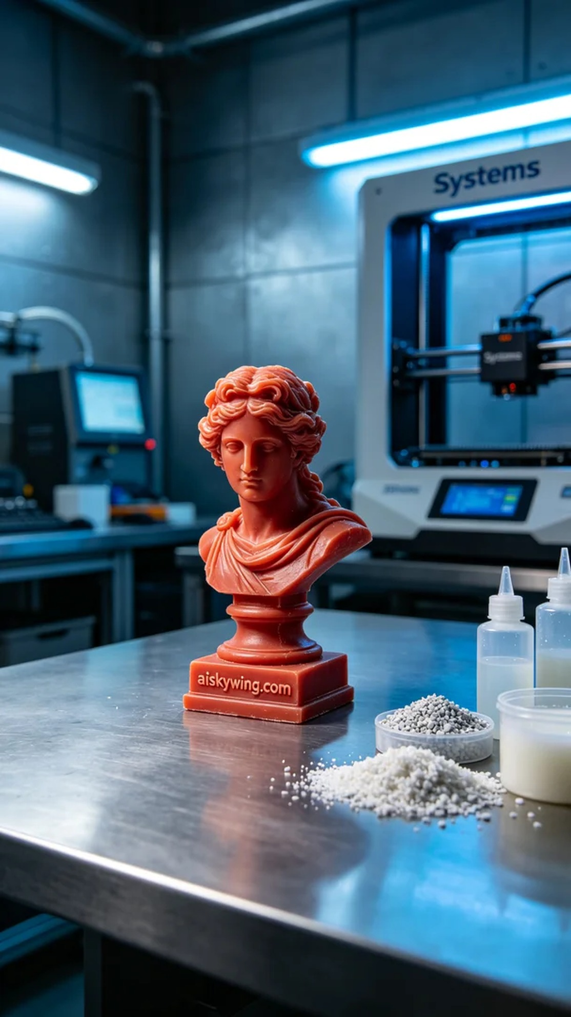
在TikTok上，有人看到我们的作品，想要定制一个写实雕塑。他们希望通过此作品展现出精湛的工艺与独特的艺术魅力。为了满足他们的需求，我们决定采用红蜡高精度3D打印技术，将这一想法变为现实。
我们选用了红蜡高精度3D打印材料，这种材料具有优良的细节表现和光泽度，适合进行精密铸造。为了保证打印效果，我们使用的Systems打印机设置了层厚为0.05mm，温度保持在30°C，功率设定为60W，打印速度调整为30mm/s，总打印时间预计在10小时左右。这一系列准备工作，为后续的打印打下了坚实的基础。
打印开始后，Systems打印机顺利运行。我们密切监控打印过程，确保每一层的细节都能完美呈现。随着时间的推移，雕塑逐渐成型，从每个细微的刻痕到整体造型，均显示出极高的品质和技术含量。在此过程中，我们也注意到光线的反射，通过冷峻的工业光线，使得雕塑的表面更加生动。
打印完成后，进入了后处理阶段。首先，我们将成品取出，进行清洗，以去除多余的树脂。接着，我们对雕塑进行打磨，确保表面的光滑与细腻。固化环节也不可忽视，我们在特定的条件下进行固化，以增强模型的硬度和耐用性。最终，对于每一个细节，我们都进行了严格的检验，确保成品能达到预期的效果。
通过这次制作，我们不仅完成了一个写实雕塑，更深刻体会到3D打印的魅力与专业性。每一步都在传递着工艺与情感的结合，我相信这个作品定能给他们带来惊喜与感动。
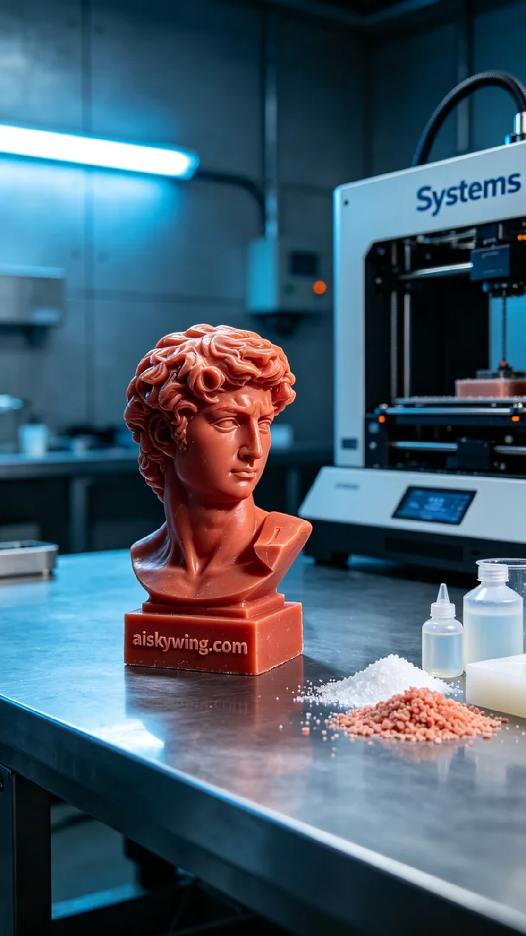
Aiskywing Industrial 3D Printing
Realistic sculpture


