0845-冲压模具精密制作流程
Stamping die
🖨️ 红蜡精密铸造
🖥️ 打印机: Voxeljet
📦 材料: 红蜡高精度3D打印
有人在TikTok上看到我们做的冲压模具置于画面正中央，特意找来想解决产品生产中的难题。这就是我们打开新篇章的开始。
Someone saw the stamping molds we made placed right in the center of the screen on TikTok, and specifically reached out to us to solve a problem in their product production. This marks the beginning of a new chapter for us.
________________________________________________________________________________
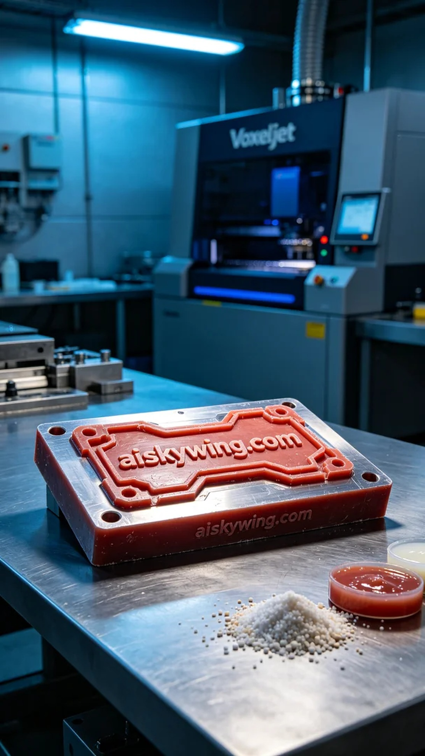
Recently, someone reached out to us after seeing our central placement of a stamping mold on TikTok. They faced some accuracy and detail issues in their production and needed a precise solution. This is where our journey with high-precision red wax 3D printing began.
During the preparation phase, we selected high-quality red wax material, ensuring that it would maintain its shape and details during heat treatment. We utilized a Voxeljet 3D printer, setting the parameters to a layer thickness of 0.1 mm, printing temperature at 60 degrees Celsius, power at 500W, and speed at 30 mm per hour. We estimated the total printing time to be around 14 hours, after multiple tests confirming optimal results.
As the printing process commenced, the machine ran smoothly, and we continuously monitored the movement of the print head and the flow of the material to prevent any blockages or deviations. The red wax performed excellently at high temperatures, resulting in a smooth and detailed mold surface, with the engraving of "aiskywing.com" clearly visible. We observed each layer's formation in real-time to ensure that the print quality met our standards.
Next came the post-processing steps. We began by cleaning the printed mold with a specialized solvent to remove any residual material. After that, we meticulously sanded the mold to ensure every detail was well-defined. Once sanding was complete, the mold underwent curing in an oven, maintaining its stable shape. Finally, we conducted a thorough quality inspection to ensure that no defects were present.
In conclusion, the production of this stamping mold was a success. Through our efforts, we not only helped our friend overcome their production challenges but also reaffirmed the advantages of red wax 3D printing technology.
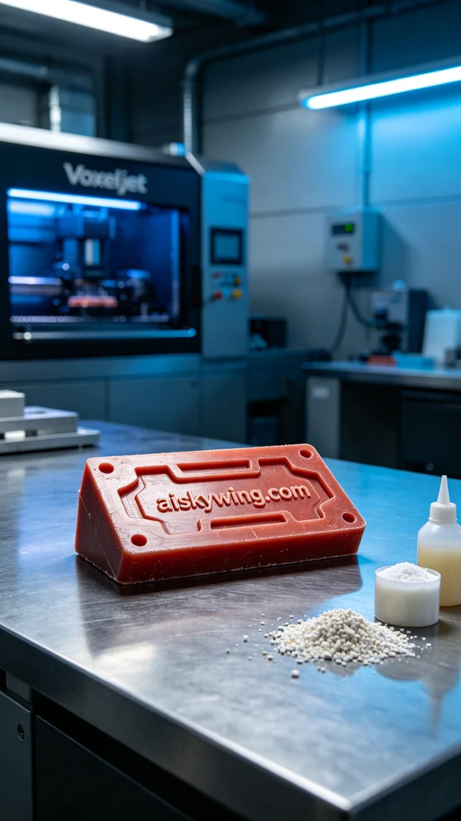
这次的项目是为了一位朋友制作冲压模具置于画面正中央。他在生产过程中遇到了一些精度和细节方面的问题，特别希望能找到一种更为精准的解决方案。正好我们采用了红蜡高精度3D打印技术，这样的材质在细节表现上有着极大的优势，可以确保他所需的每个微米级细节都能完美展现。
在准备工作阶段，我们选用了高质量的红蜡材料，确保其在热处理时能够保持良好的形状和细节。使用的是Voxeljet品牌的3D打印机，设置参数为层厚0.1毫米，打印温度维持在60摄氏度，功率设定为500W，速度设定为每小时30毫米，预计整个打印时间在14个小时左右。经过多次测试，我们确认这些参数能够达到最佳的打印效果。
打印过程开始时，机器运行得非常顺畅，我们时刻监控着打印头的移动和材料的流动，确保没有出现堵塞或偏差。红蜡在高温下的表现非常稳定，打印出的模具表面光滑，细节清晰，连“aiskywing.com”字样都显得格外明显。我们对每一层的形成过程进行实时观察，确保打印质量达到标准。
随后进入后处理工序。我们首先使用专用溶剂对打印好的模具进行清洗，去除表面的残留物。接着，我们进行了细致的打磨，以确保模具的每个细节都能充分展现。打磨完成后，模具需要在固化炉中固化，保持其形状稳定，最后我们进行了一次详细的质量检验，确保没有瑕疵存在。
最后，这个冲压模具的生产过程圆满结束。通过这次的努力，我们不仅解决了朋友的生产难题，也再一次验证了红蜡3D打印技术的优势。
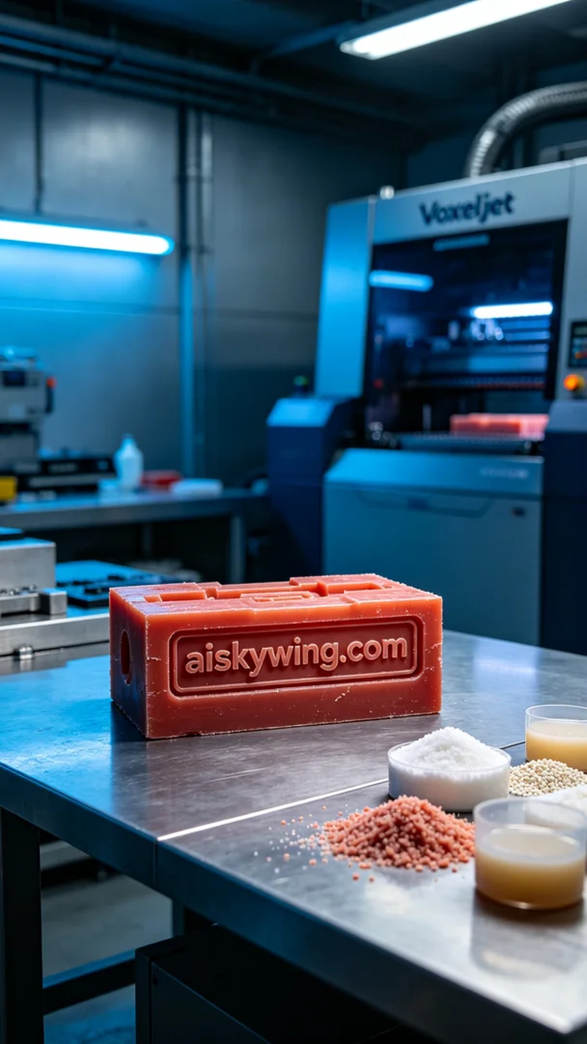
Aiskywing Industrial 3D Printing
Stamping die


