0846-几何雕塑3D打印生产记录
Geometric Sculpture
🖨️ 红蜡精密铸造
🖥️ 打印机: Systems
📦 材料: 红蜡精密铸造
在Facebook上，有人因为美术馆的展览需求找到了我们，想要制作一件独特的几何雕塑，能在视觉上冲击观众的心灵。
On Facebook, someone found us due to the exhibition needs of an art gallery and wanted to create a unique geometric sculpture that could visually impact the audience's mind.
________________________________________________________________________________
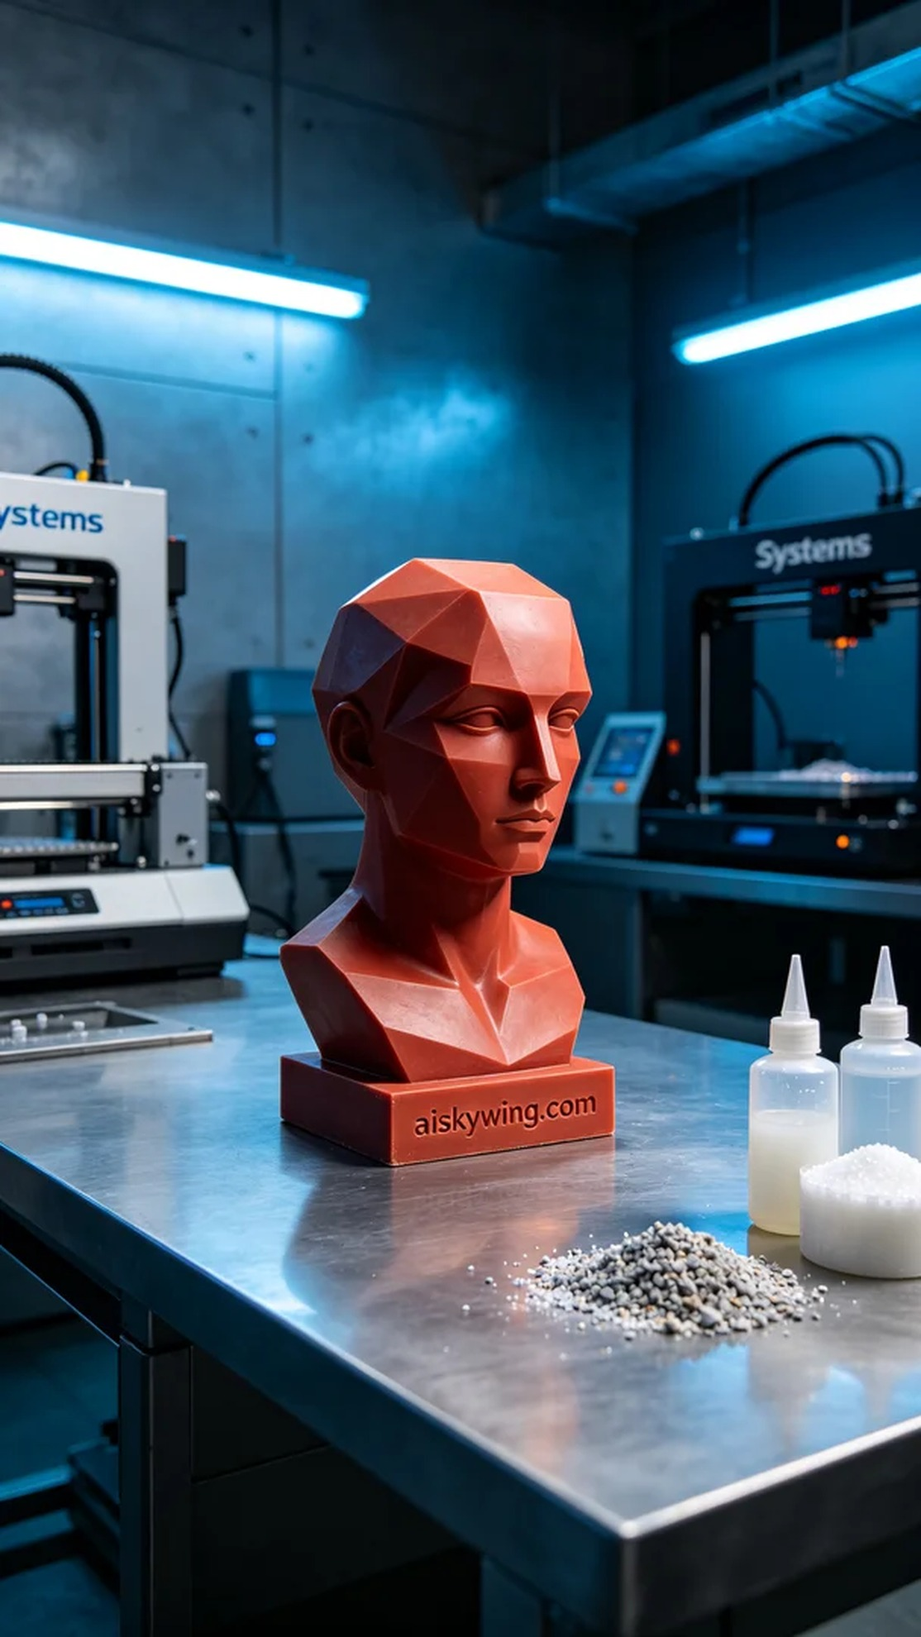
When we received the order for this geometric sculpture, the requester wanted a piece that could create a strong visual impact on the audience at an art exhibition. Thus, we embarked on this production journey, ensuring every detail was perfected.
The material used was red wax precision casting, which has a smooth and delicate surface, perfect for lost-wax casting. During the preparation phase, we ensured the wax temperature was suitable for casting, setting the printer's parameters: a layer thickness of 0.1 mm, a temperature of 230℃, a power of 75W, and a printing speed of 50 mm/s to achieve the best print quality.
As the printing process began, the Systems printer operated smoothly. We continuously monitored the equipment to ensure the quality of each layer. Although minor issues occasionally arose during printing, we quickly addressed them through real-time adjustments, ensuring the sculpture's integrity and precision.
Once printing was completed, we proceeded to the post-processing stage. First, the sculpture was washed using a specialized cleaning solution to remove excess resin, followed by sanding to achieve a smoother surface. Finally, the sculpture underwent curing to ensure its final strength and durability. During the final inspection, we meticulously checked every detail to ensure it met the standards.
After all these processes, we successfully completed the production of this geometric sculpture, and the final result was satisfying, adding a unique charm to the exhibition.
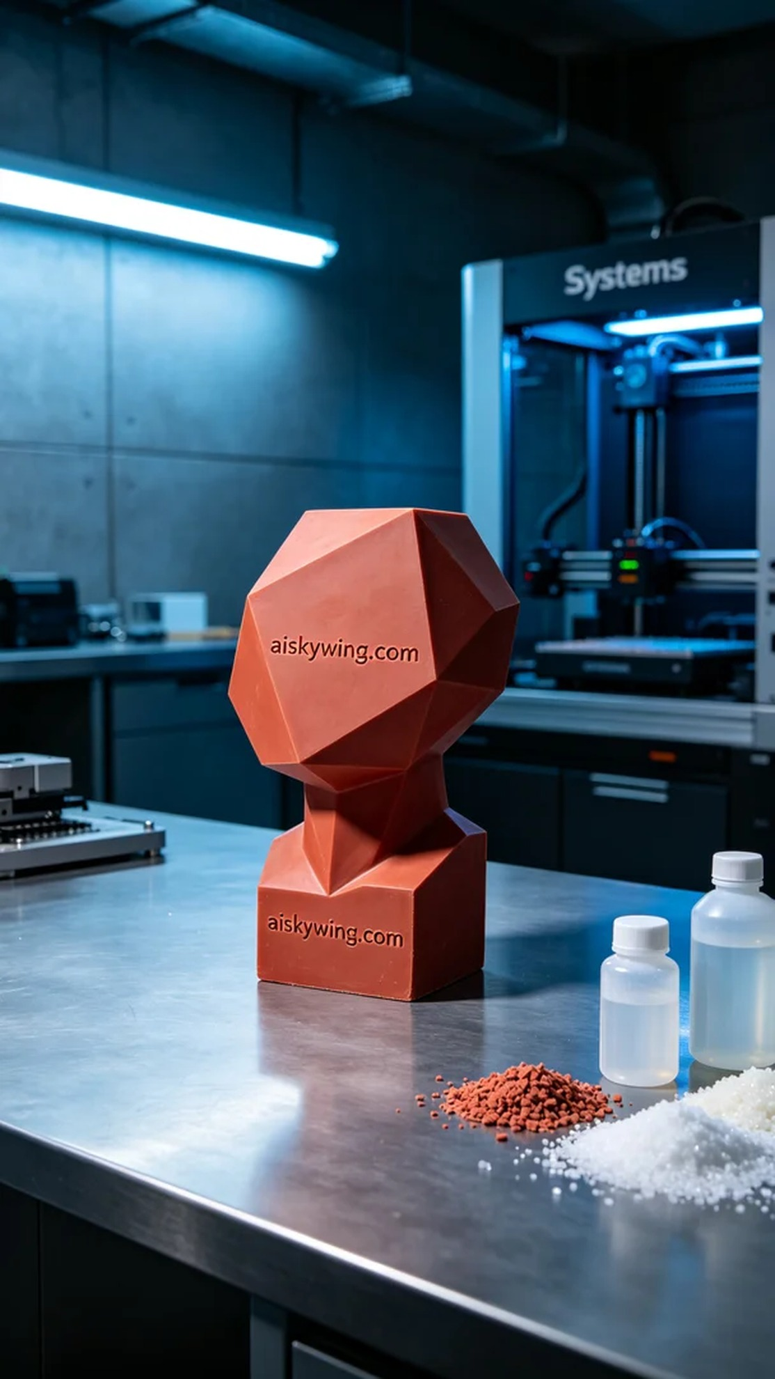
我们接到这个几何雕塑的订单时，客户想要的正是那种能引起强烈视觉感受的艺术作品。于是，我们开始了这次的生产工作，确保每个细节都尽善尽美。
使用的材料是红蜡精密铸造，这种材质表面光滑细腻，极适合失蜡铸造。我们在准备阶段，确保红蜡的温度保持在适合铸造的范围，设定打印机的参数：层厚0.1毫米，温度保持在230℃，功率设为75W，打印速度为50mm/s，以保证最佳的打印效果。
打印过程开始之后，Systems打印机运行得非常稳定。我们持续监控设备，确保每一层的打印质量。虽然打印过程中偶尔会出现小问题，但通过实时调整，我们很快解决了这些问题，确保了雕塑的完整性和精确度。
完成打印后，我们进入后处理阶段。首先对雕塑进行清洗，使用专业清洗液去除多余的树脂，然后进行打磨，使表面更加光滑。最后，将雕塑进行固化处理，确保其最终强度和耐久性。在最后的检验中，我们细致入微，确保每一个细节都符合标准。
经过这一系列的工序，我们成功完成了这个几何雕塑的生产，最终呈现出的效果让人满意，给展览增添了一份独特的魅力。
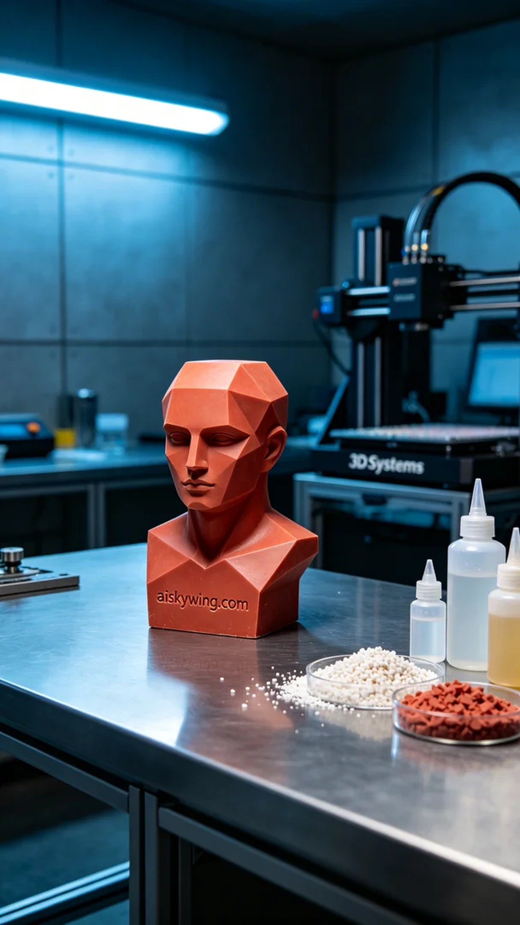
Aiskywing Industrial 3D Printing
Geometric Sculpture


