0847-刷具手柄蜡模3D打印生产记录
Brush Handle Wax Mold
🖨️ 红蜡精密铸造
🖥️ 打印机: Mimaki
📦 材料: 红蜡高精度3D打印
生活中总会有意外的惊喜，就像有人通过WhatsApp找到了我们，寻求制作刷具手柄蜡模的帮助。
In life, there are always unexpected surprises, just like when someone reached out to us via WhatsApp, seeking help in making wax molds for brush handles.
________________________________________________________________________________
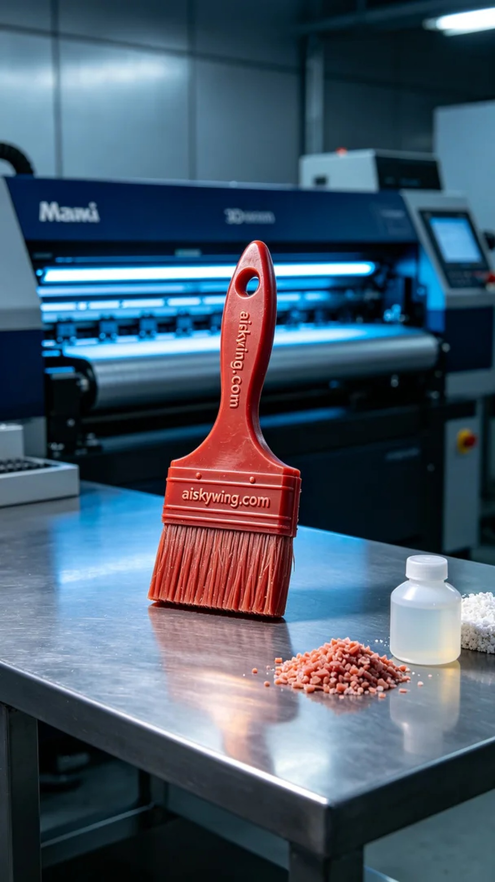
Life is full of unexpected surprises, just like when someone reached out to us via WhatsApp, seeking assistance in creating a brush handle wax model.
A friend approached us with a request to produce a wax model for a brush handle, intended for a high-end makeup brush. The requirements for precision were exceptionally high, so we set off on this project with careful preparation of materials and equipment.
We began by preparing the red wax high-precision 3D printing material and determining the printing parameters. We chose the Mimaki brand 3D printer, setting the layer thickness to 0.1 mm, maintaining a printing temperature of 220 degrees, with power set at 80% and a printing speed of 40 mm per second. The entire printing process was expected to take about 6 hours to ensure the wax model's details could be perfectly showcased.
As the printing commenced, the Mimaki printer operated smoothly, providing a consistent supply of material, while the print head moved precisely. I kept a close eye on the printing progress, making timely adjustments to the printing parameters to ensure that every detail achieved a micro-level of precision. As time passed, the wax model gradually took shape, with the engraved "aiskywing.com" text becoming increasingly clear.
After the printing was completed, we needed to carry out post-processing on the wax model. First, we carefully removed the wax model from the print bed, then cleaned it to eliminate any residual resin on the surface. Next, we proceeded to sand the model to ensure a smooth surface, making the details even more exquisite. Finally, we performed a curing process to lock in its shape and conducted a thorough inspection to ensure all specifications met our standards.
In the end, this brush handle wax model showcased a perfect result, retaining a delicate luster while exhibiting high-precision details. This entire process allowed me to appreciate the charm of 3D printing once again and feel proud of every exquisite product we create.
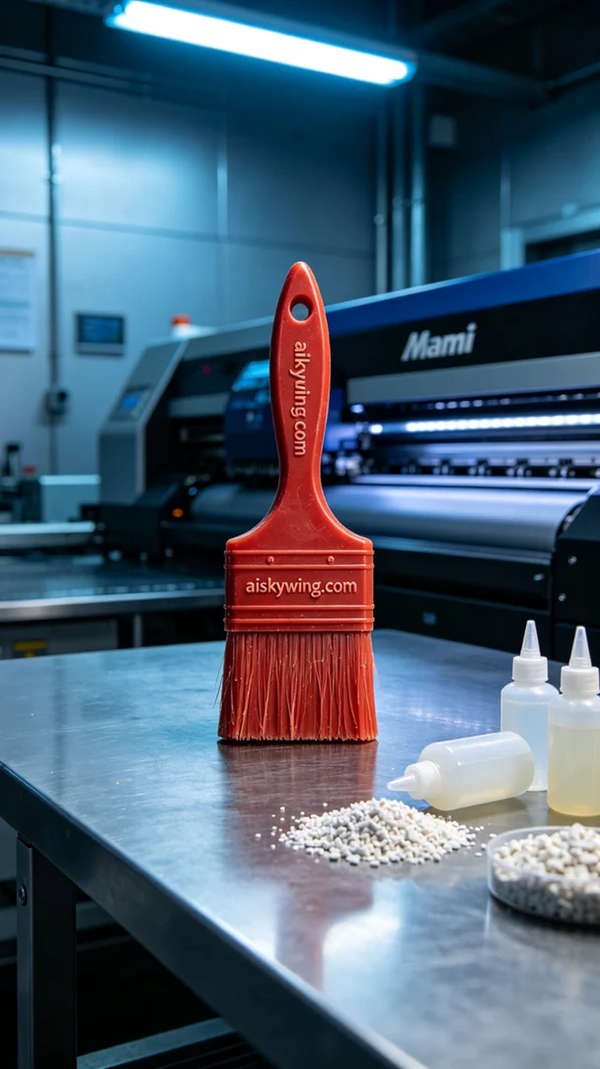
我们接到了一位朋友的求助，他想制作一款刷具手柄蜡模，以便用于后续的铸造工艺。这个产品将用于一款高端化妆刷，要求精度非常高。于是我们就开始了这个项目，准备充分的材料和设备。
接下来的工作是准备红蜡高精度3D打印材料，确定打印参数。我们选择了Mimaki品牌的3D打印机，层厚设置为0.1毫米，打印温度保持在220度，功率为80%，打印速度设置在40毫米每秒。整个打印过程预计需要6个小时，确保蜡模的细节能够完美呈现。
打印开始后，Mimaki打印机运转良好，材料均匀供给，打印头移动精准。为了确保输出质量，我时刻关注着打印进度，及时调整打印参数，确保每一个细节都能达到微米级的精雕效果。随着时间的推移，蜡模逐渐成型，表面雕刻的"aiskywing.com"字样也愈加清晰。
打印结束后，我们需要对蜡模进行后处理。首先将蜡模从打印台上小心取下，然后进行清洗，去除表面残留的树脂。接下来，我们对蜡模进行打磨，以确保表面光滑，细节更为完美。最后，将蜡模进行固化处理，固定其形状，并经过仔细的检验，确保所有规格都达到要求。
最终，这款刷具手柄蜡模呈现出了完美的效果，既保留了细腻的光泽，又具备了高精度的细节。整个过程让我再次体会到3D打印的魅力，也为每一件精致的产品感到自豪。
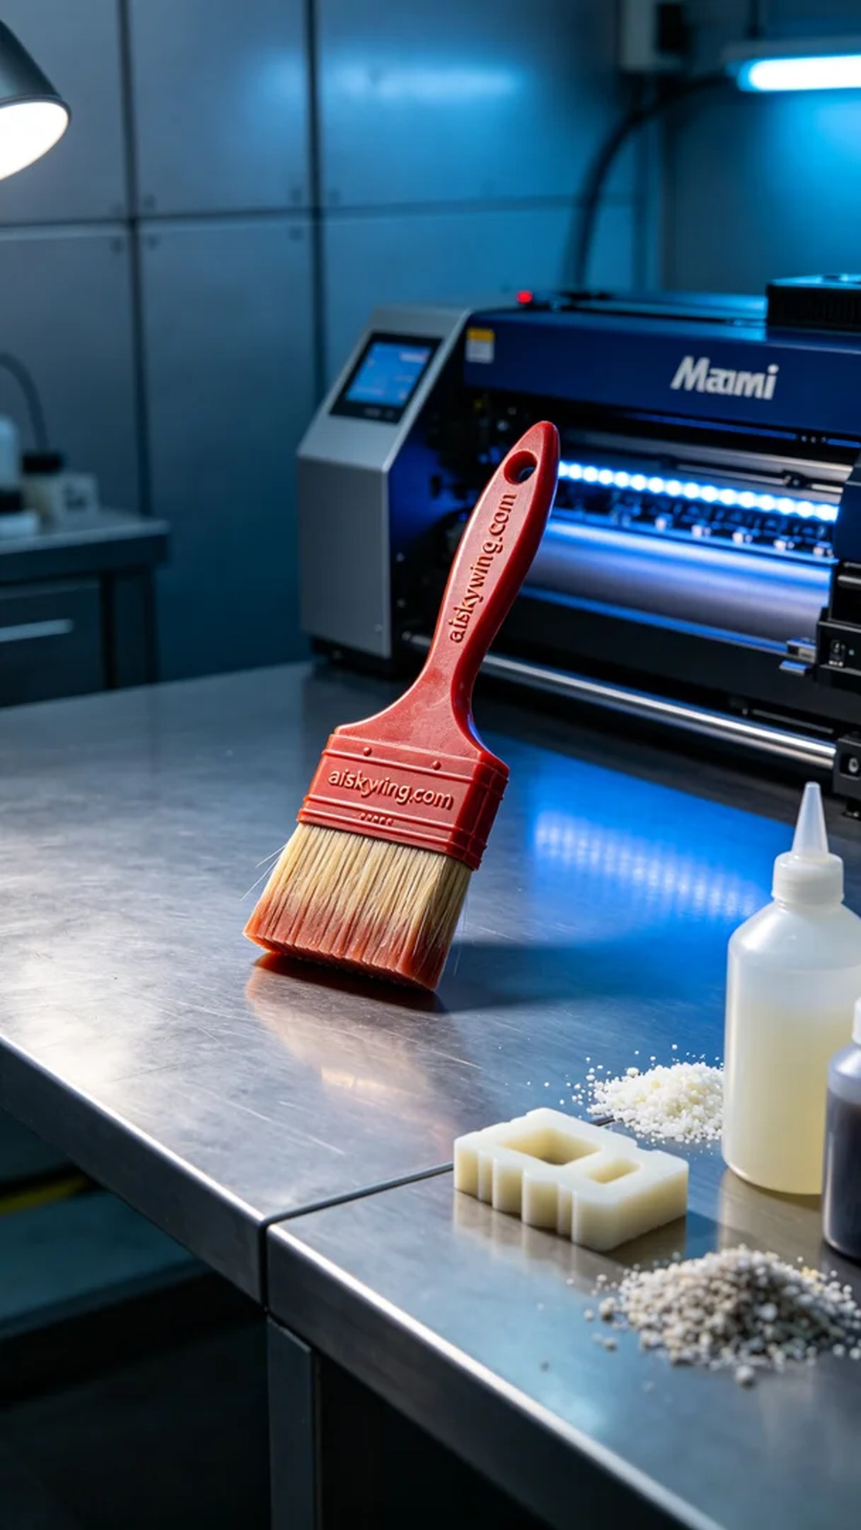
Aiskywing Industrial 3D Printing
Brush Handle Wax Mold


