0848-3D打印动物雕塑的生产记录
Animal Sculpture
🖨️ 红蜡精密铸造
🖥️ 打印机: Xjet
📦 材料: 红蜡精密铸造
生活就像3D打印，有时需要反复调整才能成型。最近，有人因为想制作一件动物雕塑置于画面正中央而找上我们。
Life is like 3D printing; sometimes it requires repeated adjustments to take shape. Recently, someone approached us because they wanted to create an animal sculpture to place right in the center of the scene.
________________________________________________________________________________
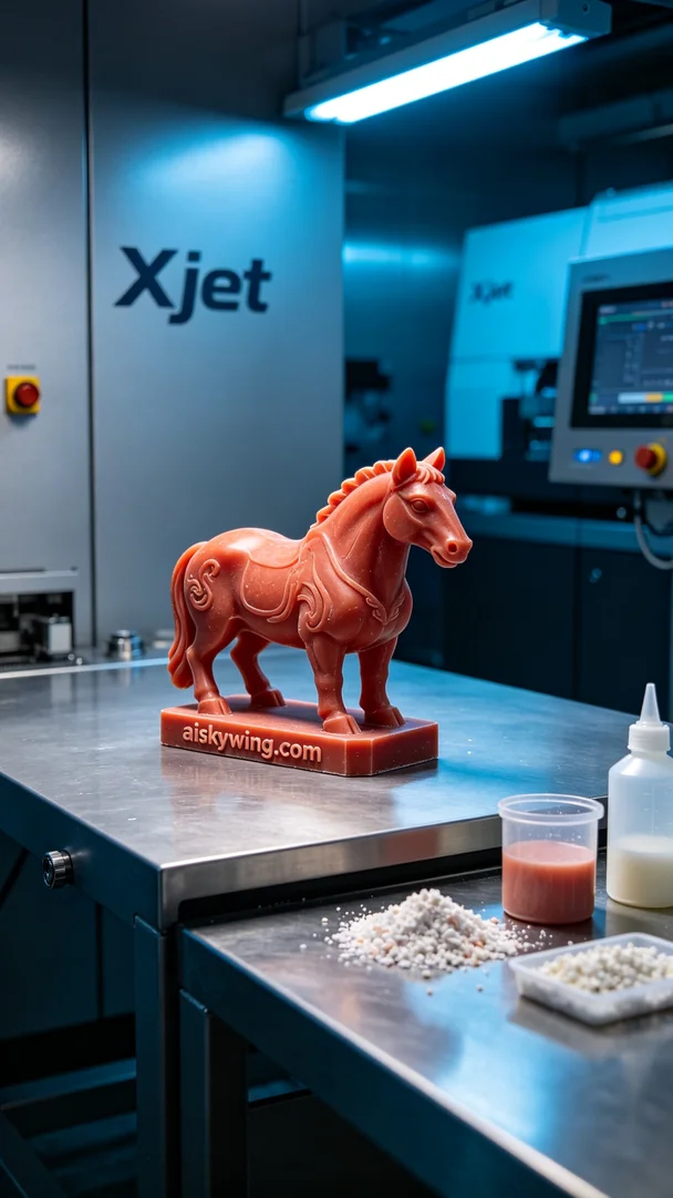
Life is like 3D printing; sometimes you need to make adjustments to get the perfect form. Recently, someone reached out to us wanting to create a unique animal sculpture placed centrally in the image.
We had a passionate artist who, inspired by beautiful animal sculptures seen on TikTok, wanted to craft a special piece. We decided to use precision lost-wax casting to bring his imaginative concept to life in the form of a lifelike animal sculpture.
Before we began, we thoroughly examined our materials. This time, we opted for precision lost-wax casting, which is stable and ideal for complex sculptural details. We utilized the Xjet 3D printer, setting the layer thickness to 0.1mm, temperature to 230°C, power to 80%, and a printing speed of 50mm/s, with an estimated total printing time of around 10 hours.
During the printing process, the machine ran smoothly. The Xjet printer accurately deposited the liquid material layer by layer, gradually forming the animal sculpture's shape. We continuously monitored the print quality to ensure that no flaws emerged in any detail. The cold-toned ambient lights added a technological feel to the environment, enhancing the visual effect of the print.
After the printing was completed, we moved into the post-processing stage. We began by cleaning off the excess liquid resin, followed by meticulous sanding to achieve a smoother surface. Next, the sculpture underwent a curing process to enhance its strength, and finally, we conducted strict inspections to ensure that every detail met the highest standards.
After all our efforts, the animal sculpture was finally completed. It not only showcased exceptional artistic quality but also reflected the hard work and dedication of our team.
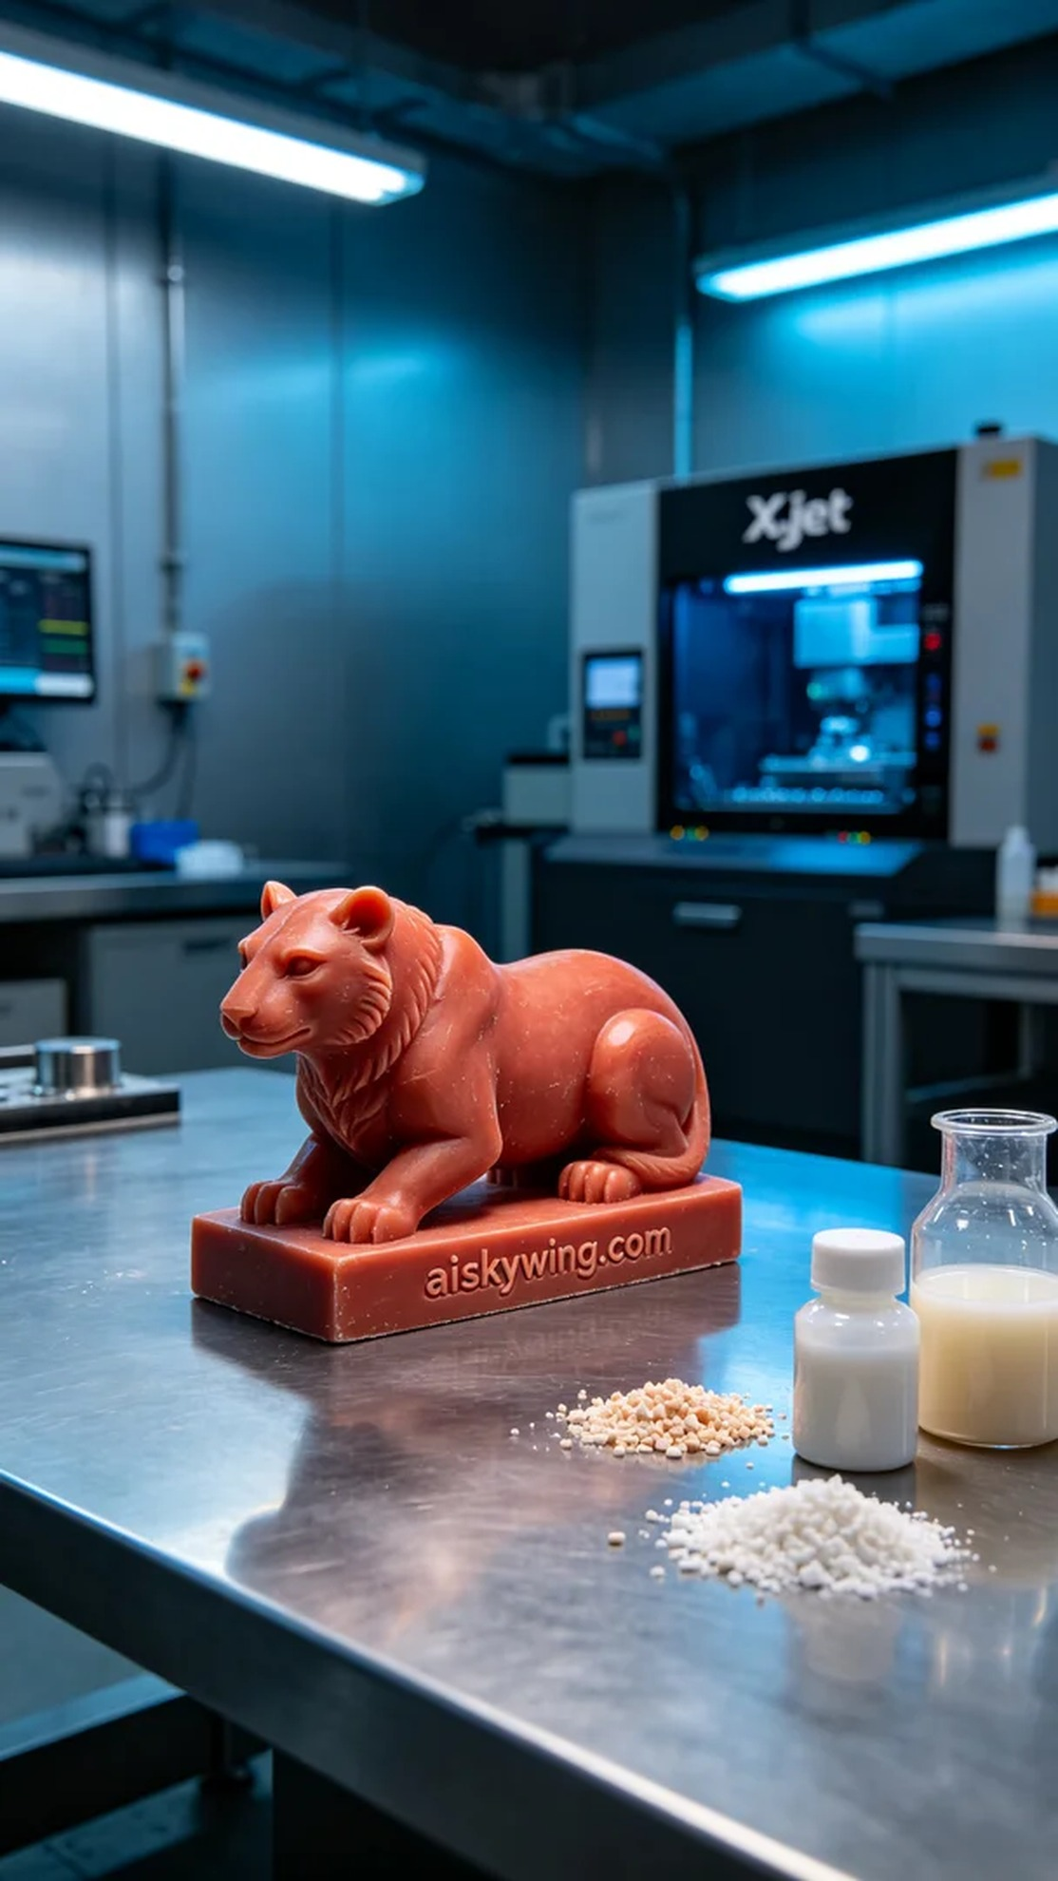
我们接到一位热爱艺术的人，他在TikTok上看到了一些精美的动物雕塑，心里也想要一件独特的作品。这让我们决定使用红蜡精密铸造，打造出一只栩栩如生的动物雕塑，完美展现出他心中的创意。
在开始之前，我们对材料进行了详细了解。这次我们选择使用红蜡精密铸造，它的性能非常稳定，适合复杂的雕刻细节。为了确保打印的效果，我们使用Xjet 3D打印机，设置了层厚0.1毫米、温度230℃、功率为80%，打印速度为50mm/s，预计打印时间为10小时。
打印过程中，设备的运行相当顺利。Xjet的打印头精准地将液态材料逐层沉积，逐渐构建出动物雕塑的形态。在此期间，我们不断监控打印质量，确保每个细节都不会出现任何瑕疵。冷色调的氛围灯为整个环境增添了科技感，进一步提升了打印的视觉效果。
完成打印后，我们进入了后处理工序。首先清洗掉多余的液态光敏树脂，然后进行细致的打磨，使表面更加光滑。接着，将雕塑进行固化处理以增强其强度，最后经过严格检验，确保每个细节都达到最佳效果。
经过一番努力，这件动物雕塑终于完工了。它不仅展现了出色的艺术水准，还有着我们团队的心血与坚持。
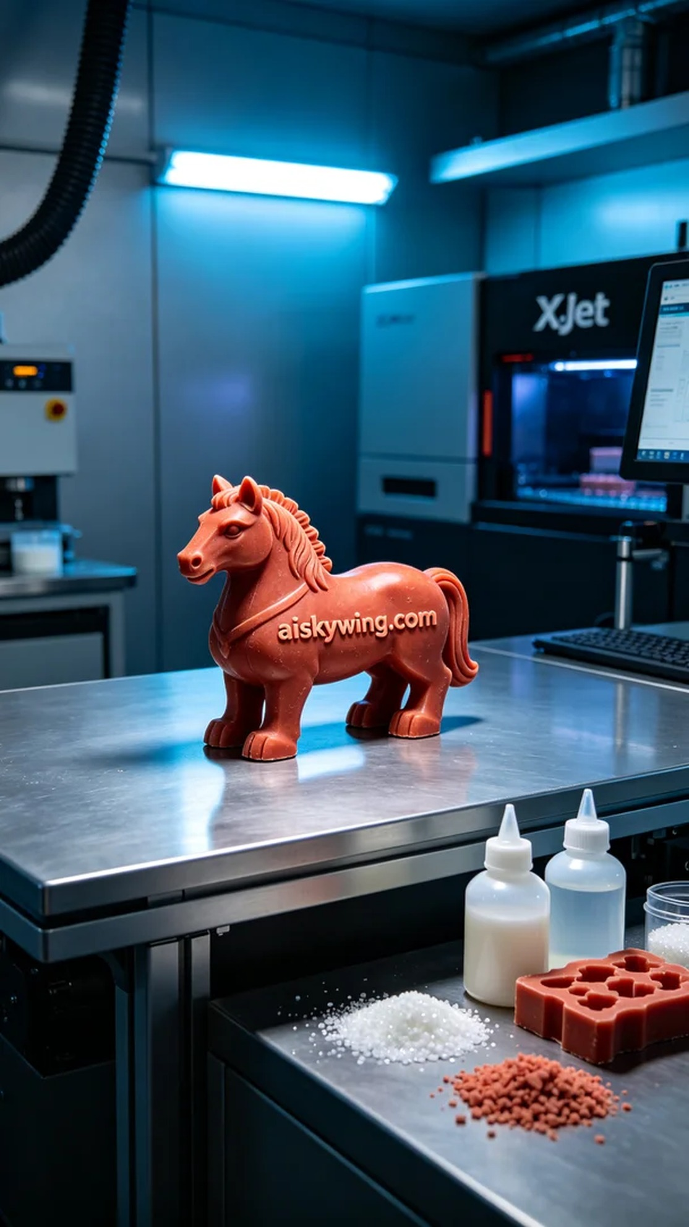
Aiskywing Industrial 3D Printing
Animal Sculpture


