0849-包装盒扣蜡模的3D打印记录
Wax seal for packaging box
🖨️ 红蜡精密铸造
🖥️ 打印机: Stratasys
📦 材料: 红蜡精密铸造
生活像一场不断打印的过程，遇到问题时，我们要勇于去解决。有人因为对包装盒扣蜡模的需求而找到了我们。
Life is like a constantly printing process. When we encounter problems, we must be brave enough to solve them. Someone found us because they needed a wax mold for a packaging box.
________________________________________________________________________________
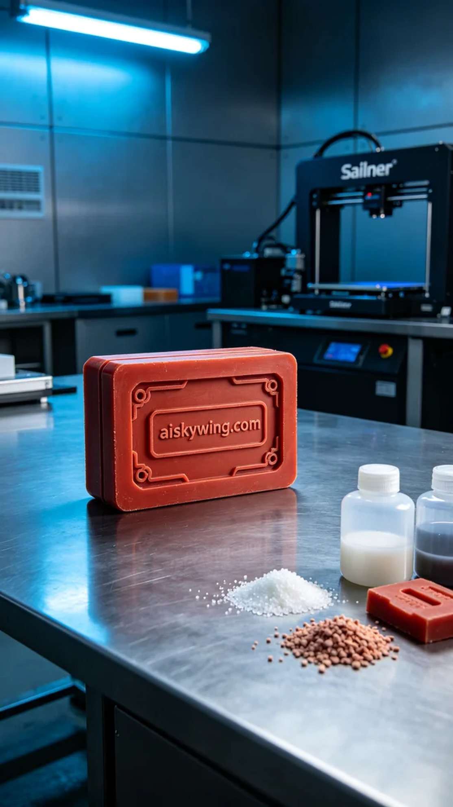
Life is like an ongoing printing process; when faced with challenges, we must bravely solve them. Someone reached out to us via YouTube seeking a custom wax mold for packaging boxes, highlighting their precise needs.
For this project, we opted for red wax precision casting material, known for its excellent fluidity and smooth surface finish, making it ideal for lost wax casting. We employed a Stratasys printer, setting the layer thickness to 0.1mm, the printing temperature at 60℃, power at 80W, and maintained a printing speed of about 30mm/s. The estimated time for the entire printing process was around 8 hours for individual molds.
Once printing commenced, the equipment operated smoothly, with the red wax material melting and solidifying steadily during the process. We regularly monitored the printing status to ensure each layer was completed accurately. Throughout the process, we utilized a real-time monitoring system to promptly adjust any parameters that could affect print quality, ensuring perfection in the final results.
After completing the printing, we moved on to the post-processing stage. First, we thoroughly washed the wax molds with clean water to remove any uncured resin. Next, we used specialized sanding tools to finely polish the molds, enhancing their smoothness. Finally, we positioned the molds in a UV curing device to solidify them, ensuring their strength and stability. After inspection, all molds met the expected standards, successfully achieving the project goals.
Through this project, we not only addressed the user's needs but also showcased our capabilities in the 3D printing field. Every detail reinforces our belief that continuous innovation and excellence are the common pursuits we share.
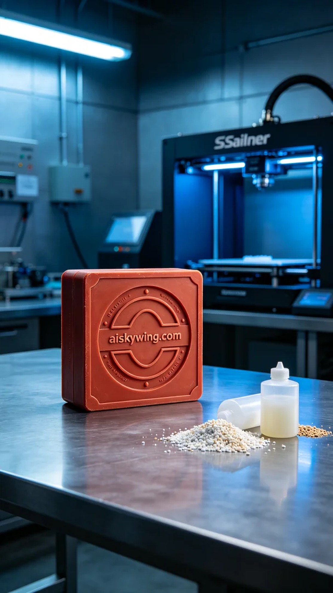
为了应对一些特定需求，有人通过YouTube的渠道找到我们，寻求定制的包装盒扣蜡模。这个项目不仅需要精准的设计，还要借助我们强大的3D打印技术来实现。
我们选择使用红蜡精密铸造作为原材料，这种材料具有良好的流动性和细腻的表面光滑度，特别适合失蜡铸造工艺。设备方面，我们使用的是Stratasys的打印机，设置了层厚为0.1mm，打印温度为60℃，功率为80W，打印速度保持在30mm/s左右。整个打印过程预计时间为个别模具约8小时。
打印启动后，设备运行平稳，红蜡材料在打印过程中稳定地熔融和固化。我们定期监控打印状态，确保每一层都能精确准确地完成。在整个过程中，我们使用了实时监测系统，及时调整任何可能影响打印质量的参数，确保最终成果的完美。
完成打印后，我们进入到后处理流程。首先，我们用清水将蜡模进行彻底清洗，以去除任何未固化的树脂。接着，使用专门的打磨工具对模具进行精细打磨，使其表面更加光滑。最后，我们将模具放入紫外线固化设备中进行固化，确保它的强度和稳定性。经过检验，所有的模具都达到预期标准，成功实现了项目目标。
通过这个项目，不仅解决了用户的需求，也展示了我们在3D打印领域的实力。每一个细节都让我们更加坚信，持续创新和精益求精才是我们共同的追求。
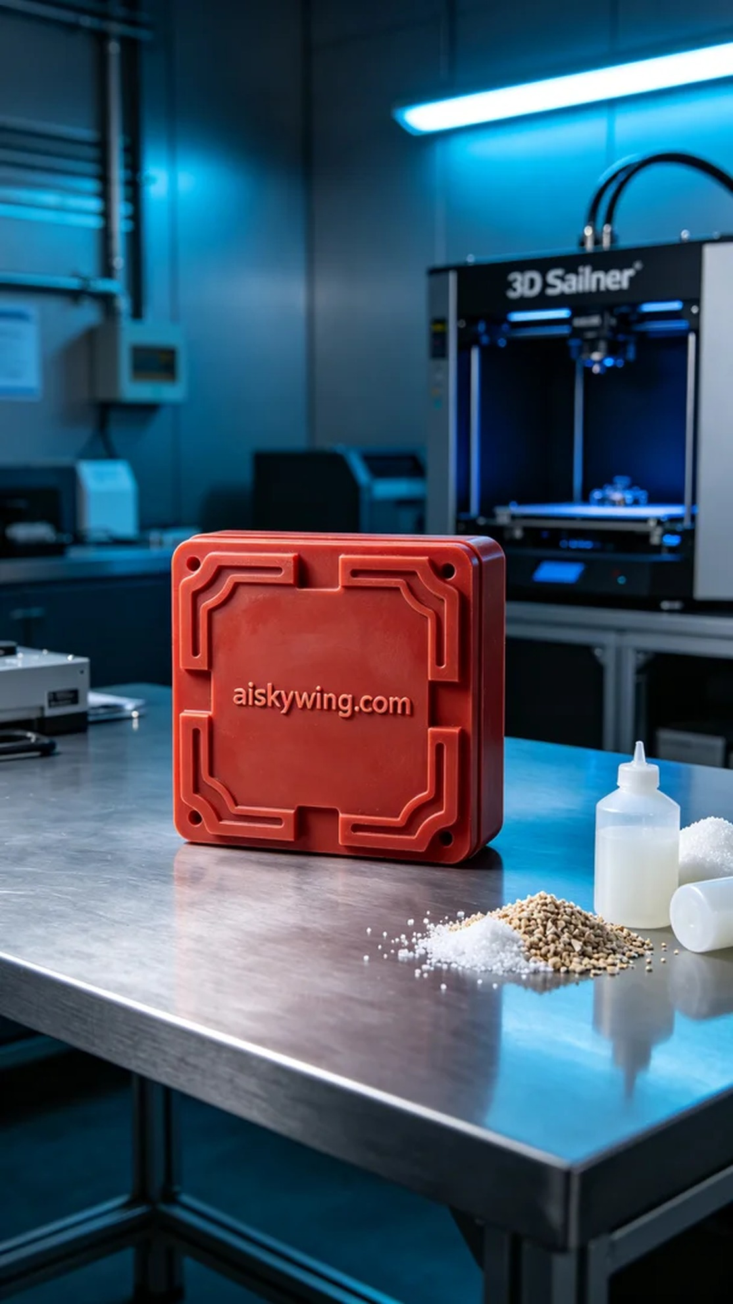
Aiskywing Industrial 3D Printing
Wax seal for packaging box


