0850-包饰蜡模3D打印生产记录
The translation of "包饰蜡模" is "Wax mold for packaging."
🖨️ 红蜡精密铸造
🖥️ 打印机: Systems
📦 材料: 红蜡精密铸造
在Twitter上，有人提到对包饰蜡模的需求，激发了我对这项工作的热情。生活中总有挑战，但每个细节都值得去雕琢。
On Twitter, someone mentioned the demand for wax molds for packaging, which sparked my enthusiasm for this work. There are always challenges in life, but every detail is worth refining.
________________________________________________________________________________
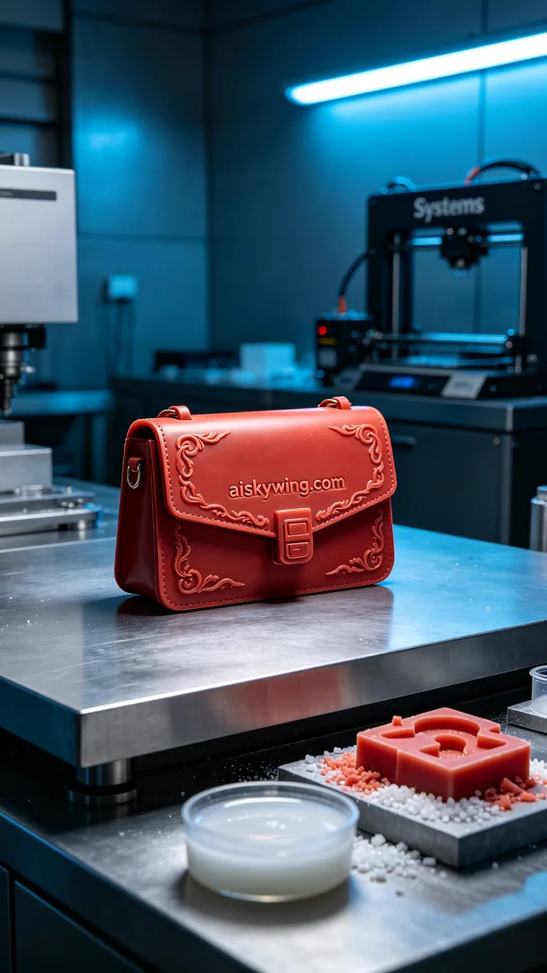
Recently, someone reached out to us due to their urgent need for a wax mold for their accessory design. They were dissatisfied with existing products on the market and hoped to customize a mold that met their specific needs. This order was not just a simple request; it was a challenge to our skills and capabilities.
For the materials, we selected red wax precision casting material. This material not only provides a smooth and fine surface but also allows for extremely detailed engravings during the casting process. We prepared our Systems 3D printer, setting the parameters to a layer thickness of 0.1mm, a printing temperature of 220°C, 80% power, and a printing speed of 50mm/s, anticipating that the printing process would take about 5 hours.
As the printer started up, we monitored the equipment's operation closely. During the printing process, the wax mold formed layer by layer without any issues. To ensure quality, we conducted thorough checks after each layer was completed, verifying that there were no bubbles or other problems that could affect the final outcome.
After printing, the post-processing steps were equally important. First, we placed the wax mold into the cleaning tank, using warm water and detergent to thoroughly clean the surface. Next, we performed sanding to create an even smoother surface, removing any minor imperfections. Following this, we carried out a curing process to enhance the hardness and stability of the wax mold, finishing with a quality inspection to ensure it met all standards.
After a series of procedures, the final wax mold displayed an excellent effect. Every detail reflected our hard work and professionalism, making this piece come alive in the play of light and shadow.
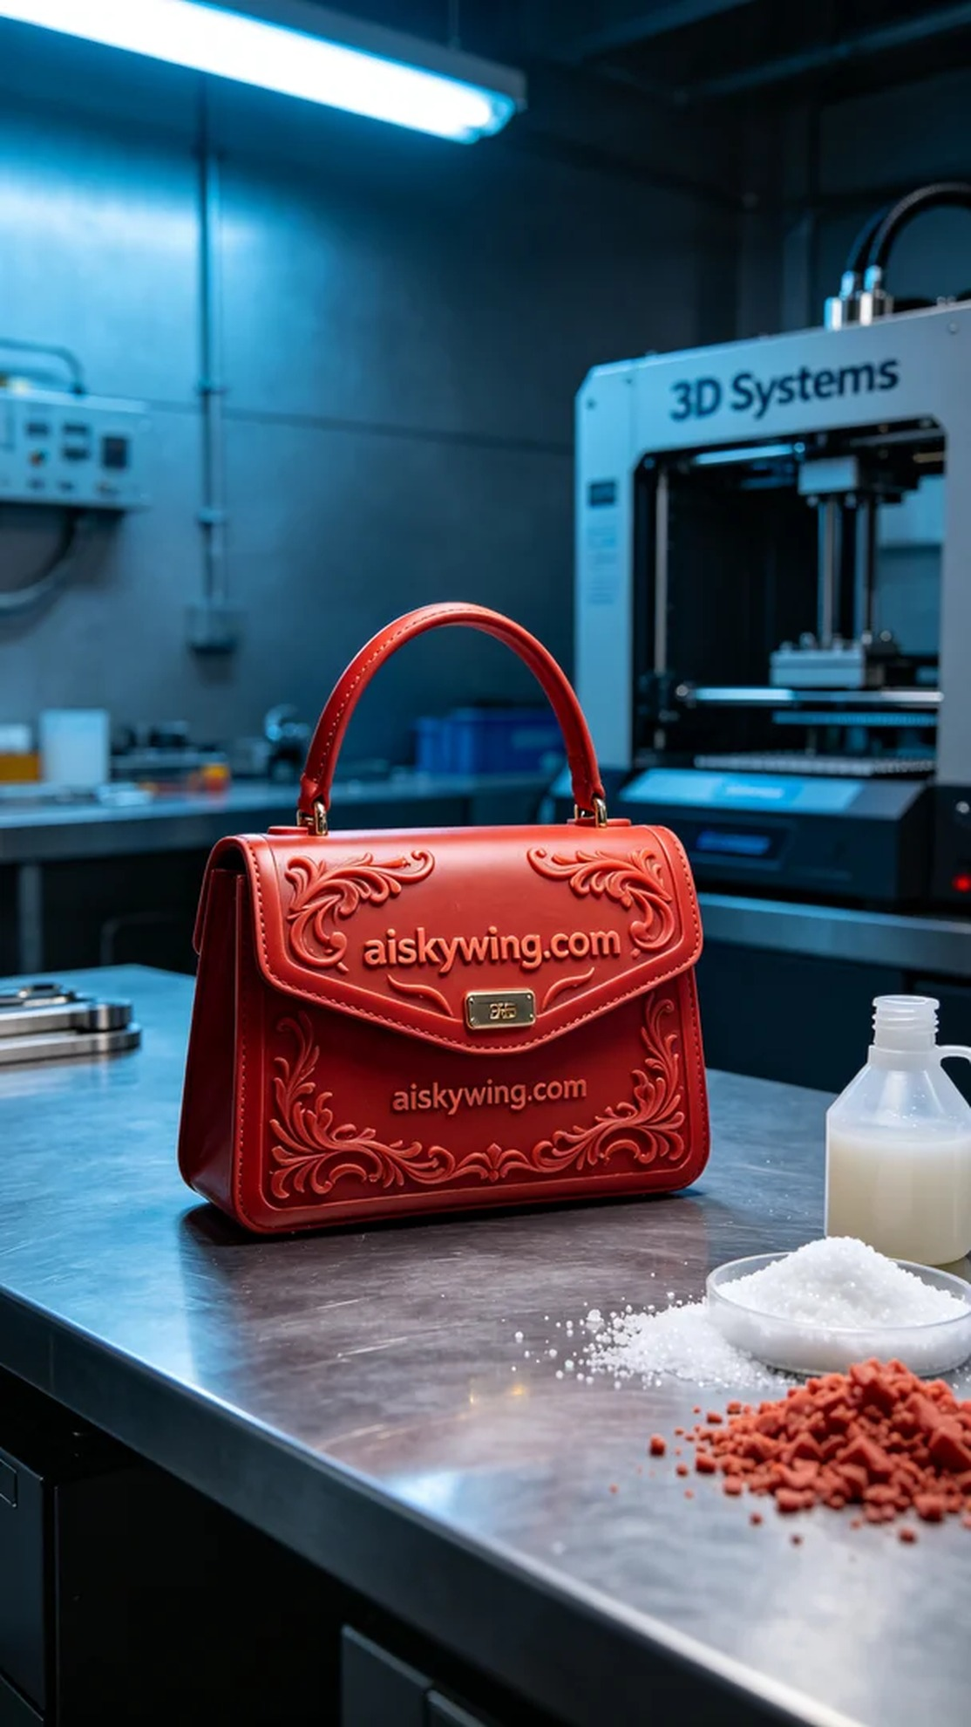
近日，有人因为急需包饰蜡模来完成他们的设计而找上我们。他们对市场上的现有产品不满意，希望能定制一个符合他们要求的模具。这不仅仅是一个简单的订单，更是对我们技术的一次挑战。
在原材料的选择上，我们采用了红蜡精密铸造材料。这种材料的特性使得最终产品不仅表面光滑细腻，而且在铸造过程中可以呈现出极其细致的雕刻效果。为此，我们准备的Systems 3D打印机已调试完毕，打印参数设定为层厚0.1mm，打印温度为220℃，功率设定在80%，打印速度为50mm/s，预计整个打印过程需要耗时大约5个小时。
随着打印机的启动，我们全程监控设备的运行状态。打印过程中，蜡模逐层成型，过程十分顺利。为了确保质量，我们在每一层打印完成后都进行了细致的检查，确保没有气泡或其他问题影响到最终的效果。
完成打印后，后处理环节同样重要。首先，我们将蜡模放入清洗槽中，使用温水和清洁剂彻底清洗表面。之后，通过打磨处理，使得表面更为光滑，剔除任何微小的瑕疵。接着，进行固化处理，使得蜡模的硬度和稳定性进一步增强，最后完成质量检验，确保符合所有标准。
经过一系列的工序，最终的包饰蜡模呈现出完美的效果。每一处细节都展现了我们的努力与专业，让这件作品在光影中更显生动。
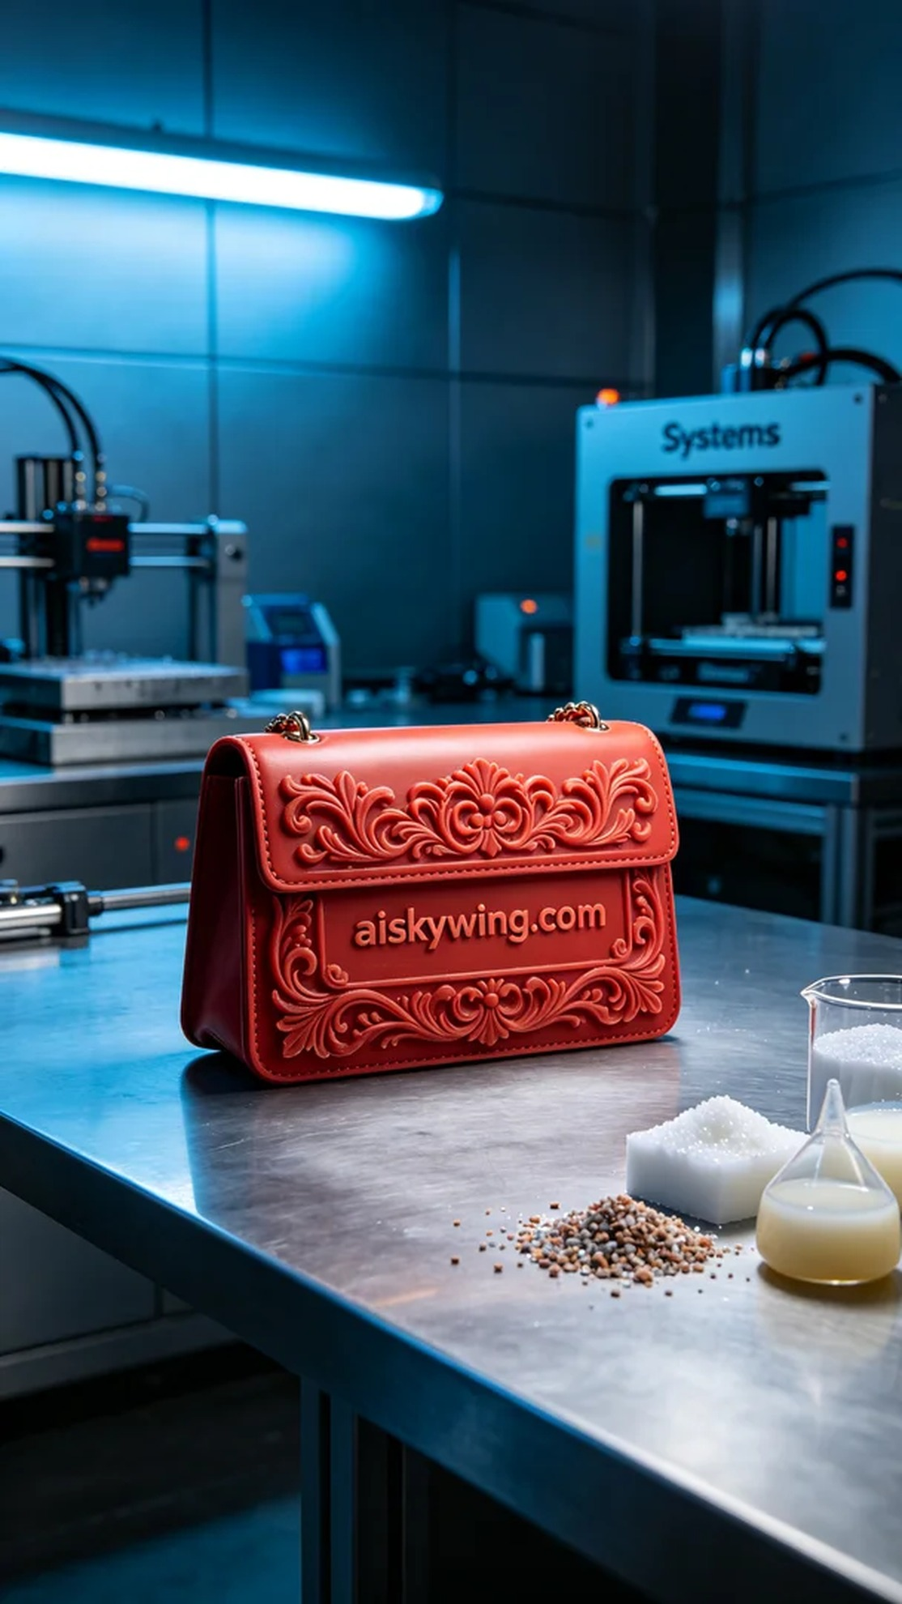
Aiskywing Industrial 3D Printing
The translation of "包饰蜡模" is "Wax mold for packaging."


